|  | **MINISTRY OF EDUCATION AND TRAINING** |
| --- | --- |

| **FPT UNIVERSITY** |
| --- |
| Capstone Project Document |
| Chatbot AI Platform (CAIP) |

| **SEP490_G47** | |
| --- | --- |
| **Group Members** | Ngô Minh Đức - Leader - HE173177  Phạm Viết Long - Member - HE170788  Trần Anh Đức - Member - HE176711  Hoàng Mai Dung - Member - HE176572  Ngô Minh Tuấn Anh - Member - HE176111 |
| **Supervisor** | Nguyễn Trung Kiên - Lecturer |

- Hanoi, Jan 2025 -

**Table of Contents**

Acknowledgement 4

Definition and Acronyms 4

I. Project Introduction 5

1. Overview 5

2. Product Background 5

3. Business Opportunity 6

4. Existing Solutions 8

5. Evaluation of Existing Solutions 11

6. Software Product Vision 12

7. Project Scope & Limitations 13

II. Project Management Plan 16

1. Overview 16

2. Management Approach 20

3. Project Deliverables 22

4. Responsibility Assignments 23

5. Project Communications 24

6. Configuration Management 24

III. Software Requirement Specification 26

1. Overall Requirements 26

2. Use Case Specifications 39

3. Functional Requirements 70

4. Non-Functional Requirements 114

5. Requirement Appendix 116

IV. Software Design Document 124

1. System Design 124

2. Database Design 143

3. Detailed Design 152

V. Software Testing Documentation 198

1. Scope of Testing 198

2. Test Strategy 199

3. Test Plan 200

4. Test Cases 201

5. Test Reports 203

VI. Release Package & User Guides 205

1. Deliverable Package 205

2. Installation Guides 205

3. User Guides 210

4. Config Bot 225

5. Bot Integration 241

6. Admin Management 249

# Acknowledgement

ChatBees was a significant project that most team members hadn't experienced before, and we initially doubted whether we could complete it. Looking back on our journey from the beginning, we’ve received tremendous support from many people. While the rest of this document may be technical, we believe it’s important to take a moment to express our sincere gratitude.

First and foremost, we extend our deepest thanks to our team supervisor, Mr. Nguyen Trung Kien. Not only is he highly skilled in design and software expertise, but he is also a tremendous motivator, constantly encouraging us to push forward and never give up during this challenging journey.

We also want to express our gratitude to the dedicated lecturers at FPT University. Throughout this semester and our Capstone Project, their guidance and support have been invaluable. Their lessons have not only helped shape us into capable professionals but have also given us the confidence to pursue our ambitions.

ChatBees is just the beginning of our long journey in software engineering. Nevertheless, we have every right to be proud of the resilience of our team and the invaluable knowledge and memories we’ve gained along the way.

ChatBees Project

Hanoi, April 29th, 2025

# Definition and Acronyms

| **Acronym** | **Definition** |
| --- | --- |
| AWS | Amazon Web Services |
| BA | Business Analysis |
| BR | Business Rule |
| ERD | Entity Relationship Diagram |
| GUI | Graphical User Interface |
| PM | Project Manager |
| SDD | Software Design Description |
| SPMP | Software Project Management Plan |
| SRS | Software Requirement Specification |
| UC | Use Case |
| API | Application Program Interface |

# I. Project Introduction

## 1. Overview

### 1.1 Project Information

* Project name: ***Chatbot AI Platform***
* Vietnamese name: ***Nền tảng AI giao tiếp***
* Project code: ***CAIP***
* Group name: ***SEP490_G47***
* Software type: ***Web App***

### 1.2 Project Team

| **Full Name** | **Role** | **Email** | **Mobile** |
| --- | --- | --- | --- |
| Nguyễn Trung Kiên | Lecturer | kiennt@fpt.edu.vn | 0912345678 |
| Ngô Minh Đức | Leader | ducnmhe173177@fpt.edu.vn | 0355761159 |
| Phạm Viết Long | Member | longpvhe170788@fpt.edu.vn | 0368353613 |
| Trần Anh Đức | Member | ductahe176711@fpt.edu.vn | 0918478364 |
| Hoàng Mai Dung | Member | dunghmhe176572@fpt.edu.vn | 0834235369 |
| Ngô Minh Tuấn Anh | Member | anhnmthe176111@fpt.edu.vn | 0708328518 |

*Table 1.2.1. Project Team*

## 2. Product Background

In today's fast-paced business environment, both employees and customers struggle to access the right information quickly. Customer service reps waste time sifting through disjointed knowledge bases or escalating queries due to incomplete data, leading to frustrated customers and missed opportunities. Similarly, employees across departments, from sales to HR to engineering, face challenges in retrieving actionable insights, hampering productivity and decision-making.

Traditional chatbots, while popular, are limited to simple, predefined responses and fail to handle complex, context-rich queries. As businesses evolve, these legacy systems can't keep up, creating a demand for smarter solutions.

Enter the Conversational AI Platform, powered by Retrieval-Augmented Generation (RAG). This innovative technology combines advanced information retrieval with generative AI to deliver accurate, real-time responses to nuanced queries. Unlike static chatbots, RAG dynamically pulls from vast data repositories, ensuring up-to-date and contextually relevant answers.

In Vietnam's rapidly digitizing economy, this platform is a game-changer. For e-commerce, it handles surges in customer inquiries during peak times like Tet, providing instant answers on product availability and promotions. In banking, it simplifies complex transactions and reduces call center reliance. Tourism benefits from personalized, multilingual support, while healthcare sees improved patient interactions and faster access to medical information.

By bridging the gap between fragmented data and actionable insights, this platform enhances efficiency, customer satisfaction, and competitiveness in Vietnam's dynamic market.

## 3. Business Opportunity

Businesses worldwide, including in Vietnam, face growing customer service challenges: high costs, slow responses, and uneven quality. Our Conversational AI Platform solves these problems, tapping into a global need and a unique opportunity in Vietnam’s fast-digitizing market.

**Real-World Problems and Cost Burdens**

From multinational corporations to local enterprises, the traditional customer service model is under strain:

High Operating Costs: Globally, customer service labor costs are soaring, think $30,000 USD annually per agent in Western markets. In Vietnam, salaries range from 7-15 million VND/month ($280-600 USD), depending on experience. (ref: [vietnamworks](https://www.vietnamworks.com/muc-luong/nhan-vien-dich-vu-khach-hang-sk))

Add training costs of up to $1,000 USD per employee, and a team of 50 in Vietnam could rack up billions of VND yearly, a burden felt worldwide, but especially by Vietnam’s small and medium enterprises. (ref: [shrm](https://www.shrm.org/in/topics-tools/news/organizational-employee-development/report-employers-reap-benefits-employee-training-done-right))

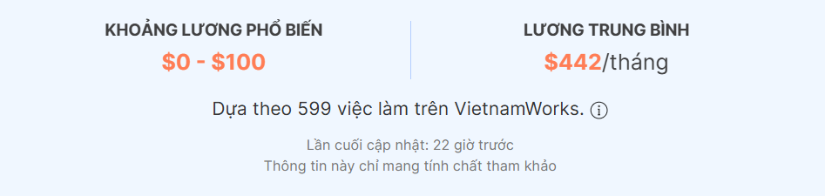

*Figure 3.1. Common salary range and average pay*

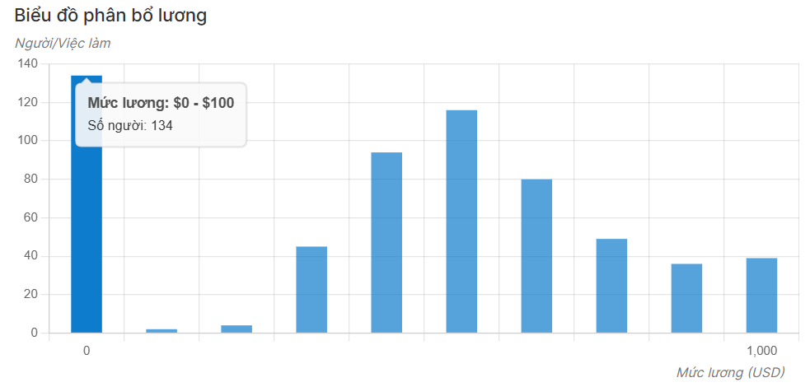

*Figure 3.2. Salary Distribution Chart from VietnamWorks*

Figures 1 and 2 chart highlights Vietnam’s salary spread, underscoring the financial pressure on local businesses.

Slow Responses, Especially During Peak Times: Worldwide, customers demand speed; 70% expect replies within an hour. In Vietnam, this tightens to 70% within 30 minutes, yet during Tet, wait times stretch into hours, driving customers away and slashing revenue a universal peak-season struggle, amplified by Vietnam’s cultural calendar. (ref: [bell24vietnam](https://bell24vietnam.vn/kien-thuc/so-lieu-noi-bat-ve-thi-truong-contact-center-update-2023))

Inconsistent Quality: Globally, human variability frustrates customers; in Vietnam, this inconsistency erodes trust in brands, a gap traditional chatbots can’t fill in either market.

These shared pain points signal a global need and a Vietnamese opportunity for transformation.

**Solutions from Our Conversational AI Platform**

Our platform delivers a breakthrough with worldwide appeal, fine-tuned for Vietnam:

* Significant Cost Reduction: Globally, it slashes interaction costs from $2-3 with humans to $0.01, saving millions annually a win for any economy. In Vietnam, this translates to tens of millions of VND saved, irresistible for cost-conscious firms.
* Instant 24/7 Responses: Meeting global speed demands, it responds instantly, aligning with Vietnam’s 30-minute expectation for 70% of customers, especially during Tet, retaining clients and boosting sales. (ref: [bell24vietnam](https://bell24vietnam.vn/kien-thuc/so-lieu-noi-bat-ve-thi-truong-contact-center-update-2023))
* Consistent Quality: Standardized answers ensure professionalism everywhere, eliminating the variability plaguing both global and Vietnamese businesses.
* Picture a customer anywhere asking about an order at midnight, or a Vietnamese shopper during Tet, both getting instant replies, that’s our game-changer.

**Why Our Product Will Succeed**

The opportunity spans the globe, with Vietnam as a standout:

* Ready Market: The global conversational AI market is booming projected to hit $32 billion USD by 2030 driven by e-commerce and banking. In Vietnam, these sectors grow 20% yearly, with firms like Vietcombank leveraging chatbots for millions of queries, proving local demand.
* Competitive Edge: Against pricey OpenAI or payment-limited Coze, we’re cheaper, faster, and globally scalable, with Vietnam-specific optimizations giving us an edge.
* Expansion Potential: From Vietnam to Southeast Asia and beyond, our platform rides a worldwide automation wave.

**Cost and Benefit Comparison Table**

Here’s how our platform stacks up against human staff, highlighting its value globally and in Vietnam:

| **Factor** | **Human Staff Service** | **Conversational AI Platform** |
| --- | --- | --- |
| Cost per Interaction | $2-3 (global avg.) | $0.01 |
| Response Time | Minutes to hours, peak delays | Instant, 24/7 |
| Quality Consistency | Inconsistent | Standardized, uniform |
| Training Cost | $1,000 USD/employee (global) | None, cost-saving |
| Scalability | Limited, hiring bottlenecks | High, no staff dependency |

*Table 3.1. Cost and Benefit Comparison*

## 4. Existing Solutions

### 4.1 N8n ([n8n](https://n8n.io/))

N8n is an open-source workflow automation platform that allows users to connect applications and automate tasks easily. It offers a flexible drag-and-drop interface, supports custom scripting for advanced logic, and can be fully self-hosted, giving users complete control over their data. With its event-driven architecture and broad integration capabilities, n8n helps streamline and scale complex automation processes efficiently.



*Figure 4.1.1. ChatGPT*

| **Highlight** | **Disadvantages** |
| --- | --- |
| * Provides a highly flexible automation platform capable of connecting a wide range of applications and services. * Open-source and self-hostable, giving businesses full control over their workflows and data privacy. * Supports complex logic, data transformation, and advanced scripting for customized automation scenarios. * Visual workflow builder enables users to design tailored processes according to their needs. | * Requires users to manually build and configure workflows, which can be time-consuming and technically demanding. * As workflows grow in complexity, managing and troubleshooting them can become challenging, especially for non-technical users. * Hosting, maintaining, and scaling n8n can incur high operational costs, including infrastructure expenses and the need for technical personnel, making it less accessible for small businesses. |

*Table 4.1. Highlight and disadvantages of n8n*

### 4.2 Coze([Coze](https://coze.com))

Coze is a next-generation AI application development platform that enables users to build conversational agents without the need for coding. It offers a user-friendly interface with drag-and-drop configurations, allowing for the creation of complex conversational flows and decision trees. Coze supports integration with various data sources, enabling chatbots to interact intelligently with real-time information.

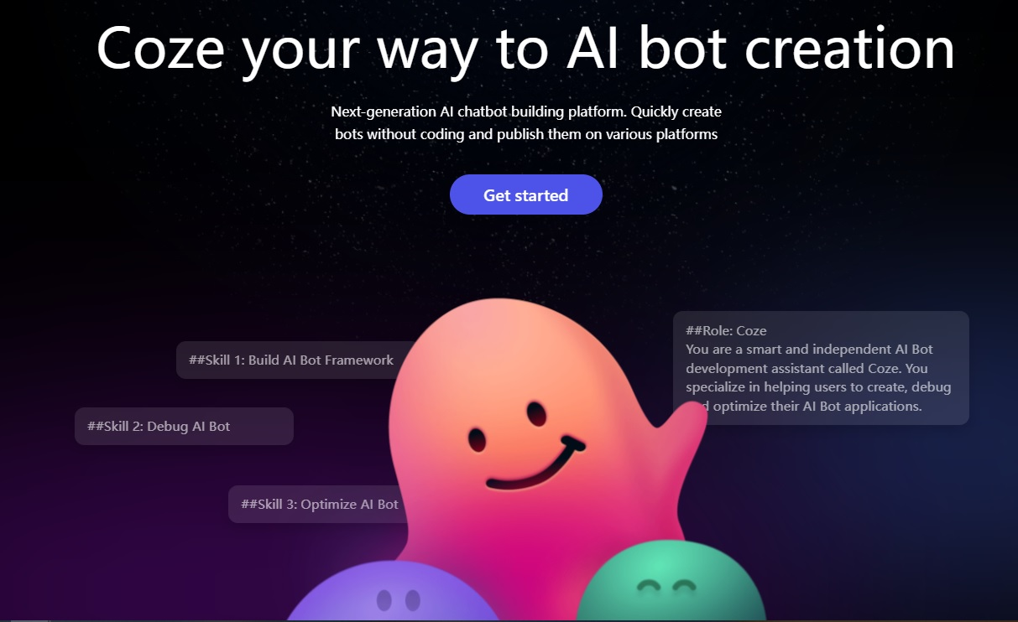

*Figure 4.2.1. Coze*

| **Highlight** | **Disadvantages** |
| --- | --- |
| * Enables personalized chatbot experiences with excellent UX/UI. * Allows users to easily create custom conversation flows tailored to their needs. * Provides a no-code platform for building conversational agents, making development more accessible. | * The payment system can be inconvenient in Vietnam, as it often requires a Visa card or a credit card. * Lacks a centralized live chat management system, making it difficult to monitor and control all active chat sessions effectively. * Bots are unable to autonomously assess conversation quality or notify human agents when intervention is needed (e.g., incorrect responses, sales closing opportunities), hindering human-in-the-loop workflows. * Despite offering many features, the platform can be overwhelming, requiring users to spend considerable time learning, integrating, and navigating the documentation before achieving optimal use. * Integration challenges and documentation complexity can slow down deployment and user adoption, especially for non-technical teams. |

*Table 4.2.1. Highlight and disadvantages of Coze*

### 4.3 Chatling([Chatling.ai](http://chatling.ai))

Chatling.ai is an emerging conversational AI platform that emphasizes simplicity and adaptability. Designed to serve both small businesses and large enterprises, it offers tools to build chatbots that are intuitive, scalable, and capable of handling complex interactions. Chatling.ai supports seamless integration with external knowledge bases and third-party applications, making it a versatile choice across industries.

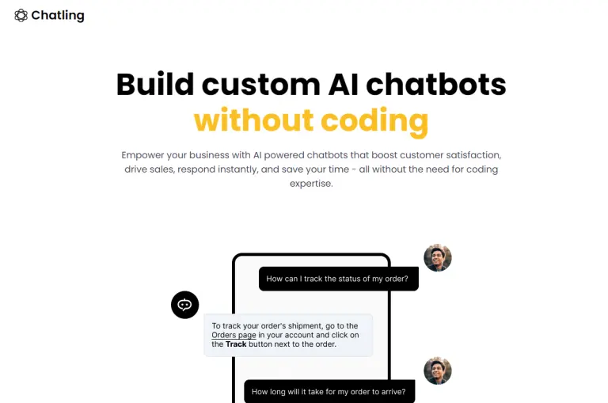

*Figure 4.3.1. Chatling ai*

| **Highlight** | **Disadvantages** |
| --- | --- |
| * Provides seamless integration of chatbots on different websites. * Allows fine-tuning to enhance model accuracy and response relevance. | * It may not be cost-effective or perform optimally for large language models (LLMs), consuming significant resources. * Tends to deliver slower responses even for simpler queries. * Lacks customizable permission settings, reducing operational flexibility and potentially limiting scalability for enterprise needs. |

*Table 4.3.1. Highlight and disadvantages of Chatling ai*

## 5. Evaluation of Existing Solutions

**Target Market:**

* Small and Medium Enterprises (SMEs) in Vietnam: Seeking affordable AI solutions to improve customer service and simplify operations.
* Key Industries: Banking, e-commerce, online education, and healthcare, where automation and accurate information retrieval are essential.
* Non-Technical Users: Businesses wanting to use AI without needing advanced skills.
* Technical Users: Developers and IT teams looking to customize bots for higher accuracy and closely monitor response workflows.

**Value Proposition:** The Conversational AI Platform is purpose-built for the Vietnamese market, addressing critical gaps left by solutions like OpenAI, Coze, and Chatling.ai. It cuts costs and provides context-aware answers using your data, unlike OpenAI’s pricey, generic responses and tough integration. It offers seamless QR code payments and scalability, bypassing Coze’s local payment and growth issues. And it ensures fast replies and easy customization, fixing Chatling.ai’s slow responses and rigid setup.

* Superior Information Retrieval: Tailored to Vietnamese context, providing accurate, locally-relevant responses that reduce costs and improve operational efficiency.
* Seamless Payment Integration: Supports QR codes, fitting Vietnam’s e-wallet culture for easy monetization.
* Effortless Customization: Non-technical users can adjust AI responses without coding, while technical users can fine-tune bots for better accuracy and track response workflows step-by-step.
* Dual Operation Modes: Simple for users, advanced for admins, ensuring maximum usability for all skill levels.
* New Advantage (Predicted): Multilingual Support for Regional Dialects: Reaches diverse Vietnamese users, increasing adoption in rural areas.

**Competitive Edge & Market Potential:** By specifically addressing unmet needs in the Vietnamese SME market, our platform delivers clear advantages for both technical and non-technical users:

* Cost-Effective: Uses task-specific AI to lower expenses, unlike OpenAI’s high-cost model.
* Plug-and-Play Scalability: Easy to deploy and integrate, unlike Coze’s scalability issues, fitting businesses of all sizes.
* Always Improving: Automated quality checks ensure top performance, addressing Chatling.ai’s slow response problem.
* Local Fit: Built for Vietnam with local language and payment support, solving integration challenges faced by others.
* Booming AI Market: Vietnam’s digital transformation creates high demand, especially in key sectors like banking and e-commerce.
* Automation Imperative: Businesses need customer service automation to stay competitive, and we deliver it better.
* Regional Growth: Scalable design ready for expansion across Southeast Asia.
* New Advantage (Predicted): Cultural Context Awareness: Understands Vietnamese nuances (e.g., holiday greetings), enhancing user engagement.

## 6. Software Product Vision

The Conversational AI Platform, powered by Retrieval-Augmented Generation (RAG), equips businesses with intelligent AI Agents that deliver real-time, accurate, and context-rich responses, surpassing traditional chatbots. It empowers companies in Vietnam’s fast-digitalizing market to enhance engagement, streamline operations, and drive growth with unmatched efficiency.

**Handles All Kinds of Data, Always Up-to-Date**: From internal files you upload to live external data like market updates or product feeds, our platform processes it all seamlessly and in real-time. Your bot stays sharp with the latest info think instant stock updates during Tet sales or real-time banking policies for a customer’s query.

**Faster Responses, Lower Costs**: We’ve fine-tuned the system to retrieve and reply at lightning speed while keeping resource use lean. Compared to traditional setups, it slashes wait times and expenses, letting you handle more queries without breaking the bank. For instance, sales teams can pull product details in seconds, no more digging through manuals, speeding up deals, and cutting down on staff workload.

**Less Manpower, More Impact**: By automating data lookups and customer interactions, the platform reduces the need for human intervention in repetitive tasks. This means fewer staff hours spent on grunt work, lower costs, and consistent answers every time. Your team can focus on what matters, like closing deals, while customers get quick, reliable service.

**Personalization Without the Hassle**: Customize your bot’s vibe to match your brand, no tech skills needed. Want a friendly tone for your e-commerce shop or a pro voice for finance clients? You decide how it speaks, making every interaction feel tailored and on-point.

This platform saves time, lowers costs, and improves productivity by providing quick and accurate answers from any data source. It grows easily across industries, reduces the need for staff, and customizes interactions, helping businesses in Vietnam innovate, keep customers happy, and stay ahead in a digital world.

## 7. Project Scope & Limitations

Our Conversational AI Platform aims to deliver a smart, adaptive web application for businesses, hosted on the cloud for maximum scalability and accessibility. The intuitive interface ensures a smooth experience for all users.

### 7.1 Major Features

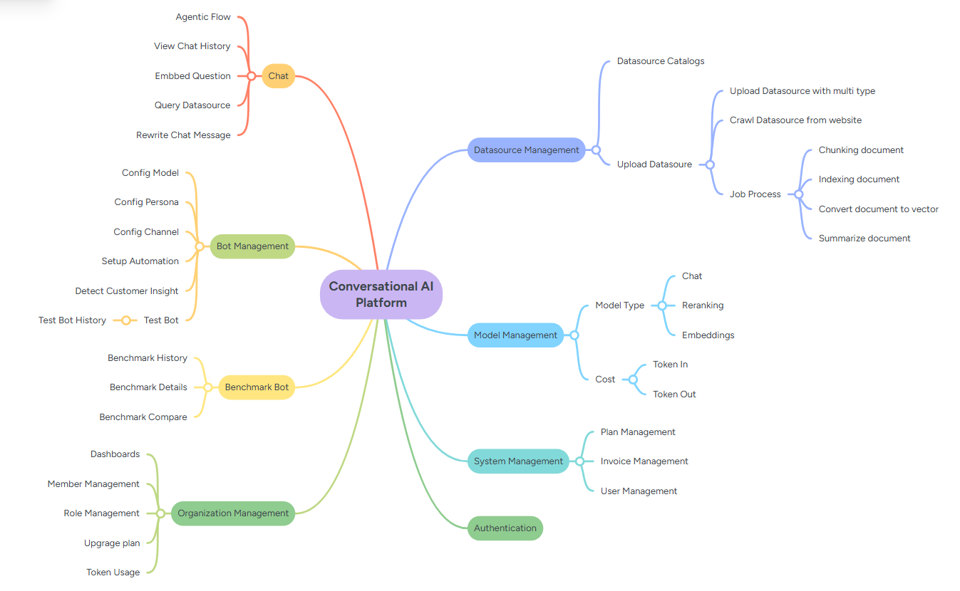

*Figure 7.1.1. Major Features Tree*

| **Feature ID** | **Feature and Description** |
| --- | --- |
| **End-user** | |
| FE-01 | Conversational Interaction (Chat AI): A real-time AI chatbot providing dynamic, context-aware responses with features like embedding questions, agentic flows (e.g., guiding users through processes), rewriting chat messages for clarity, and viewing chat history for reference. Supports FAQs, transaction guidance, and more. |
| FE-02 | Live Chat: Enables real-time human support when the AI cannot resolve a query, ensuring seamless user assistance. |
| **Business Owner** | |
| FE-03 | Analytics Dashboard: Provides business owners with detailed analytics on user interactions, chatbot performance, engagement metrics, and financial reports to monitor and optimize operations. |
| FE-04 | Bot Management: Allows business owners to create and customize chatbots, configure settings like persona, channel, and automation, and test bot performance. Includes viewing bot history and ensuring compliance with security and privacy standards. |
| FE-05 | Evaluate Bot: Enables business owners to evaluation bot performance, compare metrics, and view detailed evaluation history to ensure the bot meets business goals. |
| FE-06 | Live Chat: Enable real-time human support when needed. |
| FE-07 | Data Source Management: Data managers can add, update, or remove external knowledge sources, including uploading documents in multiple formats or pulling data directly from websites for seamless updates. |
| **Admin** | |
| FE-08 | Model Management: Admins can control active AI models, manage embeddings, track token usage (in/out), monitor costs, and select model types for optimal performance. |
| FE-09 | Plan Management: Admins can oversee subscription plans, ensuring proper allocation and upgrades for users and organizations.R |
| FE-10 | Invoice Management: Admins can manage billing and invoicing processes, ensuring accurate financial operations for the platform. |
| FE-11 | User Management: Admins can handle user accounts, assign roles, and manage permissions to ensure secure and smooth platform operations. |

*Table 7.1.1. Major features of the project*

### 7.2 Limitations & Exclusions

For the MVP, we focus on essential features to build a strong foundation. The following are out of scope for now but planned for future releases:

| **Limitations ID** | **Feature and Description** |
| --- | --- |
| LI-01 | Limited Channel Integrations: Only basic channels are supported; integrations with platforms like Facebook Messenger, Zalo, WhatsApp, Slack, and Microsoft Teams are not yet available. |
| LI-02 | No Fine-Tuning Support: Models are used in their default configurations without support for fine-tuning or custom training based on user data. |
| LI-03 | Limited UI Customization: The system does not yet support deep customization of user interfaces, such as theme changes or layout personalization. |
| LI-04 | No Human Agent Handoff: Conversations are solely between users and AI; human agents cannot currently take over ongoing chats. |
| LI-05 | Single Data Source Restriction: Bots can retrieve information from only one data source at a time; multi-datasource retrieval is not yet supported. |
| LI-06 | Limited Service Packages: Service plans are not yet diversified to accommodate varying needs like bot quantity, storage limits, or SLA levels. |
| LI-07 | Limited Admin Role Segmentation: Role and permission management are not yet segmented by bot or organization; admin privileges are currently global. |
| LI-08 | No Native Mobile Apps (iOS/Android): The platform is accessible only via web browsers; native mobile applications are not available. |
| LI-09 | No Voice or Speech-to-Text Features: Voice-related functionalities, including speech recognition and AI voice interaction, are not yet integrated. |
| LI-10 | No Editable Model Configurations: Users cannot modify model settings such as temperature, token limits, or sampling parameters through the interface. |

*Table 7.2.1. Limitations & Exclusions*

# II. Project Management Plan

## 1. Overview

### 1.1 Cost & Time Estimations

| **Total estimate effort** | | | | **237** | **29/12 - 28/4** |
| --- | --- | --- | --- | --- | --- |
| **I** | **Sprint 1: Project Initiation & Ideation (week 1-2)** | | | **16** | **29/12 - 13/1** |
| 1 | Project Ideation | Discuss and select a feasible and meaningful project idea | Medium | 3 | 11/1 - 13/1 |
| 2 | Report 1: Project Introduction | Write Project Introduction report (RP1) including objectives, scope, and team members | Simple | 3 | 29/12 - 31/12 |
| 3 | Initial Requirements Gathering | Gather initial requirements from users or supervisors | Medium | 2 | 1/1 - 2/1 |
| 4 | Report 3: SRS v0.9 (Overall Requirement) | Create a preliminary version of the Software Requirements Specification (RP3) | Complex | 6 | 3/1 - 8/1 |
| 5 | Research (Technology Stack, Tools, etc.) | Research and propose suitable technology stack and project tools | Medium | 2 | 9/1 - 10/1 |
| **II** | **Sprint 2: System Design & Initial Prototyping (weeks 3-4)** | | | **28** | **13/1 - 03/02** |
| 1 | Report 2: Project Management Plan v1.0 | Develop Project Management Plan (RP2) including timeline, resources, and assignments | Medium | 4 | *13/1 - 16/1* |
| 2 | Conduct User Interviews | Conduct interviews with users to understand their needs | Medium | 3 | 17/1 - 19/1 |
| 3 | System Architecture Design | Design the overall architecture of the system (frontend, backend, APIs) | Complex | 3 | 20/1 - 22/1 |
| 4 | System Design & DevOps Setup | Set up development environment and CI/CD pipelines | Complex | 2 | 23/1 - 24/1 |
| 5 | Vertical Prototypes (Code Demo) | Build vertical prototypes demonstrating key functionalities | Complex | 8 | 25/1 - 1/2 |
| 6 | Report 4: SDS v1.0 (High Level Design Specifications) | Write the Software Design Specification (RP4) with high-level designs | Medium | 6 | 25/1 - 30/1 |
| 7 | Set up Development Environment | Install and configure tools for development | Simple | 2 | 2/2 - 3/2 |
| **III** | **Sprint 3: Detailed Design & Proof of Concept (weeks 5-6)** | | | **37** | **5/2 - 18/2** |
| 1 | Report 5: Test Planning (ref Report5_Test Documentation) | Create a comprehensive Test Plan (RP5) for the project | Medium | 5 | 5/2 - 9/2 |
| 2 | Report 3: SRS v1.0 (Detailed Requirements for Iteration 1) | Write the detailed requirements for Iteration 1 | Complex | 6 | 5/2 - 10/2 |
| 3 | Report 4: SDS v1.0 (Detailed Design for Iteration 1) | Update the design specification for Iteration 1 | Complex | 6 | 10/2 - 16/2 |
| 4 | Design Database Schema | Design the database schema and data structure | Complex | 4 | 11/2 - 14/2 |
| 5 | UI/UX Design | Design the user interface and user experience | Medium | 6 | 11/2 - 16/2 |
| 6 | Vertical Prototypes (POC) | Build technical proof-of-concept prototypes | Complex | 10 | 11/2 - 18/2 |
| **IV** | **Sprint 4: Implementation Iteration 1 (weeks 7-8)** | | | **44** | **19/2 - 3/3** |
| 1 | Code Package & Unit Testing Report | Develop and unit test the software modules | Complex | 10 | 19/2 - 28/2 |
| 2 | Report 5.1: Unit Test Cases | Write test cases for unit testing | Medium | 4 | 19/2 - 22/2 |
| 3 | Report 5.1: Unit Test Report | Report the results of unit testing | Medium | 4 | 26/2 - 29/2 |
| 4 | Report 5.2: Integration Test Cases | Write test cases for integration testing | Medium | 4 | 22/2 - 25/3 |
| 5 | Report 5.2: Integration Test Report | Report the results of integration testing | Medium | 4 | 29/2 - 3/3 |
| 6 | Report 3: SRS v1.0 (Detailed Requirements for Iteration 2) | Update detailed requirements for Iteration 2 | Medium | 4 | 24/2 - 27/2 |
| 7 | Report 4: SDS v1.0 (Detailed Design for Iteration 2) | Update the design specification for Iteration 2 | Complex | 6 | 27/2 - 2/3 |
| 8 | Software Package Version 1 | Build and deliver the first version of the software | Complex | 8 | 23/2 - 3/3 |
| **V** | **Sprint 5: Implementation Iteration 2 (weeks 9-10)** | | | **44** | **4/3 - 17/3** |
| 1 | Code Package & Unit Testing Report | Develop and unit test the software modules | Complex | 10 | 4/3 - 13/3 |
| 2 | Report 5.1: Unit Test Cases | Write test cases for unit testing | Medium | 4 | 4/3 - 7/3 |
| 3 | Report 5.1: Unit Test Report | Report the results of unit testing | Medium | 4 | 10/3 - 13/3 |
| 4 | Report 5.2: Integration Test Cases | Write test cases for integration testing | Medium | 4 | 8/3 - 11/3 |
| 5 | Report 5.2: Integration Test Report | Report the results of integration testing | Medium | 4 | 14/3 - 17/3 |
| 6 | Report 3: SRS v1.0 (Detailed Requirements for Iteration 3) | Update detailed requirements for Iteration 3 | Medium | 4 | 9/3 -13/3 |
| 7 | Report 4: SDS v1.0 (Detailed Design for Iteration 3) | Update the design specification for Iteration 3 | Complex | 6 | 14/3 - 17/3 |
| 8 | Software Package Version 2 | Build and deliver the second version of the software | Complex | 8 | 4/3 - 17/3 |
| **VI** | **Sprint 6: Implementation Iteration 3 (weeks 11-12)** | | | **34** | **18/3 - 31/3** |
| 1 | Code Package & Unit Testing Report | Develop and unit test the software modules | Complex | 10 | 18/3 - 26/3 |
| 2 | Report 5.1: Unit Test Cases | Write test cases for unit testing | Medium | 4 | 18/3 - 21/3 |
| 3 | Report 5.1: Unit Test Report | Report the results of unit testing | Medium | 4 | 24/3 - 27/3 |
| 4 | Report 5.2: Integration Test Cases | Write test cases for integration testing | Medium | 4 | 22/3 - 25/3 |
| 5 | Report 5.2: Integration Test Report | Report the results of integration testing | Medium | 4 | 28/3 - 31/3 |
| 6 | Software Package Version 2 | Build and deliver the third version of the software | Complex | 8 | 22/3 - 31/3 |
| **VII** | **Sprint 7: Verification & Finalization (week 13-14)** | | | **19** | **1/4 - 14/4** |
| 1 | System Test Report | Report results from full system testing. | Medium | 5 | 1/4 - 5/4 |
| 2 | User Guides | Write user manuals and guides | Medium | 7 | 6/4 - 12/4 |
| 3 | Final Software Package | Deliver the final version of the software | Medium | 7 | 8/4 - 14/4 |
| **VIII** | **Sprint 8: Closing (week 15)** | | | **15** | **15/4 - 28/4** |
| 1 | Final Project Report | Write the final comprehensive project report | Medium | 6 | 15/4 - 20/4 |
| 2 | Presentation File | Prepare the final presentation slides | Simple | 5 | 21/4 - 25/4 |
| 3 | Project Retrospective | Summarize project lessons learned | Simple | **2** | 26/4 - 27/4 |
| 4 | Documentation Review and Finalization | Review and finalize all project documentation | Medium | **2** | 27/4 - 28/4 |

*Table 1.1.1. Work Breakdown Structure*

### 1.2 Project Objectives

| **#** | **Metric** | **Unit** | **Planned** | **Actual** | **Notes / References** |
| --- | --- | --- | --- | --- | --- |
| 1 | Effort Usage | Person-day | 237 person-days | 230 person-days | Reduced effort due to part-time contributions, and review team workload. |
| 2 | Review Defects | No of defects | 5 defects | 7 defects | Slightly above target, additional review sessions scheduled. |
| 3 | Unit Test Defects | No of defects | 10 defects | 8 defects | Fewer issues were found; early bug fixes improved unit quality. |
| 4 | Integration Test Defects | No of defects | 15 defects | 12 defects | Good performance overall; focus on critical integration points. |
| 5 | System Test Defects | No of defects | 20 defects | 18 defects | Minor issues remain; further refinements are planned before release. |

*Table 1.2.1. Project Objectives*

### 1.3 Project Risks

| **#** | **Risk Description** | **Impact** | **Possibility** | **Response Plans** |
| --- | --- | --- | --- | --- |
| 1 | Team member’s health | Very High | Low | Activate emergency response plan: boost the progress of other tasks and provide support for the responsibilities of the recuperating member. |
| 2 | Insufficient time spent on the capstone project of team members | High | High | Each member regularly reports any abnormal events to the whole team to quickly facilitate. Make a clear commitment on the day of the project's commencement. |
| 3 | Misalignment between project requirements and actual needs | High | Low | Adopt the Agile methodology and narrow a sprint down to 1 week to quickly adapt to changes and to receive stakeholder feedback. |
| 4 | Wrong budget estimation | Medium | High | Establish a clear and realistic budget plan for deployment, and server,.. and evaluate it regularly. |
| 5 | Scopes are expanded beyond expectation | Medium | Medium | Establish a clear scope and regularly review it to ensure that it remains under control. Any proposed changes should be carefully reviewed before being implemented. |
| 6 | Dependency and Compatibility of open-sourced services | Medium | Medium | Use APIs/wrappers to decouple open-source tools from core systems. Test integrations rigorously in staging first. Prioritize projects with corporate backing or large communities for reliability. |
| 7 | Operation Complexity of Using Microservice Architecture | Medium | High | Implement centralized monitoring and logging by integrating tools such as Grafana, Kibana,… to gain real-time insights into system performance and troubleshoot issues efficiently. |

*Table 1.3.1. Project Risks*

## 2. Management Approach

### 2.1 Quality Management

#### 2.1.1 Principles

Our project quality management follows several guiding principles:

* Well-defined, measurable quality goals that align with strategic directions.
* Team members must commit to quality through actions and dedication. Leader leads by example, set quality targets, and ensure members have what they need to succeed.
* Core workflows are researched to analyze inputs, outputs, interactions, and flow. Bottlenecks and inefficiencies are thus identified for improvement opportunities.

#### 2.1.2 Testing Process

| **Testing method** | **Target** |
| --- | --- |
| Unit Test | Isolate each part of the program and show that the individual parts are correct |
| Integration Test | Conducted to evaluate the compliance of a system or component with specified functional requirements. |
| System Test | Conducted on a complete integrated system to evaluate the system's compliance with its specified requirements. |
| Usability Test | Witness real users perform tasks on a prototype to evaluate the app’s ease of use, efficiency, and overall user satisfaction. |

*Table 2.1.2.1. Testing Process*

#### 2.1.3 Defect Classification

| **Defect Label** | **Note** | **Action** |
| --- | --- | --- |
| URGENT | Defects that prevent essential functionality from working or cause a severe performance issue. The system is unusable until it is addressed. | Fix immediately before any further development. Assign the highest priority. |
| HIGH | Causes major disruption of functions or features. Workarounds may exist but the functionality is compromised. | Fix at the earliest in the current development cycle. Address before release. |
| MEDIUM | Annoying but not serious discrepancies that do not impact core functionality. Cosmetic or minor procedural bugs. | Schedule fixes based on impact and effort. It can be postponed to future releases depending on risk assessment. |
| LOW | Very minor aesthetic or cosmetic discrepancies with minimal or no impact on use such as typos, missing labels, etc. | Defer fix to future releases. No immediate action is required but record for future reference. |

*Table 2.1.3.1. Defect Classification*

#### 2.1.4 Reviewing

* Conduct regular design and code reviews by independent teams to identify issues early. Static code analysis tools can also help.
* Perform inspections and walkthroughs on requirements, design documents, and other work products.

### 2.2 Project Training Plan

Some conventions must be followed by all members during the development process, as well as new technologies adopted. For those factors, the team assigns one member with the most proficient expertise in that field to host training sessions for the members involved.

| **Training Area** | **Participants** | **When, Duration** |
| --- | --- | --- |
| Git flow | All members | 07/12 |
| RAG flow | All member | 15/21 - 27/12 |
| Nest.js framework | All members | 22/12 |
| Figma design | DungHM, LongPV, DucNM | 07/01 |
| Docker, devops basic | DucTA, DucNM, AnhNMT | 11/01 |

*Table 2.2.1. Project Training Plan*

## 3. Project Deliverables

| **#** | **Deliverables** | **Due Date** | **Notes** |
| --- | --- | --- | --- |
| 1 | Project Introduction | 31/01/2025 | Provide an overview of the project: background, objective, and scope. |
| 2 | Project Plan | 16/01/2025 | Outline project schedule and milestones. A risk management plan and communication plan are also included |
| 3 | Software Requirement Specification (SRS) | 13/03/2025 | Detail the functional & non-functional requirements and use case description |
| 4 | Software Design Description (SDD) | 17/03/2025 | Include architectural design, database design, and app prototype |
| 5 | Product Release 1 | 03/03/2024 | Launch the first official usable product to collect feedback |
| 6 | Product Release 2 | 17/03/2025 | Launch the 1.1 version of the product, with added functionalities compared to the first version |
| 7 | Product Release 3 | 31/03/2025 | Launch the 1.2 version of the product, with added functionalities compared to the second version |
| 9 | Software Test Document (STD) | 05/04/2025 | Detail the result of different types of testing: UT, IT, AT |
| 10 | Software User Guides | 25/04/2025 | Provide clear instructions on how to use the developed software, with concise language and illustrated screenshots and diagrams |
| 11 | Final Project Report | 27/04/2025 | Includes all the previous project documents in combined, source code, and thesis presentation slide |

*Table 3.1. Project Deliverables*

## 4. Responsibility Assignments

Overall, the team consists of five members, supervised by lecturer KienNT. Our team is made up of two roles: the Team Leader, and the Development team. The development team is then divided into 4 smaller teams that correspond to a specific area, each of which has persons in charge (PIC) and supporting members

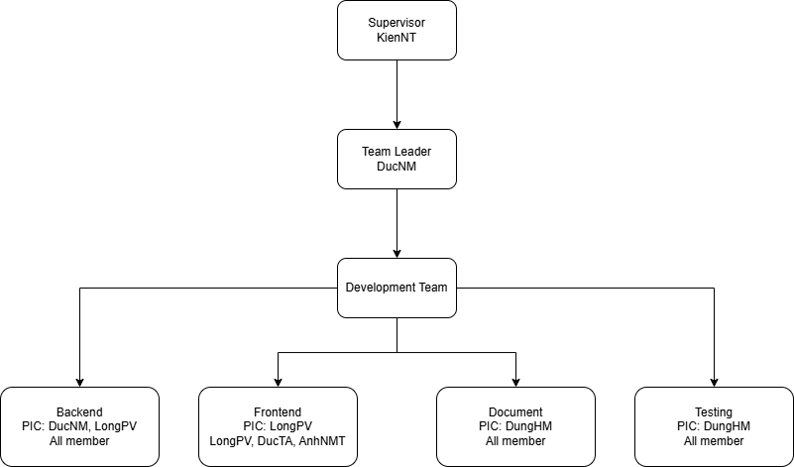

*Figure 4.1. Team Structure*

**RACI Chart**: R~Responsible, A~Accountable, C~Consulted, I~Informed

| **Work Package** | **LongPV** | **DucNM** | **DucTA** | **DungHM** | **AnhNMT** |
| --- | --- | --- | --- | --- | --- |
| Project Planning & Tracking | C | R, A | C | A | C |
| Prepare Project Introduction Document | R | A | I | I | C |
| Prepare SRS Document (Overview Part) | C | A | C | R | C |
| Prepare SRS Document (User Requirements) | A | R | C | C | R |
| Prepare SDD | R | R, A | R | R | R |
| Prepare Test Documents and Report | I | A | I | R | I |
| Prepare User Guides | R | R, A | R | R | R |
| Code Backend | R, A | R, A | R | R | R |
| Code Frontend | R, A | C | R | C | R |
| Prepare Final Report (combining previous documents and presentation slide) | R | R, A | R | R | R |

*Table 4.1. Responsibility assignments*

## 5. Project Communications

| **Communication Item** | **Who/ Target** | **Purpose** | **When, Frequency** | **Type, Tool, Method(s)** |
| --- | --- | --- | --- | --- |
| Team Check-in (Daily, 15 min) | Team members | Answer 3 questions: what did I work on, tomorrow's planned work and issues (if any) | 21:00 everyday | Google Meet |
| Weekly meeting with the supervisor | Team members and supervisor | Check current progress | 20:30 every Saturday | Google Meet |
| Work Planning Session | Team members | Align on priorities for the coming period | 09:00 every Sunday | Offline |
| Team Improvement Discussion | Team members | Reflect on what's working and what could be better | At the end of each interation | Google Meet |
| Documentation & Async Communication | Team members | Record key decisions and information without excessive formality | Ongoing, as needed | Google Meet, In person |
| Issue Resolution | Team members | Solve unexpected problems quickly | As needed | Google Meet, In-person |

*Table 5.1. Project Communications*

## 6. Configuration Management

### 6.1 Document Management

Our team stores and manages project documents using Google Drive. This cloud-based platform facilitates real-time collaboration where teams can edit files simultaneously. Google Drive also retains previous document revisions.

Google Drive contains three main categories. The "Documents" section contains deliverables and additional documents for the project. It unites all the components into one comprehensive collection. The "Management" area includes information on the team and its operations during the product development phase. The last part is "Testing" to contain Testing reports.

In Google Drive, we create project documents using Google Docs and Google Sheets. This allows the entire team to coordinate their work virtually together.

**Link to Driver:** [**click here**](https://drive.google.com/drive/u/3/folders/19ZiIg-693a6Mqwef5xbVAvkNqyyzf8AB)

| **Tool** | **Activity** |
| --- | --- |
| **Google Drive** | Store all documents |
| **Googles Docs** | Document Report, User Guide |
| **Google Sheet** | Project Tracking, Project Weekly, Issues Report |
| **Canva** | Slide Presentation |
| **Figma** | Design Components, Screens |
| **Draw.io / Lucid Chart** | Diagrams |

*Table 6.1.1. Document Management*

### 6.2 Source Code Management

We manage project source codes & their changes/versions in GitHub organization. Also, we strictly follow the Git workflow described in the following diagram:   
**Link to GitHub:** [**click here**](https://github.com/orgs/Hard-working-bees/repositories)

### 6.3 Tools & Infrastructures

| **Category** | **Tools / Infrastructure** |
| --- | --- |
| **Development** | Next.js, Nodejs, FastAPI |
| **Data platform** | PostgreSQL, MongoDB, Milvus |
| **Tech platform** | Sonar (Check source code),  Docker (Launching applications),  RabbitMQ (Manage message queue),  Redis (Caching data),  Prometheus & Grafana (Monitoring system),  Kibana (Check log system),  Elastic search ( searching data),  LiteLLM (Manage Model) |
| **IDEs/Editors** | Pycharm, Visual Studio Code |
| **Diagramming** | Draw.io, Lucid Chart |
| **Designing** | Adobe Figma |
| **Testing tools** | Postman, Junit |
| **Documentation** | Google Docs/Sheets/Drive |
| **Version Control** | GitHub (Source Code) |
| **Deployment server** | AWS (Amazon Web Services), On-premises server |
| **Project management** | Clickup (Schedule, Tasks, Defects), GitHub (Issues) |
| **Collaborations** | Google Meet |

*Table 6.3.1. Tools and infrastructures*

# III. Software Requirement Specification

## 1. Overall Requirements

### 1.1 Context Diagram

The Conversational AI Platform is a software system designed to improve communication between businesses and their customers through chatbot management, conversation handling, and document processing. It provides role-specific functionalities for customers, business owners, and admins, enabling seamless interactions, efficient management, and comprehensive reporting. The platform aims to enhance customer engagement while offering tools for managing chat conversations, user roles, and billing processes.

The context diagram outlines the system's boundaries and its interactions with external entities, including customers, business owners, and administrators. It illustrates data flows such as message exchanges, user management, payment processing, and reporting. This version of the platform is designed to evolve, with plans for integrating additional features and connections in future releases.

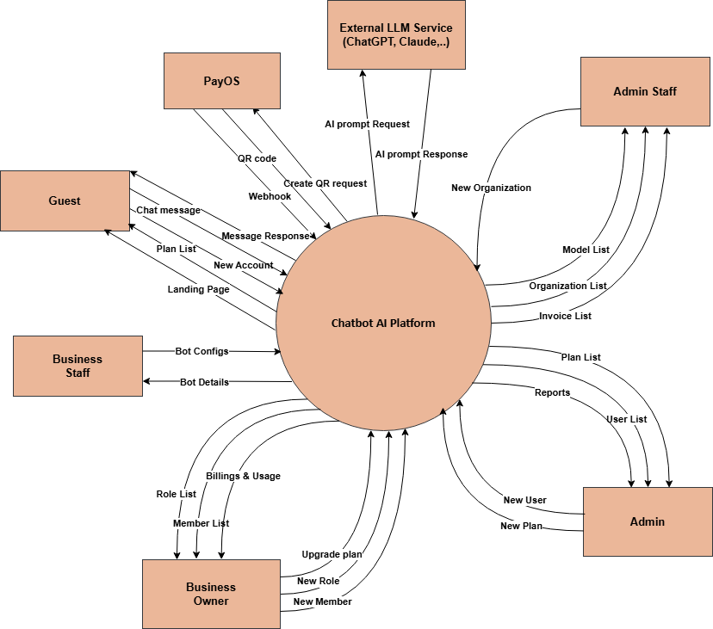

*Figure 1.1.1 Context Diagram*

### 1.2 Main Workflows

#### 1.2.1 Setup an organization

##### **1.2.1.1 Setup an organization workflow**

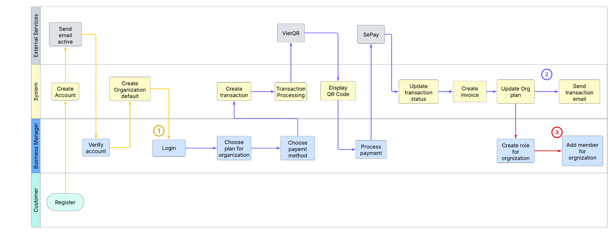

*Figure 1.2.1.1.1 Organization Workflow*

##### **1.2.1.2 Detail flow**

1. **User Registration and Organization Creation:** A user signs up for the system, confirms their email, and gets a default organization.
   * The user registers by providing their details (e.g., email and password).
   * The system sends a confirmation email to the user.
   * The user clicks a link in the email to verify their account.
   * Once verified, the system automatically creates a default organization for the user, linked to their account.
2. **Payment Flow:** The user selects a subscription plan, completes payment through a third-party service, and their organization’s plan is updated.
   * The user chooses a plan (e.g., basic, premium) from the system’s pricing options.
   * The system creates a transaction and redirects the user to a third-party payment provider to process the payment.
   * After the user completes the payment, the third-party service sends a callback to the system confirming the payment’s success.
   * The system generates an invoice and updates the user’s organization with the selected plan, granting access to the plan’s features.
3. **Add Members to Organization:** After successfully purchasing a plan, business owner can invite members and assign roles.
   * The organization owner (BO) accesses the organization’s settings in the system.
   * The BO creates roles (e.g., admin, developer, sale) with specific permissions for the organization.
   * The BO invites members to join the organization by sending email invitations.
   * Invited members accept the invitation and are added to the organization with their assigned roles, allowing them to collaborate within the system.

#### 1.2.2 Bot Setup

##### **1.2.2.1 Bot Setup workflow**

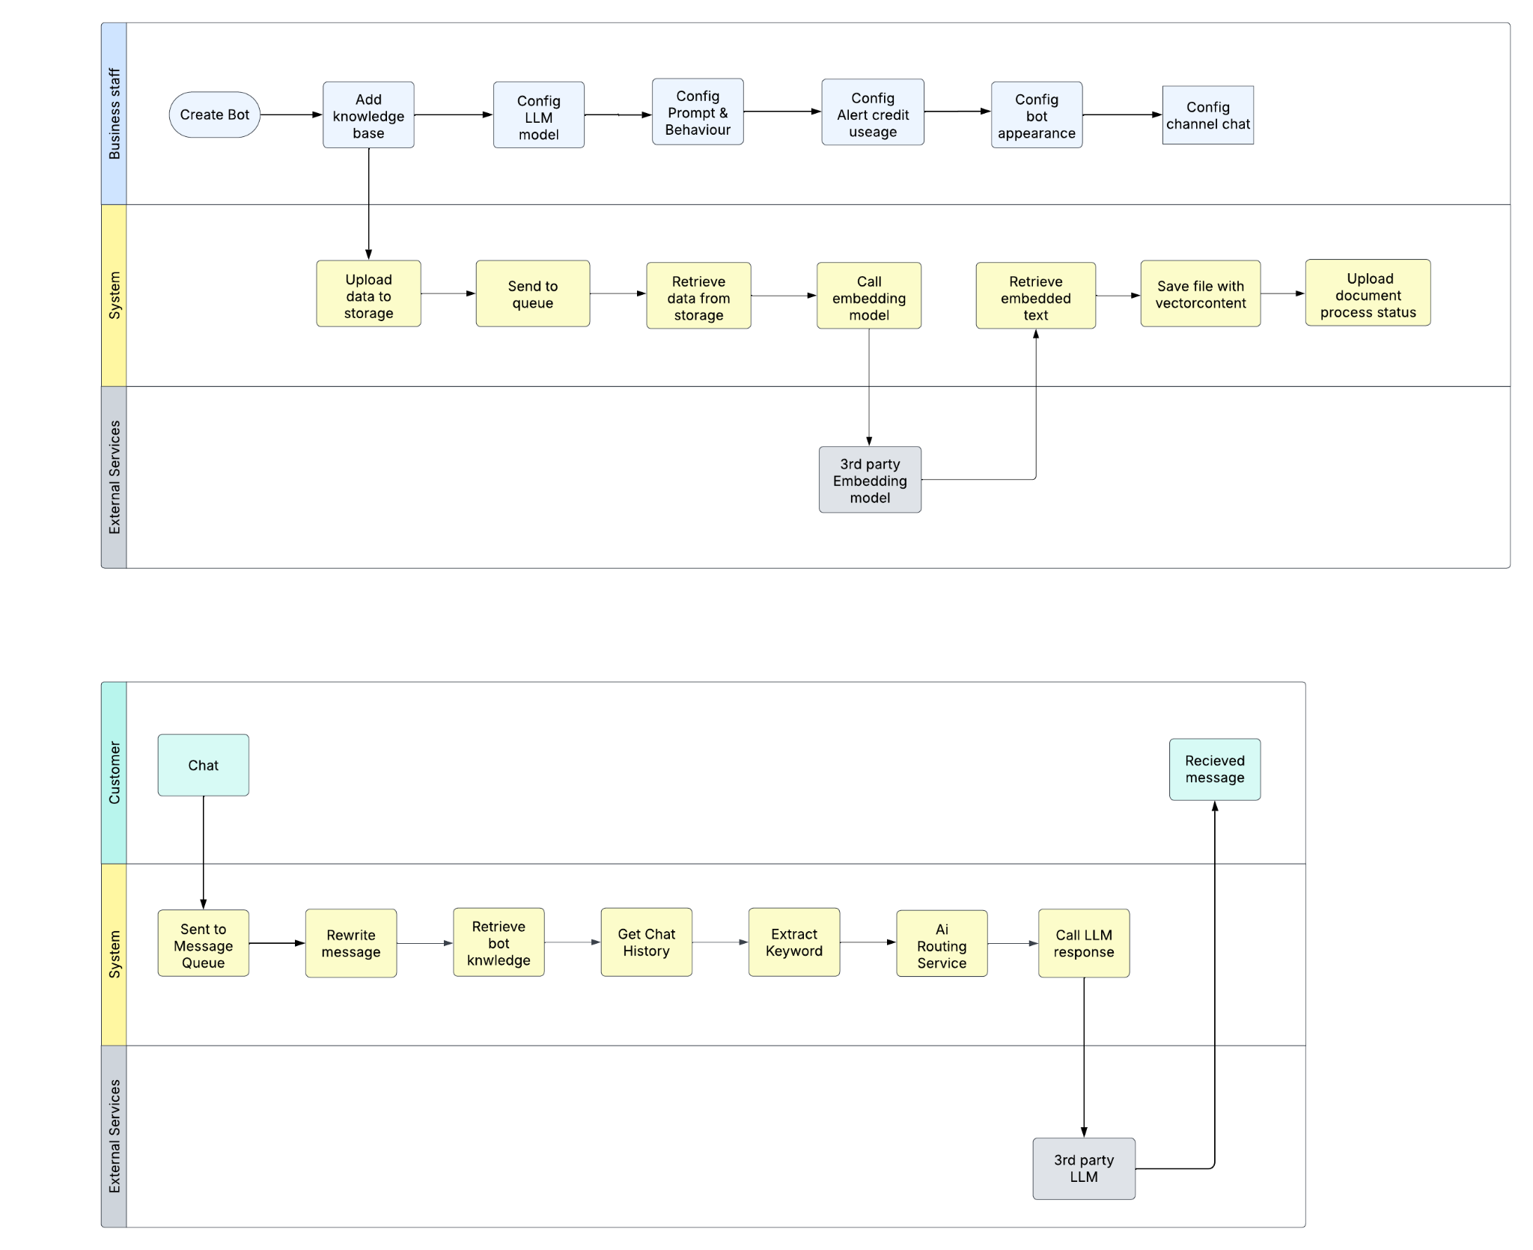

*Figure 1.2.2.1.1 Bot setup workflow*

##### **1.2.2.2 Detail flow**

1. Create Bot: Business staff initiate the bot creation process.
2. Add Knowledge Base:
   1. Upload data to secure storage with format validation
   2. Add files to processing queue to manage system load
   3. Retrieve documents from storage as processing begins
   4. Call embedding model to extract and segment text
   5. Utilize third-party embedding services when needed
   6. Process text into vector embeddings for semantic understanding
   7. Save vectorized content in specialized databases
   8. Update document processing status with real-time feedback
3. The system then processes this information in the background.
4. Configure LLM Model: Business staff select the appropriate language model based on their specific needs (speed, cost, or accuracy).
5. Configure Prompt & Behavior: Business staff define the bot's behavior, tone, and response patterns by setting up specific prompts.
6. Configure Alert Credit Usage: Business staff set up notifications for credit consumption to manage costs.
7. Configure Bot Appearance: Business staff customize the visual aspects and interface of the chatbot.
8. Configure Channel Chat: Business staff set up integration with various communication platforms (website, Zalo, Telegram, Slack).

#### 1.2.3 Chat

##### **1.2.3.1 Chat workflow**



*Figure 1.2.3.1.1 Chat workflow*

##### **1.2.3.2 Detail flow**

1. User Initiates Chat: Customer starts a conversation with the bot.
2. Message Processing:
   1. Messages are sent to a queue for management
   2. The system rewrites/processes the message
   3. Retrieves relevant bot knowledge
   4. Gets chat history for context
   5. Extracts keywords from the message
   6. Routes through AI service
   7. Calls LLM response generation
   8. May utilize third-party LLM services as needed
3. Response Delivery: The system delivers the processed response back to the customer.

### 1.3 User Requirements

#### 1.3.1 Actors

| **#** | **Actor** | **Description** |
| --- | --- | --- |
| 1 | Guest | A user who is not logged into the system, with limited access to public information. |
| 2 | Business Staff | Employees working for a business, responsible for managing bots. |
| 3 | Business Owner | The owner of the business, with access to and control over all business operations |
| 4 | Admin Staff | Administrative staff responsible for supporting and managing system operations, with more limited permissions compared to Admin |
| 5 | Admin | The system administrator with the highest level of access, managing the entire system and assigning roles to other users. |

*Table 1.3.1.1 Actors*

#### 1.3.2 Use Cases

| **ID** | **Use Case** | **Feature** | **Use Case Description** |
| --- | --- | --- | --- |
| 1 | View Landing Page | Common | Displays the homepage with an overview of the system's services. |
| 2 | Register An Account | Common | Allows a visitor to create an account. |
| 3 | Login To The System | Common | Authenticates a user and provides access to the system. |
| 4 | Change Password | Common | Allows users to update their password. |
| 5 | Reset Password | Common | Resets the user's password if forgotten. |
| 6 | Logout | Common | Logs out the user from the system. |
| 7 | View/Edit Profile | Common | Allows users to view and edit their profile details. |
| 8 | Chat | Common | Enables real-time chat functionality. |
| 9 | View Bot List | Business Staff | Displays a list of available bots. |
| 10 | Add New Bot | Business Staff | Adds a new chatbot to the system. |
| 11 | Update Bot Details | Business Staff | Modify detailed information about a specific bot. |
| 12 | Activate/Deactivate Bot | Business Staff | Changes the active status of a bot. |
| 13 | View Data Source List | Business Staff | Displays available data sources. |
| 14 | Add New Data Source | Business Staff | Adds a new data source for bots. |
| 15 | Delete Data Source | Business Staff | Deletes a specific data source. |
| 16 | Config Bot’s Persona | Business Staff | Configures the bot's persona. |
| 17 | Test Bot | Business Staff | Tracks each step in a bot's conversation flow, measuring response time and returned data for testing and validation. |
| 18 | View Test History | Business Staff | Access and review the results of previously conducted tests |
| 19 | Config Bot Channel | Business Staff | Configures integrations like Telegram, Slack, etc., enabling the bot to connect with external platforms. |
| 20 | Setup Automation | Business Staff | Allows users to turn the bot’s automation mode on or off, and configure tools the bot can use such as accessing external data (e.g. Excel) or managing transaction logs. |
| 21 | Detect customer insight | Business Staff | Allows users to view user contacts based on insights. |
| 22 | View Live Chat | Business Staff | Allows users to monitor and review customer chat interactions in real-time or historically. |
| 23 | Evaluate Bot | Business Staff | Evaluates the bot's performance based on various criteria. |
| 24 | View Evaluation History | Business Staff | Displays a list of previously executed bot evaluation runs, including model details, configuration settings, and timestamps. |
| 25 | View Evaluation Details | Business Staff | Shows detailed information about a specific evaluation run, including input data, model responses, scoring metrics. |
| 26 | Compare Evaluation Results | Business Staff | Allows users to select and compare multiple evaluation runs side-by-side, highlighting differences in model performance, accuracy, and configuration settings to support data-driven evaluations and improvements. |
| 27 | View Dashboard | Business Owner | Provides an overview of key evaluationing statistics, recent activity, and performance trends through interactive charts and summaries. |
| 28 | View Organization List | Business Owner | Displays a list of registered organizations. |
| 29 | Add New Organization | Business Owner | Allows the admin to register a new organization. |
| 30 | Update Organization Details | Business Owner | Modify detailed information about a specific organization. |
| 31 | Activate/Deactivate Organization | Business Owner | Changes the active status of an organization. |
| 32 | View Member List | Business Owner | Displays a list of registered members. |
| 33 | Add New member | Business Owner | Allows the admin to register a new member. |
| 34 | Delete Member | Business Owner | Changes the active status of a member. |
| 35 | View Role List | Business Owner | Displays a list of roles. |
| 36 | Add New Role | Business Owner | Allows the business owner to define a new role. |
| 37 | Update Role Details | Business Owner | Modify details of a specific role |
| 38 | Activate/Deactivate Role | Business Owner | Changes the active status of a role. |
| 39 | View Plan & Usage | Business Owner | Displays billing information and usage statistics. |
| 40 | Upgrade Plan | Business Owner | Enables users to upgrade their subscription plan and payment |
| 41 | Setup Credit Alerts | Business Owner | Configure an email address to receive automatic alerts when their credit balance reaches a specified threshold |
| 42 | View Model List | Admin Staff | Displays a list of available models. |
| 43 | View Model Details | Admin Staff | Displays detailed information about a specific model. |
| 44 | View Invoice List | Admin Staff | Displays a list of invoices. |
| 45 | Add New Invoice | Admin Staff | Allows admins to add a new invoice. |
| 46 | Update Invoice Details | Admin Staff | Modify detailed information about a specific invoice. |
| 47 | Change Invoice Status | Admin Staff | Changes the active status of a model. |
| 48 | View User List | Admin | Displays a list of system users. |
| 49 | Add New User | Admin | Allows the admin to create a new user account. |
| 50 | Update User Details | Admin | Modify detailed information about a specific user. |
| 51 | Activate/Deactivate User | Admin | Changes the active status of a user account. |
| 52 | View Plan List | Admin | Displays a list of available subscription plans. |
| 53 | Add New Plan | Admin | Allows admins to define a new subscription plan. |
| 54 | Update Plan Details | Admin | Modify details of a specific subscription plan. |
| 55 | Activate/Deactivate Plan | Admin | Changes the active status of a subscription plan. |

*Table 1.3.2.1 Use Cases*

#### 1.3.3 Use Case Diagram

##### **1.3.3.1 UCs for Guest**

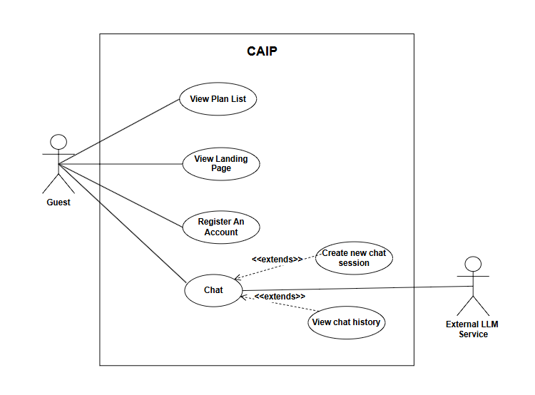

*Figure 1.3.3.1.1 UCs for Guest*

##### **1.3.3.2 UCs for Registered user**

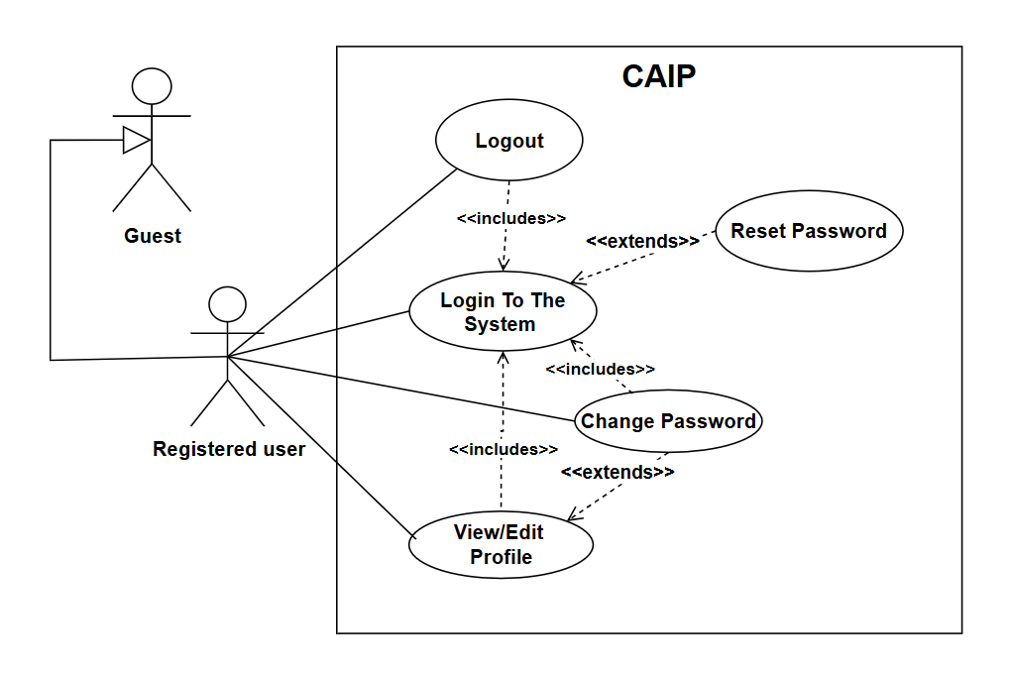

*Figure 1.3.3.2.1 UCs for Registered user*

##### **1.3.3.3 UCs for Business Staff**

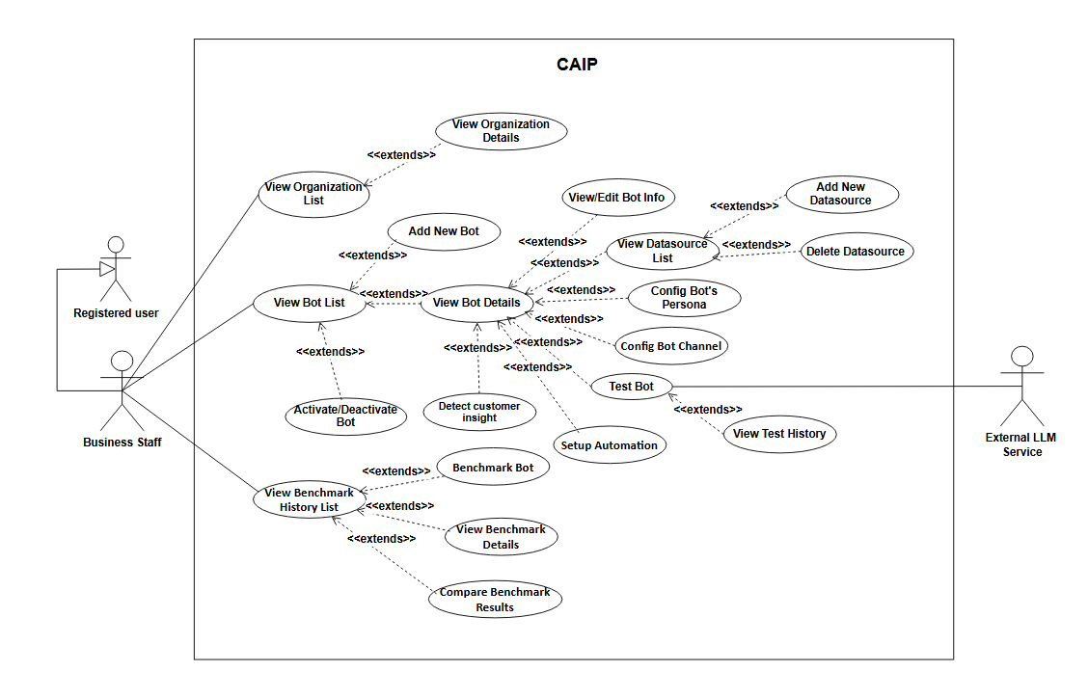

*Figure 1.3.3.3.1 UCs for Business Staff*

##### **1.3.3.4 UCs for Business Owner**

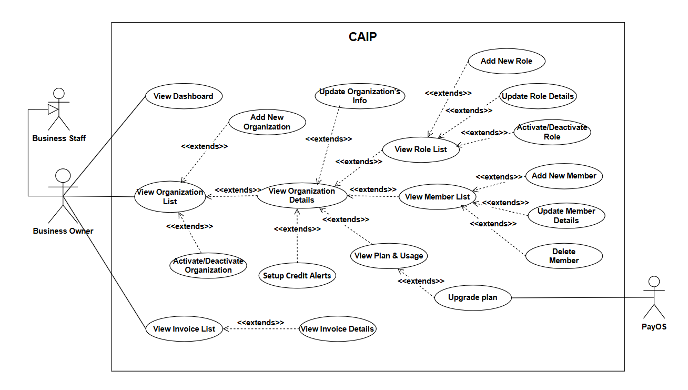

*Figure 1.3.3.4.1 UCs for Business Owner*

##### **1.3.3.5 UCs for Admin Staff**

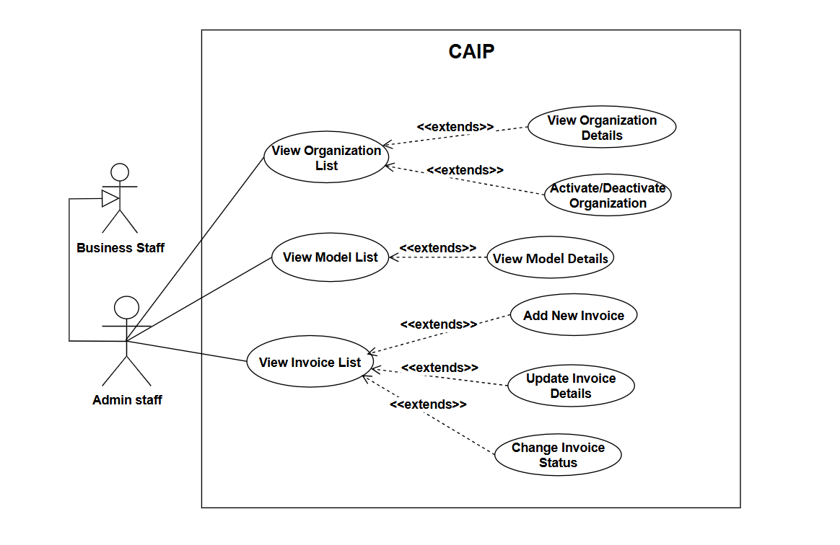

*Figure 1.3.3.5.1 UCs for Admin Staff*

##### **1.3.3.6 UCs for Admin**

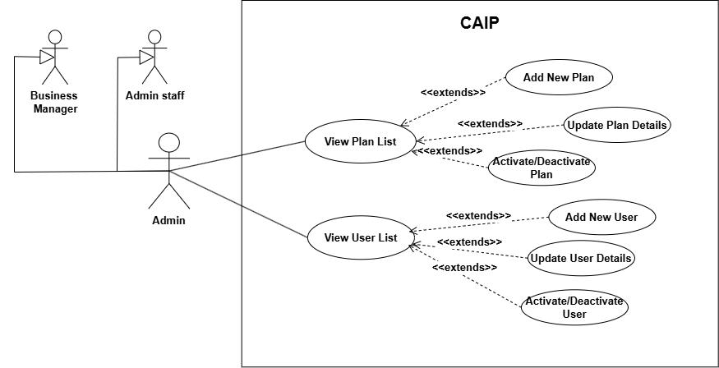

*Figure 1.3.3.6.1 UCs for Admin*

### 1.4 System Functionalities

#### 1.4.1 Screens Flow

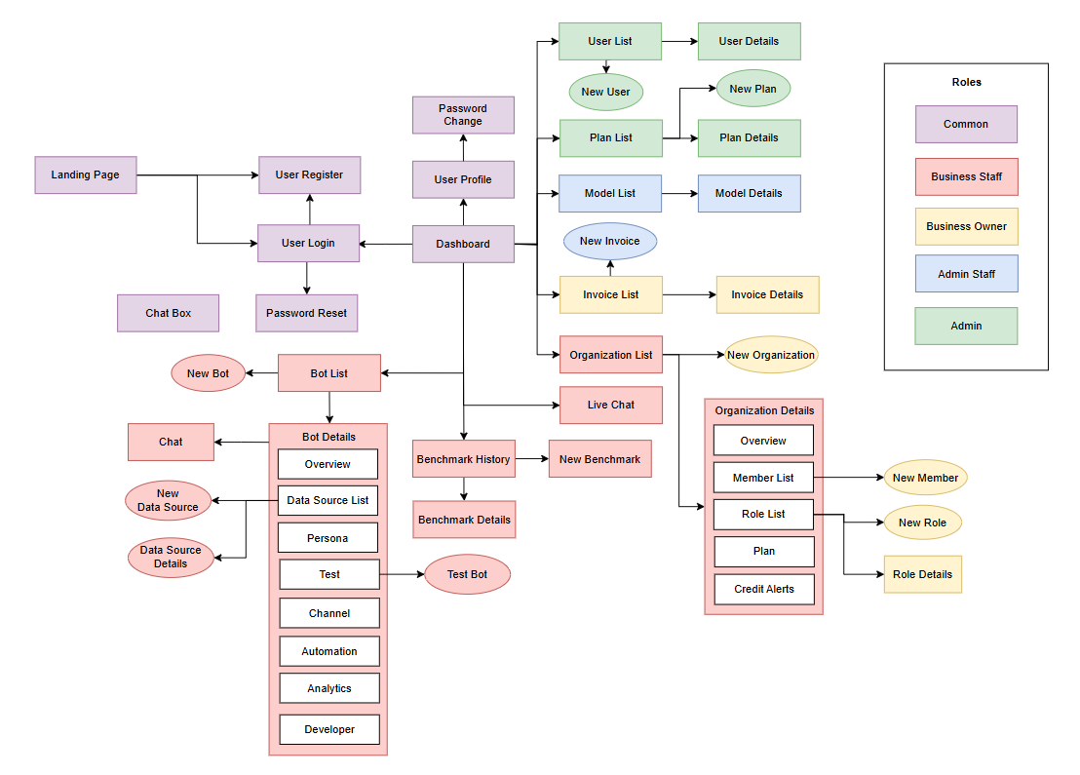

*Figure 1.4.1.1 Screens Flow*

#### 1.4.2 Screen Authorization

| **Screen** | **Guest** | **Business Staff** | **Business Owner** | **Admin Staff** | **Admin** |
| --- | --- | --- | --- | --- | --- |
| Landing Page | X | X | X | X | X |
| Chat Box | X | X | X | X | X |
| User Register | X | X | X | X | X |
| User Login |  | X | X | X | X |
| Password Reset |  | X | X | X | X |
| Password Change |  | X | X | X | X |
| User Profile |  | X | X | X | X |
| Dashboard |  | X | X | X | X |
| Bot List |  | X | X | X | X |
| Bot Details |  | X | X | X | X |
| New Bot |  | X | X | X | X |
| Live Chat |  | X | X | X | X |
| Chat |  | X | X | X | X |
| Test Bot |  | X | X | X | X |
| New Data Source |  | X | X | X | X |
| Data Source Details |  | X | X | X | X |
| Organization List |  | X | X | X | X |
| Organization Details |  | X | X | X | X |
| Evaluation History |  | X | X | X | X |
| New Evaluation |  | X | X | X | X |
| Evaluation Details |  | X | X | X | X |
| New Organization |  |  | X | X | X |
| New Member |  |  | X | X | X |
| New Role |  |  | X | X | X |
| Role Details |  |  | X | X | X |
| Invoice List |  |  | X | X | X |
| Invoice Details |  |  | X | X | X |
| Model List |  |  |  | X | X |
| Model Details |  |  |  | X | X |
| New Invoice |  |  |  | X | X |
| User List |  |  |  |  | X |
| New User |  |  |  |  | X |
| User Details |  |  |  |  | X |
| Plan List |  |  |  |  | X |
| New Plan |  |  |  |  | X |
| Plan Details |  |  |  |  | X |

*Table 1.4.2.1 Screen Authorization*

#### 1.4.3 Non-UI Functions

| **#** | **Feature** | **System Function** | **Description** |
| --- | --- | --- | --- |
| 1 | Datasource Management | Process uploaded data | Automatically ingests and processes knowledge data received from external sources or system integrations in the background, without requiring user interaction. |
| 2 | Datasource Management | Persist Processed Data | Saves processed data and original files into designated storage systems, such as cloud-based S3 buckets or on-premise storage, ensuring data integrity and accessibility for future retrieval. |
| 3 | Chat | Insight and process chat responses | Utilizes multiple LLM models to analyze chat responses for personal information (e.g., email, phone numbers). Backend systems automatically evaluate the responses and notify the business with relevant insights or alerts. |

*Table 1.4.3.1 Non-UI Functions*

### 1.5 Entity Relationship Diagram

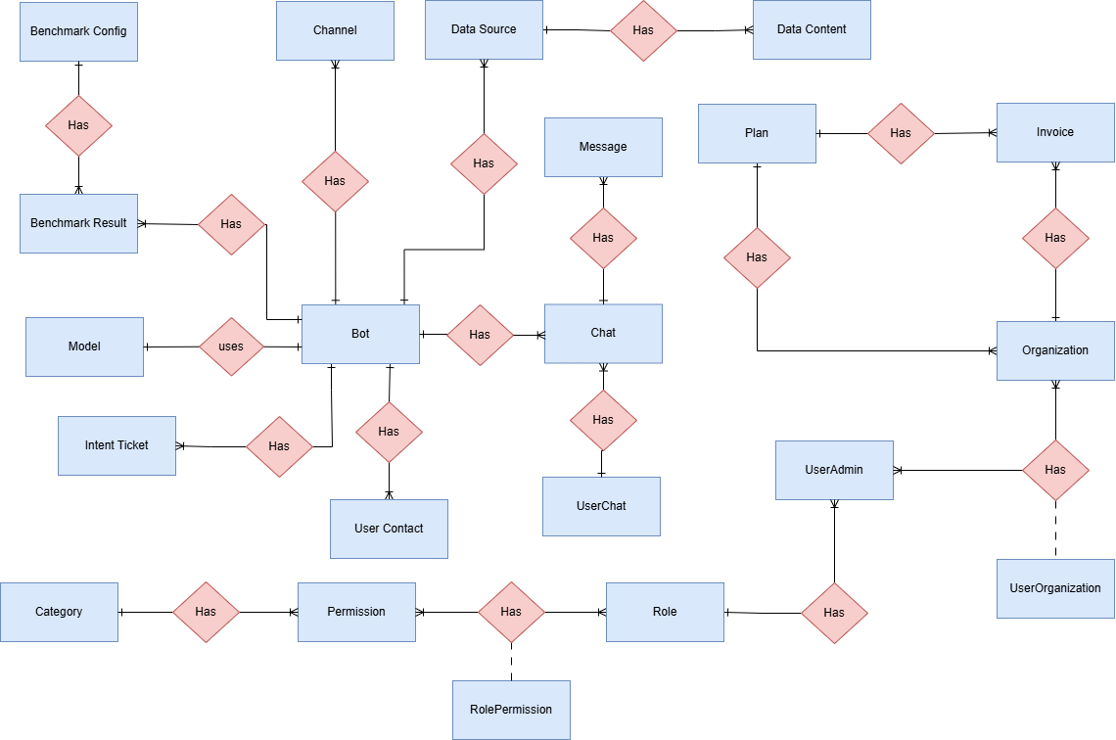

*Table 1.5.1 Entity Relationship Diagram*

## 2. Use Case Specifications

### 2.1 Common Feature

#### 2.1.1 View landing page

| UC ID and Name: | **UC-1_View landing page** | | |
| --- | --- | --- | --- |
| Created By: | DungHM | Date Created: | 22/Jan/2025 |
| Primary Actor: | Amin, Admin Staff, Business Owner, Business Staff, Customer, Guest | Secondary Actors: | None |
| Trigger: | This screen triggers when a user enters the website | | |
| Description: | As a user, I want to view the landing page to get an overview of the system's features and offerings. | | |
| Preconditions: | PRE-1. Users enter the website | | |
| Postconditions: | POST-1. The website display sliders, information, plans | | |
| Normal Flow: | **1.0 View landing page**  1. Displaying the company logo and/or name  2. Providing a navigation menu to help users explore different sections of the site  3. Highlighting featured content or promotions  4. Providing access to user account information, if applicable. | | |
| Alternative Flows: | 1. If the user is not logged in, the home page might provide a call-to-action button to encourage them to create an account. | | |
| Exceptions: | N/A | | |

*Table 2.1.1.1 View landing page*

#### 2.1.2 Register an account

| UC ID and Name: | **UC-2_Register an account** | | |
| --- | --- | --- | --- |
| Created By: | DungHM | Date Created: | 22/Jan/2025 |
| Primary Actor: | Amin, Admin Staff, Business Owner, Business Staff, Customer, Guest | Secondary Actors: | None |
| Trigger: | Click a button Register | | |
| Description: | As a user, I want to register an account so that I can access platform features and services. | | |
| Preconditions: | PRE-1. The user email/phone does not register | | |
| Postconditions: | POST-1. The user has an account to login into system | | |
| Normal Flow: | **2.0 Register an account**  1. User selects the account registration function on the main screen.  2. The system displays a text box allowing the user to create an  fullname, username, password.  3. User fills in the account name and password he wants to create.  **4. The system checks the characters entered in the username and**  **password fields.**  5. User selects “Register”.  **6. The system checks the account name and password with the**  **data on the system. If it exists, go to the registration page..**  7. The system checks the email domain with the data on the system. If it does not exist, add the account and password to the system.  8.1 The user receives the OTP from the inputted phone.  8.2 The user receives a link to verify from inputted email.  9.1 The web moves to enter the OTP screen.  9.2 User clicks the links then redirects to his/her dashboard.  10. The user enters the OTP.  11. The user clicks the “Confirm” button.  12 The system moves to the his/her dashboard. | | |
| Alternative Flows: | **2.1 Register an account**  **4. Username containing special characters**  1. The system displays the message "Invalid username or password"  below the text box of the registered name.  2. User re-enters the username.  3. Go back to step 4.  **2.2 Register an account**  **6. The registered name matches the data on the system**  1. The system displays the message "Registered name is already in  use".  2. User re-enters the registered name and password.  3. Go back to step 6.  7. The system checks the email domain with the data on the system. If it does not exist, add the account and password to the system.  1. The system displays the message "Email domain is not allowed".  2. User re-enters the registered name and password.  3. Go back to step 6. | | |
| Exceptions: | N/A | | |
| Business Rules: | BR1, BR2 | | |

*Table 2.1.2.1 Register an account*

#### 2.1.3 Login to the system

| UC ID and Name: | **UC-3_Login to the system** | | |
| --- | --- | --- | --- |
| Created By: | DungHM | Date Created: | 22/Jan/2025 |
| Primary Actor: | Amin, Admin Staff, Business Owner, Business Staff, Customer, Guest | Secondary Actors: | None |
| Trigger: | User clicks Login button | | |
| Description: | As a user, I want to be able to log into the system so that I can use the system’s authenticated features and access my personalized account. | | |
| Preconditions: | PRE-1. User account has been created & authorized | | |
| Postconditions: | POST-1. User logs in the system successfully | | |
| Normal Flow: | **3.0 Login to the system**  1. User accesses the User Login screen  2. User types in the login details or choose other login options (see 3.1)  3. User clicks the Login button  4. System validates the login details (see 3.0.E1)  5. System allows user to access  6. System tracks user’s success login to the Activity Log  7. System accesses the DashBoard | | |
| Alternative Flows: | ***3.1 Google Login***  1. User chooses to login system using Google account  2. System redirects the user to the Google’s Login screen  3. User types in the Google account details and chooses to login  4. Google validates user’s login information successfully and redirect him/her back to the system  5. Return to step 5 of normal flow. | | |
| Exceptions: | ***3.0.E1 System can’t authenticate the user***  1. The Error Message screen is shown to the user  2. User cancels the logging in *=> UC stops, change to UC-1_View Landing Page*  3. User clicks “Forgot Password?” link *=> change to UC-5_Reset Password*  4. User clicks “Register” link *=> change to UC-2_Register*  ***3.0.E2 User has been blocked***  1. The system show show the message “ Your account has been blocked” | | |
| Business Rules: | BR1, BR2 | | |

*Table 2.1.3.1 Login to the system*

#### 2.1.4 Change Password

| UC ID and Name: | **UC-4_Change password** | | |
| --- | --- | --- | --- |
| Created By: | DungHM | Date Created: | 22/Jan/2025 |
| Primary Actor: | Amin, Subject manager, Class Manager, Team Leader, Student | Primary Actor: | None |
| Trigger: | When users click on the button “Change Password” | | |
| Description: | As a user, I want to change my account password to maintain account security or update it to a new one. | | |
| Preconditions: | PRE-1. Users login successfully | | |
| Postconditions: | POST-1. Users can change passwords. | | |
| Normal Flow: | **4.0 Change password**  1. User selects "Change Password”  **2. The system displays a text box allowing the user to enter the old password (1 time) and enter the old password (2 times).**  4. Click “Save Changes” and the user has changed the new password for the system. | | |
| Alternative Flows: | **4.1 User entered wrong old password**  1. The system displays the message “Need to enter the correct old password”.  2. After entering, continue the sequence.  **4.2 User entered wrong new password**  1. The system displays the message “New password does not match”.  2. The user must enter the new password twice, making sure that the two passwords match.  3. After entering, continue the sequence. | | |
| Exceptions: | N/A | | |
| Business Rules: | BR1, BR2 | | |

*Table 2.1.4.1 Change Password*

#### 2.1.5 Reset Password

| UC ID and Name: | **UC-5_Reset password** | | |
| --- | --- | --- | --- |
| Created By: | DungHM | Date Created: | 22/Jan/2025 |
| Primary Actor: | Amin, Admin Staff, Business Owner, Business Staff, Customer, Guest | Secondary Actors: | None |
| Trigger: | When users click on the “Forgot Password” button in the Login screen | | |
| Description: | As a user, I want to reset my password if I forget it so that I can regain access to my account. | | |
| Preconditions: | PRE-1. The user account is active | | |
| Postconditions: | POST-1. The user can log in with the new password | | |
| Normal Flow: | **5.0** **Reset password**  1. The user clicks “Forgot password?”  2. The user enters an email/phone.  3. The user clicks the “Continue” button.  4. The system checks the email that the user entered.  **5. The user receives the OTP from inputted email/phone.**  6. The web moves to enter the OTP screen.  **7. The user enters the OTP.**  8. The user clicks the “Confirm” button.  9. The system checks the input OTP that the user entered.  10. The web moves to reset the password screen.  11. The user enters the new password and confirms the new password, then clicks the “Save” button.  12. The system checks the valid password that the user entered.  15. When the user clicks OK, the dialog is closed and the web returns to the home page | | |
| Alternative Flows: | **4.1** **User did not receive the confirmation code**  1. The system displays the message “Confirmation code sent”.  2. User re-enters the confirmation code.  3. Go back to step 6.  **4.2**  **User entered wrong confirmation code**  1. The system displays the message "Invalid confirmation code".  2. User re-enters the confirmation code.  3. Go back to step 8. | | |
| Exceptions: | N/A | | |
| Business Rules: | BR1, BR2 | | |

*Table 2.1.5.1 Reset Password*

#### 2.1.6 Logout

| UC ID and Name: | **UC-6_Logout** | | |
| --- | --- | --- | --- |
| Created By: | DungHM | Date Created: | 22/Jan/2025 |
| Primary Actor: | Amin, Admin Staff, Business Owner, Business Staff, Customer, Guest | Secondary Actors: | None |
| Trigger: | When users click on the button “Logout” | | |
| Description: | As a user, I want to log out of my account to end my session and protect my account from unauthorized access. | | |
| Preconditions: | PRE-1. Users login successfully | | |
| Postconditions: | POST-1. Users logout of the system. | | |
| Normal Flow: | **6.0 Logout**  1. User selects "Logout”  2. User logout of the system successfully | | |
| Alternative Flows: | N/A | | |
| Exceptions: | N/A | | |
| Business Rules: | N/A | | |

*Table 2.1.6.1 Logout*

#### 2.1.7 View/Edit Profile

| UC ID and Name: | **UC-7_View/Edit profile** | | |
| --- | --- | --- | --- |
| Created By: | DungHM | Date Created: | 22/Jan/2025 |
| Primary Actor: | Amin, Admin Staff, Business Owner, Business Staff, Customer, Guest | Secondary Actors: | None |
| Trigger: | User clicks “My profile” button | | |
| Description: | *As a user, I want to view my profile so that i can confirm and update information* | | |
| Preconditions: | PRE-1. User has logged the system | | |
| Postconditions: | POST-1. User see profile successfully | | |
| Normal Flow: | **7.0 View/Edit profile**  1. User selects "My profile”  2. The system displays the profile of the user.  3. User edits his/her own profile.  4. Click “Save Changes” and the user has updated his/her profile for the system. | | |
| Alternative Flows: | **7.1 Full name contains special characters**  1. The system displays the message "Invalid fullname"  2. User re-enters the full name.  3. Go back to step 4 of normal flow | | |
| Exceptions: | N/A | | |
| Business Rules: | None | | |

*Table 2.1.7.1 View/Edit Profile*

#### 2.1.8 Chat

| UC ID and Name: | **UC-8_Chat** | | |
| --- | --- | --- | --- |
| Created By: | DungHM | Date Created: | 22/Jan/2025 |
| Primary Actor: | Guest | Secondary Actors: | External LLM Service |
| Trigger: | User use Chat box in website | | |
| Description: | *As a user, I want to chat with a bot so that I can quickly get answers to my questions, receive assistance, or complete tasks without needing to contact a human agent.* | | |
| Preconditions: | PRE-1. User has logged the system | | |
| Postconditions: | POST-1. The user receives automated responses or assistance from the chatbot. | | |
| Normal Flow: | **8.0 Chat**  1. User selects the "Chat with Bot" option from the application.  2. The chatbot welcomes the user and offers help or suggestions.  3. User types a query or request in the chat input field.  4. The system processes the input and generates an appropriate response.  5. The chatbot displays the response in the conversation thread.  6. User continues the conversation or completes the interaction by ending the chat. | | |
| Alternative Flows: | N/A | | |
| Exceptions: | N/A | | |
| Business Rules: | BR20 | | |

*Table 2.1.8.1 Chat*

### 2.2 Business Staff Feature

#### 2.2.1 View Bot List

| UC ID and Name: | **UC-9_View bot list** | | |
| --- | --- | --- | --- |
| Created By: | DungHM | Date Created: | 23/Jan/2025 |
| Primary Actor: | Business Staff, Business Owner, Admin Staff, Admin | Secondary Actors: | None |
| Trigger: | Clicks “Bots” from the sidebar | | |
| Description: | *As a business staff, I want to view a list of available bots so that I can monitor, manage, and select bots for specific tasks or interactions.* | | |
| Preconditions: | PRE-1. User has logged the system | | |
| Postconditions: | POST-1. Show a list of all users in the system and their information. | | |
| Normal Flow | **9.0 List bots**  1. User clicks the “User” in the sidebar  2. System show a list of all users | | |
| Alternative Flows: | None | | |
| Exceptions: | N/A | | |
| Business Rules: | BR21 | | |

*Table 2.2.1.1 View Bot List*

#### 2.2.2 Add New Bot

| UC ID and Name: | **UC-10_Add New Bot** | | |
| --- | --- | --- | --- |
| Created By: | DungHM | Date Created: | 23/Jan/2025 |
| Primary Actor: | Business Staff, Business Owner, Admin Staff, Admin | Secondary Actors: | None |
| Trigger: | Clicks *Add new chatbot* button in Bot list screen | | |
| Description: | *As a business staff, I want to add a new bot with custom configuration,*  *So that the system can automate tasks and improve efficiency.* | | |
| Preconditions: | PRE-1. User has logged the system | | |
| Postconditions: | POST-1. Add a new bot to the system successfully | | |
| Normal Flow | **10.0 Add New Bot**  1. User clicks the “Add newBot” button.  2. The web displays a form for the admin to fill out the bot's details.  3. User fills out the form and clicks the “Add” button.  4. A new bot has been created to the system. | | |
| Alternative Flows: | **10.1. Name of a new bot existing in the system**  1. Fill other name that isn’t existed in system  2. Return to step 4 of normal flow. | | |
| Exceptions: | N/A | | |
| Business Rules: | N/A | | |

*Table 2.2.2.1 Add New Bot*

#### 2.2.3 Update Bot Details

| UC ID and Name: | **UC-11_Update Bot Details** | | |
| --- | --- | --- | --- |
| Created By: | DungHM | Date Created: | 23/Jan/2025 |
| Primary Actor: | Business Staff, Business Owner, Admin Staff, Admin | Secondary Actors: | None |
| Trigger: | Clicks View details button from Bot list screen | | |
| Description: | *As a business staff, I want to be able to update the details of an existing bot so that I can ensure its configuration remains accurate and optimized for current requirements.* | | |
| Preconditions: | PRE-1. User has logged the system  PRE-2. The bot to be updated exists in the system | | |
| Postconditions: | POST-1. Bot details has been updated successfully | | |
| Normal Flow | **11.0 Update Bot Details**  1. User clicks “View Details” of the bot list screen.  2. The system displays the bot's details.  3. User edits the bot's details .  4. Click “Update” and the user has updated the bot's details for the system. | | |
| Alternative Flows: | **11.1. Update name that existed in the system**  1. Fill other name that isn’t existed in system  2. Return to step 4 of normal flow. | | |
| Exceptions: | None | | |
| Business Rules: | None | | |

*Table 2.2.3.1 Update Bot Details*

#### 2.2.4 Activate/Deactivate Bot

| UC ID and Name: | **UC-12_Activate/Deactivate Bot** | | |
| --- | --- | --- | --- |
| Created By: | DungHM | Date Created: | 23/Jan/2025 |
| Primary Actor: | Business Staff, Business Owner, Admin Staff, Admin | Secondary Actors: | None |
| Trigger: | Clicks Status toggle in Bot List screen | | |
| Description: | *As a business staff, I want to be able to deactivate/activate a bot so that I can control whether the bot is operational or temporarily disabled.* | | |
| Preconditions: | PRE-1. User has logged the system  PRE-2. The bot to be updated exists in the system | | |
| Postconditions: | POST-1. Activate/deactivate a bot successfully | | |
| Normal Flow | **12.0 Activate/Deactivate bot**  1. User clicks status toggle to activate/deactivate a bot.  2. The system displays a confirmation form.  3. Click “Confirm” to activate/deactivate a bot.  4. A bot has been activated/deactivated successfully | | |
| Alternative Flows: | None | | |
| Exceptions: | None | | |
| Business Rules: | None | | |

*Table 2.2.4.1 Activate/Deactivate Bot*

#### 2.2.5 View Data Source List

| UC ID and Name: | **UC-13_View data source list** | | |
| --- | --- | --- | --- |
| Created By: | DucNM | Date Created: | 23/Jan/2025 |
| Primary Actor: | Business Staff, Business Owner, Admin Staff, Admin | Secondary Actors: | None |
| Trigger: | Clicks “Knowledge base” from the sidebar | | |
| Description: | *As a business staff, I want to view a list of base data sources so that I can manage or verify the information used by the bot for interactions.* | | |
| Preconditions: | PRE-1. User has logged the system | | |
| Postconditions: | POST-1. Show a list of all data sources for a specific bot in the system. | | |
| Normal Flow | **13.0 View data source list**  1. User clicks the “Knowledge” in the tab in “Bot Details” screen  2. System shows a list of all data sources. | | |
| Alternative Flows: | N/A | | |
| Exceptions: | N/A | | |
| Business Rules: | N/A | | |

*Table 2.2.5.1 View Data Source List*

#### 2.2.6 Add New Data Source

| UC ID and Name: | **UC-14_Add New Data Source** | | |
| --- | --- | --- | --- |
| Created By: | DucNM | Date Created: | 23/Jan/2025 |
| Primary Actor: | Business Staff, Business Owner, Admin Staff, Admin | Secondary Actors: | None |
| Trigger: | Clicks *Add new data source* button in Data source list screen | | |
| Description: | *As a business staff, I want to add a new base data source so that the bot can use it for better responses and interactions.* | | |
| Preconditions: | PRE-1. User has logged the system | | |
| Postconditions: | POST-1. Add a new data source to the system successfully | | |
| Normal Flow | **14.0 Add New Data Source**  1. User clicks the “Add new data source” button.  2. The web displays a form for the admin to fill out the data source's details.  3. User fills out the form and clicks the “Add” button.  4. A new data source has been added to the system. | | |
| Alternative Flows: | N/A | | |
| Exceptions: | N/A | | |
| Business Rules: | N/A | | |

*Table 2.2.6.1 Add New Data Source*

#### 2.2.7 Delete Data Source

| UC ID and Name: | **UC-15_Delete Data Source** | | |
| --- | --- | --- | --- |
| Created By: | DucNM | Date Created: | 23/Jan/2025 |
| Primary Actor: | Business Staff, Business Owner, Admin Staff, Admin | Secondary Actors: | None |
| Trigger: | Clicks *Delete* button in Data source list screen | | |
| Description: | *As a business staff, I want to delete an existing base data source so that it is no longer used by the bot.* | | |
| Preconditions: | PRE-1. User has logged the system | | |
| Postconditions: | POST-1. The selected data source is successfully removed from the system. | | |
| Normal Flow | **15.0 Delete Data Source**  1. User navigates to the data source list.  2. User selects a data source to delete.  3. The system prompts for confirmation.  4. The system deletes the selected data source.  5. The system confirms the successful deletion and updates the list of data sources. | | |
| Alternative Flows: | N/A | | |
| Exceptions: | N/A | | |
| Business Rules: | N/A | | |

*Table 2.2.7.1 Delete Data Source*

#### 2.2.8 Config Bot’s Persona

| UC ID and Name: | **UC-16_Config Bot’s Persona** | | |
| --- | --- | --- | --- |
| Created By: | DucNM | Date Created: | 23/Jan/2025 |
| Primary Actor: | Business Staff, Business Owner, Admin Staff, Admin | Secondary Actors: | None |
| Trigger: | User navigates to the “Persona” tab in “Bot Details” screen | | |
| Description: | *As a business staff, I want to configure the bot settings so that I can customize its behavior.* | | |
| Preconditions: | PRE-1. User has logged the system | | |
| Postconditions: | POST-1. Bot configurations are successfully updated. | | |
| Normal Flow | **16.0 Config Bot’s Persona**  1. User clicks the “Persona” tab in “Bot Details” screen  2. System displays the current bot configuration.  3. User updates bot information  4. User saves the configuration changes.  5. System confirms successful configuration. | | |
| Alternative Flows: | N/A | | |
| Exceptions: | N/A | | |
| Business Rules: | N/A | | |

*Table 2.2.8.1 Config Bot’s Persona*

#### 2.2.9 Test Bot

| UC ID and Name: | **UC-17_Test Bot** | | |
| --- | --- | --- | --- |
| Created By: | DucNM | Date Created: | 23/Jan/2025 |
| Primary Actor: | Business Staff, Business Owner, Admin Staff, Admin | Secondary Actors: | External LLM Service |
| Trigger: | User navigates to the “Test” tab in “Bot Details” screen | | |
| Description: | *As a business staff, I want to know the details behind the response so that I can ensure it behaves correctly before releasing it to customers.* | | |
| Preconditions: | PRE-1. User has logged the system | | |
| Postconditions: | POST-1. Detailed information behind the response is shown. | | |
| Normal Flow | **17.0 Test Bot**  1. User clicks the “Test” tab in the “Bot Details” screen.  2. User clicks the “Debug Chat Flow” button.  3. User types a query or request in the chat input field.  4. The system processes the input and generates an appropriate response.  5. Click “Transaction Log” above the response.  6. The chatbot displays detailed info about the response. | | |
| Alternative Flows: | N/A | | |
| Exceptions: | N/A | | |
| Business Rules: | N/A | | |

*Table 2.2.9.1 Test Bot*

#### 2.2.10 View Test History

| UC ID and Name: | **UC-18_View Test History** | | |
| --- | --- | --- | --- |
| Created By: | DucNM | Date Created: | 23/Jan/2025 |
| Primary Actor: | Business Staff, Business Owner, Admin Staff, Admin | Secondary Actors: | None |
| Trigger: | User navigates to the “Test” tab in the “Bot Details” screen. | | |
| Description: | *As a business staff, I want to access and review the results of previously conducted tests so that I can analyze performance, track progress* | | |
| Preconditions: | PRE-1. User has logged the system | | |
| Postconditions: | POST-1. Show a list of all previously conducted tests for a specific bot in the system. | | |
| Normal Flow | **18.0 View Test History**  1. User clicks the “Test” tab in “Bot Details” screen  2. System shows a list of previously conducted tests. | | |
| Alternative Flows: | N/A | | |
| Exceptions: | N/A | | |
| Business Rules: | N/A | | |

*Table 2.2.10.1 View Test History*

#### 2.2.11 Config Bot Channel

| UC ID and Name: | **UC-19_Config Bot Channel** | | |
| --- | --- | --- | --- |
| Created By: | DucNM | Date Created: | 23/Jan/2025 |
| Primary Actor: | Business Staff, Business Owner, Admin Staff, Admin | Secondary Actors: | None |
| Trigger: | User navigates to the “Channel” tab in “Bot Details” screen. | | |
| Description: | *As a business staff, I want to configure the bot settings so that I can customize its behavior.* | | |
| Preconditions: | PRE-1. User has logged the system | | |
| Postconditions: | POST-1. Bot configurations are successfully updated. | | |
| Normal Flow | **19.0 Config Bot Channel**  1. User clicks the “Channel” tab in “Bot Details” screen  2. System displays the current bot integration info.  3. User updates bot integration info  4. User saves the configuration changes.  5. System confirms successful configuration. | | |
| Alternative Flows: | N/A | | |
| Exceptions: | N/A | | |
| Business Rules: | N/A | | |

*Table 2.2.11.1 Config Bot Channel*

#### 2.2.12 Setup Automation

| UC ID and Name: | **UC-20_Setup Automation** | | |
| --- | --- | --- | --- |
| Created By: | DucNM | Date Created: | 23/Jan/2025 |
| Primary Actor: | Business Staff, Business Owner, Admin Staff, Admin | Secondary Actors: | None |
| Trigger: | User navigates to the "Appearance" settings page. | | |
| Description: | *As a business staff, I want to configure the bot settings so that I can customize its behavior.* | | |
| Preconditions: | PRE-1. User has logged the system | | |
| Postconditions: | POST-1. Bot configurations are successfully updated. | | |
| Normal Flow | **20.0 Setup Automation**  1. User clicks the “Automation” in the tab in “Bot Details” screen  2. System displays the current bot configuration.  3. User updates bot information  4. User saves the configuration changes.  5. System confirms successful configuration. | | |
| Alternative Flows: | N/A | | |
| Exceptions: | N/A | | |
| Business Rules: | N/A | | |

*Table 2.2.12.1 Setup Automation*

#### 2.2.13 Detect Customer Insight

| UC ID and Name: | **UC-21_Detect Customer Insight** | | |
| --- | --- | --- | --- |
| Created By: | DucNM | Date Created: | 23/Jan/2025 |
| Primary Actor: | Business Staff, Business Owner, Admin Staff, Admin | Secondary Actors: | None |
| Trigger: | User navigates to the "Appearance" settings page. | | |
| Description: | *As a business staff, I want to view potential customer contacts based on insights so that I can reach out to them and drive sales.* | | |
| Preconditions: | PRE-1. User has logged the system | | |
| Postconditions: | POST-1. System show list of potential customer contact based on insights | | |
| Normal Flow | **21.0 Detect Customer Insight**  1. User clicks the “Analytics” in the tab in “Bot Details” screen  2. User enter list of insights  3. System shows a list of potential customer contacts based on insights. | | |
| Alternative Flows: | N/A | | |
| Exceptions: | N/A | | |
| Business Rules: | N/A | | |

*Table 2.2.13.1 Detect Customer Insight*

#### 2.2.14 View Live Chat

| UC ID and Name: | **UC-22_View Live Chat** | | |
| --- | --- | --- | --- |
| Created By: | DungHM | Date Created: | 23/Jan/2025 |
| Primary Actor: | Business Staff, Business Owner, Admin Staff, Admin | Secondary Actors: | None |
| Trigger: | Clicks “Chat Tracking” from the sidebar | | |
| Description: | *As a business staff, I want to view live chat so that I can monitor conversations and assist if needed* | | |
| Preconditions: | PRE-1. User has logged the system | | |
| Postconditions: | POST-1. The user receives automated responses or assistance from the chatbot. | | |
| Normal Flow: | **22.0 View Live Chat**  1. User selects the “ChatTracking” from the sidebar.  2. System show list of conversations  3. Users choose a specific conversation.  4. System shows details of the chosen conversation. | | |
| Alternative Flows: | N/A | | |
| Exceptions: | N/A | | |
| Business Rules: | None | | |

*Table 2.2.14.1 View Live Chat*

#### 2.2.15 Evaluate Bot

| UC ID and Name: | **UC-23_Evaluate Bot** | | |
| --- | --- | --- | --- |
| Created By: | LongPV | Date Created: | 23/Jan/2025 |
| Primary Actor: | Business Staff, Business Owner, Admin Staff, Admin | Secondary Actors: | External LLM Service |
| Trigger: | User clicks the “New Evaluation” button in the “Evaluation History” screen. | | |
| Description: | *As a business staff, I want to evaluation the bot's performance to assess its response time, accuracy, and efficiency under various conditions.* | | |
| Preconditions: | PRE-1. User has logged the system | | |
| Postconditions: | POST-1. Evaluation results are generated and presented to the user. | | |
| Normal Flow | **23.0 Evaluate Bot**  1. User clicks the “New Evaluation” button in the “Evaluation History” screen.  2. User selects the model to evaluation.  3. System displays evaluating options.  4. System runs evaluation tests on the bot.  5. System displays evaluation results. | | |
| Alternative Flows: | N/A | | |
| Exceptions: | N/A | | |
| Business Rules: | N/A | | |

*Table 2.2.15.1 Evaluate Bot*

#### 2.2.16 View Evaluation History

| UC ID and Name: | **UC-24_View Evaluation History** | | |
| --- | --- | --- | --- |
| Created By: | LongPV | Date Created: | 23/Jan/2025 |
| Primary Actor: | Business Staff, Business Owner, Admin Staff, Admin | Secondary Actors: | None |
| Trigger: | User navigates to the "Evaluation" from the sidebar. | | |
| Description: | *As a Business Staff, I want to view the evaluation history so that I can review past evaluation data and performance metrics.* | | |
| Preconditions: | PRE-1. User has logged the system | | |
| Postconditions: | POST-1. Evaluation history is displayed to the user. | | |
| Normal Flow | **24.0 View Evaluation History**  1. User clicks on "Evaluation" from the sidebar menu. 2. System loads and displays the Evaluation History page. | | |
| Alternative Flows: | N/A | | |
| Exceptions: | N/A | | |
| Business Rules: | N/A | | |

*Table 2.2.16.1 View Evaluation History*

#### 2.2.17 View Evaluation Details

| UC ID and Name: | **UC-25_View Evaluation Details** | | |
| --- | --- | --- | --- |
| Created By: | LongPV | Date Created: | 23/Jan/2025 |
| Primary Actor: | Business Staff, Business Owner, Admin Staff, Admin | Secondary Actors: | None |
| Trigger: | User navigates to the **"**Details**"** from the Evaluation History screen. | | |
| Description: | *As a Business Staff, I want to view detailed information about previously conducted evaluations so that I can analyze results and make informed decisions for future actions.* | | |
| Preconditions: | PRE-1. User has logged the system | | |
| Postconditions: | POST-1. Evaluation details are displayed to the user. | | |
| Normal Flow | **25.0 View Evaluation Details**  1. User clicks on the **"**Details**"** from the Evaluation History screen.  2. System retrieves and displays a detailed view of selected evaluations, including data such as criteria, results, dates, and any associated scores. | | |
| Alternative Flows: | N/A | | |
| Exceptions: | N/A | | |
| Business Rules: | N/A | | |

*Table 2.2.17.1 View Evaluation Details*

#### 2.2.18 Compare Evaluation Results

| UC ID and Name: | **UC-26_Compare Evaluation Results** | | |
| --- | --- | --- | --- |
| Created By: | LongPV | Date Created: | 23/Jan/2025 |
| Primary Actor: | Business Staff, Business Owner, Admin Staff, Admin | Secondary Actors: | None |
| Trigger: | User selects evaluation results from the list to compare. | | |
| Description: | *As a Business Staff, I want to compare multiple evaluation results so that I can choose an appropriate model and prompt for my bot.* | | |
| Preconditions: | PRE-1. User has logged the system | | |
| Postconditions: | POST-1. Comparison of selected evaluation results is displayed to the user. | | |
| Normal Flow | **26.0 Compare Evaluation Results**  1. User navigates to the Evaluation History screen and selects multiple evaluation results from the list to compare.  2. System processes the selected evaluations and generates a comparison view that shows key differences, trends, and metrics.  3. Users can analyze the data side-by-side, and make data-driven decisions. | | |
| Alternative Flows: | N/A | | |
| Exceptions: | N/A | | |
| Business Rules: | N/A | | |

*Table 2.2.18.1 Compare Evaluation Results*

### 2.3 Business Owner Feature

#### 2.3.1 View Dashboard

| UC ID and Name: | **UC-27_View Dashboard** | | |
| --- | --- | --- | --- |
| Created By: | DucNM | Date Created: | 25/Jan/2025 |
| Primary Actor: | Business Owner, Admin | Secondary Actors: | None |
| Trigger: | User navigates to the dashboard page. | | |
| Description: | *As a Business Owner, I want to view the dashboard to monitor bot performance, data insights, and system statistics.* | | |
| Preconditions: | PRE-1. User has logged the system | | |
| Postconditions: | POST-1. Dashboard information is successfully displayed. | | |
| Normal Flow | **27.0 View Dashboard**  1. User navigates to the dashboard page.  2. System processes and visualizes data into charts, tables, and metrics.  3. System displays real-time and historical insights on the dashboard.  4. User reviews the dashboard information. | | |
| Alternative Flows: | N/A | | |
| Exceptions: | N/A | | |
| Business Rules: | N/A | | |

*Table 2.3.1.1 View Dashboard*

#### 2.3.2 View Organization List

| UC ID and Name: | **UC-28_View Organization List** | | |
| --- | --- | --- | --- |
| Created By: | AnhNMT | Date Created: | 28/Jan/2025 |
| Primary Actor: | Business Owner, Admin | Secondary Actors: | None |
| Trigger: | User navigates to the organization list page. | | |
| Description: | *As a Business Owner, I want to view a list of organizations to manage or select them as needed.* | | |
| Preconditions: | PRE-1. User has logged the system | | |
| Postconditions: | POST-1. Organization list is successfully displayed. | | |
| Normal Flow | **28.0 View Organization List**  1. User navigates to the organization list page.  2. System show a list of all organization | | |
| Alternative Flows: | None | | |
| Exceptions: | N/A | | |
| Business Rules: | None | | |

*Table 2.3.2.1 View Organization List*

#### 2.3.3 Add New Organization

| UC ID and Name: | **UC-29_Add New Organization** | | |
| --- | --- | --- | --- |
| Created By: | AnhNMT | Date Created: | 18/Jan/2025 |
| Primary Actor: | Business Owner, Admin | Secondary Actors: | None |
| Trigger: | Clicks *Add new organization* button in Organization list screen | | |
| Description: | *As a Business Owner, I want to add a new organization to manage users and bots under a structured hierarchy.* | | |
| Preconditions: | PRE-1. User has logged the system | | |
| Postconditions: | POST-1. Add a new organization to the system successfully | | |
| Normal Flow | **29.0 Add New Organization**  1. User clicks the “Add new organization” button.  2. The web displays a form for the admin to fill out the organization's details.  3. User fills out the form and clicks the “Add” button.  4. A new organization has been created to the system. | | |
| Alternative Flows: | **29.1. Name of a new organization existing in the system**  1. Fill other name that isn’t existed in system  2. Return to step 4 of normal flow. | | |
| Exceptions: | N/A | | |
| Business Rules: | N/A | | |

*Table 2.3.3.1 Add New Organization*

#### 2.3.4 Update Organization Details

| UC ID and Name: | **UC-30_Update Organization Details** | | |
| --- | --- | --- | --- |
| Created By: | AnhNMT | Date Created: | 28/Jan/2025 |
| Primary Actor: | Business Owner, Admin | Secondary Actors: | None |
| Trigger: | Clicks View details button from Organization list screen | | |
| Description: | *As a Business Owner, I want to be able to update the details of an existing organization to keep information accurate and up to date.* | | |
| Preconditions: | PRE-1. User has logged the system  PRE-2. The organization to be updated exists in the system | | |
| Postconditions: | POST-1. Organization details has been updated successfully | | |
| Normal Flow | **30.0 Update Organization Details**  1. User clicks “View Details” of the organization list screen.  2. The system displays the organization's details.  3. User edits the organization details .  4. Click “Update” and the user has updated the organization's details for the system. | | |
| Alternative Flows: | **30.1. Update name that existed in the system**  1. Fill other name that isn’t existed in system  2. Return to step 4 of normal flow. | | |
| Exceptions: | None | | |
| Business Rules: | None | | |

*Table 2.3.4.1 Update Organization Details*

#### 2.3.5 Activate/Deactivate Organization

| UC ID and Name: | **UC-31_Activate/Deactivate Organization** | | |
| --- | --- | --- | --- |
| Created By: | AnhNMT | Date Created: | 28/Jan/2025 |
| Primary Actor: | Business Owner, Admin | Secondary Actors: | None |
| Trigger: | Clicks Status toggle in Organization List screen | | |
| Description: | *As a Business Owner, I want to be able to activate or deactivate an organization to control its availability and access to system resources.* | | |
| Preconditions: | PRE-1. User has logged the system  PRE-2. The organization to be updated exists in the system | | |
| Postconditions: | POST-1. Activate/deactivate a organization successfully | | |
| Normal Flow | **31.0 Activate/Deactivate Organization**  1. User clicks status toggle to activate/deactivate an organization .  2. The system displays a confirmation form.  3. Click “Confirm” to activate/deactivate an organization.  4. An organization has been activated/deactivated successfully. | | |
| Alternative Flows: | None | | |
| Exceptions: | None | | |
| Business Rules: | None | | |

*Table 2.3.5.1 Activate/Deactivate Organization*

#### 2.3.6 View Member List

| UC ID and Name: | **UC-32_View Member List** | | |
| --- | --- | --- | --- |
| Created By: | DucNM | Date Created: | 25/Jan/2025 |
| Primary Actor: | Business Owner, Admin Staff, Admin | Secondary Actors: | None |
| Trigger: | User navigates to “Members” tab in the “Bot Details” screen. | | |
| Description: | *As a Business Owner, I want to view the member list to see members of the organization.* | | |
| Preconditions: | PRE-1. User has logged the system | | |
| Postconditions: | POST-1. Member list is successfully displayed. | | |
| Normal Flow | **32.0 View Member List**  1. User clicks the “Member” tab in the “Bot Details” screen.  2. System show a list of all members | | |
| Alternative Flows: | None | | |
| Exceptions: | N/A | | |
| Business Rules: | None | | |

*Table 2.3.6.1 View Member List*

#### 2.3.7 Add New Member

| UC ID and Name: | **UC-33_Add New Member** | | |
| --- | --- | --- | --- |
| Created By: | DucNM | Date Created: | 25/Jan/2025 |
| Primary Actor: | Business Owner, Admin | Secondary Actors: | None |
| Trigger: | Clicks *Add member* button in member list screen | | |
| Description: | *As a Business Owner, I want to add a new member to the system to expand the member list.* | | |
| Preconditions: | PRE-1. User has logged the system | | |
| Postconditions: | POST-1. A new member is successfully added and notified via email. | | |
| Normal Flow | **33.0 Add New Member**  1. User clicks the “Invite member” button.  2. System displays a form with an email input field.  3. User enters the email address of the new member.  4. User submits the form.  5. System validates the email format and checks for duplicates.  6. System sends a notification email to the new member with account activation details.  7. System confirms the successful addition of the member. | | |
| Alternative Flows: | **33.1. Email of a new member existing in the system**  1. Fill other email that isn’t existed in system  2. Return to step 4 of normal flow. | | |
| Exceptions: | N/A | | |
| Business Rules: | N/A | | |

*Table 2.3.7.1 Add New Member*

#### 2.3.8 Delete Member

| UC ID and Name: | **UC-34_Delete Member** | | |
| --- | --- | --- | --- |
| Created By: | DucNM | Date Created: | 25/Jan/2025 |
| Primary Actor: | Business Owner, Admin | Secondary Actors: | None |
| Trigger: | Clicks Delete in Member List screen | | |
| Description: | *As a Business Owner, I want to be able to delete a member so that I can manage the team structure and remove inactive or unauthorized users.* | | |
| Preconditions: | PRE-1. User has logged the system | | |
| Postconditions: | POST-1. Delete a member successfully | | |
| Normal Flow | **34.0 Delete Member**  1. User clicks the “Members” tab in the “Bot Details” screen.  2. User clicks Delete on the specific member.  3. The system displays a confirmation form.  4. Click “Confirm” to delete a member.  5. A member has been deleted successfully | | |
| Alternative Flows: | None | | |
| Exceptions: | None | | |
| Business Rules: | None | | |

*Table 2.3.8.1 Delete Member*

#### 2.3.9 View Role List

| UC ID and Name: | **UC-35_View Role List** | | |
| --- | --- | --- | --- |
| Created By: | LongPV | Date Created: | 25/Jan/2025 |
| Primary Actor: | Business Owner, Admin | Secondary Actors: | None |
| Trigger: | User navigates to the member list page. | | |
| Description: | *As a Business Owner, I want to view the list of roles to manage or assign roles to members.* | | |
| Preconditions: | PRE-1. User has logged the system | | |
| Postconditions: | POST-1. Role list is successfully displayed. | | |
| Normal Flow | **35.0 View Role List**  1. User clicks the “Roles” tab in the “Bot Details” screen.  2. System show a list of all role | | |
| Alternative Flows: | None | | |
| Exceptions: | N/A | | |
| Business Rules: | None | | |

*Table 2.3.9.1 View Role List*

#### 2.3.10 Add New Role

| UC ID and Name: | **UC-36_Add New Role** | | |
| --- | --- | --- | --- |
| Created By: | LongPV | Date Created: | 25/Jan/2025 |
| Primary Actor: | Business Owner, Admin | Secondary Actors: | None |
| Trigger: | Clicks *Add new role* button in Role list screen | | |
| Description: | *As a Business Owner, I want to add a new role to manage user permissions effectively.* | | |
| Preconditions: | PRE-1. User has logged the system | | |
| Postconditions: | POST-1. New role is successfully added to the system. | | |
| Normal Flow | **36.0 Add New Role**  1. User clicks the “Add new role” button.  2. System displays a role creation form.  3. User enters the role name and sets permissions.  4. User submits the form.  5. System confirms the successful addition of the role. | | |
| Alternative Flows: | **36.1. Name of a new role existing in the system**  1. Fill other name that isn’t existed in system  2. Return to step 4 of normal flow. | | |
| Exceptions: | N/A | | |
| Business Rules: | N/A | | |

*Table 2.3.10.1 Add New Role*

#### 2.3.11 Update Role Details

| UC ID and Name: | **UC-37_Update Role Details** | | |
| --- | --- | --- | --- |
| Created By: | LongPV | Date Created: | 25/Jan/2025 |
| Primary Actor: | Business Owner, Admin | Secondary Actors: | None |
| Trigger: | Clicks View details button from Role list screen | | |
| Description: | *As a Business Owner, I want to be able to update role details to modify permissions or correct information.* | | |
| Preconditions: | PRE-1. User has logged the system  PRE-2. The role to be updated exists in the system | | |
| Postconditions: | POST-1. Role details has been updated successfully | | |
| Normal Flow | **37.0 Update Role Details**  1. User clicks “View Details” of the role list screen.  2. The system displays the role's details.  3. User edits the role's details .  4. Click “Update” and the user has updated the role's details for the system. | | |
| Alternative Flows: | **37.1. Update name that existed in the system**  1. Fill other name that isn’t existed in system  2. Return to step 4 of normal flow. | | |
| Exceptions: | None | | |
| Business Rules: | None | | |

*Table 2.3.11.1 Update Role Details*

#### 2.3.12 Activate/Deactivate Role

| UC ID and Name: | **UC-38_Activate/Deactivate Role** | | |
| --- | --- | --- | --- |
| Created By: | AnhNMT | Date Created: | 28/Jan/2025 |
| Primary Actor: | Business Owner, Admin | Secondary Actors: | None |
| Trigger: | Clicks Status toggle in Role List screen | | |
| Description: | *As a user, I want to be able to activate or deactivate a role* | | |
| Preconditions: | PRE-1. User has logged the system  PRE-2. The role to be updated exists in the system | | |
| Postconditions: | POST-1. Activate/deactivate a role successfully | | |
| Normal Flow | **38.0 Activate/Deactivate Role**  1. User clicks status toggle to activate/deactivate a role.  2. The system displays a confirmation form.  3. Click “Confirm” to activate/deactivate a role.  4. A role has been activated/deactivated successfully. | | |
| Alternative Flows: | None | | |
| Exceptions: | None | | |
| Business Rules: | None | | |

*Table 2.3.12.1 Active/Deactive Role*

#### 2.3.13 View Plan & Usage

| UC ID and Name: | **UC-39_View Plan & Usage** | | |
| --- | --- | --- | --- |
| Created By: | LongPV | Date Created: | 25/Jan/2025 |
| Primary Actor: | Business Owner, Admin Staff, Admin | Secondary Actors: | None |
| Trigger: | User navigates to the "Billing & Usage" page. | | |
| Description: | *As a Business Owner, I want to view current plan so that**I can monitor subscription details and ensure the plan aligns with business needs.* | | |
| Preconditions: | PRE-1. User has logged the system | | |
| Postconditions: | POST-1. Billing and usage information is successfully displayed. | | |
| Normal Flow | **39.0 View Plan & Usage**  1. User clicks the “Plan” tab in the “Bot Details” screen.  2. System displays current plan and usage metrics. | | |
| Alternative Flows: | N/A | | |
| Exceptions: | N/A | | |
| Business Rules: | N/A | | |

*Table 2.3.13.1 View Plan & Usage*

#### 2.3.14 Upgrade Plan

| UC ID and Name: | **UC-40_Upgrade plan** | | |
| --- | --- | --- | --- |
| Created By: | LongPV | Date Created: | 25/Jan/2025 |
| Primary Actor: | Business Owner, Admin | Secondary Actors: | None |
| Trigger: | User navigates to the “Plan” tab in the “Bot Details” screen. | | |
| Description: | *As a Business Owner, I want to be able to upgrade my current subscription plan to access additional features and resources.* | | |
| Preconditions: | PRE-1. User has logged the system | | |
| Postconditions: | POST-1. Subscription plan is successfully upgraded. | | |
| Normal Flow | **40.0 Upgrade plan**  1. User clicks the “Plan” tab in the “Bot Details” screen.  2. System displays available subscription plans with features and pricing.  3. User selects a plan.  4. System prompts the user to confirm the upgrade.  5. User confirms the action  6. System show an QR code in the screen  7. User scan QR code and payment  8. System confirms the successful upgrade | | |
| Alternative Flows: | None | | |
| Exceptions: | None | | |
| Business Rules: | None | | |

*Table 2.3.14.1 Upgrade plan*

#### 2.3.15 Setup Credit Alerts

| UC ID and Name: | **UC-41_Setup Credit Alerts** | | |
| --- | --- | --- | --- |
| Created By: | LongPV | Date Created: | 25/Jan/2025 |
| Primary Actor: | Business Owner, Admin | Secondary Actors: | None |
| Trigger: | User navigates to the “Plan” tab in the “Bot Details” screen. | | |
| Description: | *As a Business Owner, I want to configure an email address to receive automatic alerts when the credit balance reaches a specified threshold, so that I can proactively manage and maintain sufficient credits.* | | |
| Preconditions: | PRE-1. User has logged the system | | |
| Postconditions: | POST-1. Credit alert is successfully configured and active. | | |
| Normal Flow | **41.0 Setup Credit Alerts**  1. User clicks the “Plan” tab in the “Bot Details” screen.  2. User selects or enters the email address to receive credit alerts.  3. User sets the credit balance threshold for the alert.  4. User saves the configuration.  5. System confirms that the credit alert has been set up successfully. | | |
| Alternative Flows: | None | | |
| Exceptions: | None | | |
| Business Rules: | None | | |

*Table 2.3.15.1 Setup Credit Alerts*

### 2.4 Admin Staff Feature

#### 2.4.1 View Model List

| UC ID and Name: | **UC-42_View Model List** | | |
| --- | --- | --- | --- |
| Created By: | AnhNMT | Date Created: | 28/Jan/2025 |
| Primary Actor: | Admin Staff, Admin | Secondary Actors: | None |
| Trigger: | User navigates to the "Model List" page. | | |
| Description: | *As an admin staff, I want to view a list of available models to select and manage them as needed.* | | |
| Preconditions: | PRE-1. User has logged the system | | |
| Postconditions: | POST-1. The list of models is displayed successfully. | | |
| Normal Flow | **42.0 View Model List**  1. User navigates to the "Model List" page.  2. System displays the model list with relevant details | | |
| Alternative Flows: | None | | |
| Exceptions: | N/A | | |
| Business Rules: | None | | |

*Table 2.4.1.1 View Model List*

#### 2.4.2 View Model Details

| UC ID and Name: | **UC-43_View Model Details** | | |
| --- | --- | --- | --- |
| Created By: | AnhNMT | Date Created: | 28/Jan/2025 |
| Primary Actor: | Admin Staff, Admin | Secondary Actors: | None |
| Trigger: | Clicks View details button from Model list screen | | |
| Description: | *As an admin staff, I want to be able to update the details of an existing model to adjust the bot's configuration and behavior.* | | |
| Preconditions: | PRE-1. User has logged the system  PRE-2. The model to be updated exists in the system | | |
| Postconditions: | POST-1. Model has been updated successfully | | |
| Normal Flow | **43.0 View Model Details**  1. User clicks “View Details” of the model list screen.  2. The system displays the model's details. | | |
| Alternative Flows: | None | | |
| Exceptions: | None | | |
| Business Rules: | None | | |

*Table 2.4.2.1 View Model Detail*

#### 2.4.3 View Invoice List

| UC ID and Name: | **UC-44_View Invoice List** | | |
| --- | --- | --- | --- |
| Created By: | AnhNMT | Date Created: | 28/Jan/2025 |
| Primary Actor: | Admin Staff, Admin | Secondary Actors: | None |
| Trigger: | User navigates to the "Invoice List" page. | | |
| Description: | *As an admin staff, I want to view a list of invoices to track payment history and manage billing.* | | |
| Preconditions: | PRE-1. User has logged the system | | |
| Postconditions: | POST-1. The list of invoices is displayed successfully. | | |
| Normal Flow | **44.0 View Invoice List**  1. User navigates to the "Invoice List" page.  2. System show a list of all invoices | | |
| Alternative Flows: | None | | |
| Exceptions: | N/A | | |
| Business Rules: | None | | |

*Table 2.4.3.1 View Invoice List*

#### 2.4.4 Add New Invoice

| UC ID and Name: | **UC-45_Add New Invoice** | | |
| --- | --- | --- | --- |
| Created By: | AnhNMT | Date Created: | 28/Jan/2025 |
| Primary Actor: | Admin Staff, Admin | Secondary Actors: | None |
| Trigger: | User clicks the "Add New Invoice" button. | | |
| Description: | *As an admin staff, I want to be able to add a new invoice so that I can manage and track billing records accurately.* | | |
| Preconditions: | PRE-1. User has logged the system | | |
| Postconditions: | POST-1. A new invoice is successfully created and added to the invoice list. | | |
| Normal Flow | **45.0 Add New Invoice**  1. User clicks the "Add New Invoice" button. 2. User fills in the required invoice information. 3. User clicks "Save" to create the new invoice. 4. System validates and adds the invoice to the list. | | |
| Alternative Flows: | None | | |
| Exceptions: | N/A | | |
| Business Rules: | None | | |

*Table 2.4.4.1 Add New Invoice*

#### 2.4.5 Update Invoice Details

| UC ID and Name: | **UC-46_Update Invoice Details** | | |
| --- | --- | --- | --- |
| Created By: | AnhNMT | Date Created: | 28/Jan/2025 |
| Primary Actor: | Admin Staff, Admin | Secondary Actors: | None |
| Trigger: | User selects an invoice from the "Invoice List" page. | | |
| Description: | *As an admin staff, I want to be able to update the details of an existing invoice so that I can ensure billing information is accurate and up-to-date.* | | |
| Preconditions: | PRE-1. User has logged the system | | |
| Postconditions: | POST-1. The selected invoice's information is successfully updated. | | |
| Normal Flow | **46.0 Update Invoice Details**  1. User navigates to the "Invoice List" page.  2. User selects an invoice to update.  3. User clicks the "Edit" button.  4. User modifies the necessary invoice fields.  5. User clicks "Save" to apply the changes.  6. System validates and updates the invoice. | | |
| Alternative Flows: | None | | |
| Exceptions: | N/A | | |
| Business Rules: | None | | |

*Table 2.4.5.1 Update Invoice Details*

#### 2.4.6 Change Invoice Status

| UC ID and Name: | **UC-47_Change Invoice Status** | | |
| --- | --- | --- | --- |
| Created By: | AnhNMT | Date Created: | 28/Jan/2025 |
| Primary Actor: | Admin Staff, Admin | Secondary Actors: | None |
| Trigger: | User selects an invoice from the "Invoice List" page. | | |
| Description: | *As an admin staff, I want to be able to change the status of an invoice (e.g., from pending to paid) so that I can accurately reflect the invoice's current state.* | | |
| Preconditions: | PRE-1. User has logged the system | | |
| Postconditions: | POST-1. The invoice's status is successfully updated. | | |
| Normal Flow | **47.0 Change Invoice Status**  1. User navigates to the "Invoice List" page.  2. User selects an invoice to change.  3. User clicks the "Change Status" button.  4. User selects the new status from the available options.  5. User confirms the change.  6. System updates the invoice status. | | |
| Alternative Flows: | None | | |
| Exceptions: | N/A | | |
| Business Rules: | None | | |

*Table 2.4.6.1 Change Invoice Status*

### 2.5 Admin Feature

#### 2.5.1 View User List

| UC ID and Name: | **UC-48_View User List** | | |
| --- | --- | --- | --- |
| Created By: | DucTA | Date Created: | 2/Feb/2025 |
| Primary Actor: | Admin | Secondary Actors: | None |
| Trigger: | Clicks “User” from the sidebar | | |
| Description: | *As an admin, I want to be able to view all users of the system so that I can manage all users.* | | |
| Preconditions: | PRE-1. User account have admin role | | |
| Postconditions: | POST-1. Show a list of all users in the system and their information. | | |
| Normal Flow | **48.0 View User List**  1. User clicks the “User” in the sidebar  2. System show a list of all users | | |
| Alternative Flows: | None | | |
| Exceptions: | N/A | | |
| Business Rules: | None | | |

*Table 2.5.1.1 View User List*

#### 2.5.2 Add New User

| UC ID and Name: | **UC-49_Add New User** | | |
| --- | --- | --- | --- |
| Created By: | DucTA | Date Created: | 2/Feb/2025 |
| Primary Actor: | Admin | Secondary Actors: | None |
| Trigger: | Clicks *Add new user* button in User list screen | | |
| Description: | *As an admin, I want to be able to add new users so that I can add new users like a new admin account, quickly create users without registering.* | | |
| Preconditions: | PRE-1. User account have admin role | | |
| Postconditions: | POST-1. Add a new user to the system successfully | | |
| Normal Flow | **49.0 Add new user**  1. User clicks the “Add new user” button.  2. The web displays a form for the admin to fill out the user's details.  3. User fills out the form and clicks the “Add” button.  4. A new user has been added to the system. | | |
| Alternative Flows: | **49.1. Email of a new user existing in the system or email domain isn’t appropriate.**  1. Fill other email that isn’t existed in system  2. Return to step 4 of normal flow. | | |
| Exceptions: | N/A | | |
| Business Rules: | N/A | | |

*Table 2.5.2.1 Add new user*

#### 2.5.3 View User Details

| UC ID and Name: | **UC-50_Update User Details** | | |
| --- | --- | --- | --- |
| Created By: | DucTA | Date Created: | 2/Feb/2025 |
| Primary Actor: | Admin | Secondary Actors: | None |
| Trigger: | Clicks View details button from User list screen | | |
| Description: | *As a user, I want to be able to update the details of a user to keep their information accurate and up to date.* | | |
| Preconditions: | PRE-1. User has logged the system  PRE-2. The user to be updated exists in the system | | |
| Postconditions: | POST-1. User details has been updated successfully | | |
| Normal Flow | **50.0 Update User Details**  1. User clicks “View Details” of the user list screen.  2. The system displays the user's details.  3. User edits the user's details .  4. Click “Update” and the user has updated the user's details for the system. | | |
| Alternative Flows: | **50.1. Update name that existed in the system**  1. Fill other name that isn’t existed in system  2. Return to step 4 of normal flow. | | |
| Exceptions: | None | | |
| Business Rules: | None | | |

*Table 2.5.3.1 View User Details*

#### 2.5.4 Activate/Deactivate User

| UC ID and Name: | **UC-51_Activate/Deactivate User** | | |
| --- | --- | --- | --- |
| Created By: | DucTA | Date Created: | 2/Feb/2025 |
| Primary Actor: | Admin | Secondary Actors: | None |
| Trigger: | Clicks Status toggle in Bot List screen | | |
| Description: | *As a user, I want to be able to deactivate/activate users so that I can control whether the user is operational or temporarily disabled.* | | |
| Preconditions: | PRE-1. User has logged the system  PRE-2. The user to be updated exists in the system | | |
| Postconditions: | POST-1. Activate/deactivate a user successfully | | |
| Normal Flow | **51.0 Activate/Deactivate User**  1. User clicks status toggle to activate/deactivate a user.  2. The system displays a confirmation form.  3. Click “Confirm” to activate/deactivate a user.  4. A user has been activated/deactivated successfully | | |
| Alternative Flows: | None | | |
| Exceptions: | None | | |
| Business Rules: | None | | |

*Table 2.5.4.1 Activate/Deactivate User*

#### 2.5.5 View Plan List

| UC ID and Name: | **UC-52_View Plan List** | | |
| --- | --- | --- | --- |
| Created By: | DucTA | Date Created: | 2/Feb/2025 |
| Primary Actor: | Admin | Secondary Actors: | None |
| Trigger: | User navigates to the "Plan List" page. | | |
| Description: | *As an admin, I want to manage the list of plans to add, update, or delete plans as needed.* | | |
| Preconditions: | PRE-1. User has logged the system | | |
| Postconditions: | POST-1. Plan list is successfully displayed. | | |
| Normal Flow | **52.0 View Plan List**  1. User navigates to the "Plan List" page.  2. System show a list of all plan | | |
| Alternative Flows: | None | | |
| Exceptions: | N/A | | |
| Business Rules: | None | | |

*Table 2.5.5.1 View Plan List*

#### 2.5.6 Add New Plan

| UC ID and Name: | **UC-53_Add New Plan** | | |
| --- | --- | --- | --- |
| Created By: | DucTA | Date Created: | 2/Feb/2025 |
| Primary Actor: | Admin | Secondary Actors: | None |
| Trigger: | Clicks *Add new plan* button in Plan list screen | | |
| Description: | *As an admin, I want to add a new plan to offer different features and pricing options for users.* | | |
| Preconditions: | PRE-1. User has logged the system | | |
| Postconditions: | POST-1. Add a new plan to the system successfully | | |
| Normal Flow | **53.0 Add New Plan**  1. User clicks the “Add new plan” button.  2. The web displays a form for the admin to fill out the plan's details.  3. User fills out the form and clicks the “Add” button.  4. A new plan has been created for the system. | | |
| Alternative Flows: | **53.1. Name of a new plan existing in the system**  1. Fill other name that isn’t existed in system  2. Return to step 4 of normal flow. | | |
| Exceptions: | N/A | | |
| Business Rules: | N/A | | |

*Table 2.5.6.1 Add New Plan*

#### 2.5.7 View Plan Details

| UC ID and Name: | **UC-54_Update Plan Details** | | |
| --- | --- | --- | --- |
| Created By: | DucTA | Date Created: | 2/Feb/2025 |
| Primary Actor: | Admin | Secondary Actors: | None |
| Trigger: | Clicks View details button from Plan list screen | | |
| Description: | *As a user, I want to be able to update the details of an existing plan to ensure accurate and relevant information.* | | |
| Preconditions: | PRE-1. User has logged the system  PRE-2. The plan to be updated exists in the system | | |
| Postconditions: | POST-1. Plan details has been updated successfully | | |
| Normal Flow | **54.0 Update Plan Details**  1. User clicks “View Details” of the plan list screen.  2. The system displays the plan's details.  3. User edits the plan's details .  4. Click “Update” and the user has updated the plan's details for the system. | | |
| Alternative Flows: | **54.1. Update name that existed in the system**  1. Fill other name that isn’t existed in system  2. Return to step 4 of normal flow. | | |
| Exceptions: | None | | |
| Business Rules: | None | | |

*Table 2.5.7.1 Update Plan Details*

#### 2.5.8 Activate/Deactivate Plan

| UC ID and Name: | **UC-55_Activate/Deactivate Plan** | | |
| --- | --- | --- | --- |
| Created By: | DucTA | Date Created: | 2/Feb/2025 |
| Primary Actor: | Admin | Secondary Actors: | None |
| Trigger: | Clicks Status toggle in Plan List screen | | |
| Description: | *As a user, I want to be able to activate or deactivate a plan to control its availability for users.* | | |
| Preconditions: | PRE-1. User has logged the system  PRE-2. The plan to be updated exists in the system | | |
| Postconditions: | POST-1. Activate/deactivate a plan successfully | | |
| Normal Flow | **55.0 Activate/Deactivate Plan**  1. User clicks status toggle to activate/deactivate a plan.  2. The system displays a confirmation form.  3. Click “Confirm” to activate/deactivate a plan.  4. A plan has been activated/deactivated successfully | | |
| Alternative Flows: | None | | |
| Exceptions: | None | | |
| Business Rules: | None | | |

*Table 2.5.8.1 Activate/Deactivate Plan*

#### 

## 3. Functional Requirements

### 3.1 Common Feature

#### 3.1.1 Landing Page

This screen allows users to know the introduction of the website.

On the screen, user can also

* Redirect to Sign In Form
* Redirect to Register Form

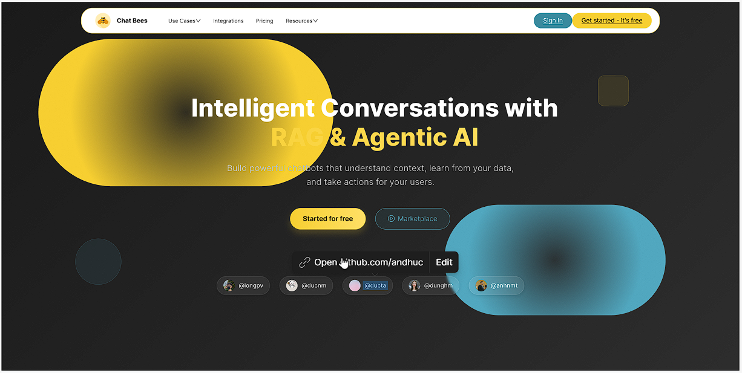

**Field Description**

| **Field Name** | **Field Type** | **Description** |
| --- | --- | --- |
| Sign In | Button | Click to redirect to Sign In Form |
| Get started - It’s free | Button | Click to redirect to Register Form |

#### 3.1.2 User Register

This screen allows users to be authenticated to the system screens/functionalities.

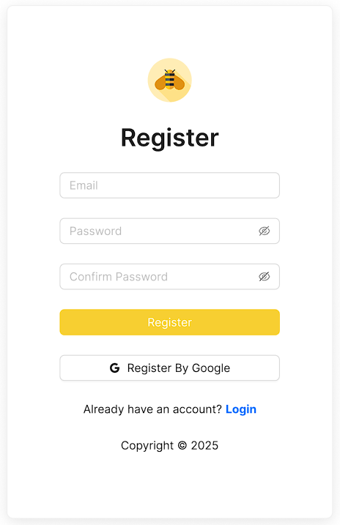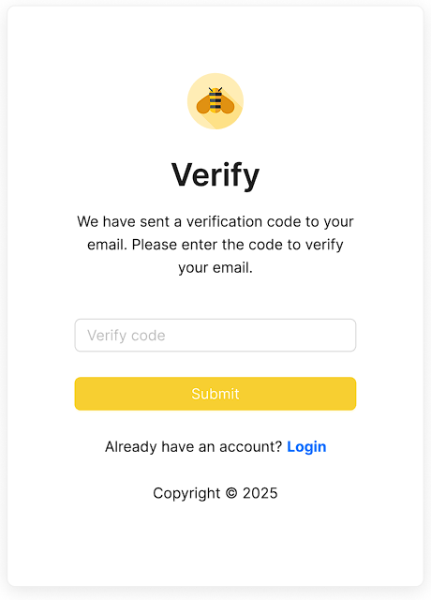

**Field Description**

| **Field Name** | **Field Type** | **Description** |
| --- | --- | --- |
| Email | Text Box | Data type: valid email format (e.g., user@example.com). Required. |
| Password | Password Box | Data type: string, minimum 8 characters. Required. |
| Confirm Password | Password Box | Data type: string. Must match the Password field. Required. |
| Register | Button | Click to submit Register Form |
| Register By Google | Button | Click to sign up with google |
| Login | Hyperlink | Click to redirect to Login Page |

**Field Description**

| **Field Name** | **Field Type** | **Description** |
| --- | --- | --- |
| Verify Code | Text Box | Data type: string,valid verify code. |
| Login | Hyperlink | Click to redirect to Login Page |

#### 3.1.3 User Login

This screen allows users to be authenticated to the system screens/functionalities.

| ***S1_User Login screen*** | ***S2_Select account to login (with Google)*** |
| --- | --- |
|  |  |

**Field Description**

| **Field Name** | **Field Type** | **Description** |
| --- | --- | --- |
| Email | Text Box | Data type: valid email format (e.g., user@example.com). Required. |
| Password | Password Box | Data type: string, minimum 8 characters. Required. |
| Login | Button | Click to submit Login Form |
| Login By Google | Button | Click to log in with google |
| Register | Hyperlink | Click to redirect to Register Page |

#### 3.1.4 Password Reset

This screen allows users to request a verification email to reset their password in case they’ve forgotten it.

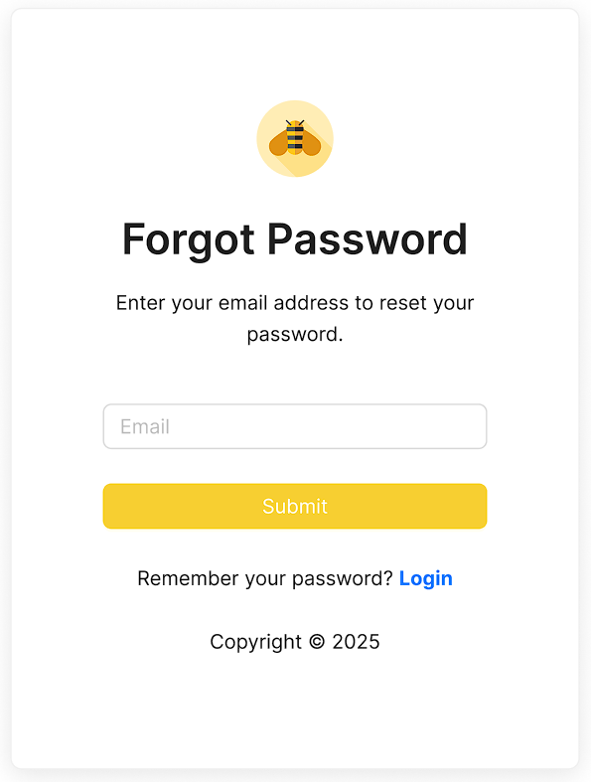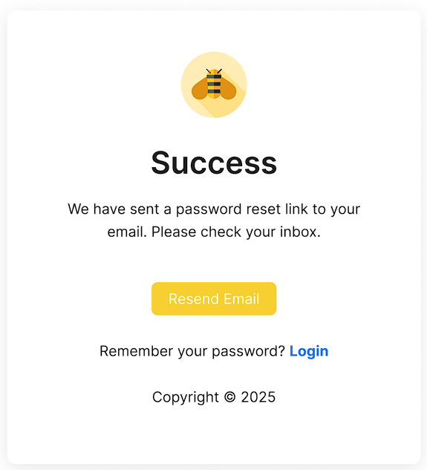

**Field Description**

| **Field Name** | **Field Type** | **Description** |
| --- | --- | --- |
| Email | Text Box | Data type: valid email format (e.g., user@example.com). Required. |
| Submit | Button | Click to submit Form |
| Login | Hyperlink | Click to redirect to Login Page |

This screen allows users to reset a new password.

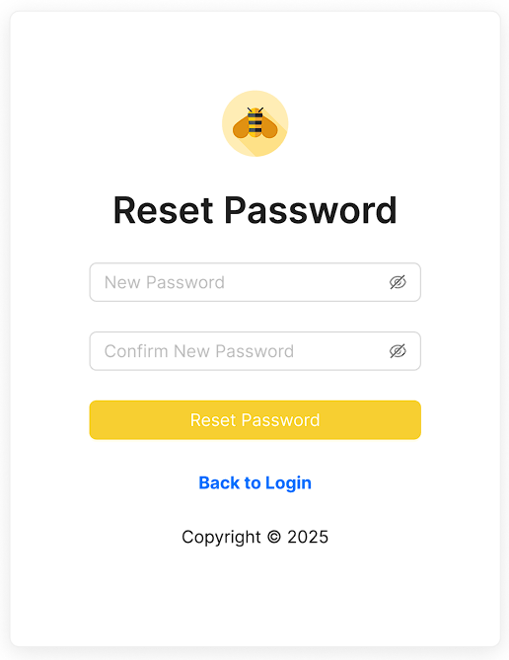

**Field Description**

| **Field Name** | **Field Type** | **Description** |
| --- | --- | --- |
| New  Password | Password Box | Data type: string, minimum 8 characters. Required. |
| Confirm Password | Password Box | Data type: string. Must match the Password field. Required. |
| Reset Password | Button | Click to submit Password Reset Form |
| Back to Login | Hyperlink | Click to redirect to Login Page |

#### 3.1.5 Password Change

This screen allows users to change password.

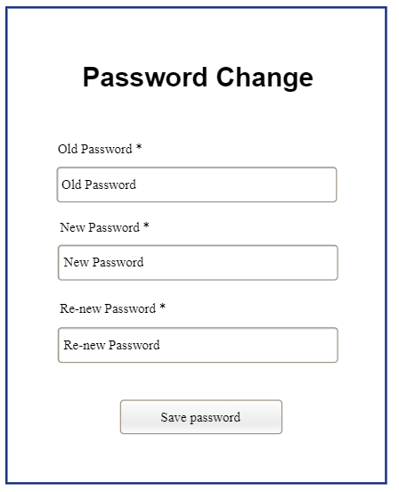

**Field Description**

| **Field Name** | **Field Type** | **Description** |
| --- | --- | --- |
| Old  Password | Password Box | Data type: string, invalid old password. Required. |
| New  Password | Password Box | Data type: string, minimum 8 characters. Required. |
| Confirm Password | Password Box | Data type: string. Must match the Password field. Required. |
| Save Password | Button | Click to submit Password Change Form |

#### 3.1.6 User Profile

This screen allows users to view profiles.

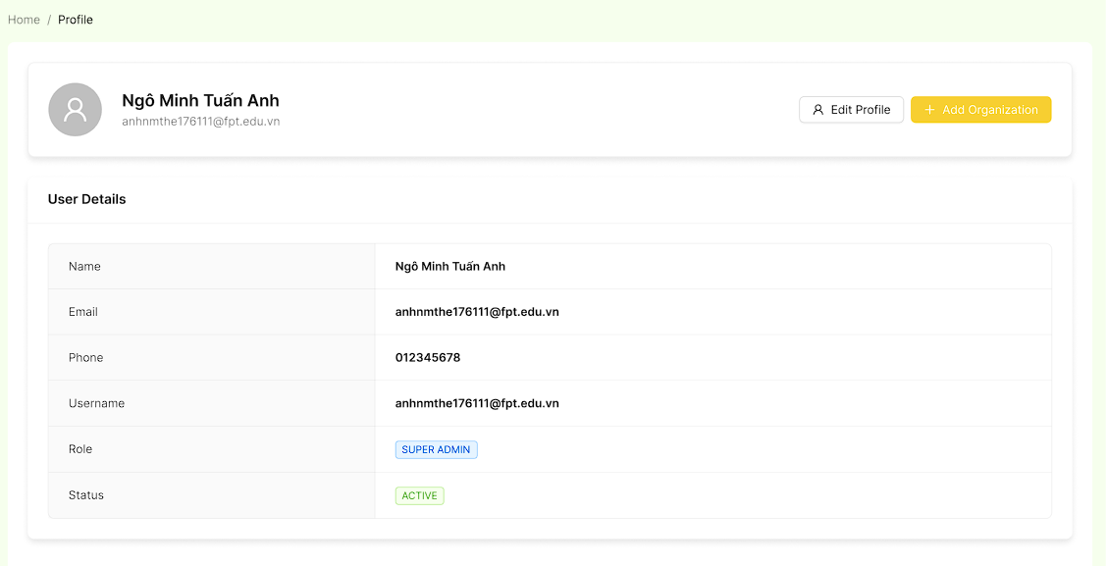

**Field Description**

| **Field Name** | **Field Type** | **Description** |
| --- | --- | --- |
| Edit Profile | Button | Click to open edit Profile Form |
| Add Organization | Button | Click to open New Organization Form |

This screen allows users to edit profiles.

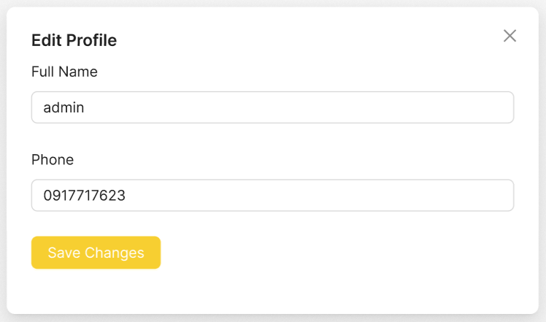

**Field Description**

| **Field Name** | **Field Type** | **Description** |
| --- | --- | --- |
| Full Name | Text Box | Data type: string, max length of 255 characters |
| Phone | Text Box | Data type: string, valid phone format. |
| Save Changes | Button | Click to submit Edit Profile Form |

#### 3.1.7 Chat Box

This screen allows users to chat.

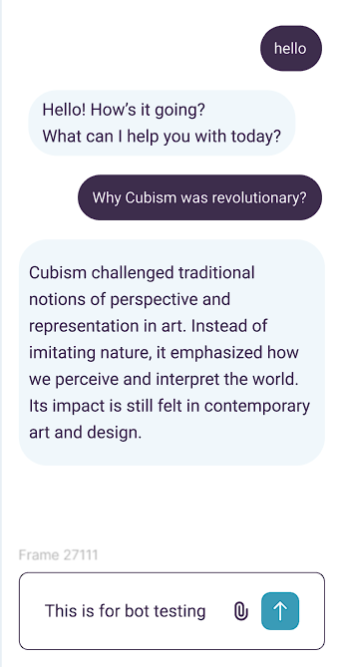

**Field Description**

| **Field Name** | **Field Type** | **Description** |
| --- | --- | --- |
| input | Text Box | Data type: string, Text field where the user types a message |
| Send | Button | Click to send the message typed in the input field. |

### 3.2 Business Staff Feature

#### 3.2.1 Dashboard

This screen allows users to view the overview of the system, displaying essential information and key metrics to help users monitor and manage activities efficiently.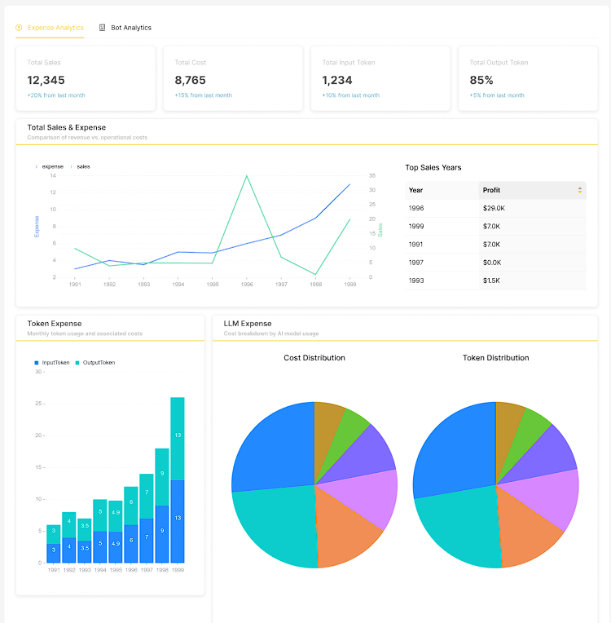

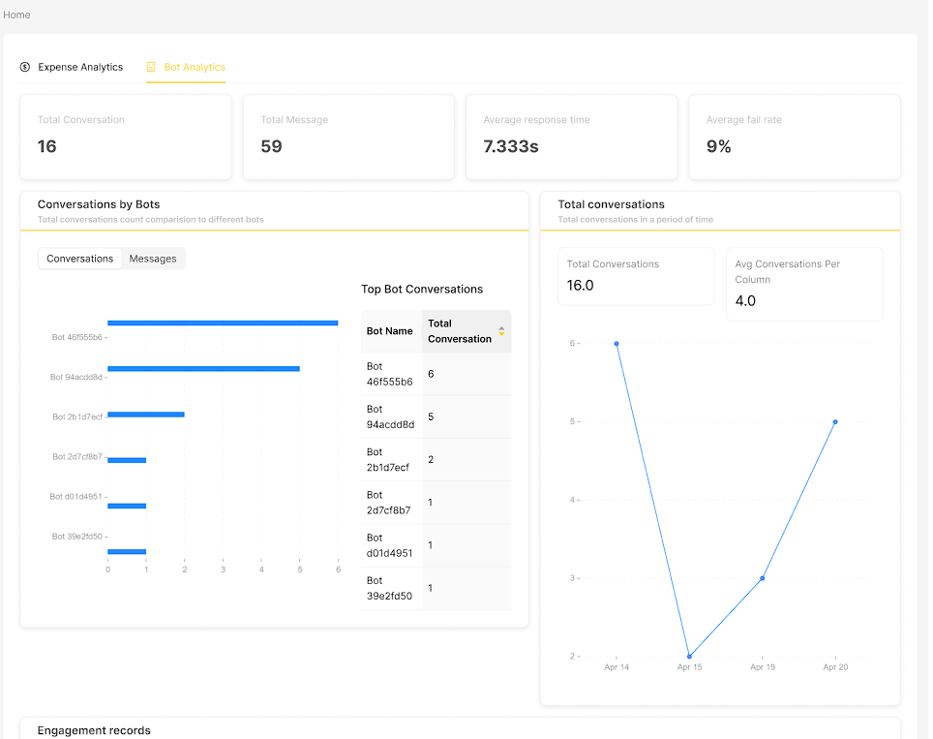

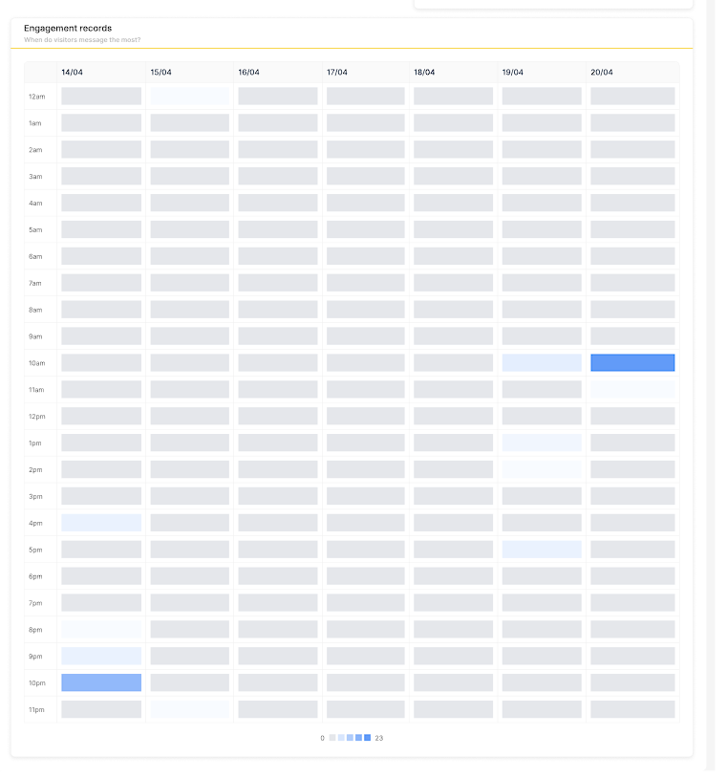

#### 3.2.2 Bot List

This screen allows the users to:

* View Bot List: view list of bot.
* Search Bot: enter keyword(s) to search bot by name

On the screen, s/he can also

* Go to the New Bot screens for adding new by clicking Add bot.
* Go to the Bot Details screens for updating existing bot by clicking “->”.

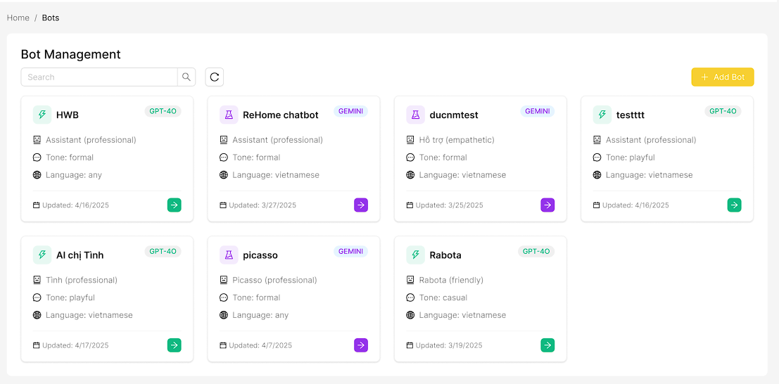

**Field Description**

| **Field Name** | **Field Type** | **Description** |
| --- | --- | --- |
| Search | Text Box | Data type: string. Allows users to search bot by name |
| Add bot | Button | Click to open the New Bot Page. |

#### 3.2.3 New Bot

This screen allows users to create a new bot

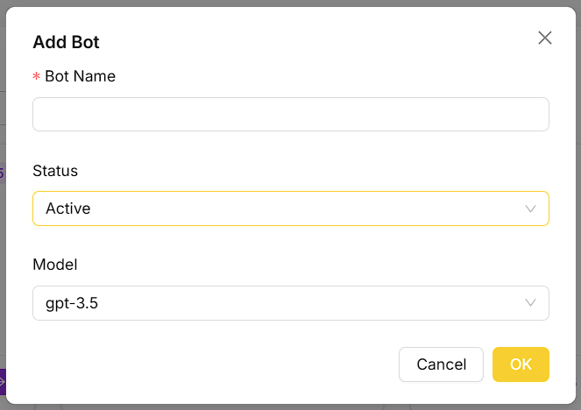

**Field Description**

| **Field Name** | **Field Type** | **Description** |
| --- | --- | --- |
| Bot Name | Text Box | Data type: string. Allows users to search bot by name |
| Ok | Button | Click to submit New Bot form |
| Cancel | Button | Closes the form. |

#### 3.2.4 Bot Details

This screen allows users to view bot details

##### **3.2.4.1 Overview**

This screen allows users to view overview detail of a bot

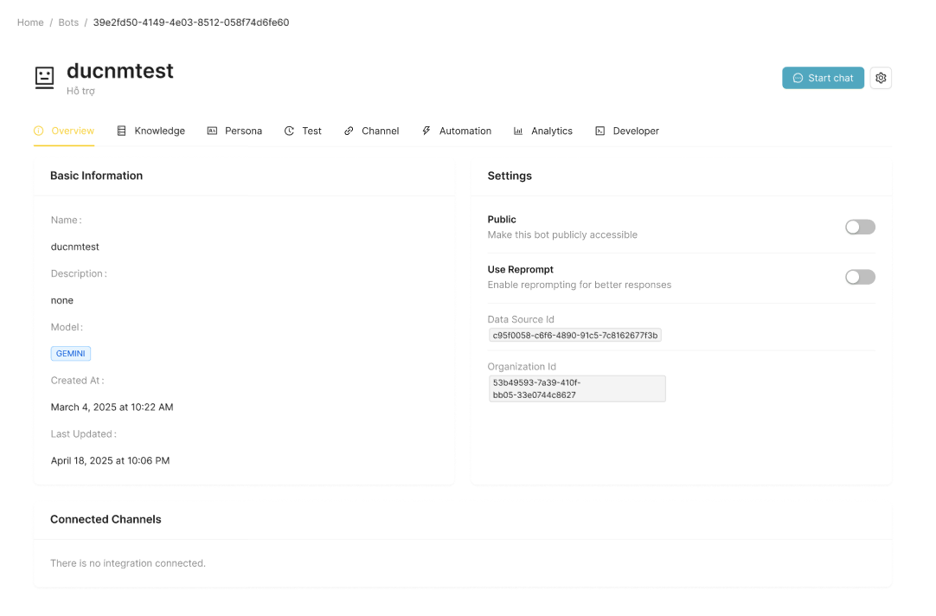

**Field Description**

| **Field Name** | **Field Type** | **Description** |
| --- | --- | --- |
| Start chat | Button | Click to open Chat Screen |
| Public | Toggle | Toggle to set the bot as public or private. |
| Use Reprompt | Toggle | Toggle to enable or disable the reprompt feature. |

##### **3.2.4.2 Knowledge**

This screen allows the users to:

* View Data Source List: view list of datasource .
* Filter Data Source List: filter datasource by statuses, lengths
* Search Data Source: enter keyword(s) to search datasource by name

On the screen, s/he can also

* Go to the New Data Source screens for adding new by clicking Add Knowledge.
* Go to the Data Source Details screens for view datasource details by clicking Details.
* Delete Data Source: Delete datasource by clicking Delete

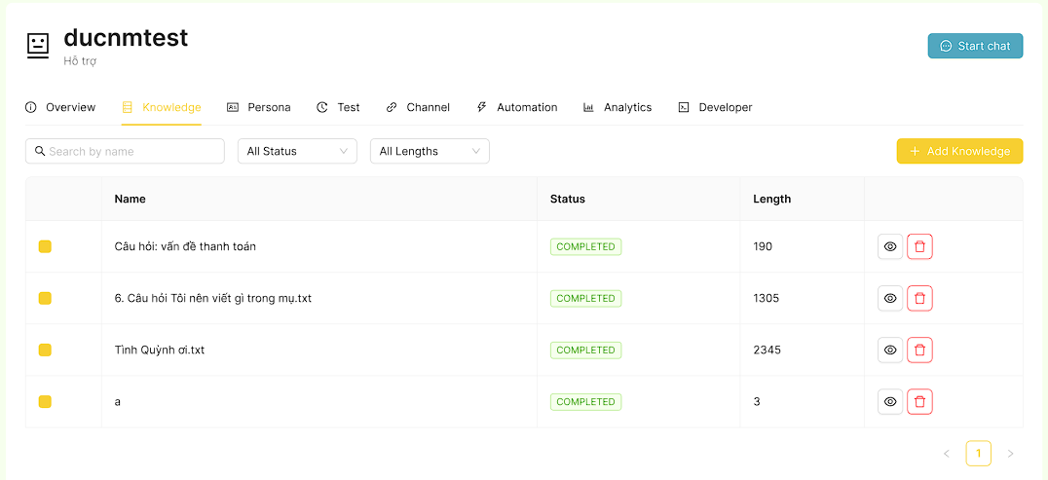

**Field Description**

| **Field Name** | **Field Type** | **Description** |
| --- | --- | --- |
| Search | Text Box | Data type: string. Allows users to search or filter data sources by name. |
| Status | Selection Box | Choose status to filter data source |
| Lengths | Selection Box | Choose lengths to filter datasource |
| Add | Button | Click to open New Datasource Page |
| Details | Button | Click to open the Datasource Details Page. |
| Delete | Button | Click to remove a datasource from the list. |
| List CheckBox | CheckBox | Click to choose data sources for the bot use. |

##### 

##### **3.2.4.3 Persona**

This screen allows users to view personalist of a bot

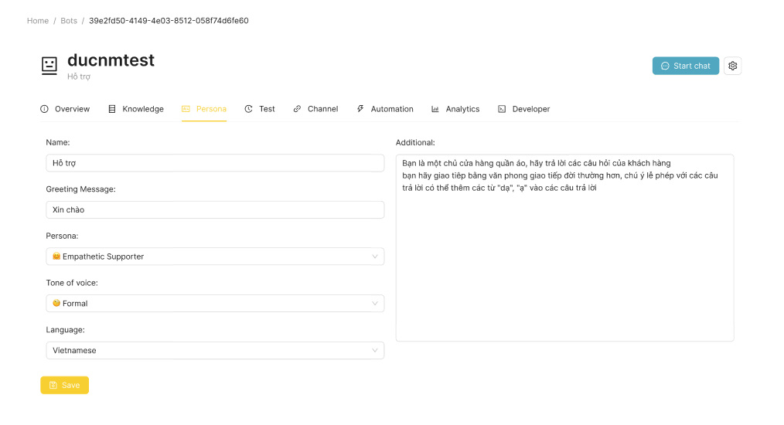

**Field Description**

| **Field Name** | **Field Type** | **Description** |
| --- | --- | --- |
| Name | Text Box | Data type: string. The display name of the AI assistant. |
| Greeting Message | Text Box | Data type: string. The initial message the assistant sends to start a conversation. |
| Persona | Select box | Select the assistant’s personality or role (e.g., Professional Assistant). |
| Tone of voice | Select box | Choose the communication tone (e.g., Playful, Formal). |
| Language | Select box | Select the language the bot will use (e.g., Vietnamese). |

##### **3.2.4.4 Test**

This screen allows the users to:

* View Test Bot History List: view list of test bot history.
* Filter Test Bot History List: filter test bot history by start date, end date
* Search Data Source: enter keyword(s) to search test bot history by title

On the screen, s/he can also

* Go to the Test Bot screens for test bot by clicking Debug Chat Flow .
* Go to the Test Bot History Details screens for view test bot history by clicking Details.

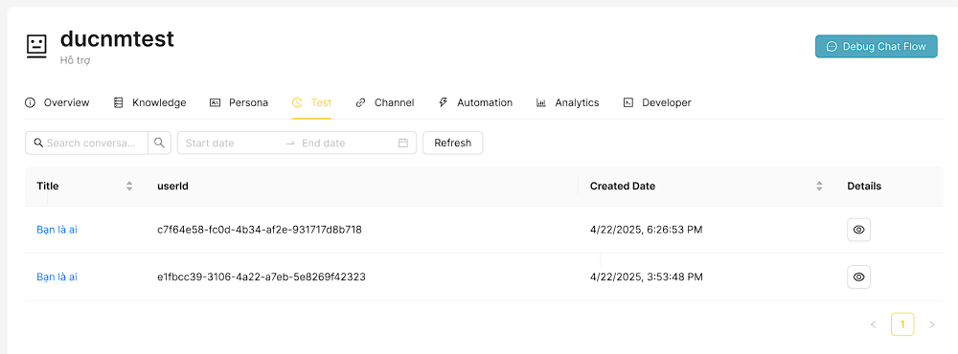

**Field Description**

| **Field Name** | **Field Type** | **Description** |
| --- | --- | --- |
| Debug Chat Flow | Button | Click to open Test Bot Page |
| Search | Text Box | Data type: string. Allows users to search or filter chat history by keywords. |
| Start date | Date Picker | Data type: date. Select the beginning date to filter chat history. |
| End date | Date Picker | Data type: date. Select the ending date to filter chat history. |
| Details | Button | Click to view details of conversation |

##### **3.2.4.5 Channel**

This screen allows users to view and update integration of a bot

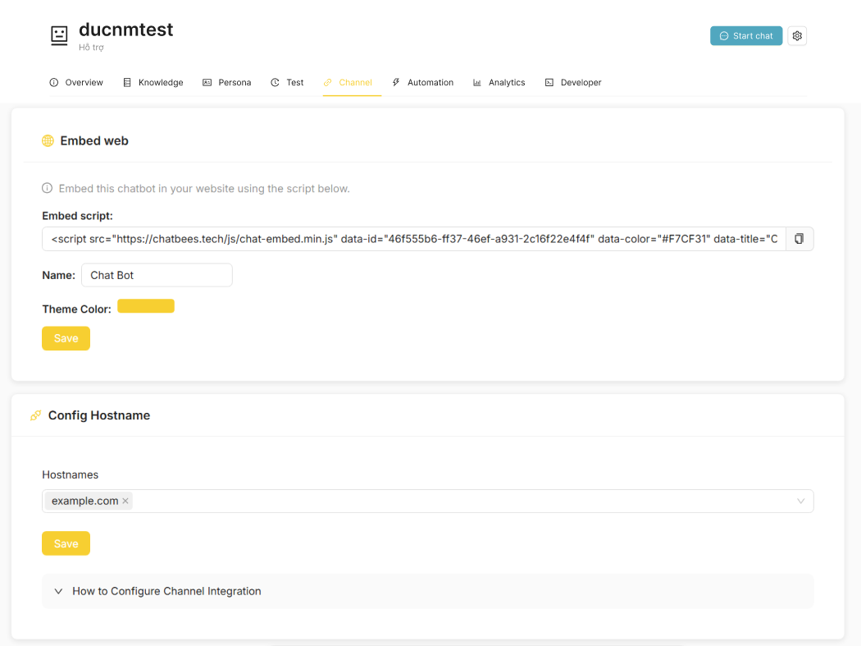

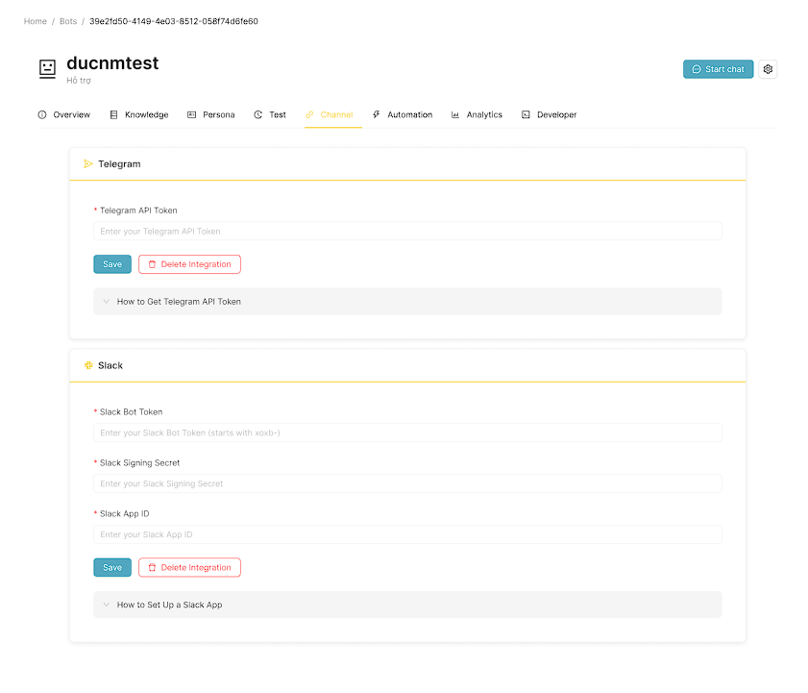

**Field Description**

| **Field Name** | **Field Type** | **Description** |
| --- | --- | --- |
| Name | Text Box | Data type: string, enter the name of the chat box. |
| Theme Color | Color Picker | Select a color for the chat box's theme. The color can be chosen from a color palette |
| Hostnames | Text Box | Data type: string, input allowed hostnames for the integration. |
| Telegram API Token | Text Box | Data type: string, input the API token for Telegram integration. |
| Slack Bot Token | Text Box | Data type: string, input the bot token for Slack integration. |
| Slack Signing Secret | Text Box | Data type: string, input the signing secret for Slack integration. |
| Slack App Id | Text Box | Data type: string, input the signing secret for Slack integration. |
| Save | Button | Save the current integration settings. |
| Delete Integration | Button | Remove or delete the current integration. |

##### **3.2.4.6 Automation**

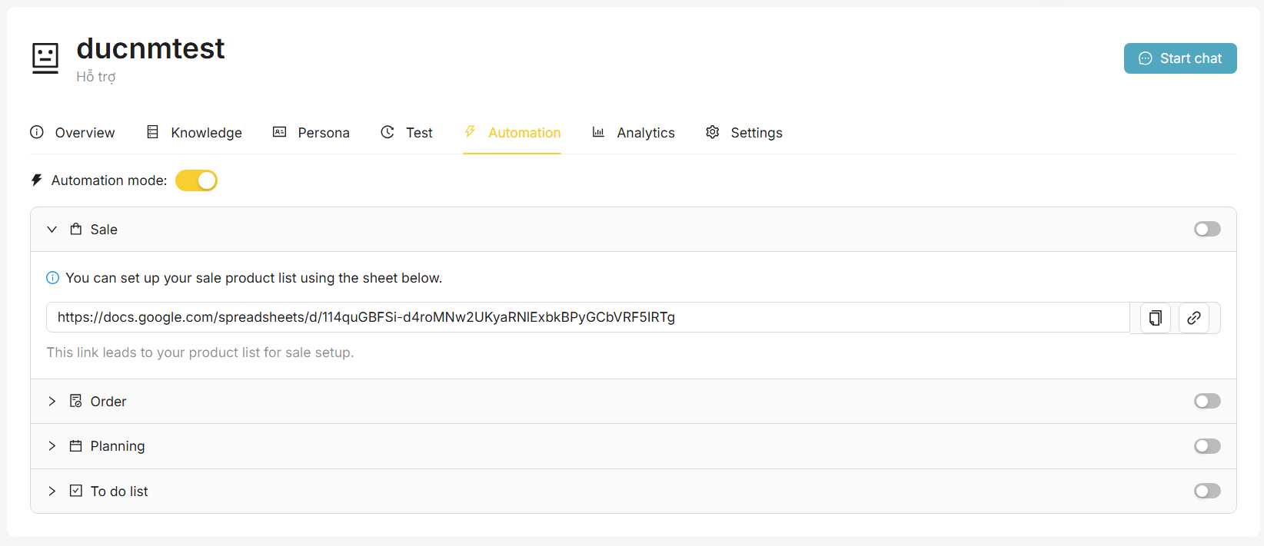

**Field Description**

| **Field Name** | **Field Type** | **Description** |
| --- | --- | --- |
| AutomationMode | Toggle | A switch to enable or disable the automation mode for the system. |
| Sale Toggle | Toggle | A switch to activate or deactivate sales automation features. |
| OrderToggle | Toggle | A switch to control the activation of order automation features. |
| Planning Toggle | Toggle | A switch to enable or disable planning functionalities. |
| To do list Toggle | Toggle | A switch to turn on or off the to-do list management feature. |
| Link Sheet | Text Box | Data type: string, a text input for entering or displaying the link to the product sheet. |

##### **3.2.4.7 Analytics**

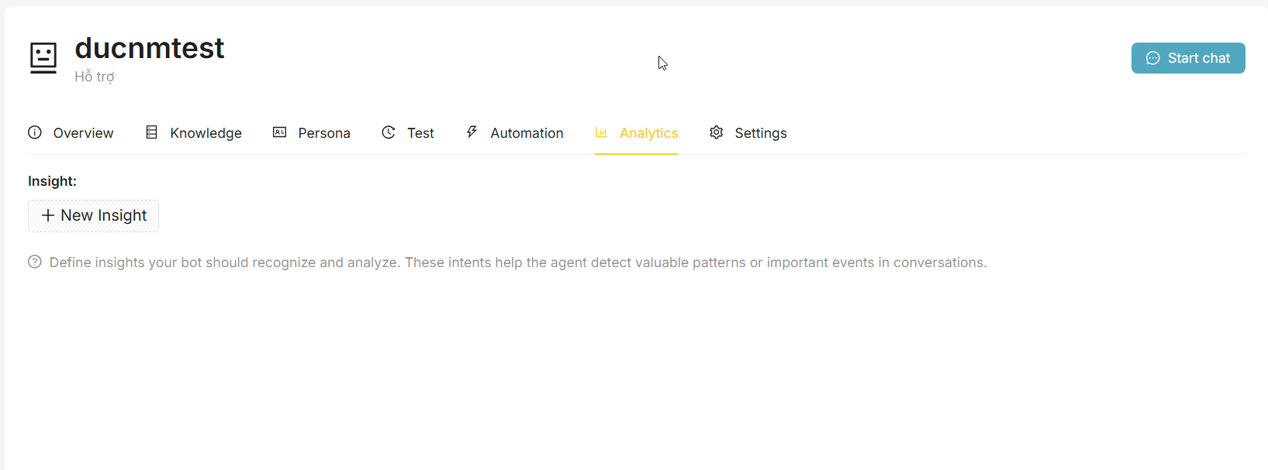

**Field Description**

| **Field Name** | **Field Type** | **Description** |
| --- | --- | --- |
| New Insight | Button | Open text box to enter new insight |

##### **3.2.4.8 Developer**

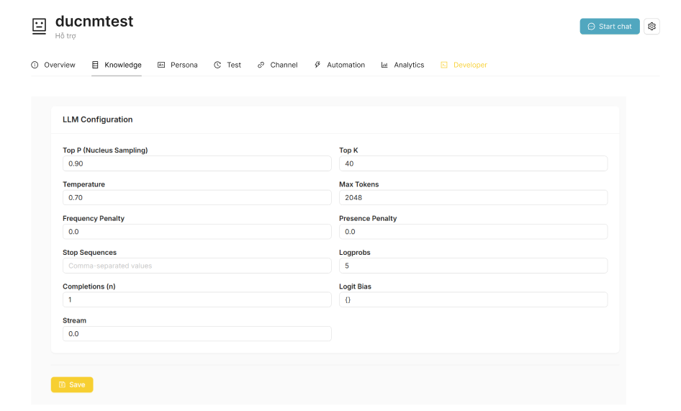

**Field Description**

| **Field Name** | **Field Type** | **Description** |
| --- | --- | --- |
| Top P | Number Box | Controls how many possible next words are considered. |
| Top K | Number Box | Limits choices to the top K most likely words. |
| Temperature | Number Box | Controls how random the output is. |
| Max Tokens | Number Box | Sets the maximum length of the response. |
| Frequency Penalty | Number Box | Decreases repeated words. |
| Presence Penalty | Number Box | Encourages talking about new topics. |
| Stop Sequences | Text Box | Tells the model when to stop writing. |
| Logprobs | Number Box | Number of most likely tokens to include log probabilities for. |
| Completions (n) | Number Box | Number of completions to generate per prompt. |
| Logit Bias | Text Box | If enabled (1), streams partial outputs as they are generated. |
| Stream | Text Box | Biases the model’s likelihood to select certain tokens more or less. Example: {"50256": -100}. |
| Save | Button | Save the current developer settings. |

#### 3.2.5 Chat

This screen allows users to live chat and view chat history

#### 

**Field Description**

| **Field Name** | **Field Type** | **Description** |
| --- | --- | --- |
| input | Text Box | Data type: string, Text field where the user types a message |
| Send | Button | Click to send the message typed in the input field. |

#### 3.2.6 Live Chat

This screen allows users to view chat tracking

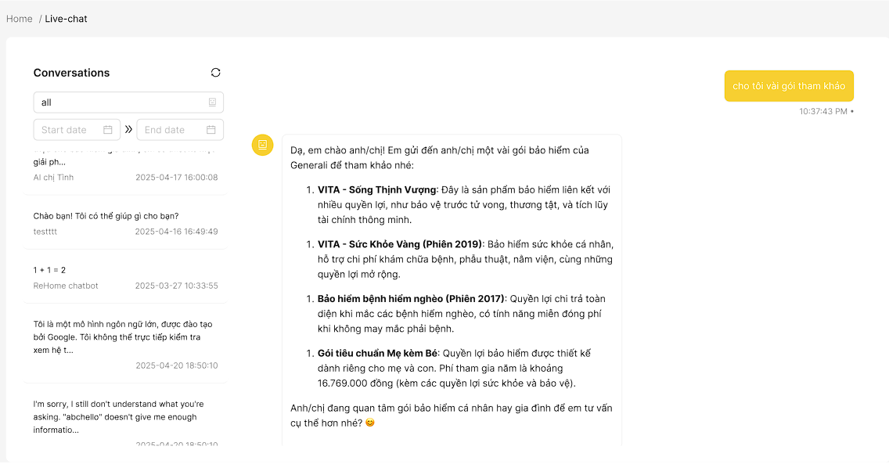

**Field Description**

| **Field Name** | **Field Type** | **Description** |
| --- | --- | --- |
| Bot | Selection  Box | Initial data values: all bot. Choose a bot to filter chat history. |
| Start date | Date Picker | Data type: date. Select the beginning date to filter chat history. |
| End date | Date Picker | Data type: date. Select the ending date to filter chat history. |

#### 

#### 3.2.7 Test Bot

This screen allows users to test bot

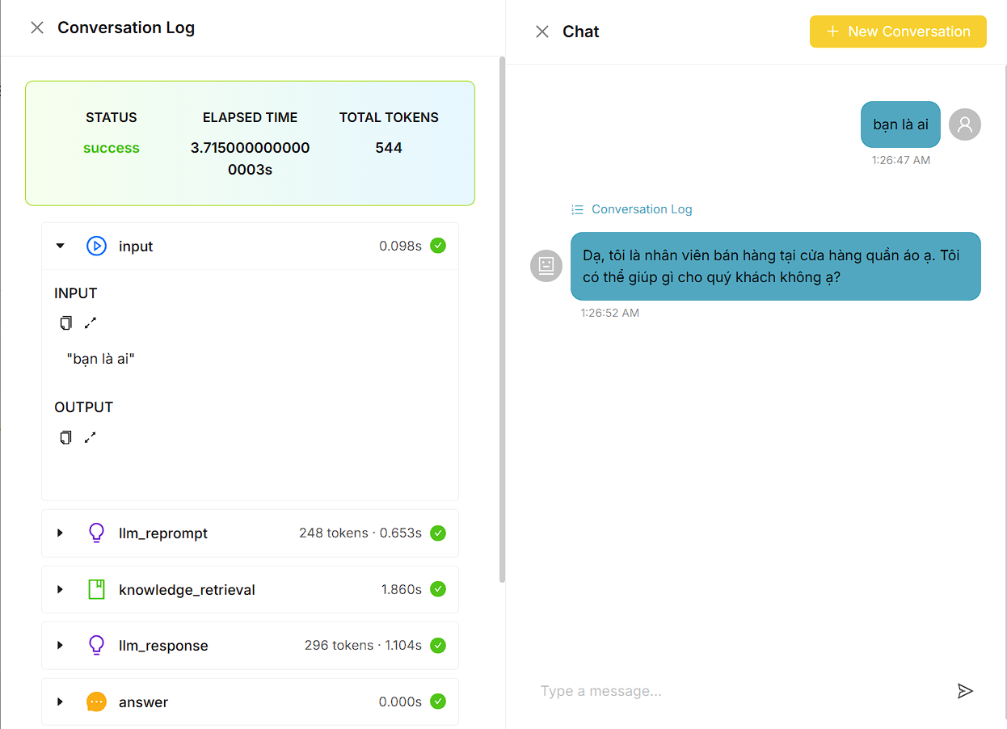

**Field Description**

| **Field Name** | **Field Type** | **Description** |
| --- | --- | --- |
| input | Text Box | Data type: string, Text field where the user types a message |
| Send | Button | Click to send the message typed in the input field. |
| New Conversation | Button | Click to create a new conversation |

#### 

#### 3.2.8 New Data Source

This screen allows users to add data source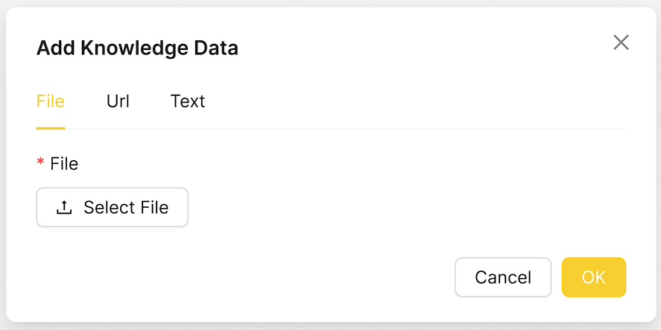

**Field Description**

| **Field Name** | **Field Type** | **Description** |
| --- | --- | --- |
| File | File Uploader | Data type: file. Required. Upload a file to be used as a knowledge source. Supported formats include .txt, .pdf, .doc, .docx, .csv, .xls, .xlsx |

#### 

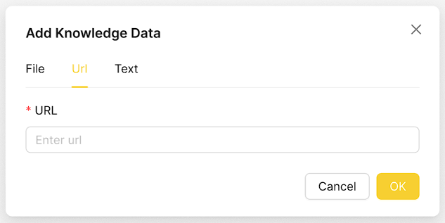

**Field Description**

| **Field Name** | **Field Type** | **Description** |
| --- | --- | --- |
| Url | Text Box | Data type: string. Required. Enter a valid web address to extract knowledge data from that webpage. Example: https://example.com/help |

#### 

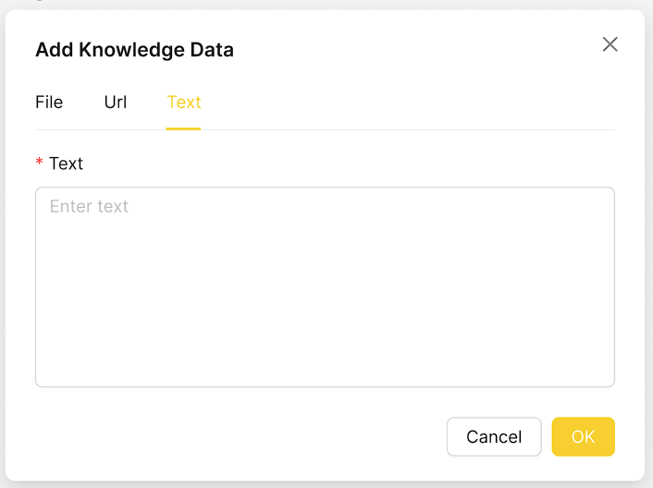

**Field Description**

| **Field Name** | **Field Type** | **Description** |
| --- | --- | --- |
| Text | Text Box | Data type: string..Required. Paste or write knowledge content directly in plain text format (e.g., instructions, FAQs). |

#### 3.2.9 Data Source Details

This screen allows users to view data source details

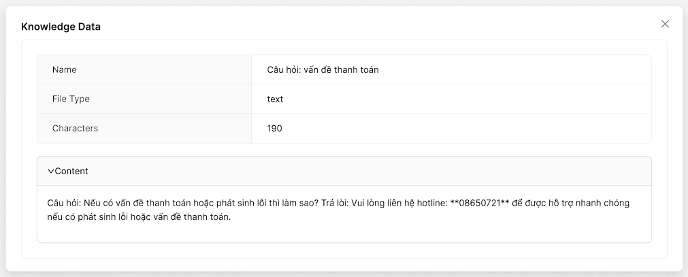

#### 3.2.10 Evaluation History

This screen allows the users to:

* View Evaluation History List: view list of evaluation history.
* Search Evaluation: enter keyword(s) to search evaluation results by name

On the screen, s/he can also

* Go to the New Evaluation screens for adding new by clicking Add bot.
* Go to the Evaluation Details screens for view details of evaluation results.

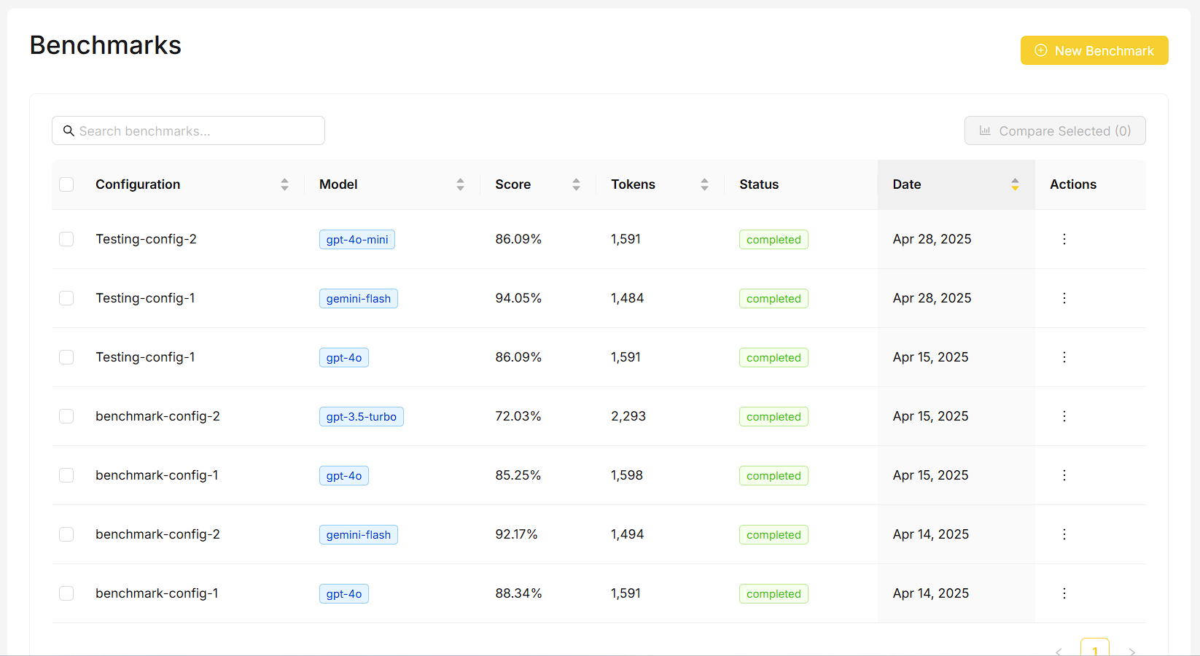

#### 3.3.11 New Evaluation

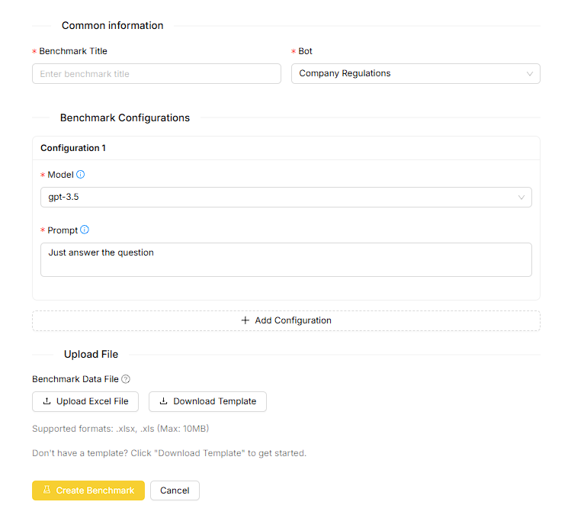

**Field Description**

| **Field Name** | **Field Type** | **Description** |
| --- | --- | --- |
| Title | Text Box | Data type: string. Required. Text for test title |
| Bot | Selection  Box | Initial data values: first bot in the list. Choose a bot to run evaluation test. |
| LLM Model | Selection  Box | Initial data values: first LLM model in the list. Choose a LLM model to run a evaluation test. |
| Prompt | Text Box | Data type: string..Required. Text for test prompt running test evaluation |
| File | File Uploader | Data type: file. Required. Upload a file to be used as a question source for test evaluation. Supported formats include .txt, .pdf, .doc, .docx, .csv, .xls, .xlsx |

#### 

#### 3.2.12 Evaluation Details

This screen allow the user to view and compare bot evaluation tests

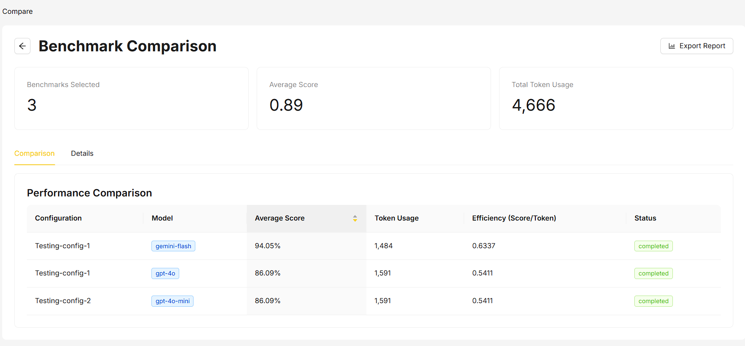

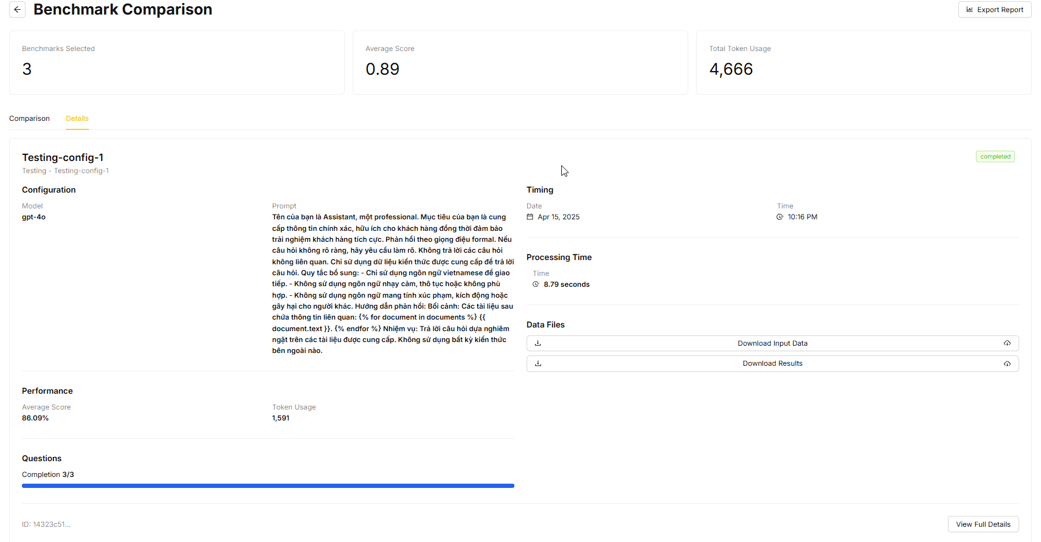

### 3.3 Business Owner Feature

#### 3.3.1 Organization Details

This screen shows details of an organization

##### **3.3.1.1 Overview**

This screen shows overview of an organization

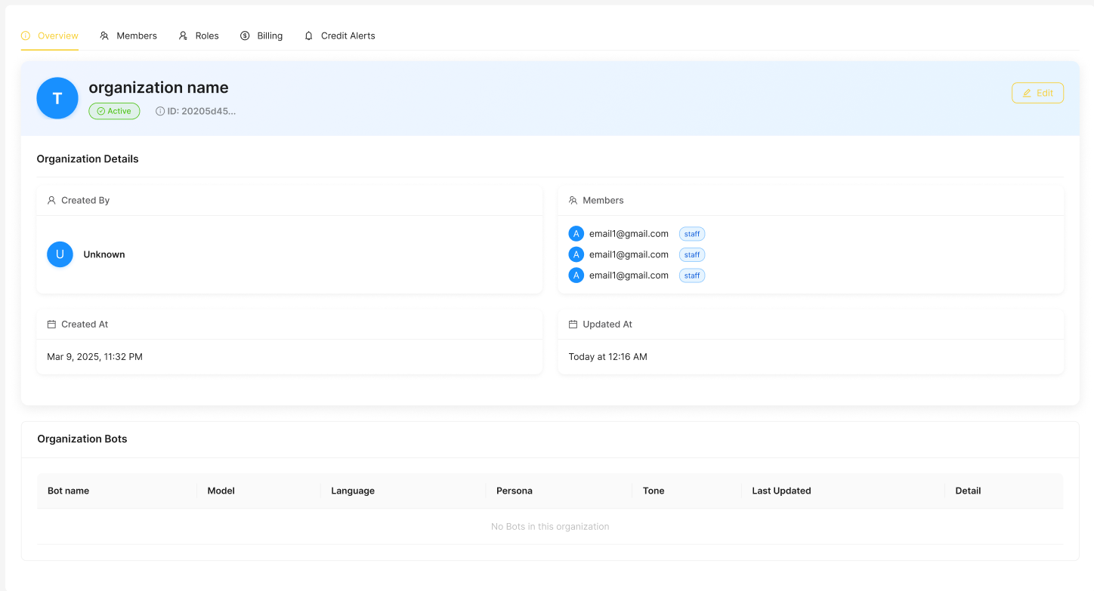

**Field Description**

| **Field Name** | **Field Type** | **Description** |
| --- | --- | --- |
| Edit | Button | Click to open Edit Organization Form |

#### 

##### **3.3.1.2 Member List**

This screen allows the users to:

* View Member List: view member list of the organization.

On the screen, s/he can also

* Go to the Invite Member screens for invite members by clicking Invite Member.
* Delete Member: Delete member by clicking Delete

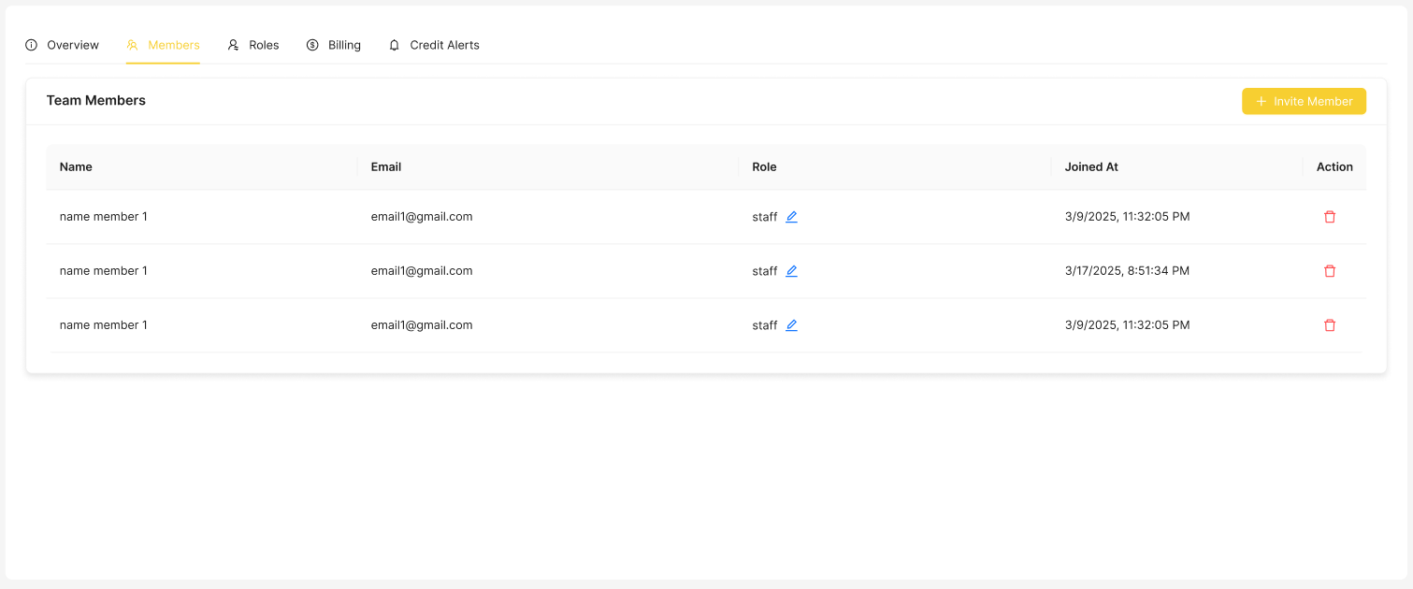

**Field Description**

| **Field Name** | **Field Type** | **Description** |
| --- | --- | --- |
| Invite Member | Button | Click to open Invite Member Form |
| Delete | Button | Click to remove a member from the organization. |

#### 

This screen allows users to confirm before deleting a member from an organization.

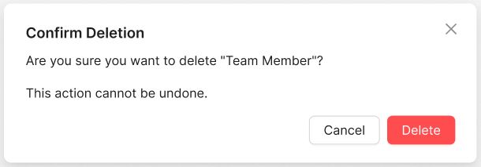

**Field Description**

| **Field Name** | **Field Type** | **Description** |
| --- | --- | --- |
| Cancel | Button | Click this button to cancel the current action and return to the previous screen without making any changes. |
| Delete | Button | Click this button to confirm and remove the selected member from the organization. |

##### **3.3.1.3 Role List**

This screen allows users to view role list of an organization

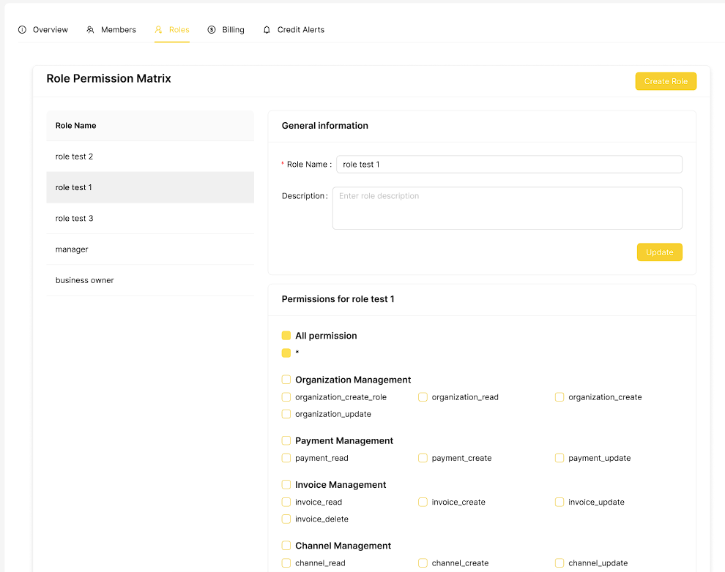

**Field Description**

| **Field Name** | **Field Type** | **Description** |
| --- | --- | --- |
| Create Role | Button | Click to open New Role Form |

##### **3.3.1.4 Plan**

This screen allows users to view current plan and plan list of the organization

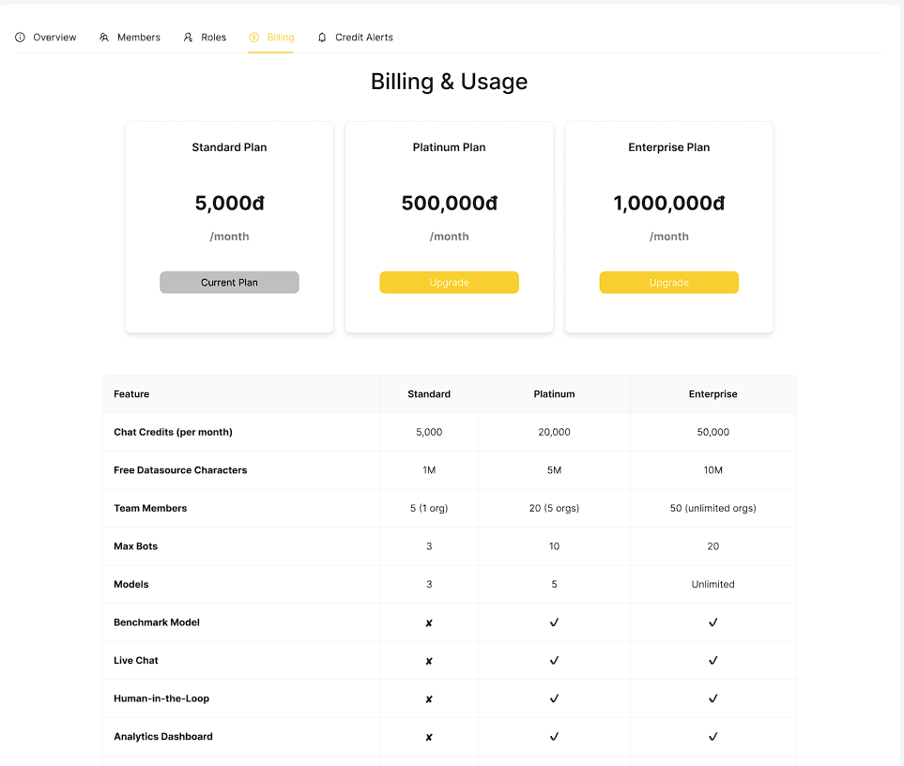

**Field Description**

| **Field Name** | **Field Type** | **Description** |
| --- | --- | --- |
| Upgrade | Button | Click to upgrade plan |

##### 

##### **3.3.1.5 Credit Alerts**

This screen allows users to credit of the organization

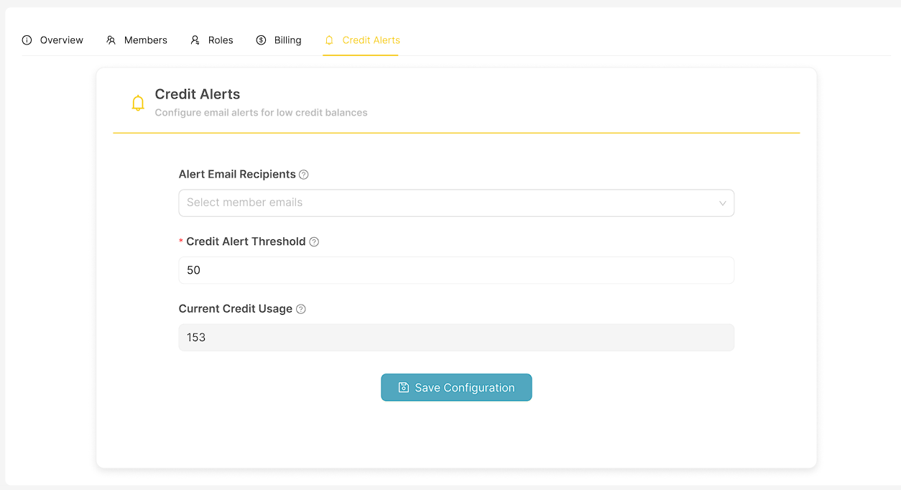

**Field Description**

| **Field Name** | **Field Type** | **Description** |
| --- | --- | --- |
| Alert Email Recipients | Text Box | Email addresses to receive credit alert notifications |
| Credit Alert Threshold | Text Box | Specify the credit balance amount that, when reached or fallen below, will trigger an alert. |
| Save Configuration | Button | Click to save the current alert settings and apply the configuration. |

#### 

#### 3.3.3 New Member

This screen allows users to add a new member

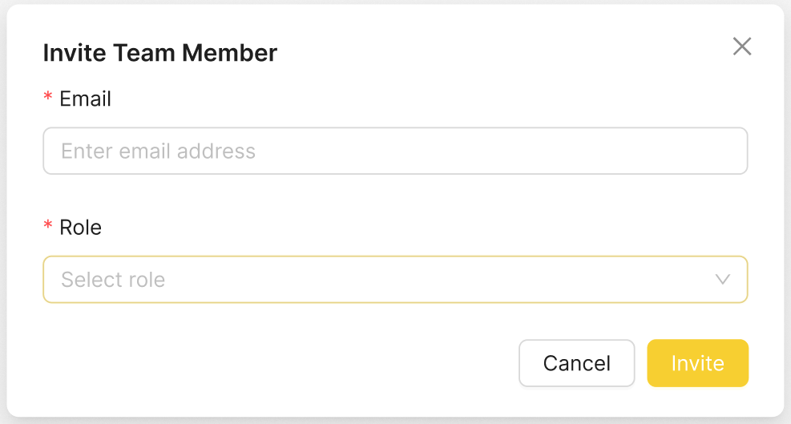

**Field Description**

| **Field Name** | **Field Type** | **Description** |
| --- | --- | --- |
| Email | Text Box | Data type: string. Required. Email address of the member you wish to invite to the organization. |
| Role | Selection Box | Required. Initial data values: all roles of organization. Select the role you want to assign to the new member within the organization. |
| Invite | Button | Click this button to send an invitation to the specified email address. |
| Cancel | Button | Click this button to cancel the invitation process and close the form without making changes. |

##### 

#### 3.3.4 New Role

This screen allows users to add a new role

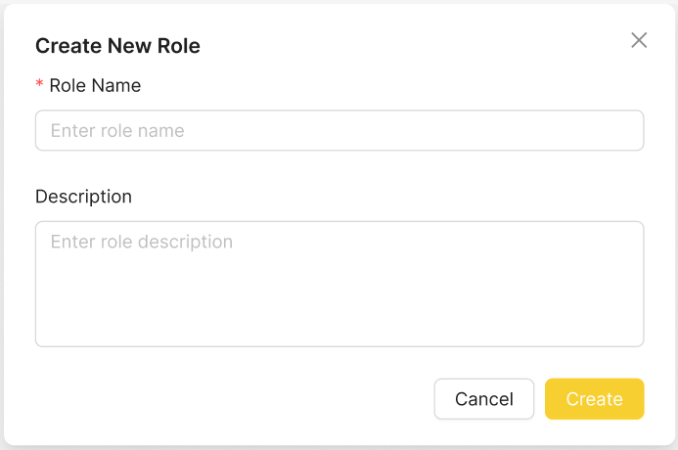

**Field Description**

| **Field Name** | **Field Type** | **Description** |
| --- | --- | --- |
| Role Name | Text Box | Data type: string. Required. Name of the role you want to create. |
| Description | Text Box | Data type: string. Provide a brief description of the role. |
| Create | Button | Click to submit New Role Form |
| Cancel | Button | Click this button to cancel the role creation process and close the form without saving |

#### 3.3.5 Role Details

This screen allows users to view role details



**Field Description**

| **Field Name** | **Field Type** | **Description** |
| --- | --- | --- |
| Role Name | Text Box | Data type: string. Required. Name of the role you want to create. |
| Description | Text Box | Data type: string. Provide a brief description of the role. |
| Permissions | Check Box | Choose the permissions that you want the role to have. |
| Update | Button | Click to save the role with the selected details and permissions. |

### 3.4 Admin Staff Feature

#### 3.4.1 Model List

This screen allows the users to:

* View Model List: view list of model.
* Filter Model List: filter model by providers, modes
* Search Model: enter keyword(s) to search model by name

On the screen, s/he can also

* Go to the Model Details screens for view model details by clicking Details.

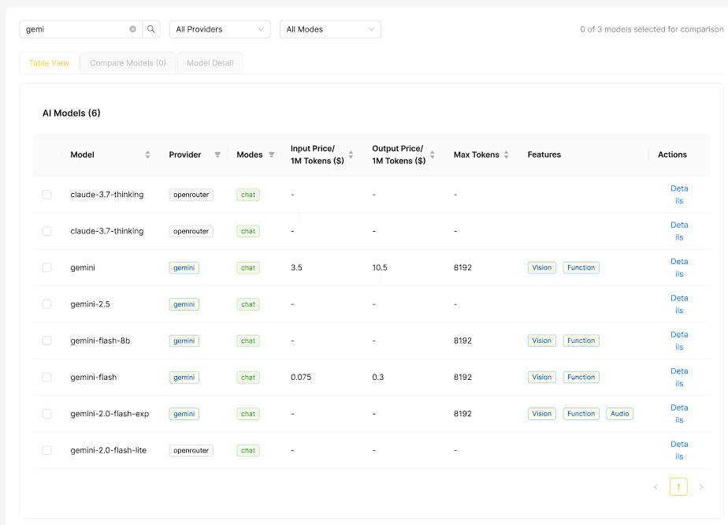

**Field Description**

| **Field Name** | **Field Type** | **Description** |
| --- | --- | --- |
| Search | Text Box | Data type: string. Allows users to search or filter models by name. |
| Provider | Selection Box | Choose provider to filter model |
| Mode | Selection Box | Choose mode to filter model |
| Details | Button | Click to open the Model Details Page. |

#### 3.4.2 Model Details

This screen allows users to view model details

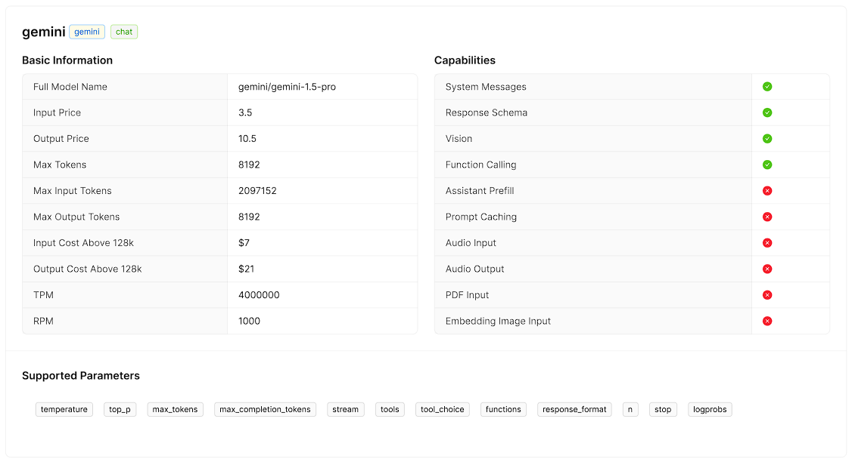

#### 

#### 3.4.3 Organization List

This screen allows the users to:

* View Organization List: view list of organization .
* Filter Organization List: filter datasource by statuses
* Search Organization : enter keyword(s) to search organization by name

On the screen, s/he can also

* Go to the New Organization screens for adding new by clicking Add Organization.
* Go to the Organization Details screens for view datasource details by clicking Details.
* Go to the Organization Details screens for edit datasource details by clicking Edit.

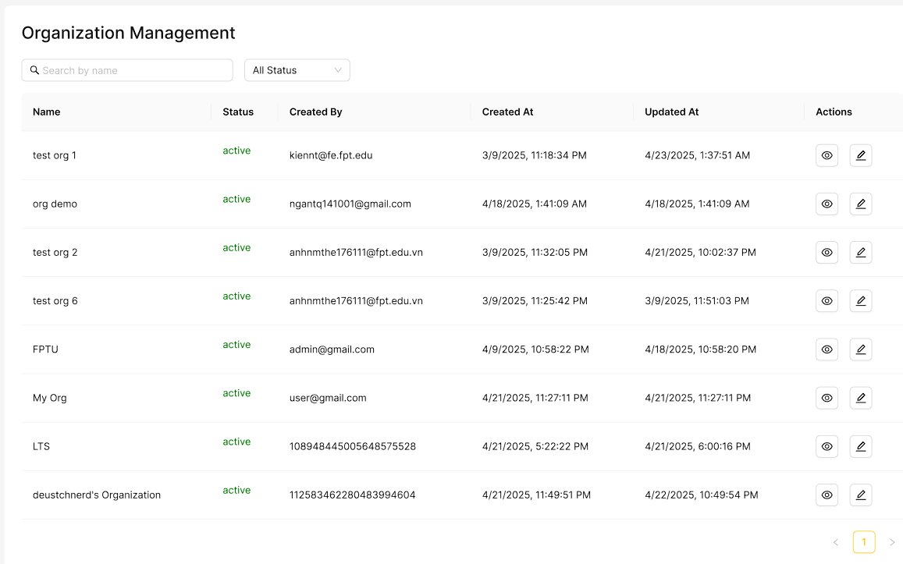

**Field Description**

| **Field Name** | **Field Type** | **Description** |
| --- | --- | --- |
| Search | Text Box | Data type: string. Allows users to search organizations by name. |
| Status | Selection Box | Initial data values: all status of organization.Filter organizations based on their current status |
| Add | Button | Click to open the "New Organization" page |
| Details | Button | Click to view detailed information about the selected organization. |
| Edit | Button | Click to open Organization Details page |

#### 

#### 3.4.4 New Organization

This screen allows users to add new organization

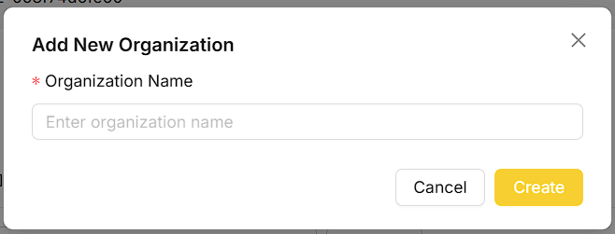

**Field Description**

| **Field Name** | **Field Type** | **Description** |
| --- | --- | --- |
| Organization Name | Text Box | Data type: string. Required. Name of the organization you want to create. |
| Create | Button | Click to submit New Organization Form |
| Cancel | Button | Click this button to cancel the organization creation process and close the form without saving |

#### 

#### 3.4.6 Invoice List

This screen allows the users to:

* View Invoice List: view list of invoice.
* Filter Invoice List: filter invoice by statuses, organization, plan
* Search Invoice: enter keyword(s) to search invoice by organization name, plan name

On the screen, s/he can also

* Go to the New Invoice screens for adding new by clicking Create Invoice.
* Go to the Invoice Details screens for view invoice details by clicking Details.
* Mark as paid: change invoice status to Paid

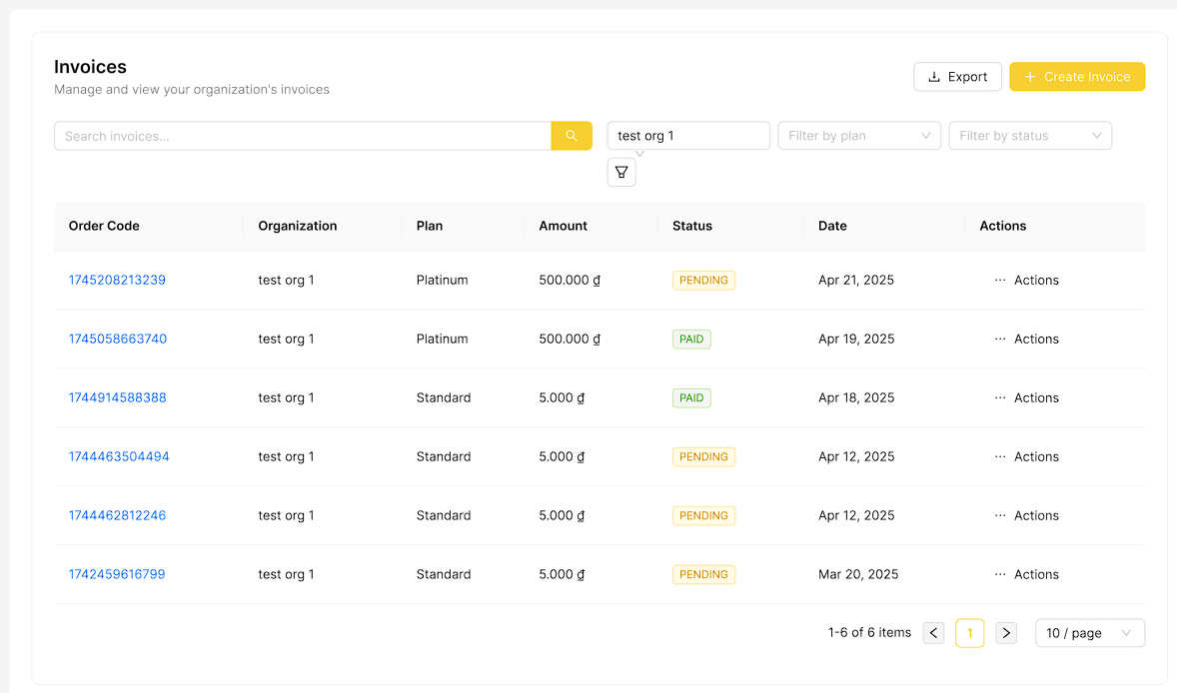

**Field Description**

| **Field Name** | **Field Type** | **Description** |
| --- | --- | --- |
| Search | Text Box | Data type: string. Allows users to search invoices by organization name, plan name |
| Organization | Selection Box | Initial data values: all organizations have invoice. Filter invoice based on their organization |
| Plan | Selection Box | Initial data values: all plans. Filter invoice based on their plan |
| Status | Selection Box | Initial data values: all status of invoice.Filter invoice based on their current status |
| Create Invoice | Button | Click to open the "New Invoice" page |
| Details | Button | Click to view detailed information of the invoice |
| Mark as paid | Button | Click to change status of invoice to Paid |

#### 3.4.7 New Invoice

This screen allows users to view user list

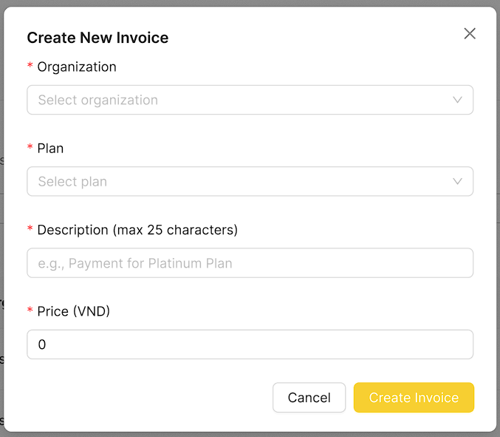

**Field Description**

| **Field Name** | **Field Type** | **Description** |
| --- | --- | --- |
| Organization | Selection Box | Select the organization for which the invoice is being created. Required |
| Plan | Selection Box | Choose the billing plan applicable to the invoice. Required |
| Description | Text Box | Data type: string. Details related to invoice |
| Price | Button | Data type: Number. Required. Total amount for the invoice. |
| Create Invoice | Button | Click to submit New Invoice Form |
| Cancel | Button | Click this button to cancel the invoice creation process and close the form without saving |

#### 

#### 3.4.8 Invoice Details

This screen allows users to view details of an invoice

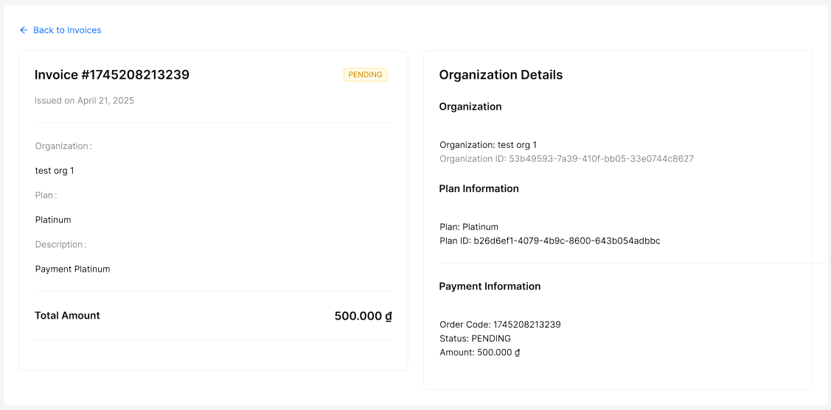

### 3.5 Admin Feature

#### 3.5.1 User List

This screen allows the users to:

* View User List: view list of users.
* Filter User List: filter users by statuses, roles
* Search User: enter keyword(s) to search user by email, username, name, phone

On the screen, s/he can also

* Go to the New User screens for adding new by clicking Create New.
* Go to the User Details screens to view user details by clicking Details.
* Go to the User Details screens to edit user details by clicking Edit.

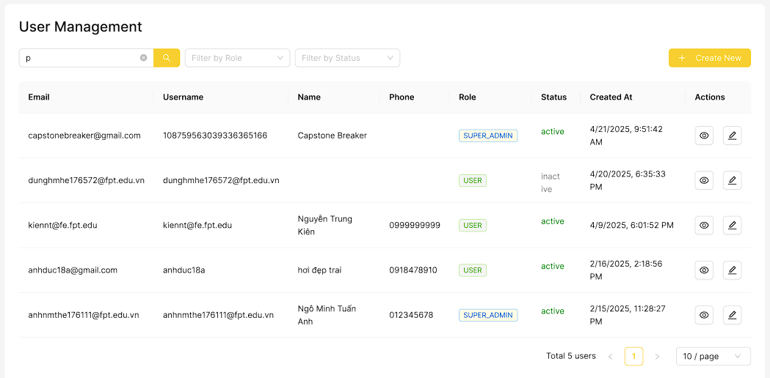

**Field Description**

| **Field Name** | **Field Type** | **Description** |
| --- | --- | --- |
| Search | Text Box | Data type: string. Allows users to search user by email, username, name |
| Role | Selection Box | Initial data values: all roles. Filter user based on their role |
| Status | Selection Box | Initial data values: all status of user. Filter users based on their current status |
| Create New | Button | Click to open the "New User" page |
| Edit | Button | Click to open the User Details Page |
| Details | Button | Click to view detailed information of the user |

#### 

#### 3.5.2 New User

This screen allows users to add new user

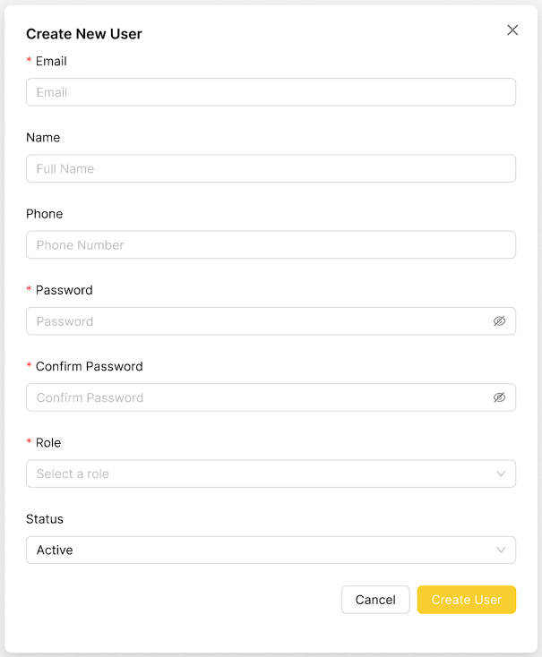

**Field Description**

| **Field Name** | **Field Type** | **Description** |
| --- | --- | --- |
| Email | Text Box | Data type: string. Required. User's email address |
| Name | Text Box | Data type: string. User's full name. |
| Phone | Text Box | Data type: number. User's phone number. |
| Password | Password Box | Data type: string. Required. Secure password for the user. |
| Confirm Password | Password Box | Data type: string. Required. Re-enter the password to confirm. |
| Role | Selection Box | Required. Select the user's role within the system. |
| Status | Selection Box | Set the user's account status (e.g., Active, Inactive). |
| Create User | Button | Click to submit the form and create the user with the provided details. |
| Cancel | Button | Click to abort the user creation process and discard any entered information. |

#### 

#### 3.5.3 User Details

This screen allows users to view user details

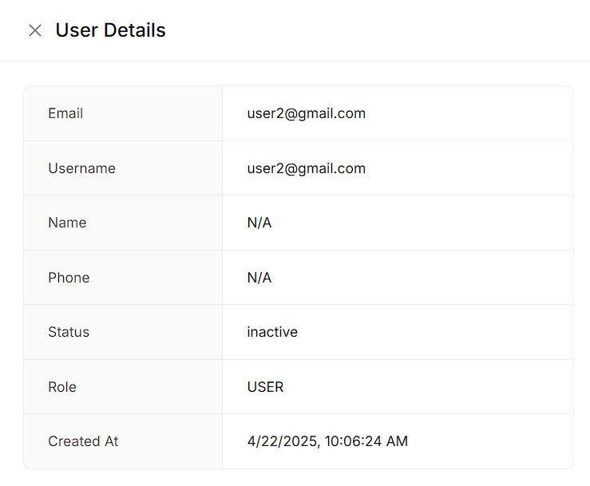

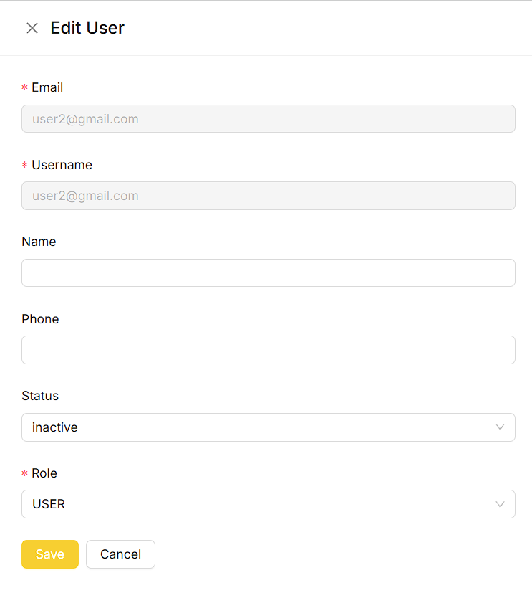

**Field Description**

| **Field Name** | **Field Type** | **Description** |
| --- | --- | --- |
| Name | Text Box | Data type: string. User's full name. |
| Phone | Text Box | Data type: number. User's phone number. |
| Role | Selection Box | Required. Select the user's role within the system. |
| Status | Selection Box | Set the user's account status (e.g., Active, Inactive). |
| Save | Button | Click to submit the form and update the user with the updated details. |
| Cancel | Button | Click to abort the user update process and discard any entered information. |

#### 3.5.4 Plan List

This screen allows the users to:

* View Plan List: view list of plan.

On the screen, s/he can also

* Go to the New Plan screens for adding new by clicking Create New Plan.
* Go to the Plan Details screens to view plan details by clicking Details.
* Go to the Plan Details screens to edit plan details by clicking Edit.

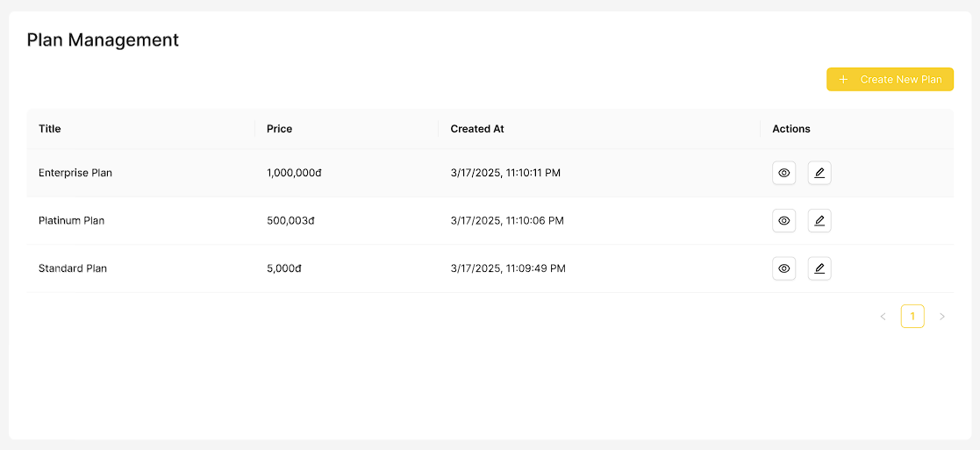

**Field Description**

| **Field Name** | **Field Type** | **Description** |
| --- | --- | --- |
| Create New | Button | Click to open the "New Plan" page |
| Edit | Button | Click to open the Plan Details Page |
| Details | Button | Click to view detailed information of the plan |

#### 

#### 3.5.5 New Plan

This screen allows users to add new plan

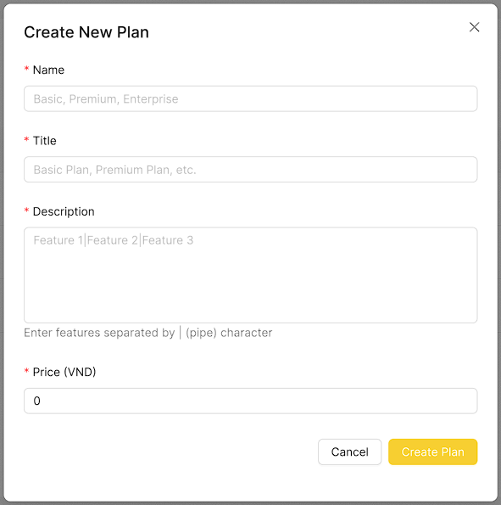

**Field Description**

| **Field Name** | **Field Type** | **Description** |
| --- | --- | --- |
| Name | Text Box | Data type: string. Required. Name of the plan |
| Title | Text Box | Data type: string. Required. Title of the plan |
| Description | Password Box | Data type: string. Required. Provide a brief description of the plan |
| Price | Password Box | Data type: number. Required. Price of the plan |
| Create Plan | Button | Click to submit the form and create the plan with the provided details. |
| Cancel | Button | Click to abort the plan creation process and discard any entered information. |

#### 3.5.6 Plan Details

This screen allows users to view plan details

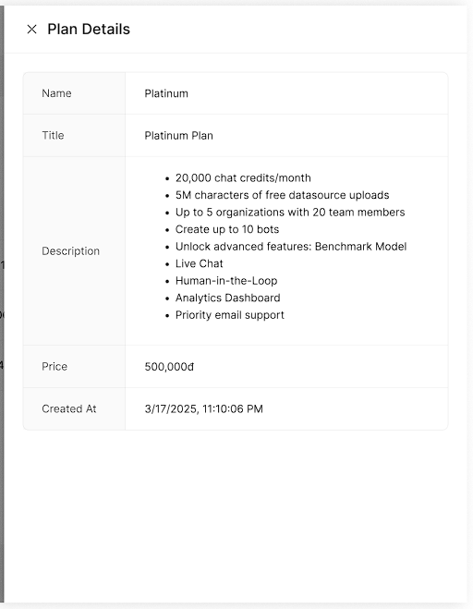

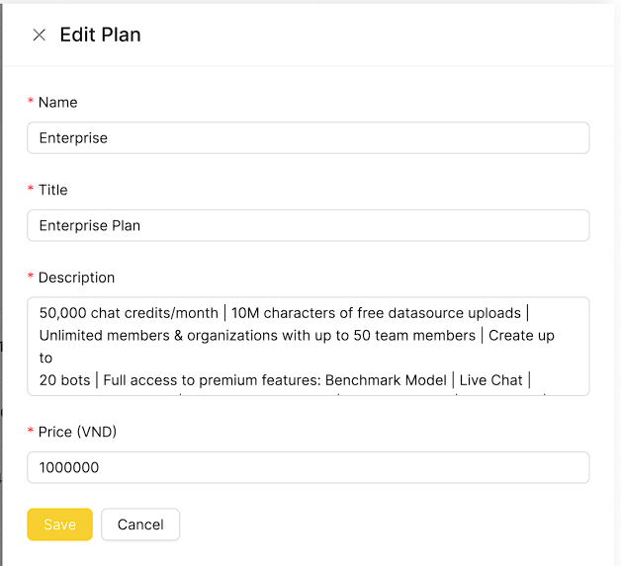

**Field Description**

| **Field Name** | **Field Type** | **Description** |
| --- | --- | --- |
| Name | Text Box | Data type: string. Required. Name of the plan |
| Title | Text Box | Data type: string. Required. Title of the plan |
| Description | Password Box | Data type: string. Required. Provide a brief description of the plan |
| Price | Password Box | Data type: number. Required. Price of the plan |
| Create Plan | Button | Click to submit the form and update the plan with the updated details. |
| Cancel | Button | Click to abort the plan updation process and discard any entered information. |

## 4. Non-Functional Requirements

### 4.1 External Interfaces

| **ID** | **Requirements** |
| --- | --- |
| UI-01 | The font size is easy to distinguish where is the title, where is the content. |
| UI-02 | The color of the background and text are eye-catching and easy to read. |
| UI-03 | A confirmation dialog is required for delete or status change actions. |
| UI-04 | Error messages must be shown in case user input in forms does not pass  validation. |
| UI-05 | Responsive design ensures dashboard accessibility on various devices. |
| UI-06 | The CAIP Page Structure is easy to add, read, edit, and delete when adding  product information fields on their website. |

### 

### 4.2 Quality Attributes

#### 4.2.1 Usability

| **ID** | **Role** | **Requirements** |
| --- | --- | --- |
| QAT-01 | Business owner | Business owners must be able to update knowledge base entries or FAQ data in a few click |
| QAT-02 | Customer | Users can effortlessly communicate with chatbot provided by business owners. |
| QAT-03 | Customer | The system must display valid information by user request given the knowledge base provided by the business owner |

#### 

#### 4.2.2 Performance

| **ID** | **Role** | **Requirements** |
| --- | --- | --- |
| QAT-04 | Business owner, Customer, Admin | System should handle high concurrent socket and API traffic without significant performance degradation. |
| QAT-05 | Business owner, Customer, Admin | Average API response time should be below 1000ms under standard load conditions. |
| QAT-06 | Business owner | Webhook data uploads must be processed and acknowledged within 1 minute. |
| QAT-07 | Admin | System must handle concurrent user connections without significant latency increases. |

#### 4.2.3 Scalability

| **ID** | **Role** | **Requirements** |
| --- | --- | --- |
| QAT-08 | Admin | System must support horizontal scaling to handle increased user traffic and data volume. |
| QAT-09 | Admin | Major services (message handling, file processing, webhook handling) must operate independently to enable flexible scaling. |
| QAT-10 | Admin | Queue mechanisms must be implemented to decouple producer and consumer services for efficient workload processing. |

#### 

#### 4.2.4 Fault Tolerance

| **ID** | **Role** | **Requirements** |
| --- | --- | --- |
| QAT-11 | Admin | The system must remain operational even if individual service instances fail. |
| QAT-12 | Admin | Failed LLM must automatically retry up to a configured maximum number of attempts. |

#### 

#### 4.2.5 Availability & Reliability

| **ID** | **Role** | **Requirements** |
| --- | --- | --- |
| QAT-13 | Admin | Health checks must automatically restart unhealthy instances without manual intervention. |
| QAT-14 | Admin | Load balancers must evenly distribute incoming traffic to available service instances. |

#### 

#### 4.2.6 Security

| **ID** | **Role** | **Requirements** |
| --- | --- | --- |
| QAT-15 | Business owner,  Customer, Admin | All API access must be protected using JWT authentication. |
| QAT-16 | Business owner,  Customer, | Implement rate limiting and input validation to prevent prompt injection or model abuse. |

#### 

#### 4.2.7 Observability & Monitoring

| **ID** | **Role** | **Requirements** |
| --- | --- | --- |
| QAT-17 | Admin | Metrics like CPU, Memory, TPS, and Latency must be collected and visualized via Grafana. |
| QAT-18 | Admin | Centralized logging must be implemented with correlation IDs (traceId, userId) for effective troubleshooting. |

#### 

## 5. Requirement Appendix

### 5.1 Business Rules

| **ID** | **Rule Definition** |
| --- | --- |
| BR-01 | User’s password must be encoded |
| BR-02 | Role permissions must be defined by the Business Owner before assigning to members. |
| BR-03 | Users must verify their email before accessing organization creation features. |
| BR-04 | Only Business Owners can create and manage organizations. |
| BR-05 | A default organization is automatically created for a user upon email verification. |
| BR-06 | Users must select and pay for a subscription plan to activate organization features. |
| BR-07 | Payments must be processed through a third-party payment provider. |
| BR-08 | Business Owners can invite members to the organization only after purchasing a plan. |
| BR-09 | Invited members must accept the email invitation to join the organization. |
| BR-10 | Only Business Staff can create, configure, and manage bots. |
| BR-11 | Bots must be linked to a verified data source before activation. |
| BR-12 | Bot responses must adhere to the configured persona and tone settings. |
| BR-14 | Chat history must be logged and accessible to Business Staff for review. |
| BR-15 | Only Admins can manage user accounts, plans, and invoices across the system. |
| BR-16 | Subscription plans must be active to grant access to corresponding features. |
| BR-17 | Credit alerts must be sent to the configured email when usage thresholds are reached. |
| BR-18 | Bots can only be integrated with supported communication platforms (e.g., Zalo, Telegram, Slack). |
| BR-19 | Only Business Owners can view and upgrade organization plans. |
| BR-20 | The chatbot must not ask for or process sensitive information such as passwords or credit card numbers. |
| BR-21 | The system must support sorting and filtering by bot name, status |

### 5.2 System Messages

| **#** | **Message Code** | **Message Type** | **Context** | **Content** |
| --- | --- | --- | --- | --- |
| 1 | MSG01 | In line | No search results returned | No search results. |
| 2 | MSG02 | In red, under the text box | Required input fields are empty | The * field is required. |
| 3 | MSG03 | Toast message | Successful update of bot information | Bot updated successfully. |
| 4 | MSG04 | Toast message | Successful creation of a new bot | Bot created successfully. |
| 5 | MSG05 | Toast message | Email confirmation sent for account activation | A confirmation email has been sent to {email_address}. |
| 6 | MSG06 | Toast message | Successful deletion of a bot | Bot deleted successfully. |
| 7 | MSG07 | Toast message | Successful creation of a new organization | Organization created successfully. |
| 8 | MSG08 | In red, under the text box | Input exceeds maximum length | Exceed max length of {max_length}. |
| 9 | MSG09 | In line | Incorrect username or password during login | Incorrect username or password. Please check again. |
| 10 | MSG10 | Toast message | Successful user registration | Register Success. |
| 11 | MSG11 | Toast message | No bot found for the provided ID | Bot not found. |
| 12 | MSG12 | Toast message | No model found for the provided ID | Model not found. |
| 13 | MSG13 | Toast message | Bot name is required | Name is required. |
| 14 | MSG14 | Toast message | Bot with the specified name already exists | Bot with this name already exist. |
| 15 | MSG15 | Toast message | Successful creation of a new channel | Channel created successfully. |
| 16 | MSG16 | Toast message | Successful update of a channel | Channel updated successfully. |
| 17 | MSG17 | Toast message | No chat found for the provided ID | Chat not found. |
| 18 | MSG18 | Toast message | Successful creation of a new chat | Chat created successfully. |
| 19 | MSG19 | Toast message | Successful deletion of a chat | Chat deleted successfully. |
| 20 | MSG20 | Toast message | Successful retrieval of data content | Get list data content success. |
| 21 | MSG21 | Toast message | Successful creation of data content | Create Success! |
| 22 | MSG22 | Toast message | Successful update of data content | Update Success! |
| 23 | MSG23 | Toast message | Successful deletion of data content | Delete Success! |
| 24 | MSG24 | Toast message | Unauthorized access attempt | Unauthenticated. |
| 25 | MSG25 | Toast message | Successful update of an invoice | Invoice updated successfully. |
| 26 | MSG26 | Toast message | Successful deletion of an invoice | Invoice deleted successfully. |
| 27 | MSG27 | Toast message | Successful retrieval of live chats | Live chats retrieved successfully. |
| 28 | MSG28 | Toast message | Successful login | Login success. |
| 29 | MSG29 | Toast message | Organization ID is required | Organization ID is required. |
| 30 | MSG30 | Toast message | Successful sending of an invitation | Invitation sent successfully. |
| 31 | MSG31 | Toast message | Successful update of member role | Member role updated successfully. |
| 32 | MSG32 | Toast message | Successful removal of a member | Member removed successfully. |
| 33 | MSG33 | Toast message | Successful retrieval of organizations | Organizations and users retrieved successfully. |
| 34 | MSG34 | Toast message | Successful update of an organization | Organization updated successfully. |
| 35 | MSG35 | Toast message | Successful deletion of an organization | Organization deleted successfully. |
| 36 | MSG36 | Toast message | Successful creation of a new role | New role created successfully! |
| 37 | MSG37 | Toast message | Successful update of role permissions | Role permissions updated successfully. |
| 38 | MSG38 | Toast message | Successful payment confirmation | Payment confirmed. |
| 39 | MSG39 | Toast message | Successful cancellation of a payment link | Payment link cancelled. |
| 40 | MSG40 | Toast message | Successful update of user profile | Profile updated successfully. |
| 41 | MSG41 | Toast message | Successful password update | Password updated successfully. |
| 42 | MSG42 | Toast message | Successful email update | Email updated successfully. |
| 43 | MSG43 | Toast message | Successful account activation | Account activated successfully. You can now log in. |
| 44 | MSG44 | Toast message | Password reset link sent | Password reset link sent successfully. Please check your email. |
| 45 | MSG45 | Toast message | Successful password reset | Password reset successfully. You can now log in. |
| 46 | MSG46 | Toast message | Successful Slack integration | Integration Slack successfully! |
| 47 | MSG47 | Toast message | Successful deletion of Slack integration | Delete Integration Slack successfully! |
| 48 | MSG48 | Toast message | Successful Telegram integration | Integration Telegram successfully! |
| 49 | MSG49 | Toast message | Successful deletion of Telegram integration | Delete Integration Telegram successfully! |
| 50 | MSG50 | Toast message | Successful message sent to Slack | Message sent to Slack successfully. |
| 51 | MSG51 | Toast message | Successful message sent to Telegram | Message sent to Telegram successfully. |
| 52 | MSG52 | Toast message | No user found for the provided ID | User not found. |
| 53 | MSG53 | Toast message | Successful creation of a new user | User created successfully. |
| 54 | MSG54 | Toast message | Successful update of a user | User updated successfully. |
| 55 | MSG55 | Toast message | Successful deletion of a user | User deleted successfully. |
| 56 | MSG56 | Toast message | No file uploaded for evaluation creation | No file uploaded! |
| 57 | MSG57 | Toast message | Title is required for evaluation creation | Title is required! |
| 58 | MSG58 | Toast message | At least one evaluation configuration is required | At least one evaluation configuration is required! |
| 59 | MSG59 | Toast message | Invalid evaluation configuration at specified index | Invalid evaluation configuration at index {index}! |
| 60 | MSG60 | Toast message | Invalid organization ID provided | Invalid organization ID. |
| 61 | MSG61 | Toast message | No channel found for the specified bot | No channel found for this bot. |
| 62 | MSG62 | Toast message | Hostname must be an array of strings | Hostname must be an array of strings. |
| 63 | MSG63 | Toast message | Invalid bot model name provided | Invalid bot model name. |
| 64 | MSG64 | Toast message | Failed to retrieve AI models | Failed to retrieve AI models. |
| 65 | MSG65 | Toast message | AI model not found for the specified name | AI model {botModelName} not found. |
| 66 | MSG66 | Toast message | Invalid credit per chat value for the model | Invalid creditPerChat value for model {botModelName}. |
| 67 | MSG67 | Toast message | Insufficient credits for chat interaction | Insufficient credits for this chat. |
| 68 | MSG68 | Toast message | Failed to save organization credits | Failed to save organization credits. |
| 69 | MSG69 | Toast message | Failed to send credit alert email | Failed to send credit alert email. |
| 70 | MSG70 | Toast message | File is required for data content creation | File is required. |
| 71 | MSG71 | Toast message | URL is required for data content creation | URL is required. |
| 72 | MSG72 | Toast message | Invalid URL provided | URL is invalid. |
| 73 | MSG73 | Toast message | Data source not found | Data Source not found. |
| 74 | MSG74 | Toast message | Data content not found | Data Content not found. |
| 75 | MSG75 | Toast message | Account not found during login | Account not found. |
| 76 | MSG76 | Toast message | Incorrect password provided during login | Wrong password! |
| 77 | MSG77 | Toast message | Invalid permission IDs provided | Invalid permission IDs provided. |
| 78 | MSG78 | Toast message | Role does not exist | Role does not exist. |
| 79 | MSG79 | Toast message | No matching role permissions found to update | No matching role permissions found to update. |
| 80 | MSG80 | Toast message | Role does not exist in the organization | Role does not exist in Organization. |
| 81 | MSG81 | Toast message | Invalid member data provided | Invalid member. |
| 82 | MSG82 | Toast message | Account already exists during registration | Account is already existed. |
| 83 | MSG83 | Toast message | Account not activated during registration | Account is not already activated. |
| 84 | MSG84 | Toast message | Invalid or expired activation code | Invalid or expired activation code. |
| 85 | MSG85 | Toast message | Account does not exist or is inactive for password reset | Account with this email does not exist or is inactive. |
| 86 | MSG86 | Toast message | Cannot reset password for non-system provider account | Cannot reset password for this account. Please log in using your original sign-in method. |
| 87 | MSG87 | Toast message | Invalid or expired reset token | Invalid or expired reset token. |
| 88 | MSG88 | Toast message | Slack Bot Token is required for integration | Slack Bot Token is required! |
| 89 | MSG89 | Toast message | Slack Signing Secret is required for integration | Slack Signing Secret is required! |
| 90 | MSG90 | Toast message | Slack App ID is required for integration | Slack App ID is required! |
| 91 | MSG91 | Toast message | Missing required fields for Slack message | Missing required fields: botId, message, channelSlackId, or replyToMessageId. |
| 92 | MSG92 | Toast message | Telegram API Token is required for integration | Telegram API Token is required! |
| 93 | MSG93 | Toast message | Invalid Telegram API Token or failed to connect | Invalid Telegram API Token or failed to connect to Telegram API. |
| 94 | MSG94 | Toast message | Missing required fields for Telegram message | Missing required fields: botId, message, channelTelegramId, or replyToMessageId. |
| 95 | MSG95 | Toast message | Unable to identify the source of the request | Unable to identify the source of your request. |
| 96 | MSG96 | Toast message | Domain mismatch for the bot | Domain mismatch: {requestHostname} is not allowed for this bot. |

### 

# IV. Software Design Document

## 1. System Design

### 1.1 Overview of RAG Architecture

#### 1.1.1 Basic RAG Architecture

The Retrieval-Augmented Generation (RAG) pipeline implemented in this research comprises three primary stages: indexing, retrieval, and generation. During the indexing stage, documents are segmented and encoded into vectors using embedding models, then stored in a vector database. The retrieval stage employs user queries to identify relevant document chunks by comparing vector similarities. Finally, the generation stage integrates retrieved document chunks into a large lan guage model (LLM) to produce contextually grounded responses, ensuring accuracy and relevance.

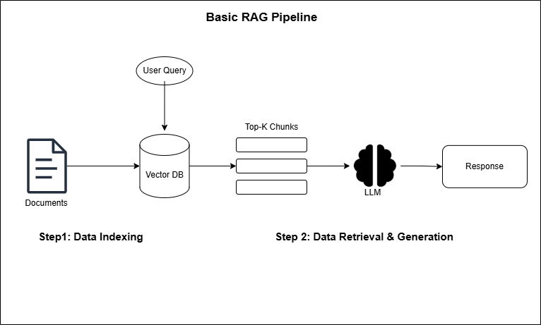

*Figure 1.1.1.1 Basic RAG Architecture*

#### 1.1.2 Advanced RAG Architecture:

##### ***1.1.2.1 Document* Indexing**

Indexing is not merely about storing data but also involves organizing and optimizing data so that the necessary information can be easily retrieved without losing the important context of the data. Some techniques in the indexing process:

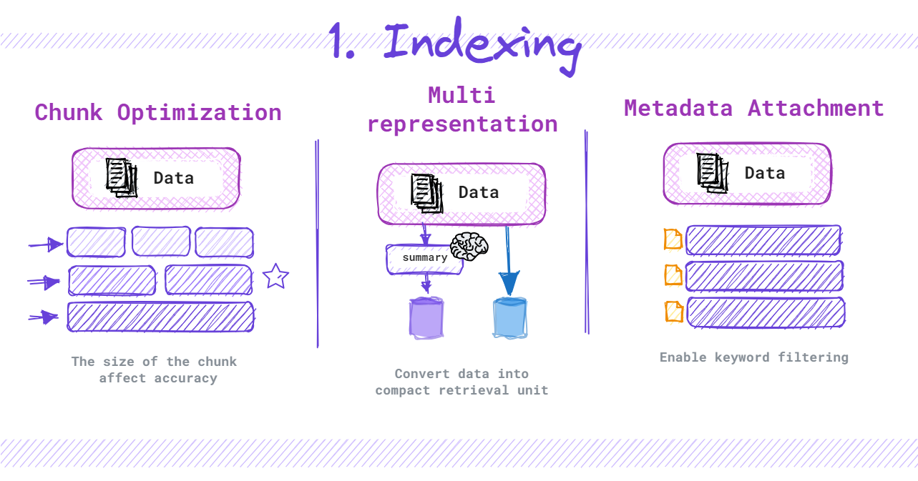

*Figure 1.1.2.1.1 Document Indexing*

* Chunk Optimization: Optimizes the size and structure of chunks to ensure that they are not too large or too small, helping to maintain the necessary context without exceeding the length limit of LLM.
* Metadata Attachment: Adding metadata to each chunk or piece of data increases the ability to analyze and classify information, allowing data to be retrieved in a more systematic way, suitable for a variety of specific situations.
* Multi-Representation: Multi-representation techniques are employed, generating multiple vector representations for each document chunk, including summary-based and content-based embeddings. Additionally, the Small-to-Big Retrieval approach is integrated, where smaller chunks are used for initial retrieval, subsequently referencing larger parent documents to provide comprehensive context.

##### ***1.1.2.2 Query Transformation and Routing***

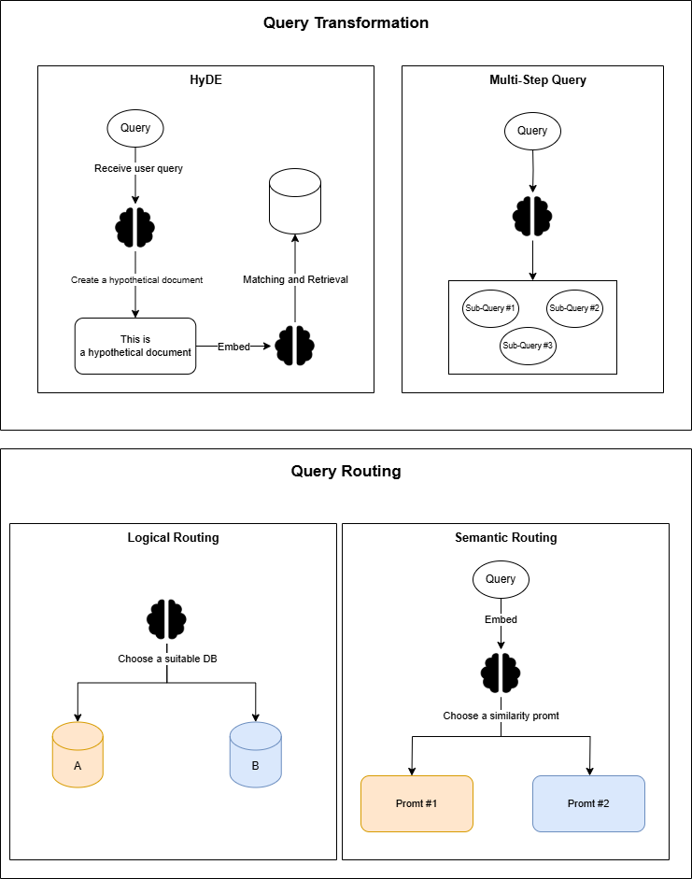*Figure 1.1.2.2.1 Query Transformation and Routing*

a, Query Transformation is a technique that uses the model LLM as a reasoning tool to edit user input to improve the quality of information retrieval. LLM can convert original questions into clearer, more understandable questions, thereby increasing the ability to search and retrieve information effectively. Some techniques in the Query Transformation process:

* HyDE: is a reversal technique in which LLM is required to generate hypothetical data based on the question, and then use the vector of this data along with the vector of the question to improve the quality of reference retrieval. This technique enhances the semantic similarity between the question and the retrieved reference, thereby enhancing the accuracy and efficiency of the query process.
* Multi-Step Query: This is a method of decomposing a complex question into more simple sub-questions, performing parallel retrieval for each of these sub-questions, and combining the retrieval results together. This allows LLM for more accurate synthesis and responses. This method is especially useful in cases where there is no direct information about the content in question.

b, Query Routing is the step taken by LLM the model to determine the next action based on the user's query. Options can be to search for content in a specific dataset or to experiment with different search directions and then aggregate the results into a unified response. This process helps direct queries to the most relevant data source, from classic vector databases to graph or relational databases, or even various hierarchical indexes. Some techniques in the Query Routing process:

* Logical Routing: It is a technique that uses logic to direct queries to the right data source. By analyzing the structure and purpose of the question, the router selects the most appropriate index or data source to perform the query. This helps to optimize the process of retrieving information by ensuring that the query is processed by the data source that is capable of the most accurate response.
* Semantic Routing: This method leverages the semantics of the question for direction. The router analyzes the semantic meaning of the question and directs it to the appropriate index or data source, in order to increase the ability to search and retrieve relevant information accurately. This method is especially effective when dealing with complex queries, which require an understanding of the context and meaning of each word and phrase in the query.

##### ***1.1.2.3 Retrieval***

The retrieval process is at the core of the RAG system, which focuses on retrieving reference data from various sources to provide the context and information needed for LLM the model to perform response sentence generation. Some techniques in the Retrieval process:

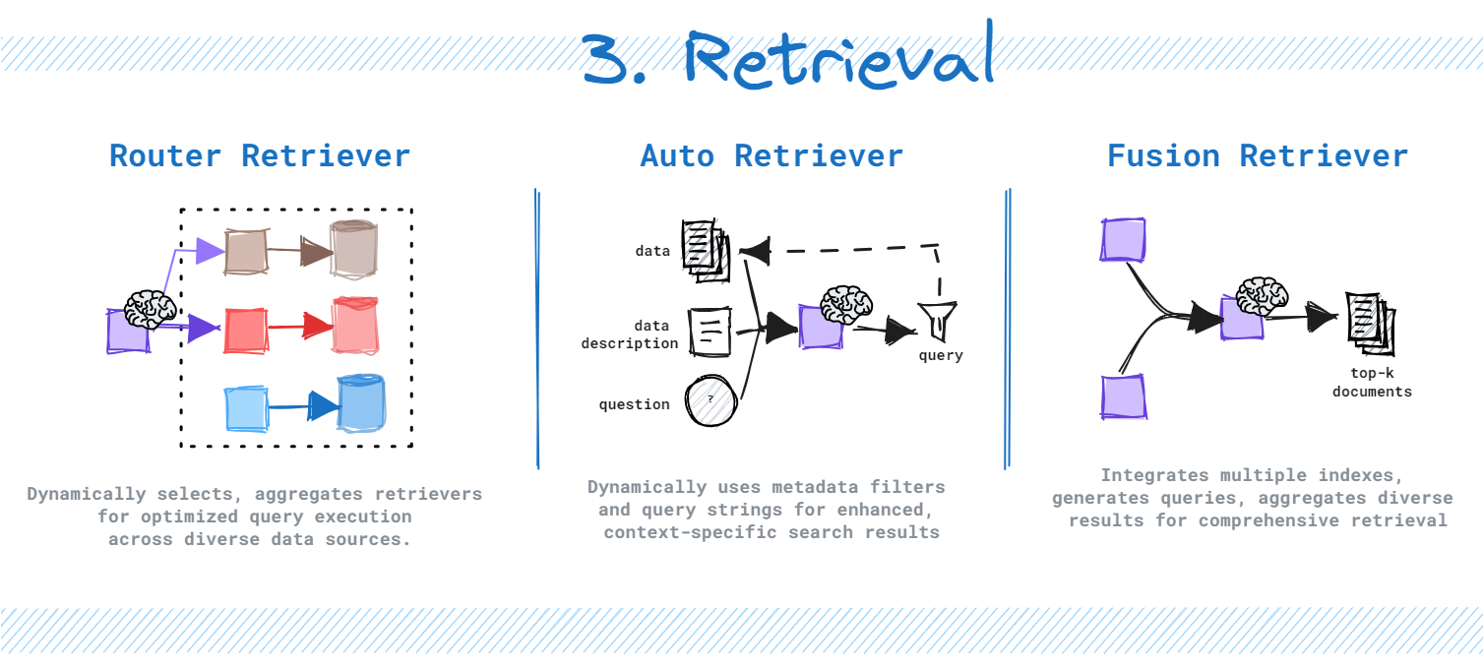

*Figure 1.1.2.3.1 Retrieval*

* Router Retriever: A technique that uses an LLM to dynamically decide the appropriate data source or query tool for each specific query.
* Auto Retriever: A method that automatically queries the database by leveraging an LLM to determine metadata for filtering or generating suitable queries for retrieval.
* Fusion Retriever: Combines results from multiple queries and indexes, optimizing information retrieval and ensuring comprehensive results without duplication, providing a multidimensional view of the retrieval process.

**Post-Retrieval:**

The Post-Retrieval process is where retrieved results are refined through filtering, reranking, or transformation. The goal of this process is to prepare and enhance the context before feeding it into the LLM to generate the final response, ensuring that the information provided to the LLM is as accurate and effective as possible.

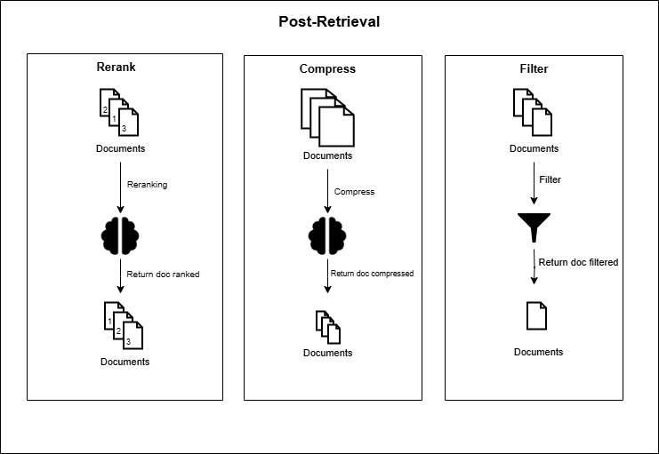*Figure 1.1.2.3.2 Post-Retrieval*

a, Rerank: Reorders retrieved text passages so that the most relevant results appear first, improving information accuracy. Reranking not only reduces the number of documents that need to be fed into the LLM but also acts as a filter to process language more precisely.

b, Compress: Removes redundant and unnecessary context, eliminating noise to enhance the LLM’s understanding of key information. Compression optimizes the context length that the LLM can handle, improving response quality by focusing on the most important details.

c, Filter: Selects relevant content before passing it to the LLM, discarding documents or information that are irrelevant or of low accuracy. This technique ensures that only high-quality and relevant information is used, enhancing the accuracy and reliability of responses.

### 1.2 System Architecture

**a, Overview**

This system is designed to provide a comprehensive platform for users to manage services and engage in intelligent interactions through multiple communication channels, primarily chat. It integrates robust internal services for business logic, data processing, and user interaction while leveraging external services for advanced natural language processing and specialized data storage. The system follows a Retrieval-Augmented Generation (RAG) and Agentic architecture to deliver accurate, context-aware responses.

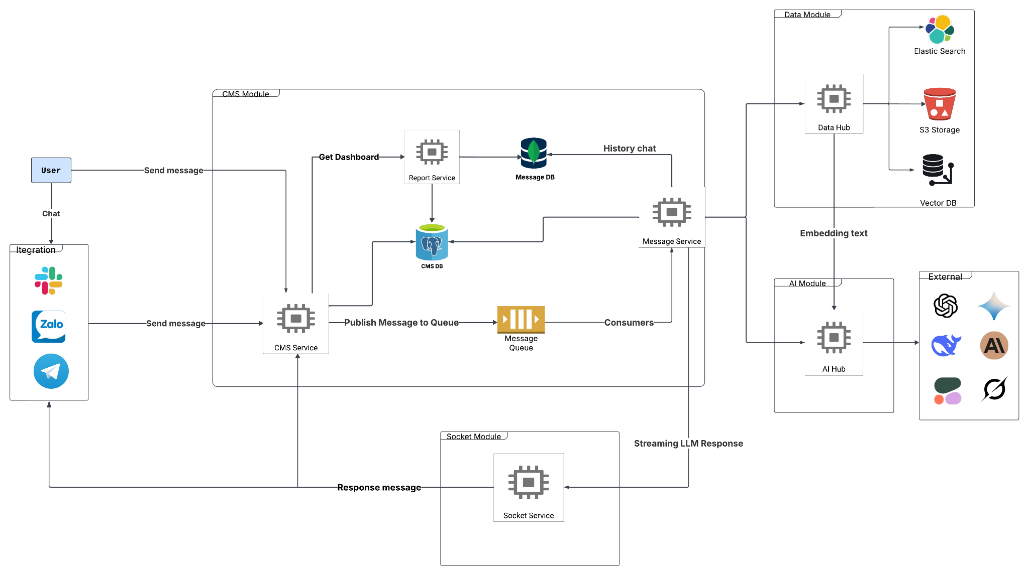

*Figure 1.2.1 System Architecture Overview*

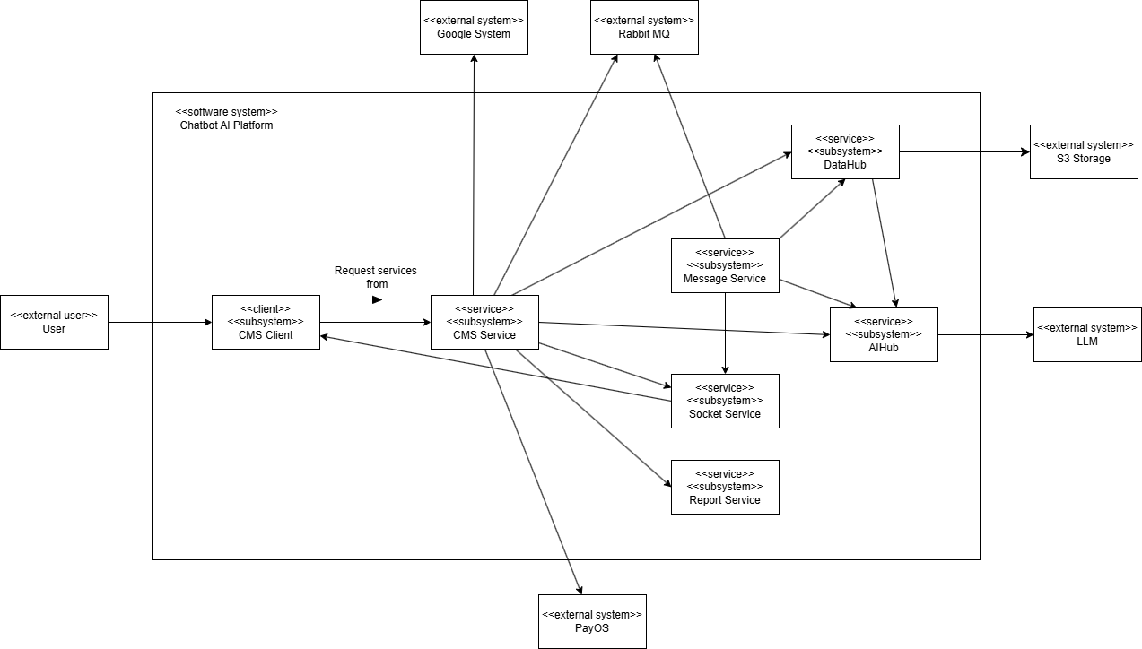

*Figure 1.2.2* Structural View

**b, Service Detail**

| **No** | **Service** | **Description** | **Key Functions** |
| --- | --- | --- | --- |
| **1** | **Internal Service** | | |
| 1.1 | CMS Service (System Gateway and Management Core) | Content Management System Service serves as the primary entry point for user requests. It orchestrates and manages core system services, including chat management, bot configurations, organization details, payments, employee data, and business logic settings. All user interactions with the system begin at the CMS Service. | - Proxy receives user requests.  - Manages system configurations (bots, organizations, users, permissions, etc.).  - Provides APIs for other modules to access management data.  - Forwards message-related requests to the Message Service. |
| 1.2 | Message Service (Message Flow Processing) | Message Service (Message Flow Processing)  Description: The Message Service handles message flows from users after receiving them from the CMS Service. It acts as an intermediary, coordinating with DataHub for data retrieval and AIHub for natural language processing to analyze messages and generate appropriate responses. It also stores conversation history. | - Processes incoming messages from CMS Service.  - Executes business logic for message handling.  - Interacts with DataHub to retrieve relevant data.  - Communicates with AIHub for NLP and response generation.  - Stores conversation history in Message DB. |
| 1.3 | AIHub | AIHub centralizes the management of external large language models (LLMs), embedding models, and reranking models. It standardizes their input/output formats and provides a unified API for other services (primarily Message Service). AIHub also evaluates question complexity (via routeLLM) to select the most suitable model for processing. | - Manages and provides APIs for LLMs, embedding, and reranking models.  - Standardizes input/output formats for AI models.  - Routes questions to appropriate LLMs based on complexity (routeLLM). |
| 1.4 | DataHub | DataHub provides APIs to ingest user data (e.g., documents) and performs critical preprocessing tasks such as text chunking and indexing. Its primary goal is to optimize data retrieval, enabling the system to quickly and efficiently find relevant information for user queries. | - Ingests user data via APIs.  - Performs text chunking.  - Indexes processed data for efficient retrieval.  - Provides APIs for Message Service to query processed data. |
| 1.5 | Socket Service | The Socket Service uses WebSocket to establish a real-time, bidirectional communication channel between the server and user applications. It enables streaming responses from LLMs, enhancing the user experience with continuous, seamless interactions. | - Manages WebSocket connections with user applications.  - Streams responses from AIHub (via Message Service) to users in real time. |
| 1.6 | Report Service | The Report Service collects message data from Message DB, preprocesses it (e.g., filtering, aggregation), and generates reports as needed. These reports provide insights into user interactions, system performance, and other business metrics. | - Retrieves message data from Message DB.  - Preprocesses and aggregates data.  - Generates reports in various formats. |
| 1.7 | CMS DB | CMS DB stores all configuration and business-related data, ensuring smooth operation of internal services. | - Stored data bot configurations, organization and member details, user permissions, and other system settings. |
| 1.8 | Message DB | Message DB stores the complete history of user-system conversations, providing critical data for tracking, analysis, and reporting. | - Message content, sender/receiver details, timestamps, and related metadata. |
| 1.9 | Message Queue | The Message Queue (RabbitMQ) manages asynchronous task processing for time-intensive operations, such as LLM response generation or data preprocessing. It ensures system stability by preventing service overload. | - Queues and distributes tasks reliably between services.  - Supports asynchronous processing for improved performance. |
| **2** | **External Services** | | |
| 2.1 | AI Service | AI Service includes LLMs, embedding models, and reranking models provided by third-party vendors. AIHub interacts with these services via APIs to leverage the latest advancements in natural language processing. | - APIs from OpenAI, Cohere, Hugging Face Inference API, etc. |
| 2.2 | Storage Service | Storage Service comprises optimized storage solutions for various data types, enhancing system efficiency and flexibility. | - S3 Storage: Object storage for user-uploaded files (e.g., documents).  - Milvus Vector DB: Vector database for storing document embeddings, enabling fast similarity searches.  - Elasticsearch: Search and analytics engine for text data, supporting high-speed, accurate full-text searches. |

*Table 1.2.1 Service Detail*

**III, Main Processing Flow**

1. **User Request**: Users send messages via chatbox embedded into website or communication channels (e.g., Chat, Zalo, Telegram).
2. **CMS Service Handling:** CMS Service receives requests and initial chat session.
3. **Queueing:** CMS Service forwards messages to the Message Queue for asynchronous processing.
4. **Message Service Processing:** Message Service retrieves messages from the queue and initiates processing.
5. **AI and Data Interaction**: Message Service collaborates with AIHub for NLP tasks (e.g., embeddings, reranking, LLM responses) and DataHub for retrieving relevant data. AIHub and DataHub may interact with external AI and Storage Services.
6. **Response Delivery:** Responses are sent to users via Socket Service (for streaming) or CMS Service (for standard responses).
7. **Conversation Storage:** Message Service stores conversation history in Message DB.
8. **Reporting:** Report Service periodically retrieves and processes data from Message DB to generate analytical reports.

### 1.3 Agentic flow

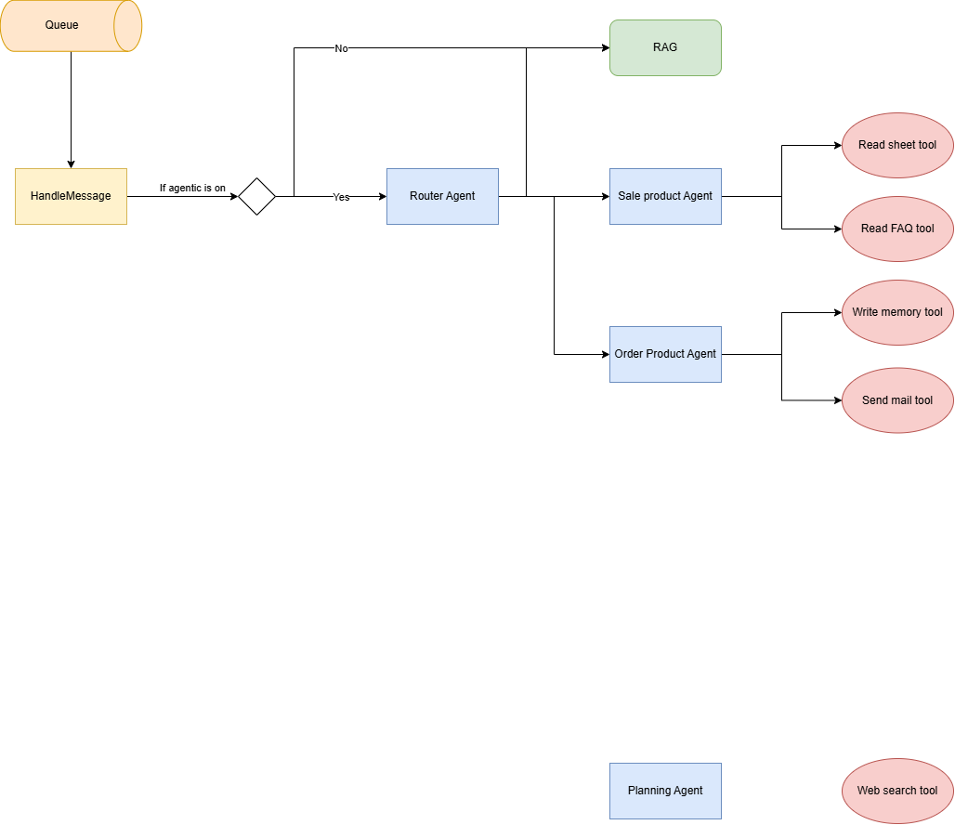

*Figure 1.3.1 Agentic Flow*

#### 1.3.1 Agentic Flow Description

**1. Queue:** Incoming user messages are placed in a queue for processing.

**2. HandleMessage:** The HandleMessage service retrieves messages from the queue and prepares them for further handling.

Check: Is Agentic Mode Enabled

* If No then The system uses a RAG (Retrieval-Augmented Generation) model to handle the user's query directly.
* If Yes then The system proceeds with the agentic architecture.

**3. Router Agent:** This agent is responsible for routing messages to the appropriate specialized agents based on the message content. It forwards the task to:

* Sale Product Agent
* Order Product Agent

#### 1.3.2 Functional Agents

#### 1. Sale Product Agent

This agent handles requests related to product details, promotions, or sales information.  
 It uses the following tools:

* **Read Sheet Tool** – to fetch data from spreadsheets (e.g., Google Sheets)
* **Read FAQ Tool** – to answer frequently asked questions.

#### 2. Order Product Agent

This agent manages order-related actions, such as placing or tracking orders.  
 It uses:

* **Write Memory Tool** – to store relevant user or order information.
* **Send Mail Tool** – to send confirmation or notification emails.

### 1.4 Analytic Flow

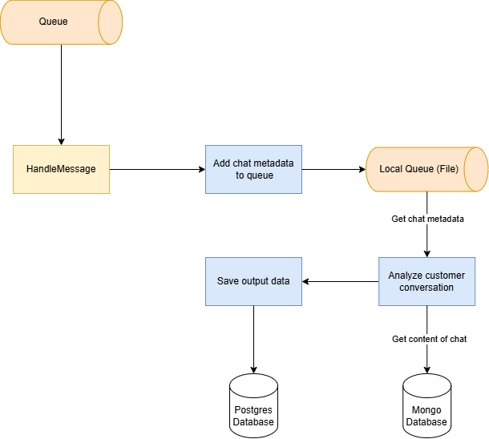

*Figure 1.4.1 Analytic Flow*

After handling a message then add chat metadata to the queue labeled "Local Queue" and store in block storage. Metadata contains: Chat Id, User Id, timestamp

When consumers get chat metadata for analyzing customer conversations, they retrieve the chat metadata from the queue and chat content from the mongo database.

In analyzing process conversation, it could involve tasks like sentiment analysis, topic detection, or identifying key customer issues. After that save the results of the analysis are then saved to a Postgres Database.

### 1.5 Package Diagram

#### 1.5.1 CMS Service

##### **a. CMS-BE**

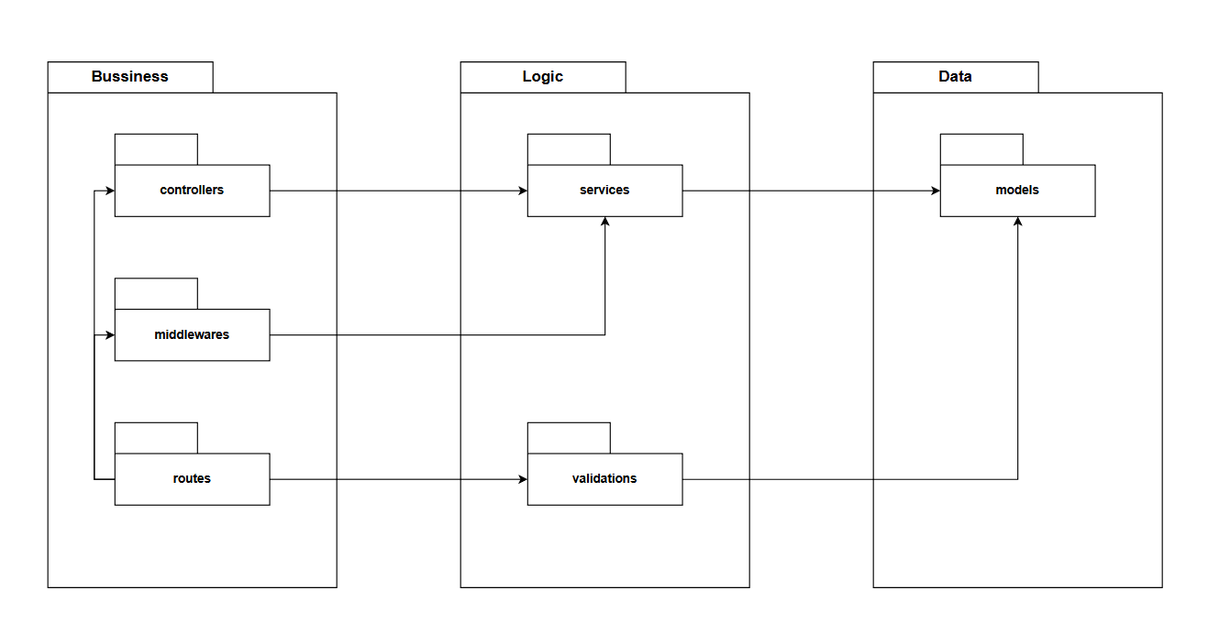

*Figure 1.5.1.1 CMS-BE Package Diagram*

***Package descriptions***

| **No** | **Package** | **Description** |
| --- | --- | --- |
| 1 | Routes | Defines API endpoints and their corresponding controllers. |
| 2 | Middleware | Handles request pre-processing, authentication, and logging. |
| 3 | Controllers | Manages incoming requests and interacts with services to process data |
| 4 | Services | Implements business logic and interacts with the data layer. |
| 5 | Validations | Ensures data integrity by validating input requests. |
| 6 | Models | Defines the structure of data entities and database schema. |

*Table 1.5.1.1 CMS-BE Package Description*

##### **b. CMS-FE**

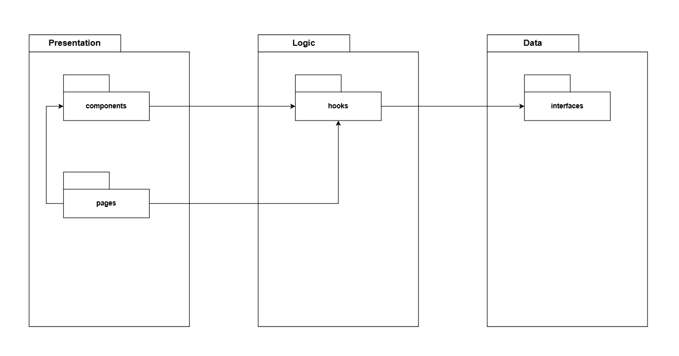

*Figure 1.5.1.2 CMS-FE Package Diagram*

***Package descriptions***

| **No** | **Package** | **Description** |
| --- | --- | --- |
| 1 | Components | Contains reusable UI elements used across different pages. |
| 2 | Pages | Represents different views or screens of the application. |
| 3 | Hooks | Custom React hooks for managing state and side effects. |
| 4 | Interfaces | Defines TypeScript interfaces for data models and API responses. |

*Table 1.5.1.2 CMS-FE Package Description*

#### 1.5.2 AI Hub

#### 

*Figure 1.5.2.1 AI Hub Package Diagram*

***Package descriptions***

| **No** | **Package** | **Description** |
| --- | --- | --- |
| 1 | Core | Implements the main business logic and operations. |
| 2 | Utils | Includes helper functions and utility methods. |
| 3 | Models | Defines data structures used throughout the application. |
| 4 | API | Handles communication between the application and external services or databases. |
| 5 | Database | Represents the data storage system. |

*Table 1.5.2.1 AI Hub Package Description*

#### 1.5.3 DataHub

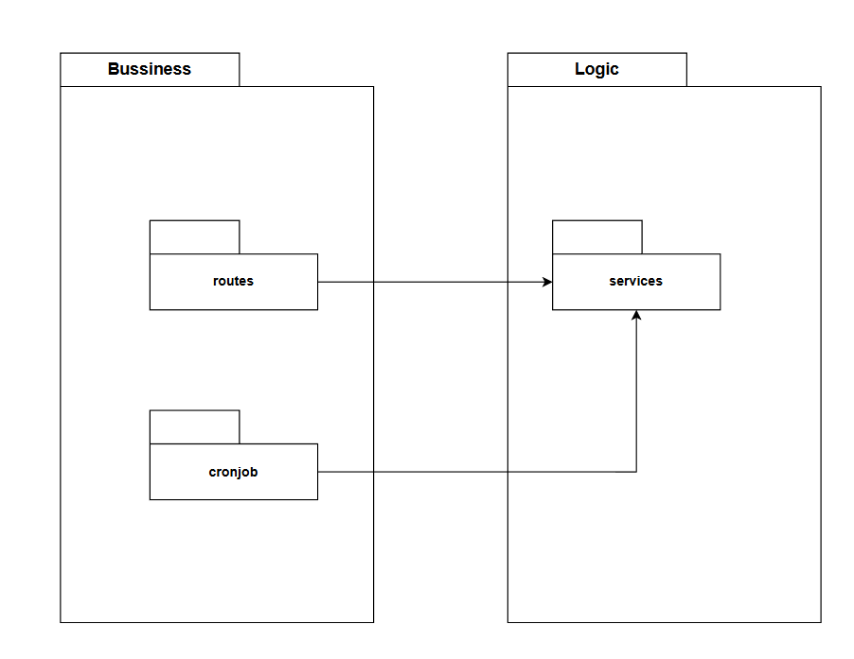

*Figure 1.5.3.1 DataHub Package Diagram*

***Package descriptions***

| **No** | **Package** | **Description** |
| --- | --- | --- |
| 1 | Routes | Defines API routes and handles incoming requests. |
| 2 | Croniob | Manages scheduled background tasks and automation. |
| 3 | Services | Implements business logic and interacts with other layers. |

*Table 1.5.3.1 DataHub Package Description*

#### 1.5.4 Message Service

*Figure 1.5.4.1 Message Service Package Diagram*

***Package descriptions***

| **No** | **Package** | **Description** |
| --- | --- | --- |
| 1 | API | Manages external requests and API interactions. |
| 2 | Handler | Processes API requests before passing them to controllers. |
| 3 | Controller | Handles business logic and orchestrates requests. |
| 4 | Repository | Manages data access and persistence. |
| 5 | Common | Contains shared utilities and helpers. |
| 6 | Core | Handles core functionalities and business rules. |
| 7 | Gateway | Manages external service integrations. |
| 8 | Utils | Provides utility functions and reusable components. |
| 9 | Models | Defines data structures and database models. |

*Table 1.5.4.1 Message Service Package Description*

#### 1.5.5 Socket Service

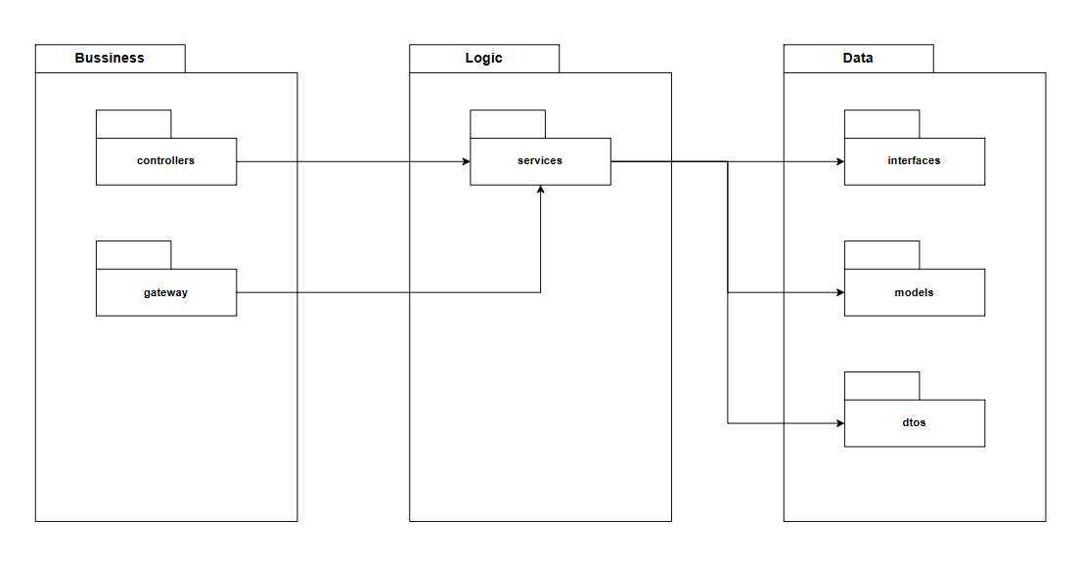

*Figure 1.5.5.1 Socket Service Package Diagram*

***Package descriptions***

| **No** | **Package** | **Description** |
| --- | --- | --- |
| 1 | Controllers | Handles HTTP requests and responses, orchestrates API logic. |
| 2 | Gateway | Manages external service calls and integrations. |
| 3 | Services | Contains business logic and processes data. |
| 4 | Interfaces | Defines contracts for data access and service implementations. |
| 5 | Models | Represents database entities and data structures. |
| 6 | DTOs | Data Transfer Objects used for communication between layers. |

*Table 1.5.5.1 Socket Service Package Description*

#### 

#### 1.5.6 Report Service

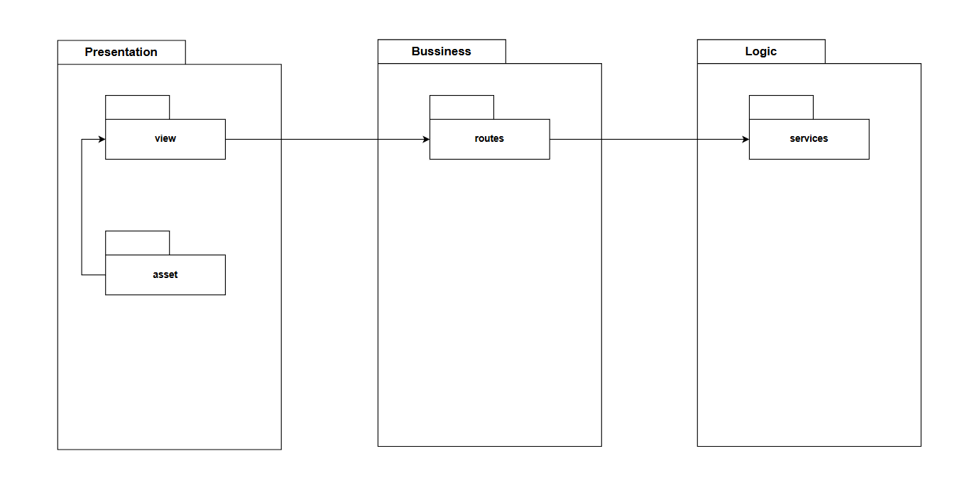

*Figure 1.5.6.1 Report Service Package Diagram*

***Package descriptions***

| **No** | **Package** | **Description** |
| --- | --- | --- |
| 1 | View | Responsible for rendering the interface presented to the user. |
| 2 | Asset | Provides static resources necessary for styling, interactivity, and media display. |
| 4 | Routes | Defines API routes and handles incoming requests. |
| 3 | Services | Implements business logic and interacts with other layers. |

*Figure 1.5.6.1 Report Service Package Description*

## 2. Database Design

### 2.1 SQL Database (CMS DB)

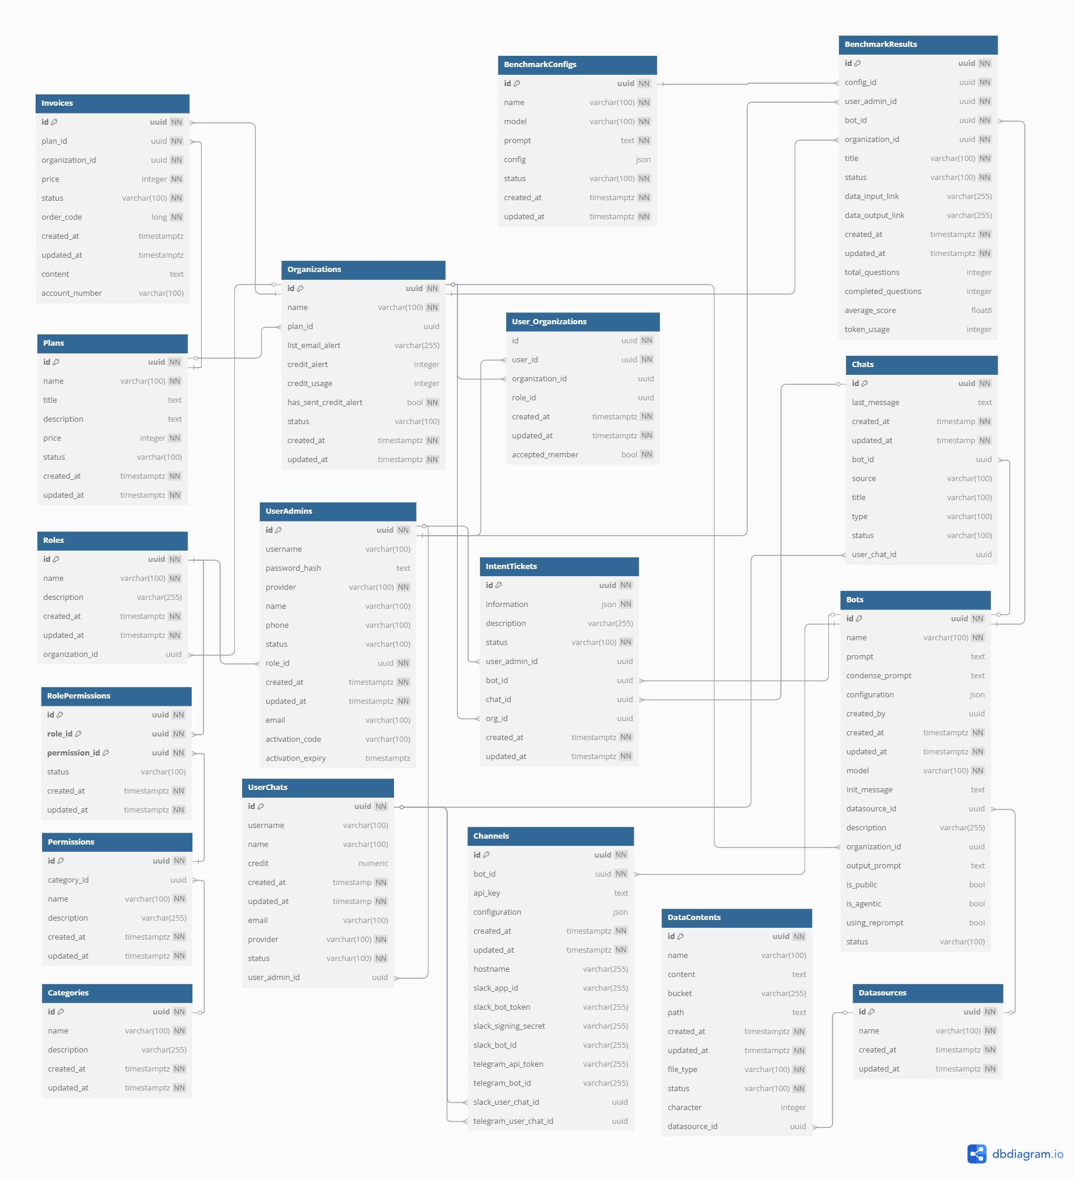

*Figure 2.1.1 SQL Database Design*

#### 2.1.1 UserAdmins

| **#** | **Field Name** | **Type** | **Constraint** | **Note** |
| --- | --- | --- | --- | --- |
| 1 | id | uuid | - Primary key  - Not null |  |
| 2 | username | varchar(100) | - Unique  - Not null |  |
| 3 | password_hash | text | - Not null |  |
| 4 | provider | varchar(100) | - Not null |  |
| 5 | name | varchar(100) |  |  |
| 6 | phone | varchar(100) |  |  |
| 7 | role_id | uuid | - Foreign key  - Not null |  |
| 8 | status | varchar(100) | - Not null |  |
| 9 | created_at | timestamp | - Not null |  |
| 10 | updated_at | timestamp | - Not null |  |
| 11 | email | varchar(100) | - Not null |  |
| 12 | activation_code | varchar(100) |  |  |
| 13 | activation_expiry | timestamp |  |  |

*Table 2.1.1.1 UserAdmins Description*

#### 2.1.2 Organizations

| **#** | **Field Name** | **Type** | **Constraint** | **Note** |
| --- | --- | --- | --- | --- |
| 1 | id | uuid | - Primary key  - Not null |  |
| 2 | name | varchar(100) |  |  |
| 3 | plan_id | uuid | - Foreign key  - Not null |  |
| 4 | status | varchar(100) | - Not null |  |
| 5 | list_email_alert | varchar(255) |  |  |
| 6 | credit_alert | integer |  |  |
| 7 | credit_usage | integer |  |  |
| 8 | has_sent_credit_alert | character varying(255)[] |  |  |
| 9 | created_at | timestamp | - Not null |  |
| 10 | updated_at | timestamp | - Not null |  |

*Table 2.1.2.1 Organizations Description*

#### 2.1.3 User_Organizations

| **#** | **Field Name** | **Type** | **Constraint** | **Note** |
| --- | --- | --- | --- | --- |
| 1 | id | uuid | - Primary key  - Not null |  |
| 2 | user_id | uuid | - Foreign key  - Not null |  |
| 3 | organization_id | uuid | - Foreign key  - Not null |  |
| 4 | role_id | uuid | - Foreign key |  |
| 5 | accepted_member | boolean |  |  |
| 6 | created_at | timestamp | - Not null |  |
| 7 | updated_at | timestamp | - Not null |  |

*Table 2.1.3.1 User_Organizations Description*

#### 2.1.4 Bots

| **#** | **Field Name** | **Type** | **Constraint** | **Note** |
| --- | --- | --- | --- | --- |
| 1 | id | uuid | - Primary key  - Not null |  |
| 2 | name | varchar(100) |  |  |
| 3 | model_id | uuid | - Foreign key  - Not null |  |
| 4 | prompt | text |  |  |
| 5 | condense_prompt | text |  |  |
| 6 | configuration | text |  |  |
| 7 | init_message | text |  |  |
| 8 | datasource_id | uuid | - Foreign key |  |
| 9 | description | varchar(255) |  |  |
| 10 | organization_id | uuid | - Foreign key |  |
| 11 | output_prompt | text |  |  |
| 12 | is_public | boolean |  |  |
| 13 | is_agentic | boolean |  |  |
| 14 | using_reprompt | boolean |  |  |
| 15 | status | varchar(100) | - Not null |  |
| 16 | created_at | timestamp | - Not null |  |
| 17 | created_by | timestamp | - Not null |  |
| 18 | updated_at | timestamp |  |  |

*Table 2.1.4.1 Bots Description*

#### 2.1.5 Channels

| **#** | **Field Name** | **Type** | **Constraint** | **Note** |
| --- | --- | --- | --- | --- |
| 1 | id | uuid | - Primary key  - Not null |  |
| 2 | api_key | text | - Not null |  |
| 3 | host_name | varchar(255) |  |  |
| 4 | configuration | json |  |  |
| 5 | bot_id | uuid | - Foreign key  - Not null |  |
| 6 | slack_app_id | varchar(255) |  |  |
| 7 | slack_bot_token | varchar(255) |  |  |
| 8 | slack_signing_secret | varchar(255) |  |  |
| 9 | slack_bot_id | varchar(255) |  |  |
| 10 | telegram_api_token | varchar(255) |  |  |
| 11 | telegram_bot_id | varchar(255) |  |  |
| 12 | slack_user_chat_id | uuid | - Foreign key |  |
| 13 | telegram_user_chat_id | uuid | - Foreign key |  |
| 14 | created_at | timestamp | - Not null |  |
| 15 | updated_at | timestamp |  |  |

*Table 2.1.5.1 Channels Description*

#### 2.1.6 Chats

| **#** | **Field Name** | **Type** | **Constraint** | **Note** |
| --- | --- | --- | --- | --- |
| 1 | id | uuid | - Primary key  - Not null |  |
| 2 | user_chat_id | uuid | - Foreign key |  |
| 3 | bot_id | uuid | - Foreign key |  |
| 4 | source | varchar(100) |  |  |
| 5 | title | varchar(100) |  |  |
| 6 | status | varchar(100) | - Not null |  |
| 7 | last_message | text |  |  |
| 8 | type | varchar(100) |  |  |
| 9 | created_at | timestamp | - Not null |  |
| 10 | updated_at | timestamp | - Not null |  |

*Table 2.1.6.1 Chats Description*

#### 2.1.7 Datasources

| **#** | **Field Name** | **Type** | **Constraint** | **Note** |
| --- | --- | --- | --- | --- |
| 1 | id | uuid | - Primary key  - Not null |  |
| 2 | name | varchar(100) | - Not null |  |
| 4 | created_at | timestamp | - Not null |  |
| 6 | updated_at | timestamp | - Not null |  |

*Table 2.1.7.1 Datasources Description*

#### 2.1.8 DataContents

| **#** | **Field Name** | **Type** | **Constraint** | **Note** |
| --- | --- | --- | --- | --- |
| 1 | id | uuid | - Primary key  - Not null |  |
| 2 | name | varchar(100) | - Not null |  |
| 3 | content | text | - Not null |  |
| 4 | bucket | varchar(255) |  |  |
| 5 | path | varchar(255) |  |  |
| 6 | file_type | varchar(100) | - Not null |  |
| 7 | character | integer |  |  |
| 8 | datasource_id | uuid | - Foreign key  - Not null |  |
| 9 | status | varchar(100) |  |  |
| 10 | created_at | timestamp | - Not null |  |
| 11 | updated_at | timestamp |  |  |

*Table 2.1.8.1 DataContents Description*

#### 2.1.9 Plans

| **#** | **Field Name** | **Type** | **Constraint** | **Note** |
| --- | --- | --- | --- | --- |
| 1 | id | uuid | - Primary key  - Not null |  |
| 2 | name | varchar(100) | - Not null |  |
| 3 | title | text |  |  |
| 4 | description | text |  |  |
| 5 | price | integer | - Not null |  |
| 6 | status | varchar(100) | - Not null |  |
| 7 | created_at | timestamp | - Not null |  |
| 8 | updated_at | timestamp | - Not null |  |

*Table 2.1.9.1 Plans Description*

#### 2.1.10 Invoices

| **#** | **Field Name** | **Type** | **Constraint** | **Note** |
| --- | --- | --- | --- | --- |
| 1 | id | uuid | - Primary key  - Not null |  |
| 2 | organization_id | uuid | - Foreign key  - Not null |  |
| 3 | plan_id | uuid | - Foreign key  - Not null |  |
| 4 | price | integer | - Not null |  |
| 5 | content | text |  |  |
| 6 | account_number | varchar(100) |  |  |
| 7 | status | varchar(100) | - Not null |  |
| 8 | order_code | long | - Not null |  |
| 9 | created_at | timestamp | - Not null |  |
| 10 | updated_at | timestamp | - Not null |  |

*Table 2.1.10.1 Invoices Description*

#### 2.1.11 UserChats

| **#** | **Field Name** | **Type** | **Constraint** | **Note** |
| --- | --- | --- | --- | --- |
| 1 | id | uuid | - Primary key  - Not null |  |
| 2 | name | varchar(100) |  |  |
| 3 | username | varchar(100) |  |  |
| 4 | credit | decimal(10,2) | - Not null |  |
| 5 | email | varchar(100) |  |  |
| 6 | provider | varchar(100) |  |  |
| 7 | user_admin_id | uuid | - Foreign key |  |
| 8 | status | varchar(100) | - Not null |  |
| 9 | created_at | timestamp | - Not null |  |
| 10 | updated_at | timestamp | - Not null |  |

*Table 2.1.11.1 UserChats Description*

#### 2.1.12 Categories

| **#** | **Field Name** | **Type** | **Constraint** | **Note** |
| --- | --- | --- | --- | --- |
| 1 | id | uuid | - Primary key  - Not null |  |
| 2 | name | varchar(100) | - Not null |  |
| 3 | description | varchar(255) |  |  |
| 4 | created_at | timestamp | - Not null |  |
| 5 | updated_at | timestamp | - Not null |  |

*Table 2.1.12.1 Categories Description*

#### 2.1.13 Roles

| **#** | **Field Name** | **Type** | **Constraint** | **Note** |
| --- | --- | --- | --- | --- |
| 1 | id | uuid | - Primary key  - Not null |  |
| 2 | name | varchar(100) | - Not null |  |
| 3 | description | varchar(255) |  |  |
| 4 | organization_id | uuid | - Foreign key |  |
| 5 | created_at | timestamp | - Not null |  |
| 6 | updated_at | timestamp | - Not null |  |

*Table 2.1.13.1 Roles Description*

#### 2.1.14 Permissions

| **#** | **Field Name** | **Type** | **Constraint** | **Note** |
| --- | --- | --- | --- | --- |
| 1 | id | uuid | - Primary key  - Not null |  |
| 2 | name | varchar(100) | - Not null |  |
| 3 | description | varchar(255) |  |  |
| 4 | category_id | uuid | - Foreign key |  |
| 5 | created_at | timestamp | - Not null |  |
| 6 | updated_at | timestamp | - Not null |  |

*Table 2.1.14.1 Permissions Description*

#### 2.1.15 RolePermissions

| **#** | **Field Name** | **Type** | **Constraint** | **Note** |
| --- | --- | --- | --- | --- |
| 1 | id | uuid | - Primary key  - Not null |  |
| 2 | role_id | uuid | - Foreign key  - Not null |  |
| 3 | permission_id | uuid | - Foreign key  - Not null |  |
| 4 | status | varchar(100) |  |  |
| 5 | created_at | timestamp | - Not null |  |
| 7 | updated_at | timestamp | - Not null |  |

*Table 2.1.15.1 RolePermissions Description*

#### 2.1.16 IntentTickets

| **#** | **Field Name** | **Type** | **Constraint** | **Note** |
| --- | --- | --- | --- | --- |
| 1 | id | uuid | - Primary key  - Not null |  |
| 2 | information | json |  |  |
| 3 | description | varchar(255) |  |  |
| 4 | status | varchar(100) |  |  |
| 5 | user_admin_id | uuid | - Foreign key |  |
| 6 | bot_id | uuid | - Foreign key |  |
| 7 | chat_id | uuid | - Foreign key |  |
| 8 | org_id | uuid | - Foreign key |  |
| 9 | created_at | timestamp | - Not null |  |
| 10 | updated_at | timestamp | - Not null |  |

*Table 2.1.16.1 IntentTickets Description*

#### 2.1.17 EvaluationConfigs

| **#** | **Field Name** | **Type** | **Constraint** | **Note** |
| --- | --- | --- | --- | --- |
| 1 | id | uuid | - Primary key  - Not null |  |
| 2 | org_id | uuid | - Foreign key  - Not null |  |
| 3 | name | varchar(100) | - Not null |  |
| 4 | model | varchar(100) | - Not null |  |
| 5 | prompt | text |  |  |
| 6 | config | json |  |  |
| 7 | status | varchar(100) | - Not null |  |
| 8 | created_at | timestamp | - Not null |  |
| 9 | updated_at | timestamp | - Not null |  |

*Table 2.1.17.1 EvaluationConfigs Description*

#### 2.1.18 EvaluationResults

| **#** | **Field Name** | **Type** | **Constraint** | **Note** |
| --- | --- | --- | --- | --- |
| 1 | id | uuid | - Primary key  - Not null |  |
| 2 | user_admin_id | uuid | - Foreign key  - Not null |  |
| 3 | organization_id | uuid | - Foreign key  - Not null |  |
| 4 | bot_id | uuid | - Foreign key  - Not null |  |
| 5 | config_id | uuid | - Foreign key  - Not null |  |
| 6 | title | varchar(100) | - Not null |  |
| 7 | status | varchar(100) | - Not null |  |
| 8 | data_input_link | varchar(255) |  |  |
| 9 | data_output_link | varchar(255) |  |  |
| 10 | total_questions | integer |  |  |
| 11 | completed_questions | integer |  |  |
| 12 | average_score | float |  |  |
| 13 | token_usage | integer |  |  |
| 14 | created_at | timestamp | - Not null |  |
| 15 | updated_at | timestamp | - Not null |  |

*Table 2.1.18.1 EvaluationResults Description*

### 

### 2.2 No-SQL Database (Message DB)

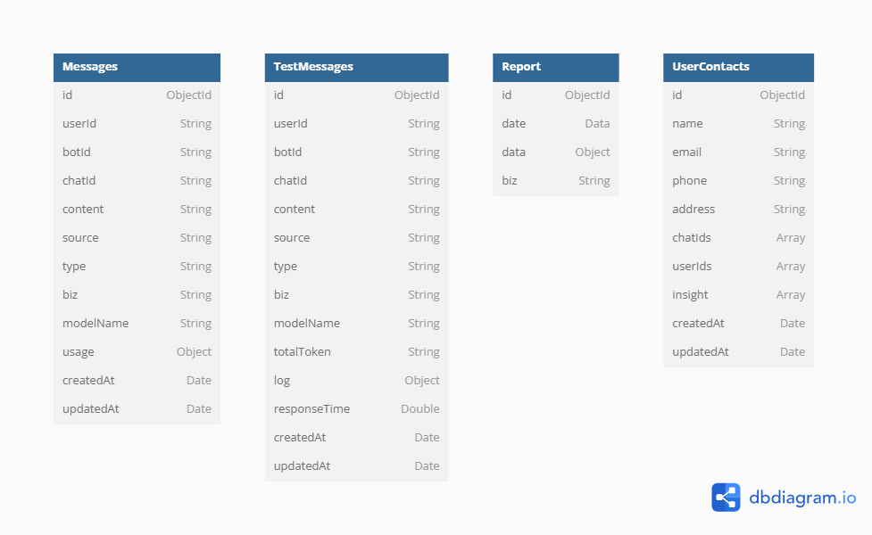

*Figure 2.2.1 No-SQL Database Design*

#### 2.2.1 Messages

| **#** | **Field Name** | **Type** | **Constraint** | **Note** |
| --- | --- | --- | --- | --- |
| 1 | id | ObjectId | - Primary key  - Not null |  |
| 2 | userId | String | - Not null |  |
| 3 | botId | String | - Not null |  |
| 4 | chatId | String | - Not null |  |
| 5 | content | String |  |  |
| 6 | source | String |  |  |
| 7 | type | String |  |  |
| 8 | biz | String |  |  |
| 9 | modelName | String |  |  |
| 10 | usage | Object |  |  |
| 11 | createdAt | Date | - Not null |  |
| 12 | updatedAt | Date | - Not null |  |

*Table 2.2.1.1 Messages Description*

#### 2.2.2 TestMessages

| **#** | **Field Name** | **Type** | **Constraint** | **Note** |
| --- | --- | --- | --- | --- |
| 1 | id | ObjectId | - Primary key  - Not null |  |
| 2 | userId | String | - Not null |  |
| 3 | botId | String | - Not null |  |
| 4 | chatId | String | - Not null |  |
| 5 | content | String | - Not null |  |
| 6 | source | String |  |  |
| 7 | type | String |  |  |
| 8 | biz | String |  |  |
| 9 | modelName | String |  |  |
| 10 | totalToken | Integer |  |  |
| 11 | log | Object |  |  |
| 12 | responseTime | Double |  |  |
| 13 | createdAt | Date | - Not null |  |
| 14 | updatedAt | Date | - Not null |  |

*Table 2.2.2.1 TestMessages Description*

#### 2.2.3 Report

| **#** | **Field Name** | **Type** | **Constraint** | **Note** |
| --- | --- | --- | --- | --- |
| 1 | id | ObjectId | - Primary key  - Not null |  |
| 2 | date | Date |  |  |
| 3 | data | Object |  |  |
| 4 | biz | String |  |  |

*Table 2.2.3.1 Report Description*

#### 2.2.4 UserContacts

| **#** | **Field Name** | **Type** | **Constraint** | **Note** |
| --- | --- | --- | --- | --- |
| 1 | id | ObjectId | - Primary key  - Not null |  |
| 2 | name | Date |  |  |
| 3 | email | Object |  |  |
| 4 | phone | String |  |  |
| 5 | address | String |  |  |
| 6 | chatIds | Array |  |  |
| 7 | userIds | Array |  |  |
| 8 | insight | Array |  |  |
| 9 | createdAt | Date | - Not null |  |
| 10 | updatedAt | Date | - Not null |  |

*Table 2.2.4.1 UserContacts Description*

## 3. Detailed Design

### 3.1 AI Interaction

#### 3.1.1 Chat

##### **a, Class Diagram**

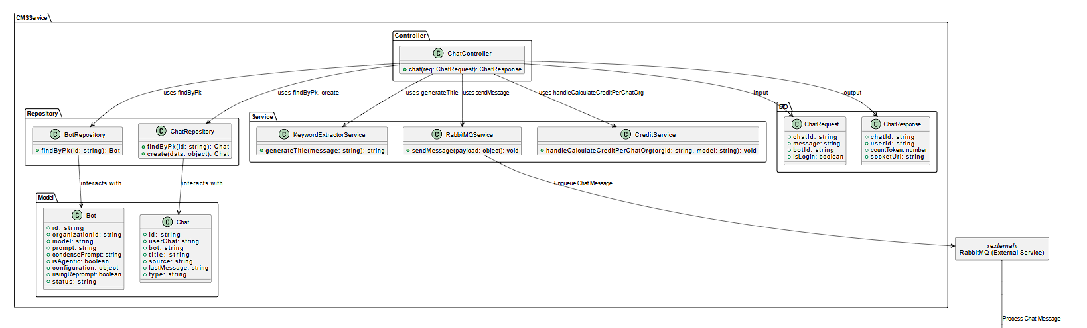

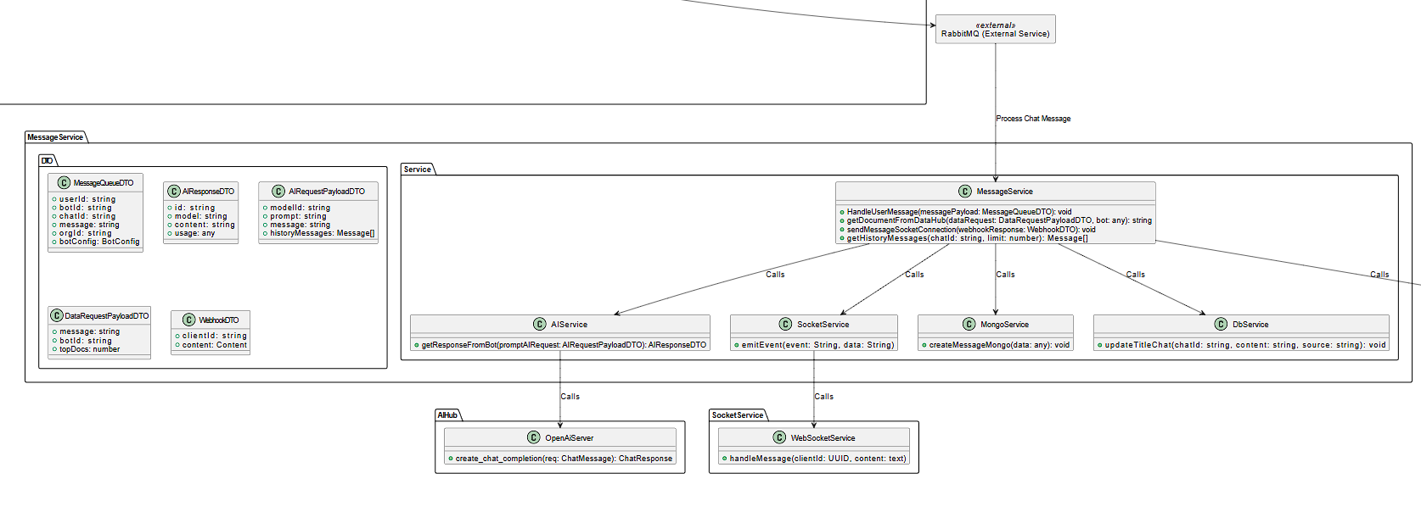

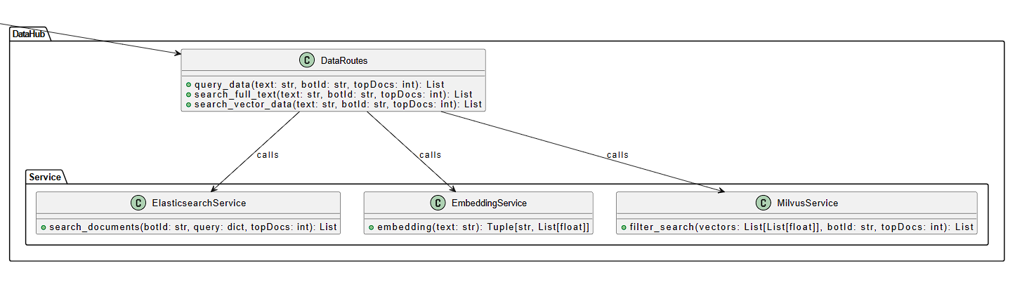

##### **b, Communication Diagram**

##### 

##### 

##### **c, Sequence Diagram**

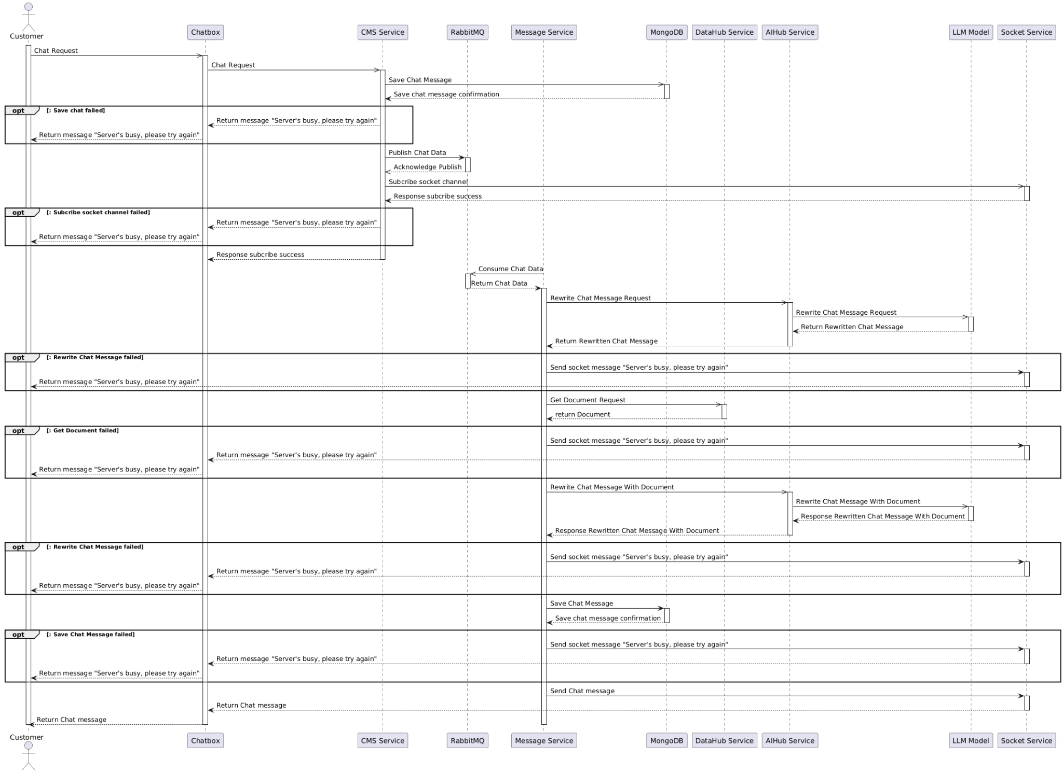

**Components**

1. **Chatbox**– Receives messages from the customer and forwards them to the backend.
2. **CMS Service** – Handles backend processing and communicates with other services.
3. **RabbitMQ** – Manages asynchronous tasks by enqueueing messages for processing.
4. **Message Service** – Processes user messages, retrieves documents, and handles bot responses.
5. **Socket Service** – Enables real-time message delivery between components.
6. **AIHub**– Processes user queries and generates bot responses using AI.
7. **External Service (LLM Model)** – Provides language model capabilities for generating bot responses.
8. **DataHub** – Manages document retrieval to support bot responses.

**Process Flow**

1. Customer Starts Chatting:

* The customer sends a message through the Chatbox.

1. Chatbox Forwards the Message:

* The Chatbox sends the message to the CMS Service. The CMS Service saves the chat info in the MessageDB and pushes the message to RabbitMQ.

1. RabbitMQ Handles the Message:

* The Message Service picks up the message from RabbitMQ, processes it, and sends the rewritten message through the Socket Service to display it back on the Chatbox.

1. Fetch Documents and Ask the Bot:

* The Message Service grabs the message from the MessageDB, asks the DataHub Service for related documents, and sends the question to the AIHub Service. The AIHub Service then asks the External Service (LLM) to generate a bot response.

1. Send the Bot’s Response Back:

* The AIHub Service gives the bot’s response to the Message Service. The Message Service saves it in the MessageDB and sends it through the Socket Service to show on the Chatbox for the customer to see.

#### 3.1.2 Add New Data Source

##### **a, Class Diagram**

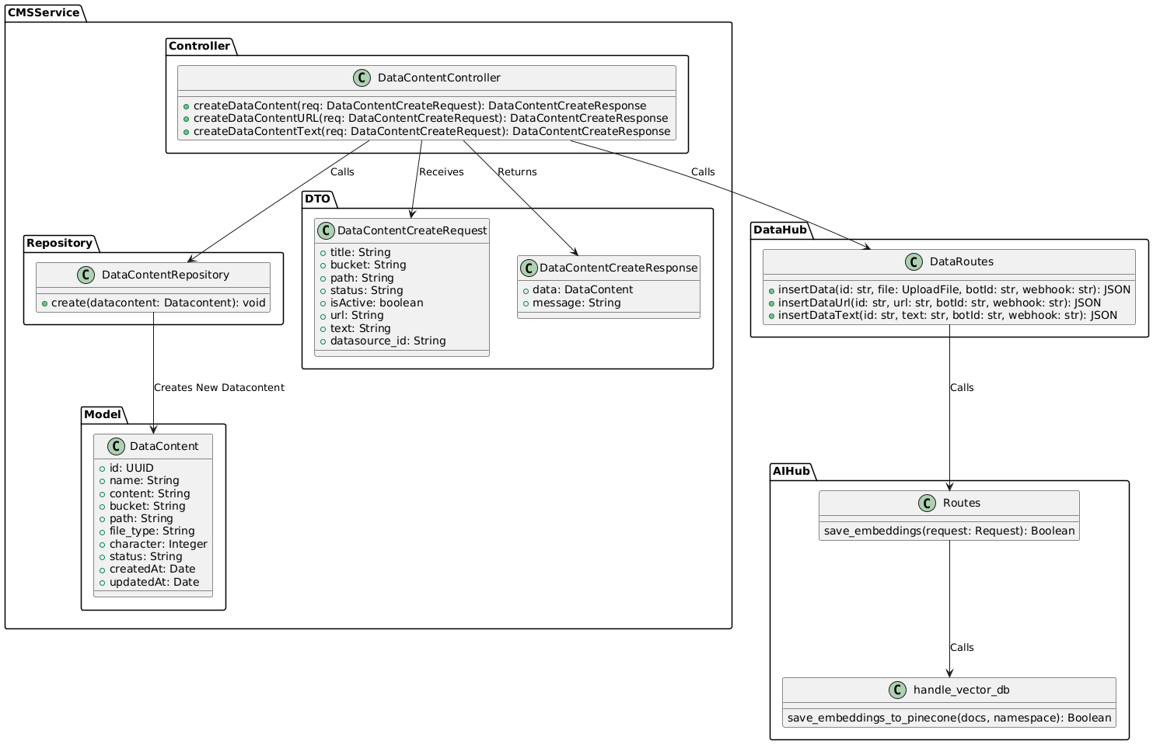

##### **b, Communication Diagram**

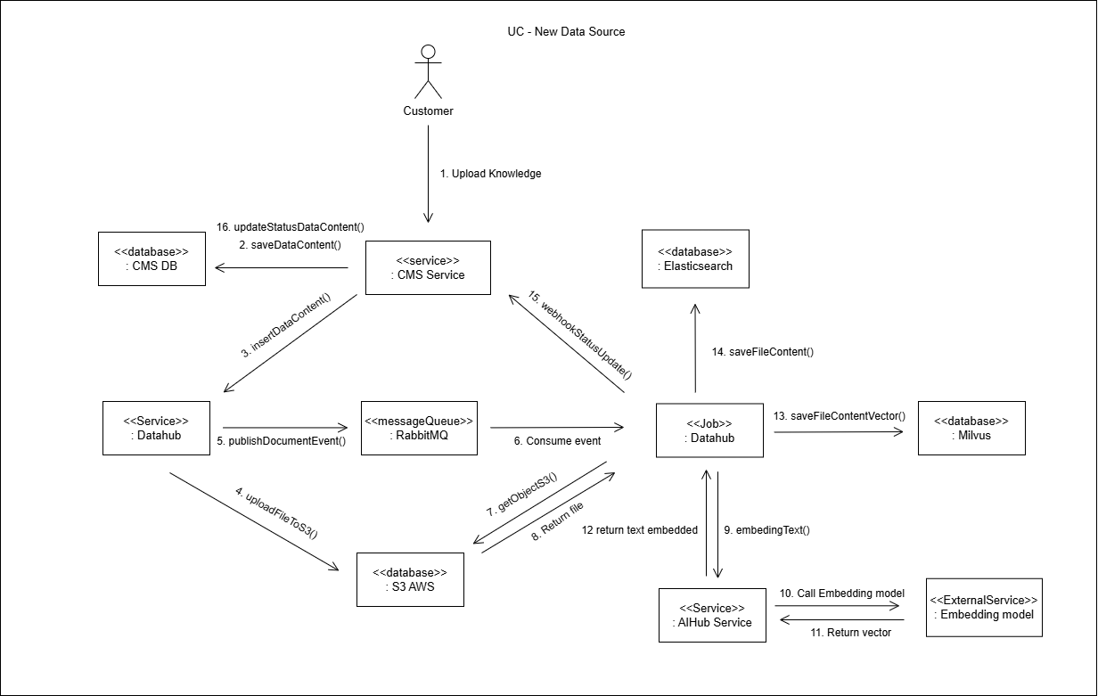

##### **c, Sequence Diagram**

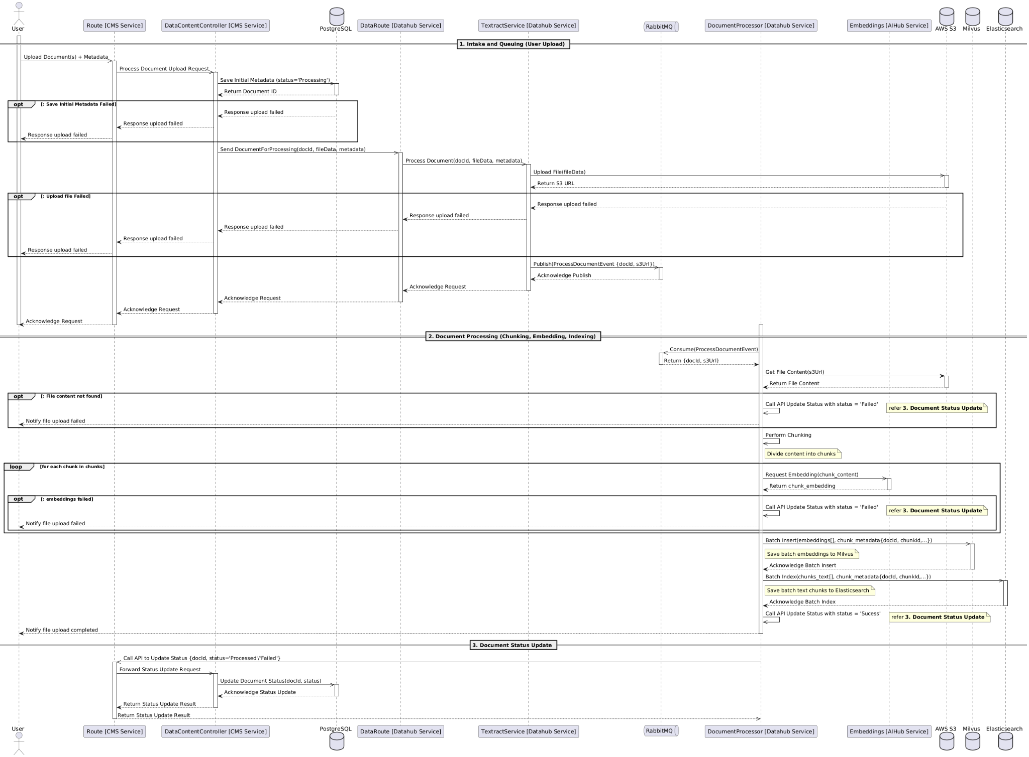

**Components**

1. Client – Initiates the file insertion process.
2. ChatBox App – Receives the file from the client and forwards it to the backend.
3. CMS Service – Handles the backend processing and communicates with other services.
4. CMS DB – Stores metadata related to the data source.
5. Data Hub – Manages data storage and retrieval, integrating with other components.
6. Queue – Manages asynchronous tasks by enqueueing file metadata.
7. AI Hub – Processes text extraction and embedding.
8. Vector Store – Stores vectorized representations of the extracted text.
9. Elastic Search – Enables full-text search capabilities.
10. Object Storage – Stores the actual file content.

**Process Flow**

1. Client Uploads File
   * The client submits a file to the CMS Service.
2. File Forwarding & Metadata Storage
   * The CMS Service creates a new data source entry in the DataSource DB.
   * The file is forwarded to the Data Hub.
3. Queue Processing
   * The Data Hub enqueues the file metadata into a message queue.
   * The system polls the queue for new file metadata.
4. File Retrieval & Text Extraction
   * The system requests the file from Object Storage.
   * Upon retrieval, text is extracted from the file.
5. Embedding & Storage
   * The AI Hub processes the extracted text and generates vector embeddings.
   * The vector embeddings and raw text are stored in the Vector Store.
   * The raw text is stored in Elastic Search for full-text search.
6. Completion & Status Update
   * The system updates the status in the Data Hub and DataSource DB.
   * The CMS Service receives the updated status and informs the ChatBox App.
   * The ChatBox App notifies the client of the file insertion status.

#### 3.1.3 Test Bot

##### **a, Class Diagram**

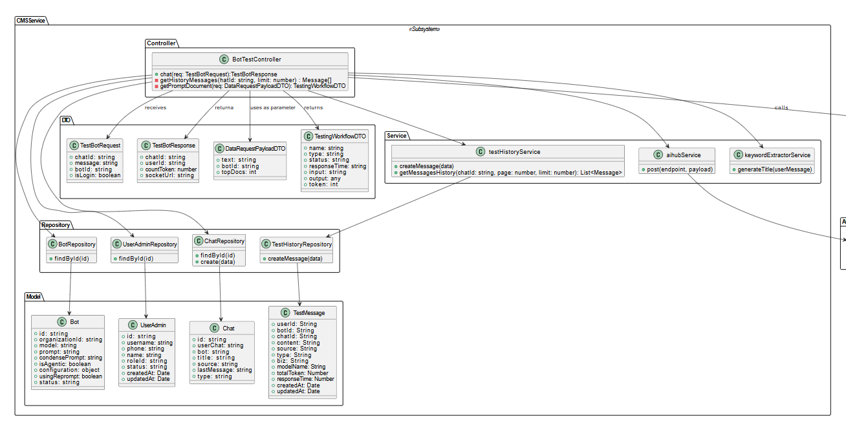

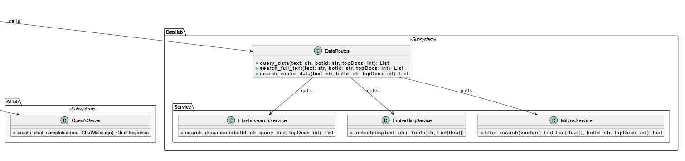

##### **b, Sequence Diagram**

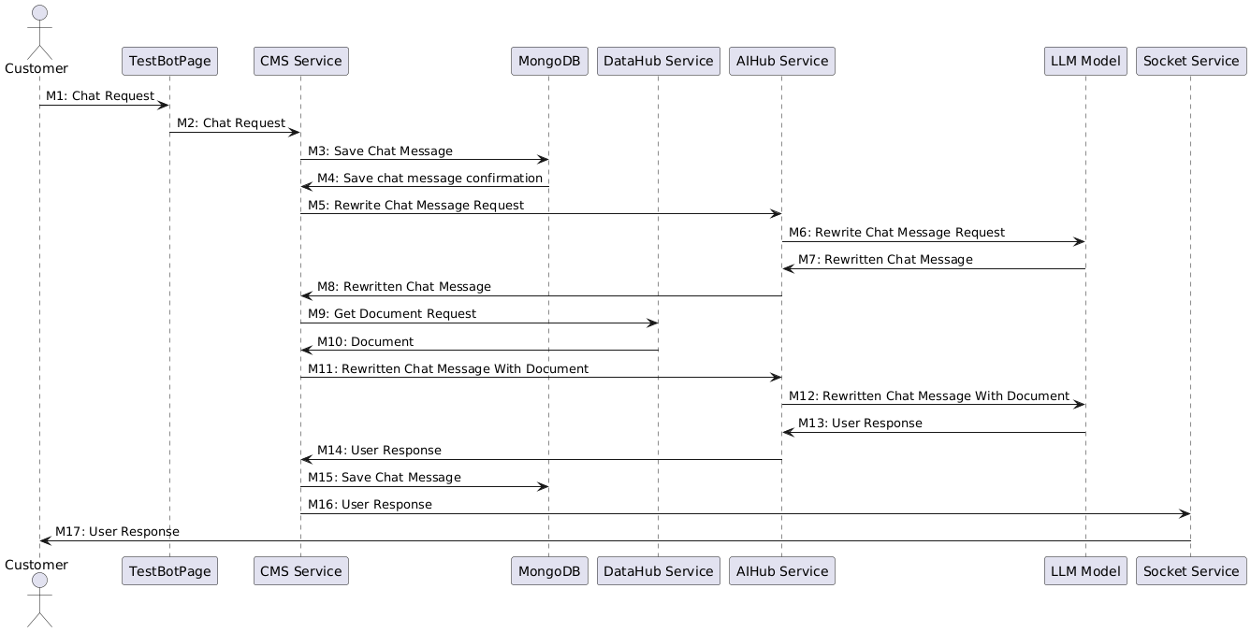

### 3.2 Common Feature

#### 3.2.1 Login

##### **3.2.1.1 Login**

###### **a, Class Diagram**

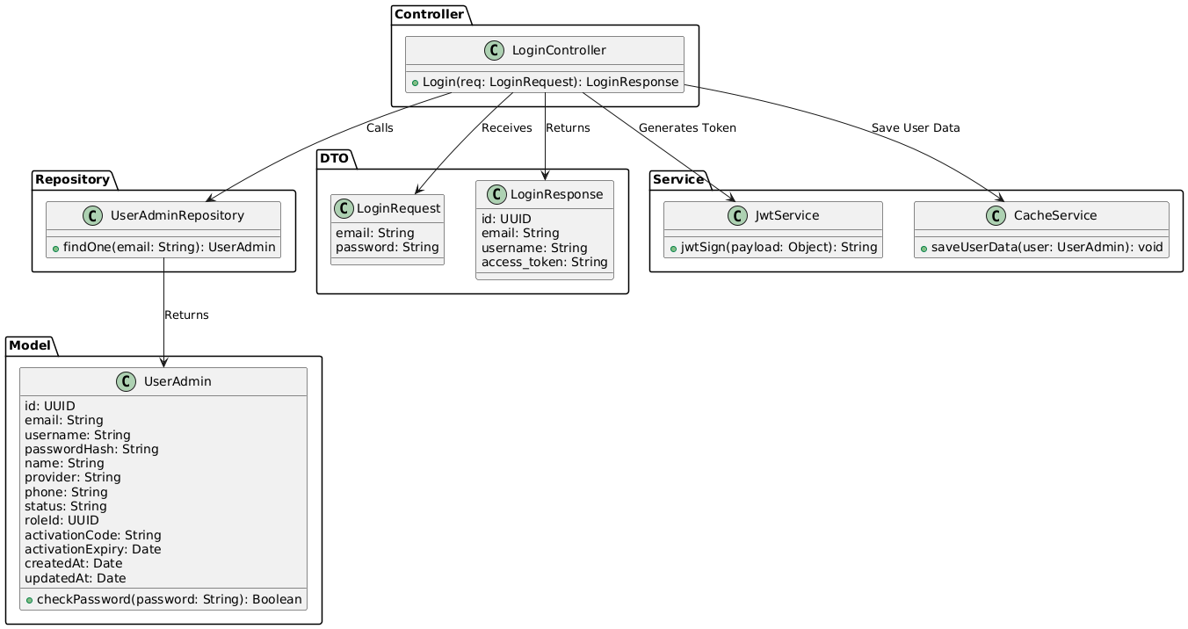

###### **b, Sequence Diagram**

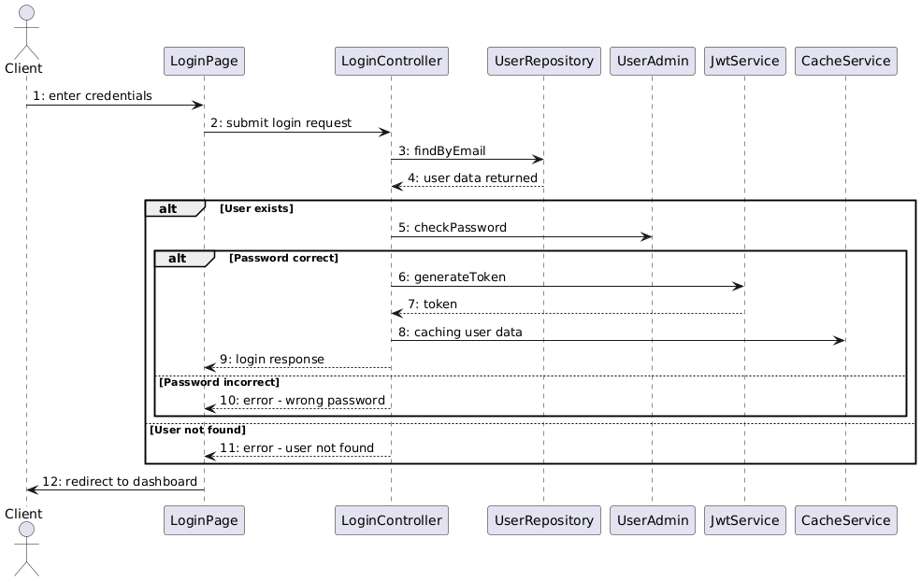

##### **3.2.1.2 Login With Google**

###### **a, Class Diagram**

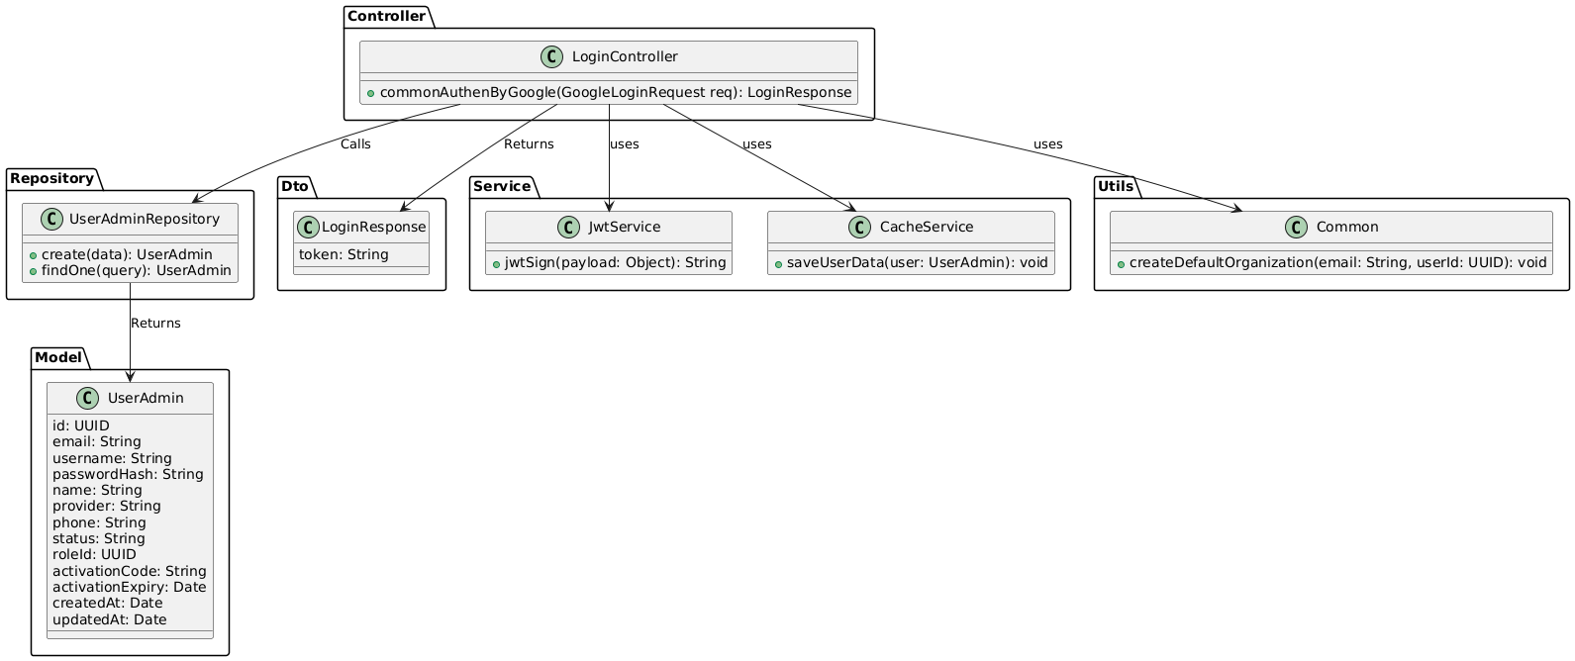

###### **b, Sequence Diagram**

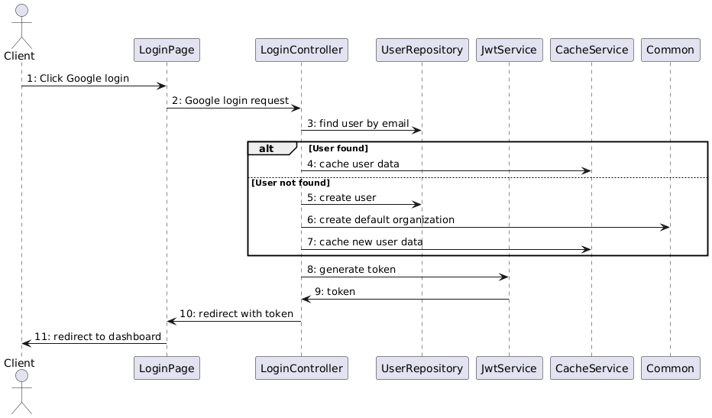

#### 3.2.2 Register

##### **a, Class Diagram**

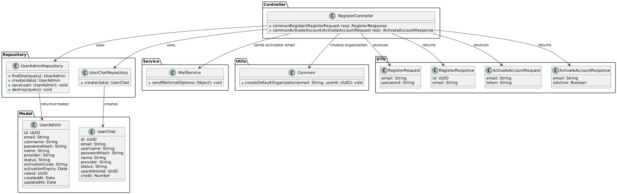

##### **b, Sequence Diagram**

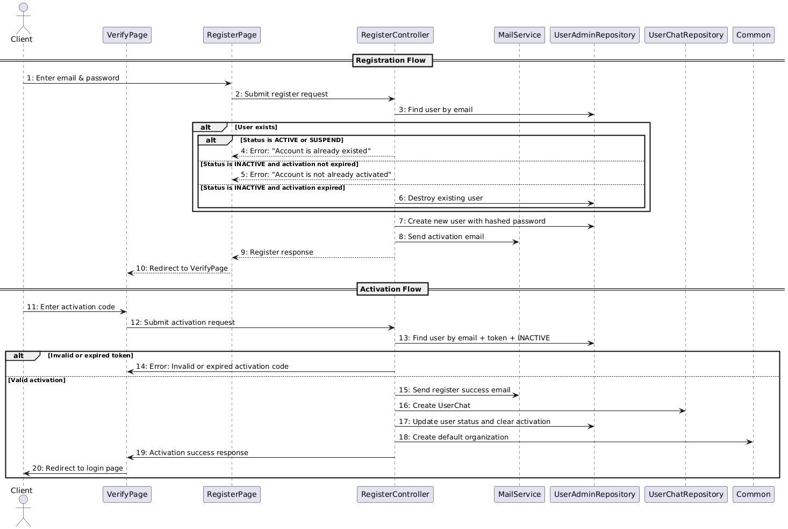

#### 3.2.2 Change Password

##### **a, Class Diagram**

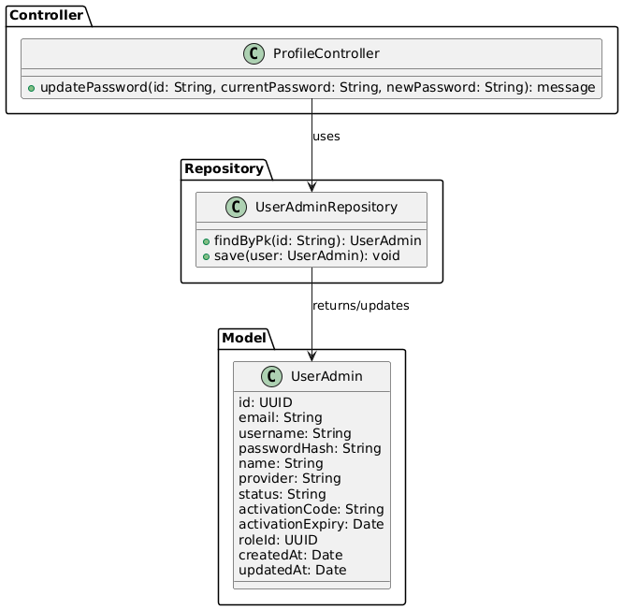

##### **b, Sequence Diagram**

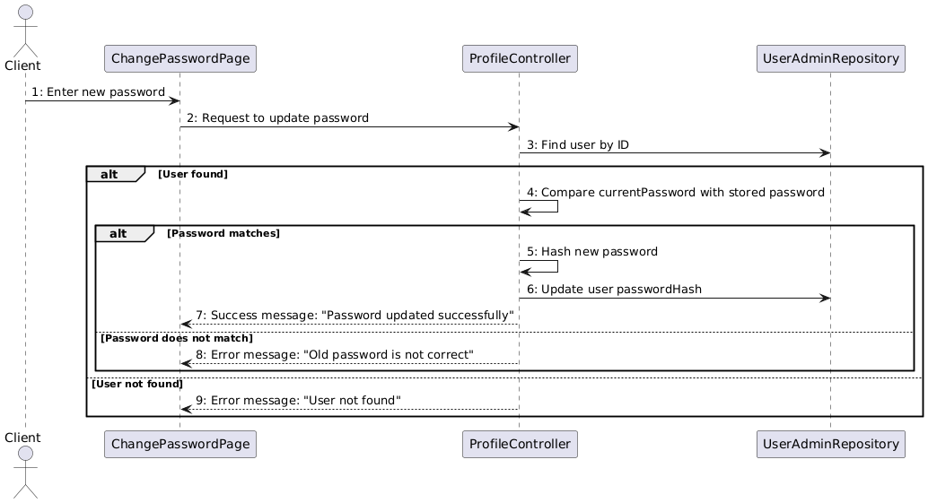

#### 3.2.3 Reset Password

##### **a, Class Diagram**

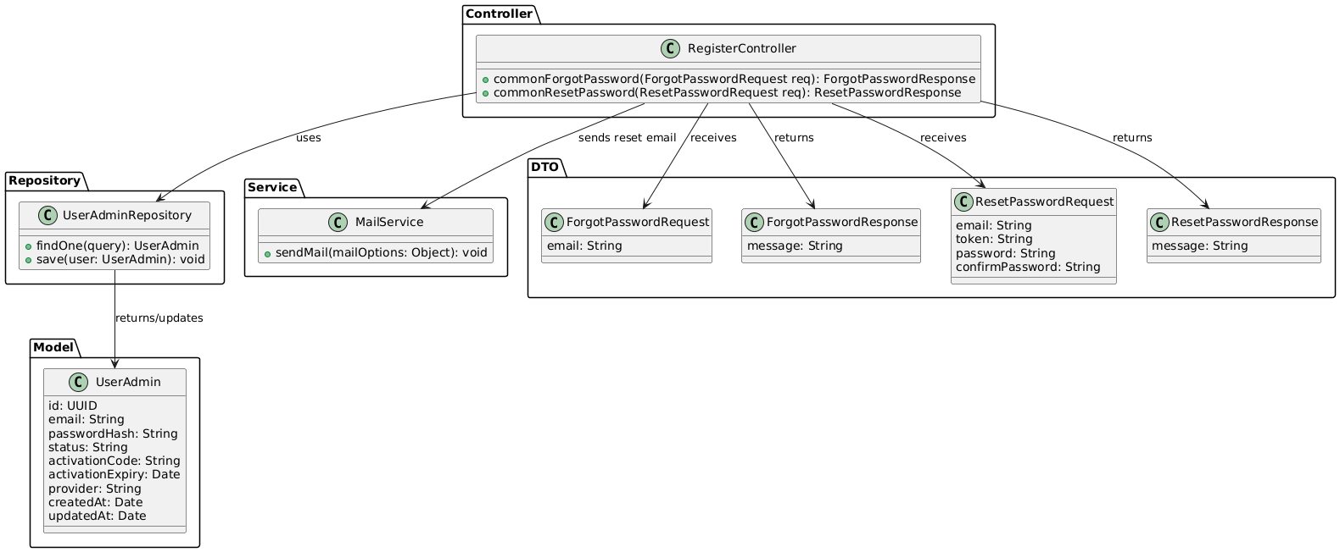

##### **b, Sequence Diagram**

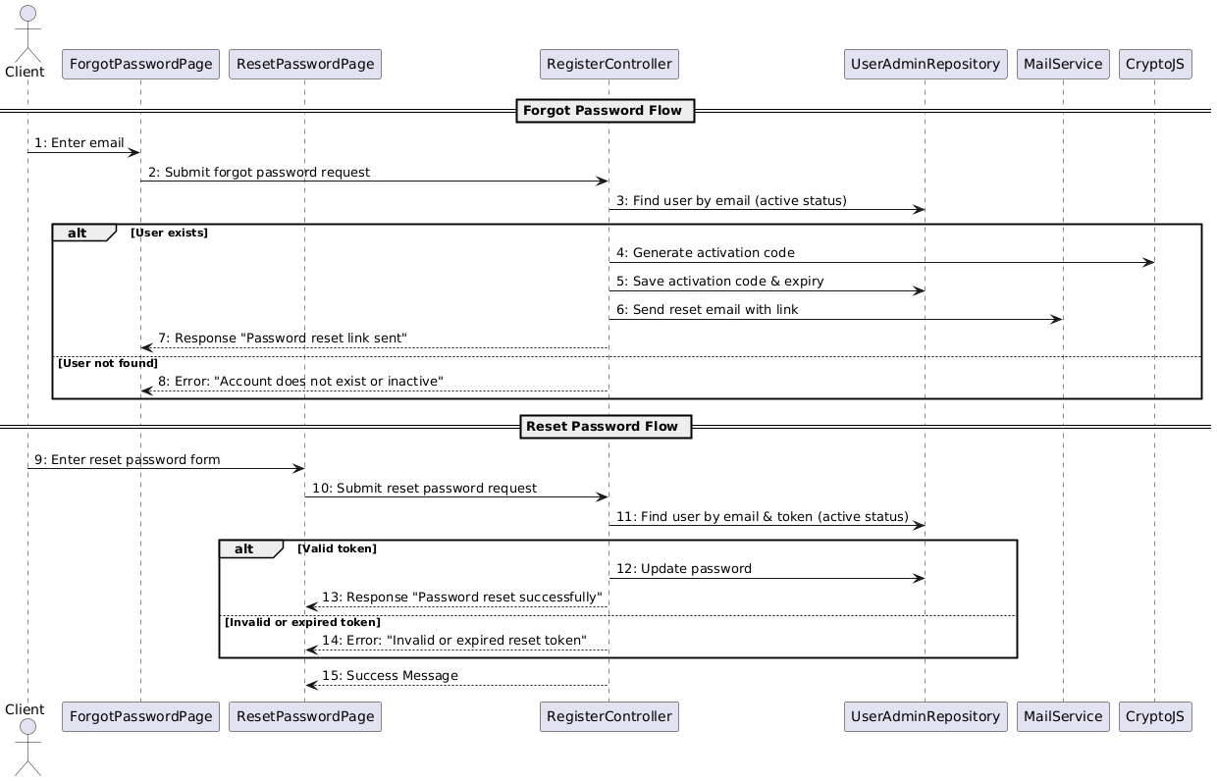

#### 3.2.4 Logout

##### **a, Class Diagram**

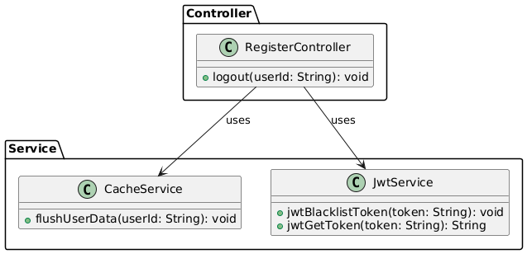

##### **b, Sequence Diagram**

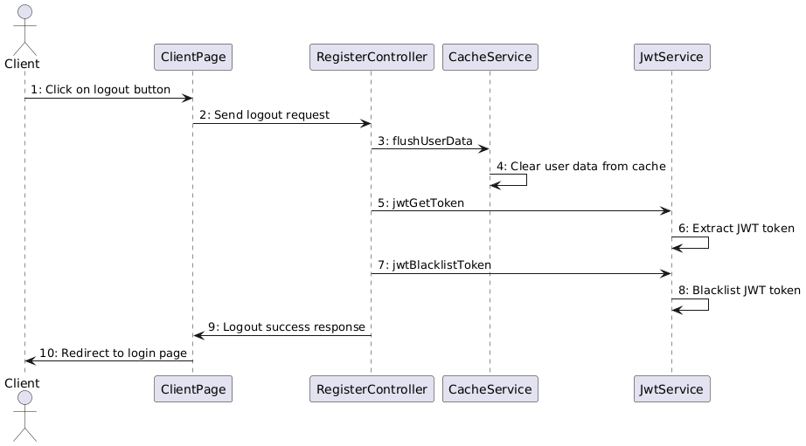

#### 3.2.5 Edit Profile

##### **a, Class Diagram**

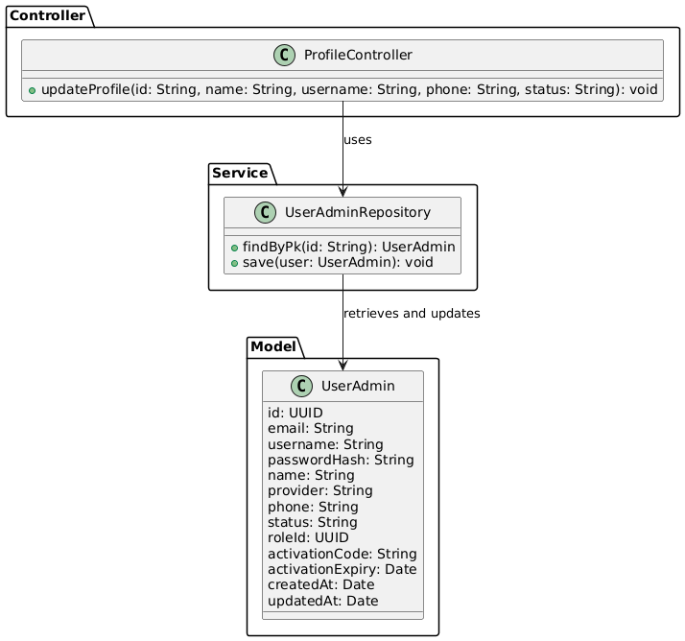

##### **b, Sequence Diagram**

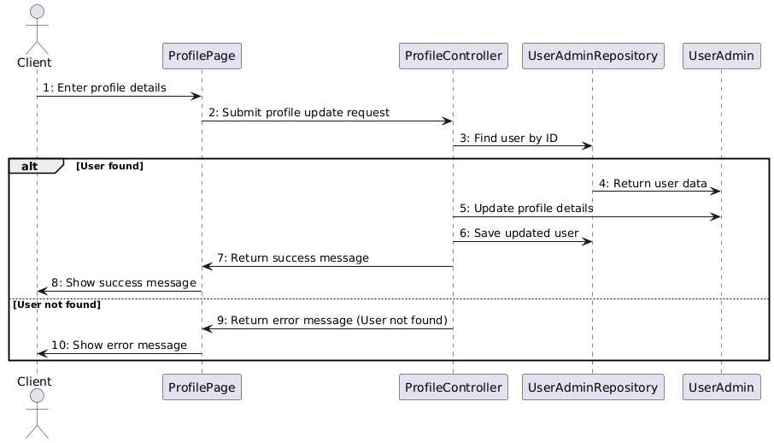

### 3.3 Business Staff Feature

#### 3.3.1 View bot list

##### **a, Class Diagram**

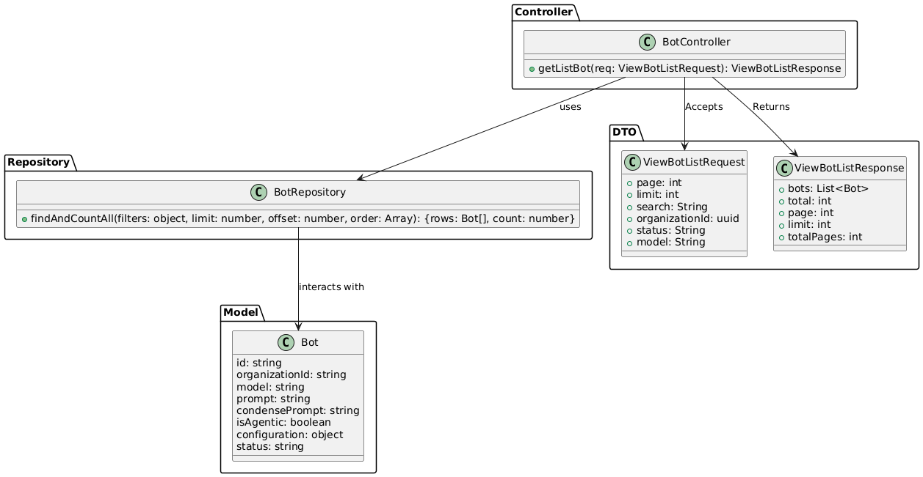

##### **b, Sequence Diagram**

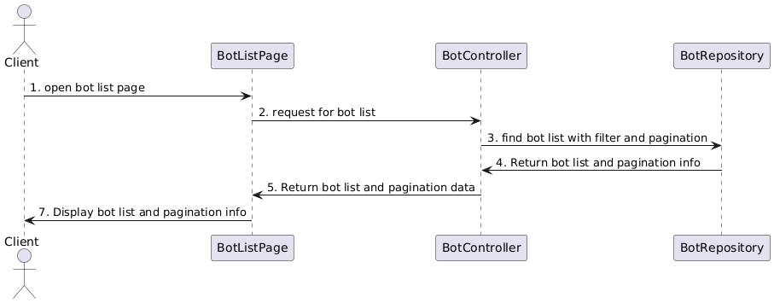

#### 3.3.2 Add New Bot

##### **a, Class Diagram**

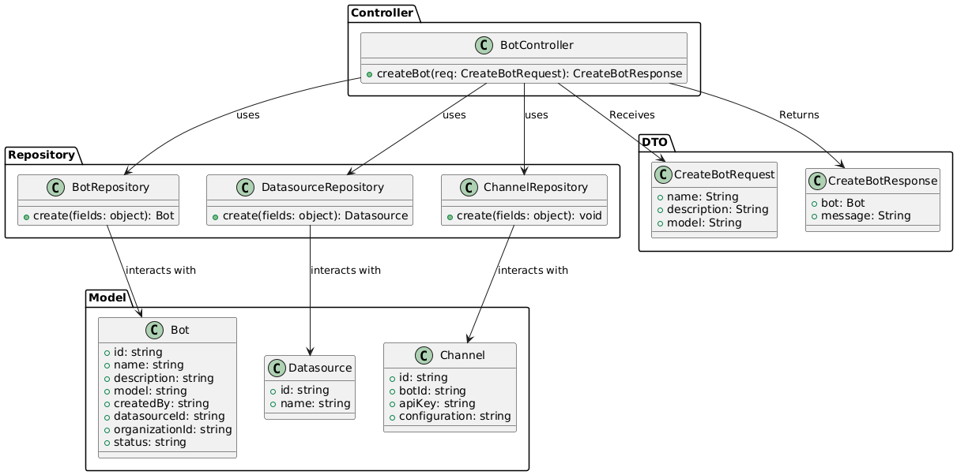

##### **b, Sequence Diagram**

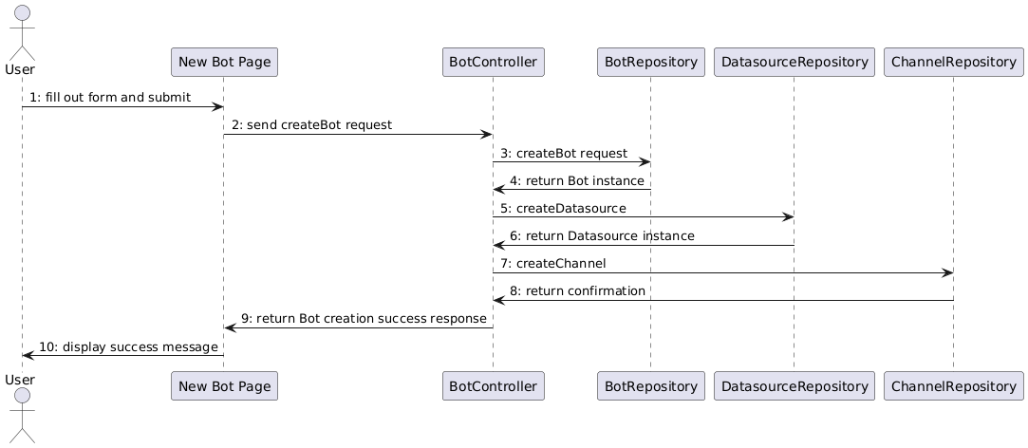

#### 3.3.3 Update Bot Details

##### **a, Class Diagram**

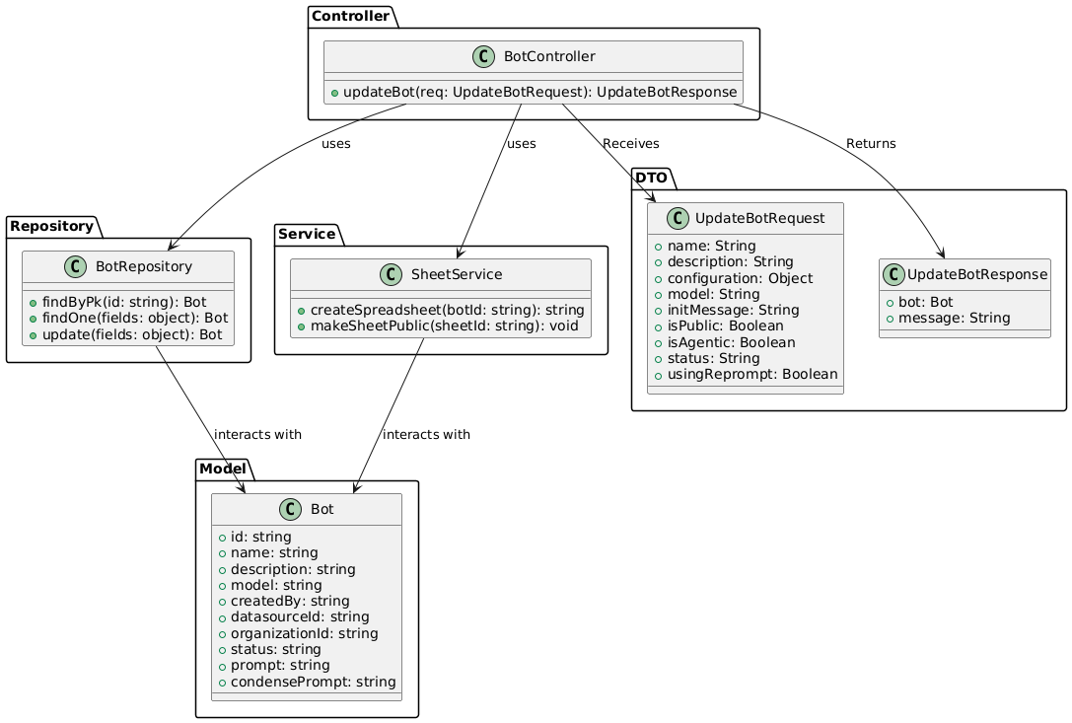

##### **b, Sequence Diagram**

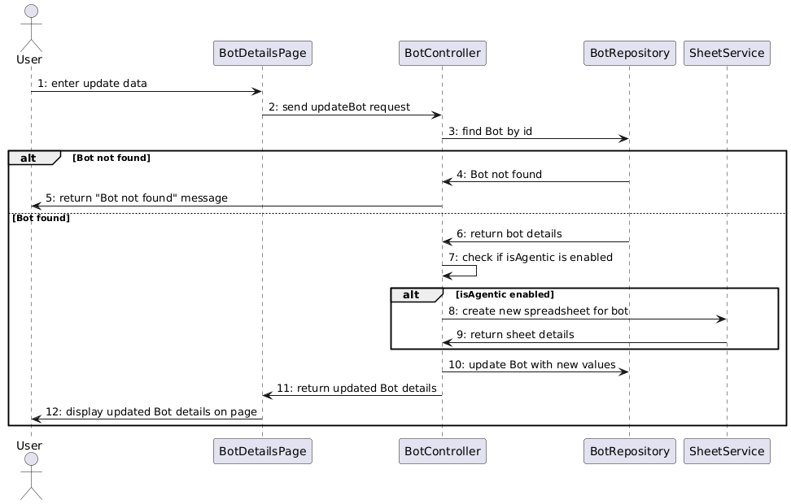

#### 3.3.4 View Data Source List

##### **a, Class Diagram**

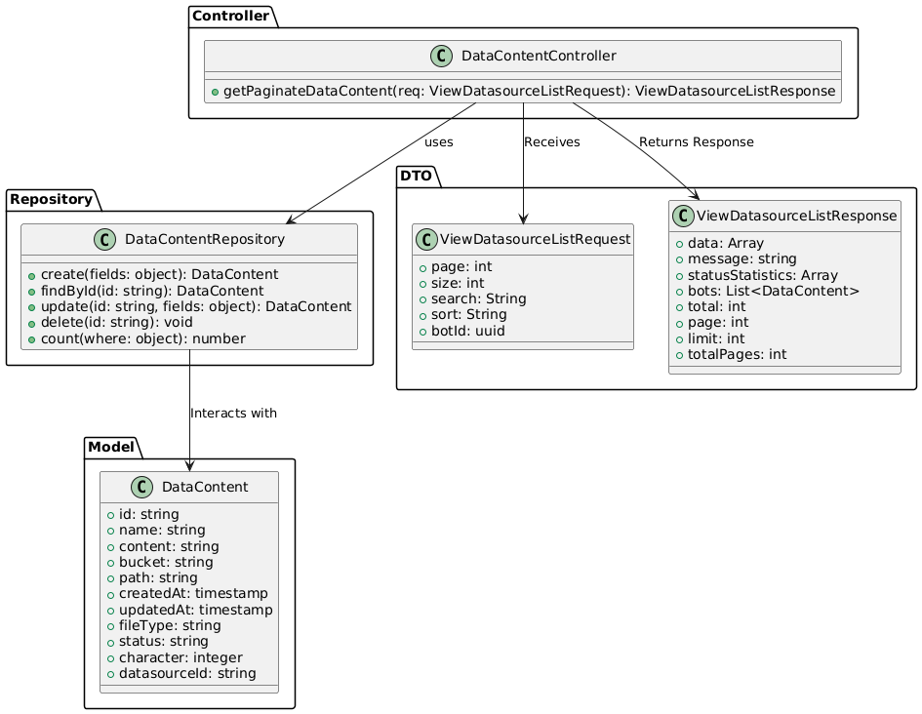

##### **b, Sequence Diagram**

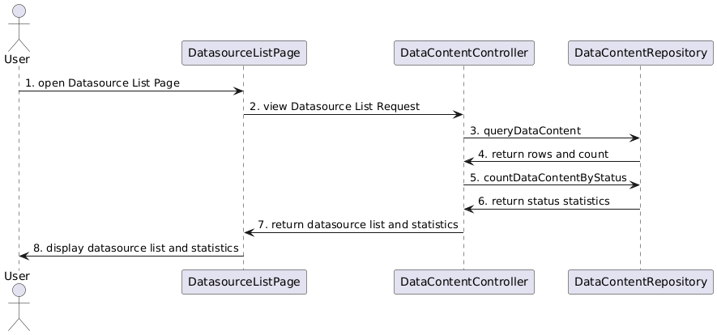

##### 

#### 3.3.5 View Data Source Details

##### **a, Class Diagram**

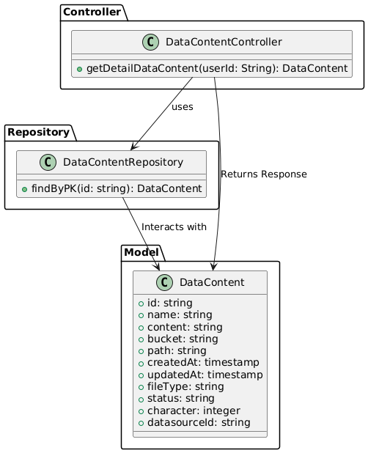

##### **b, Sequence Diagram**

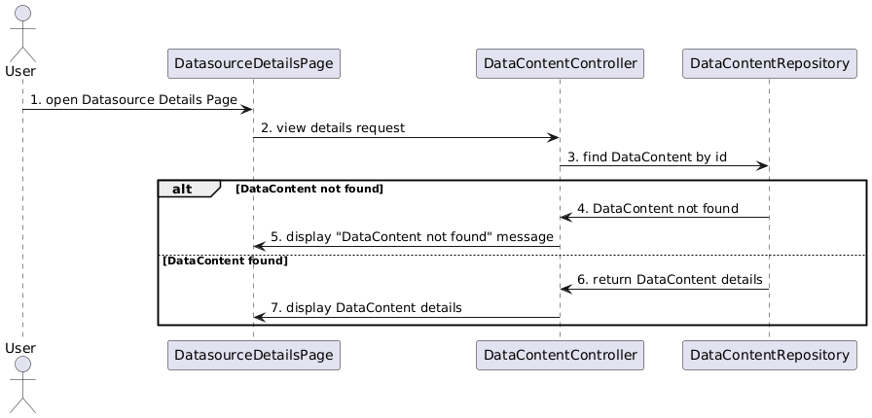

#### 3.3.6 Delete Data Source

##### **a, Class Diagram**

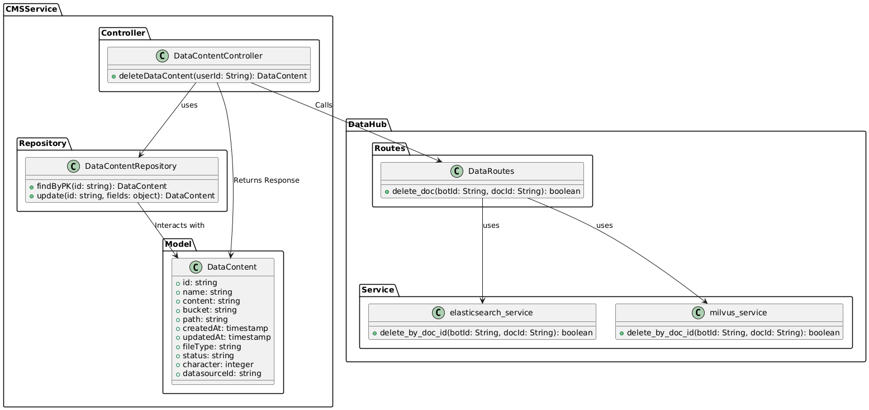

##### **b, Sequence Diagram**

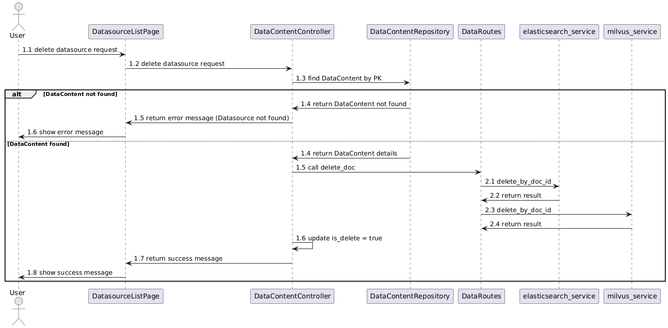

#### 3.3.7 View Test History

##### **a, Class Diagram**

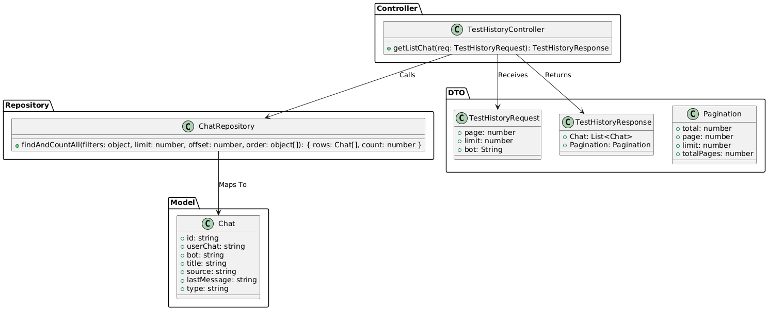

##### **b, Sequence Diagram**

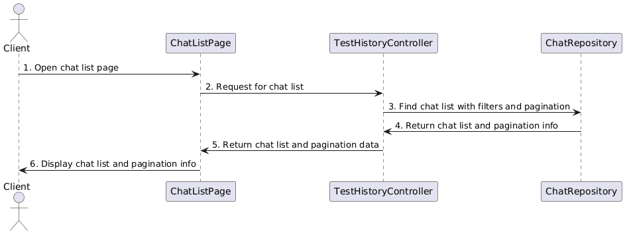

#### 3.3.8 View Evaluation History

##### **a, Class Diagram**

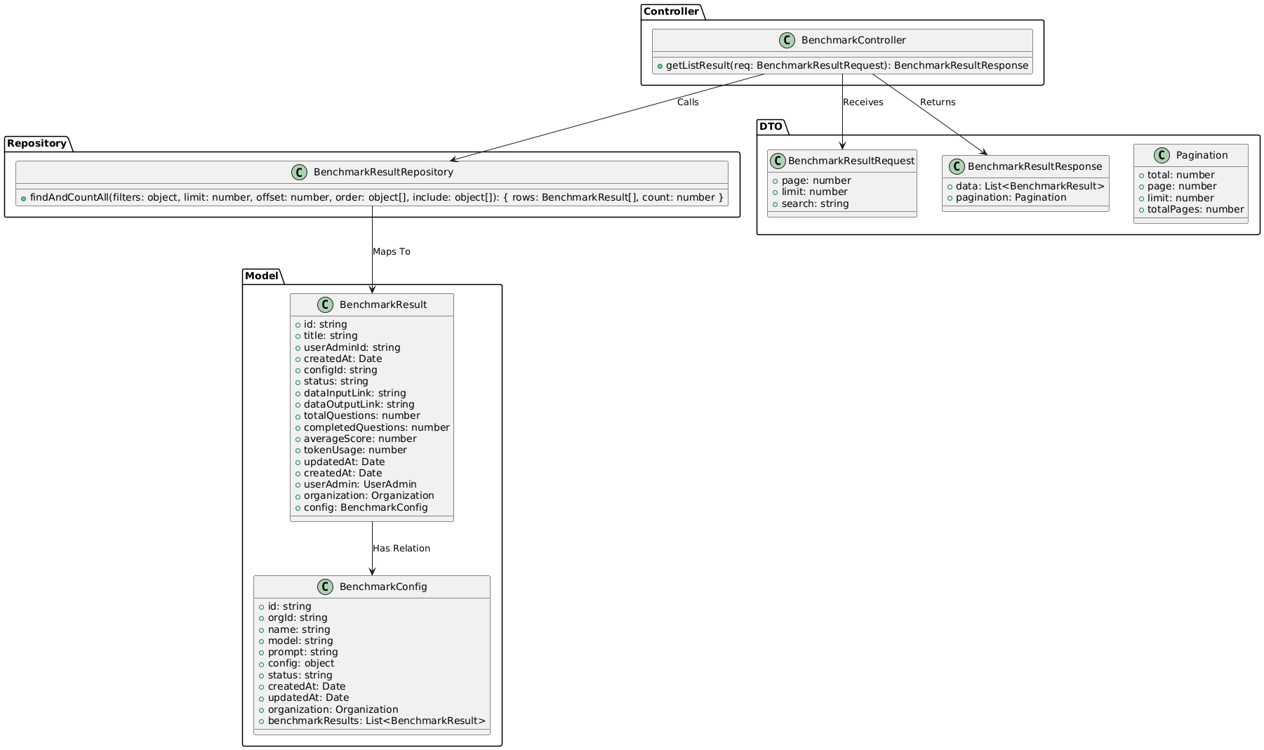

##### **b, Sequence Diagram**

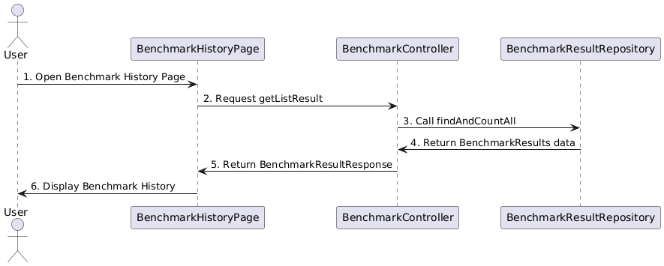

#### 3.3.9 View Evaluation Details

##### **a, Class Diagram**

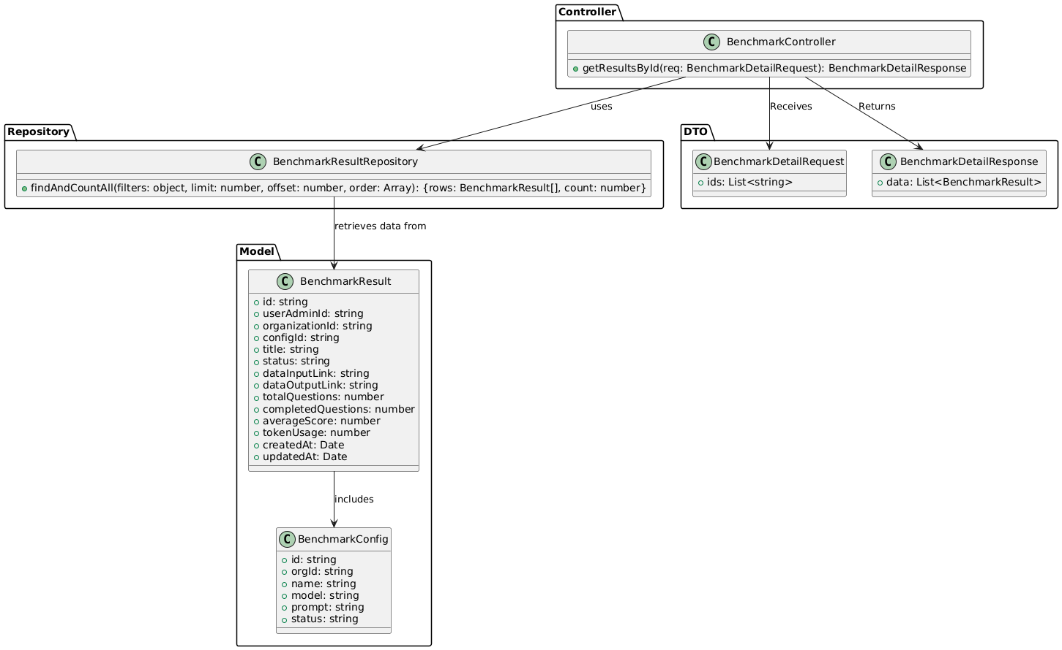

##### **b, Sequence Diagram**

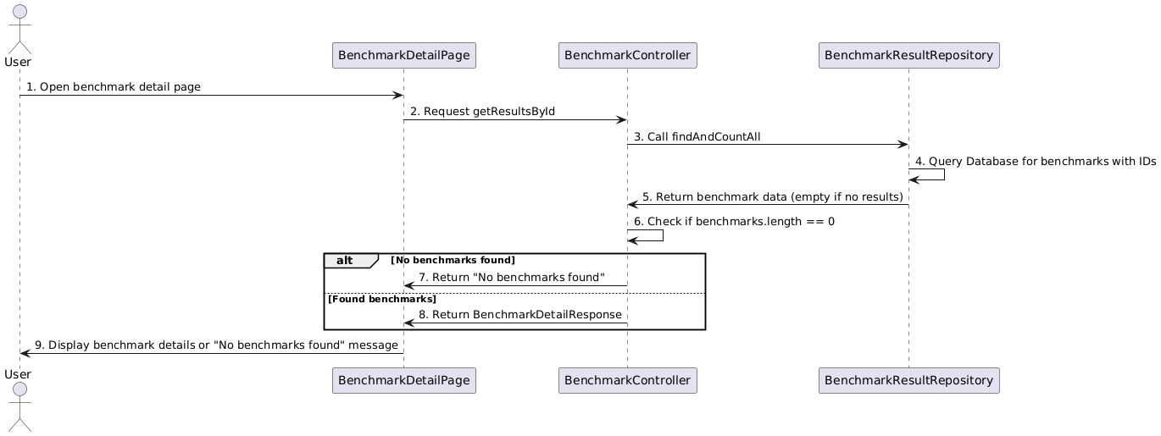

### 3.4 Business Owner Feature

#### 3.4.1 View Organization List

##### **a, Class Diagram**

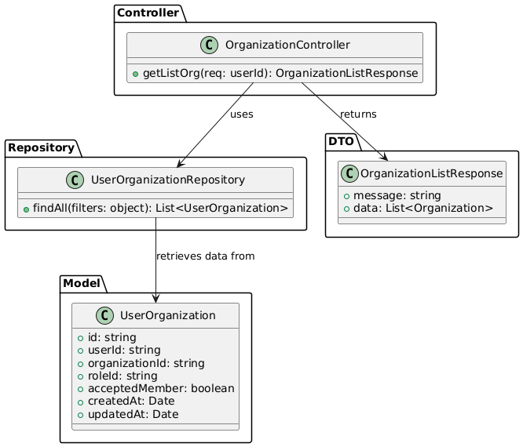

##### **b, Sequence Diagram**

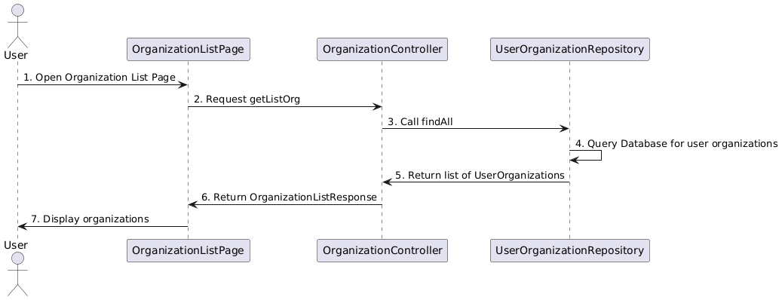

#### 3.4.2 Add New Organization

##### **a, Class Diagram**

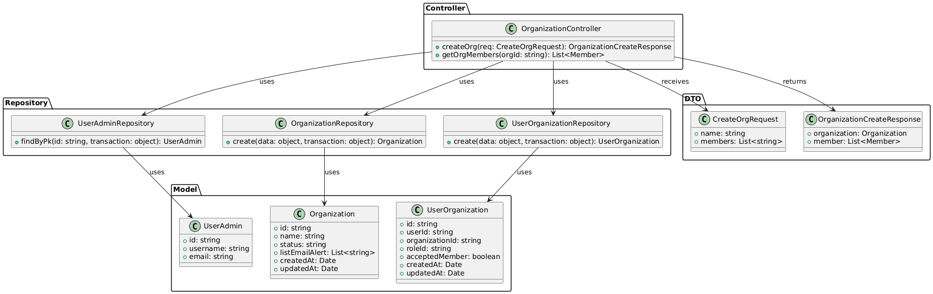

##### **b, Sequence Diagram**

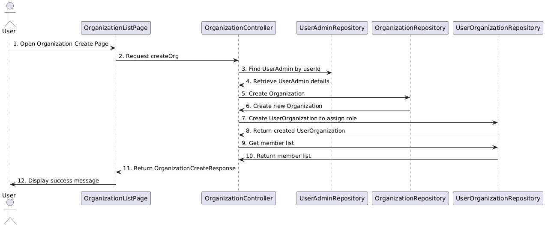

#### 3.4.3 Update Organization Details

##### **a, Class Diagram**

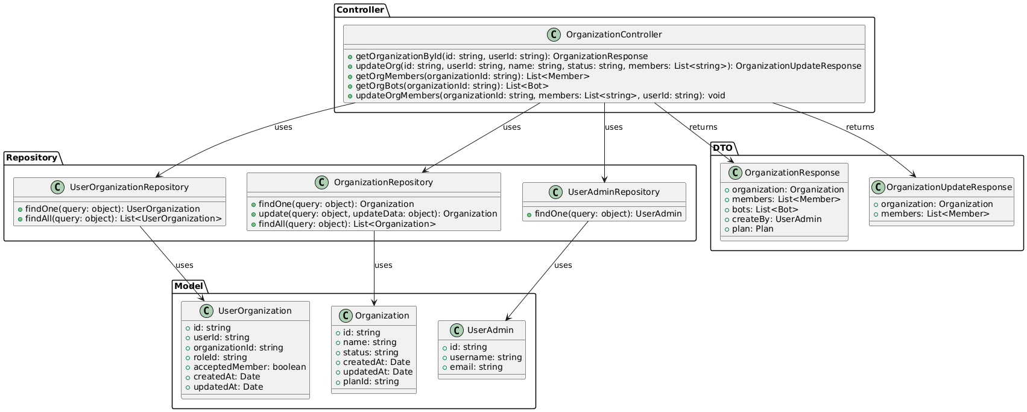

##### **b, Sequence Diagram**

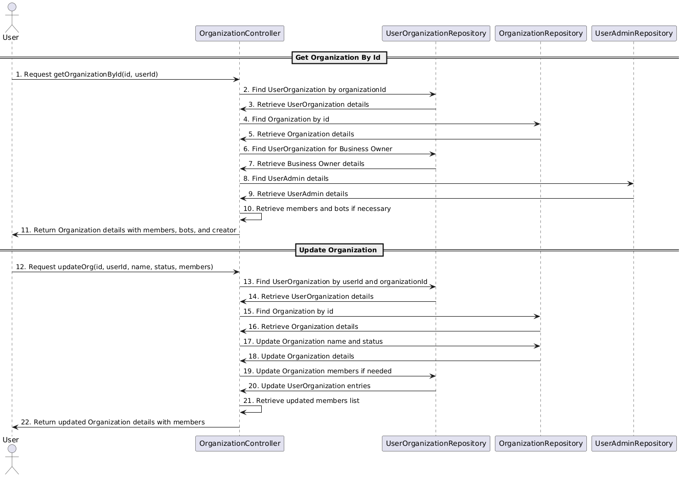

#### 3.4.4 View Member List

##### **a, Class Diagram**

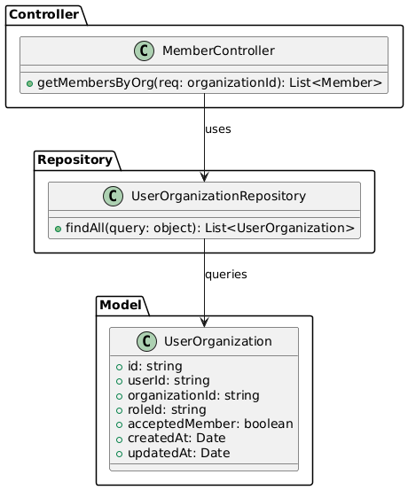

##### **b, Sequence Diagram**

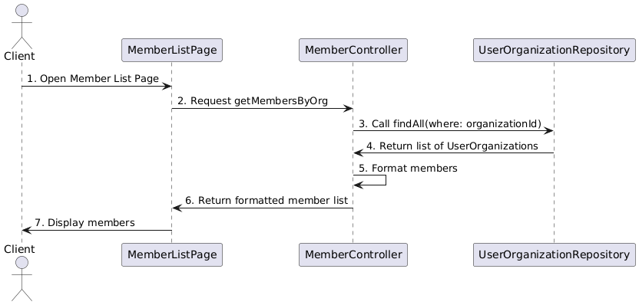

#### 3.4.5 Add New Member

##### **a, Class Diagram**

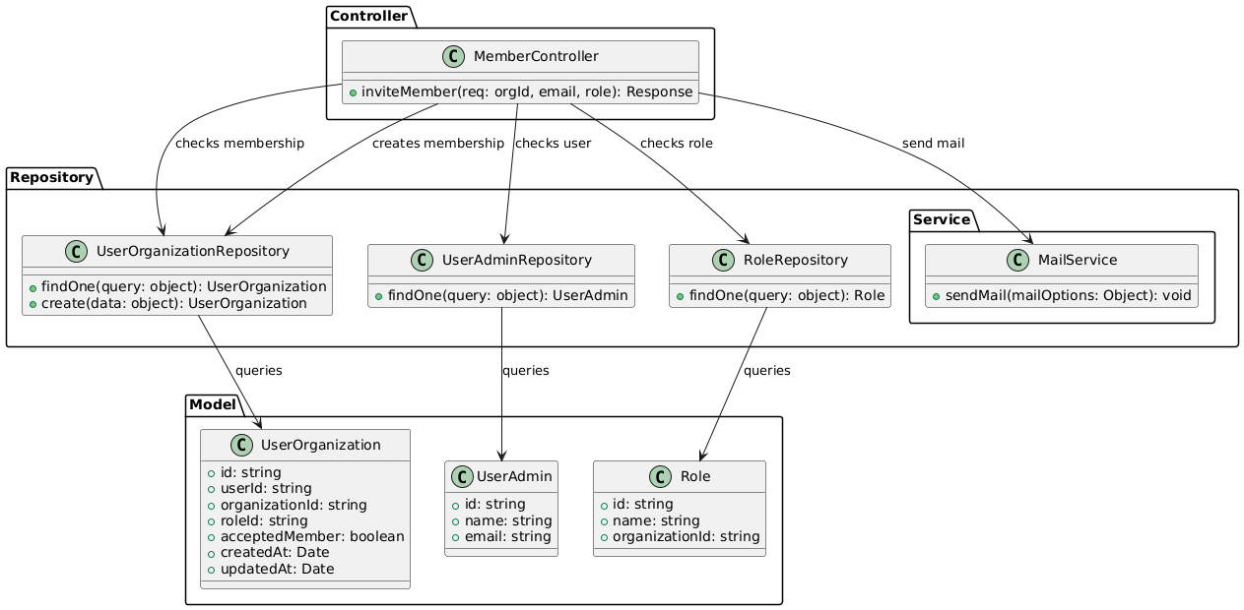

##### **b, Sequence Diagram**

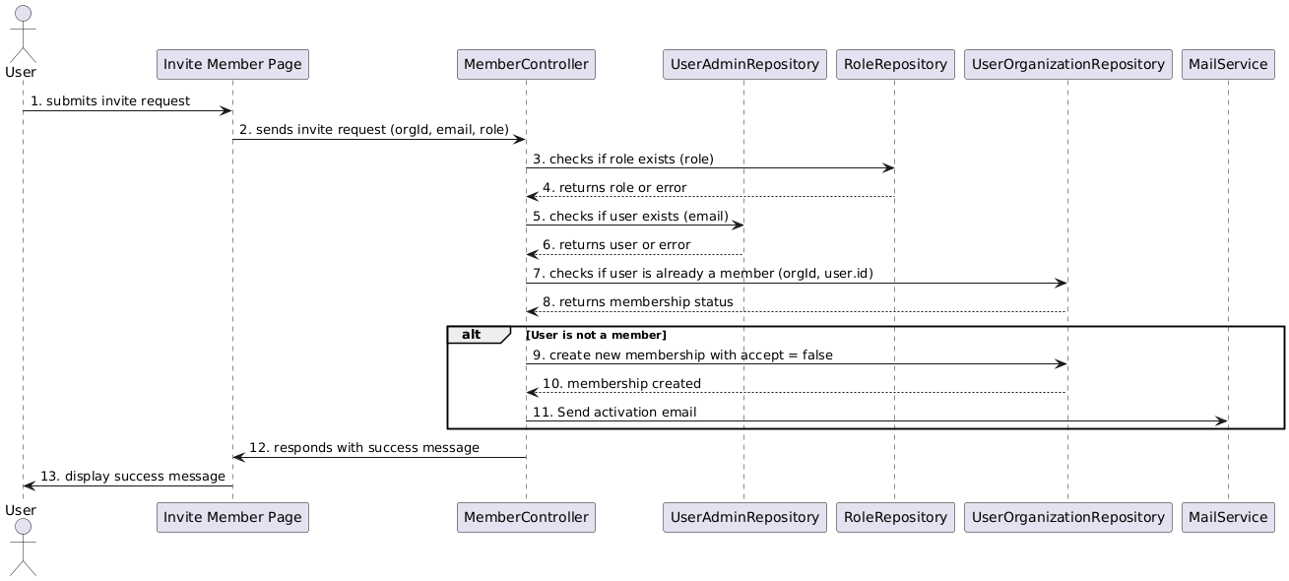

#### 3.4.6 Delete Member

##### **a, Class Diagram**

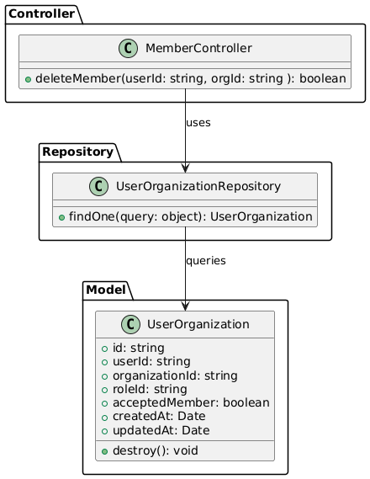

##### **b, Sequence Diagram**

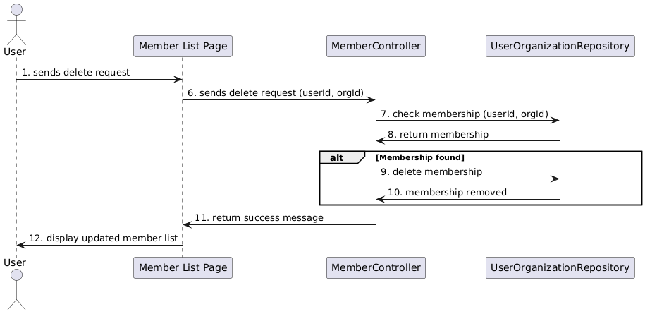

#### 3.4.7 View Role List

##### **a, Class Diagram**

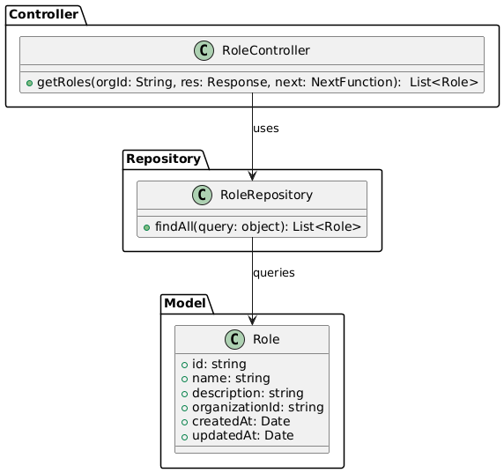

##### **b, Sequence Diagram**

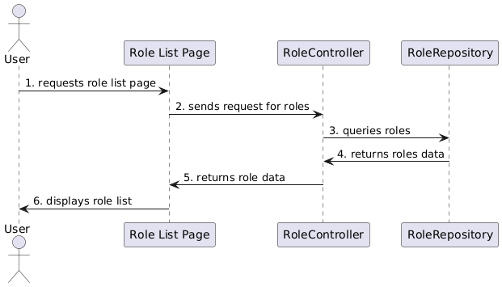

#### 3.4.8 Add New Role

##### **a, Class Diagram**

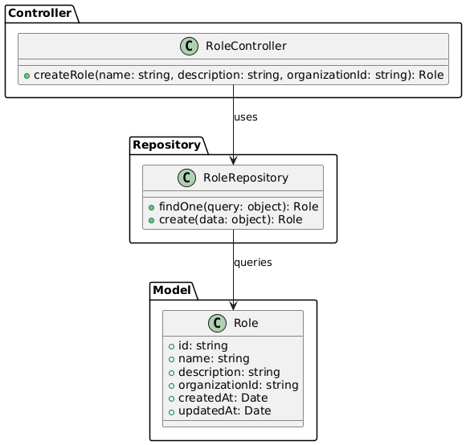

##### **b, Sequence Diagram**

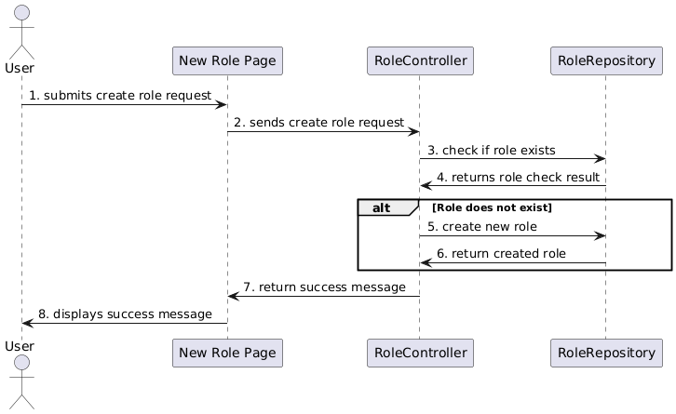

#### 3.4.9 Update Role Details

##### **a, Class Diagram**

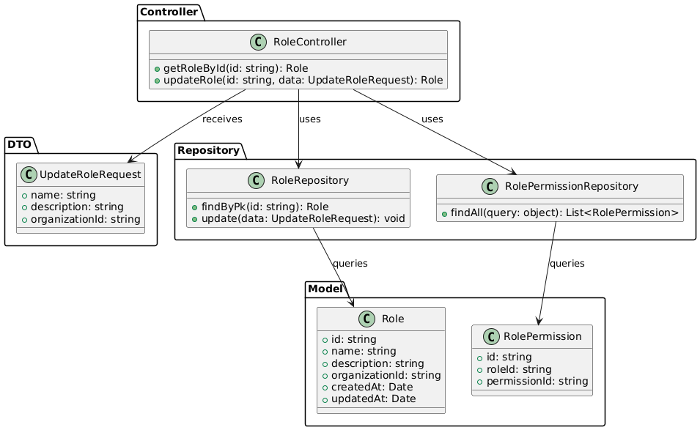

##### **b, Sequence Diagram**

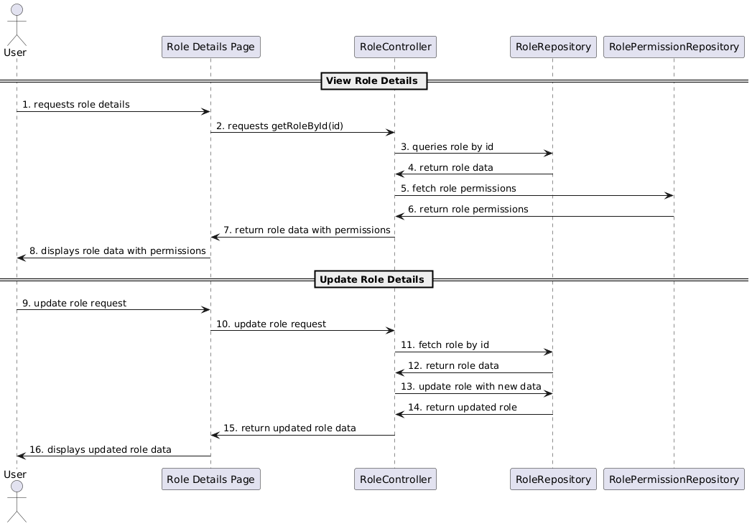

#### 3.4.10 Upgrade Plan

##### **a, Class Diagram**

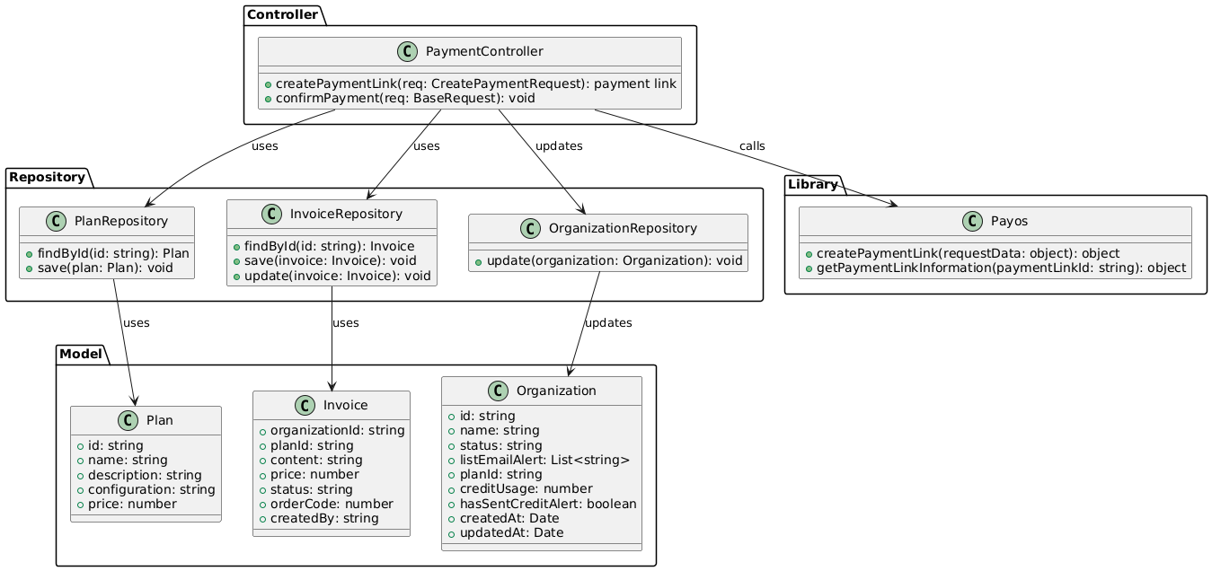

##### **b, Sequence Diagram**

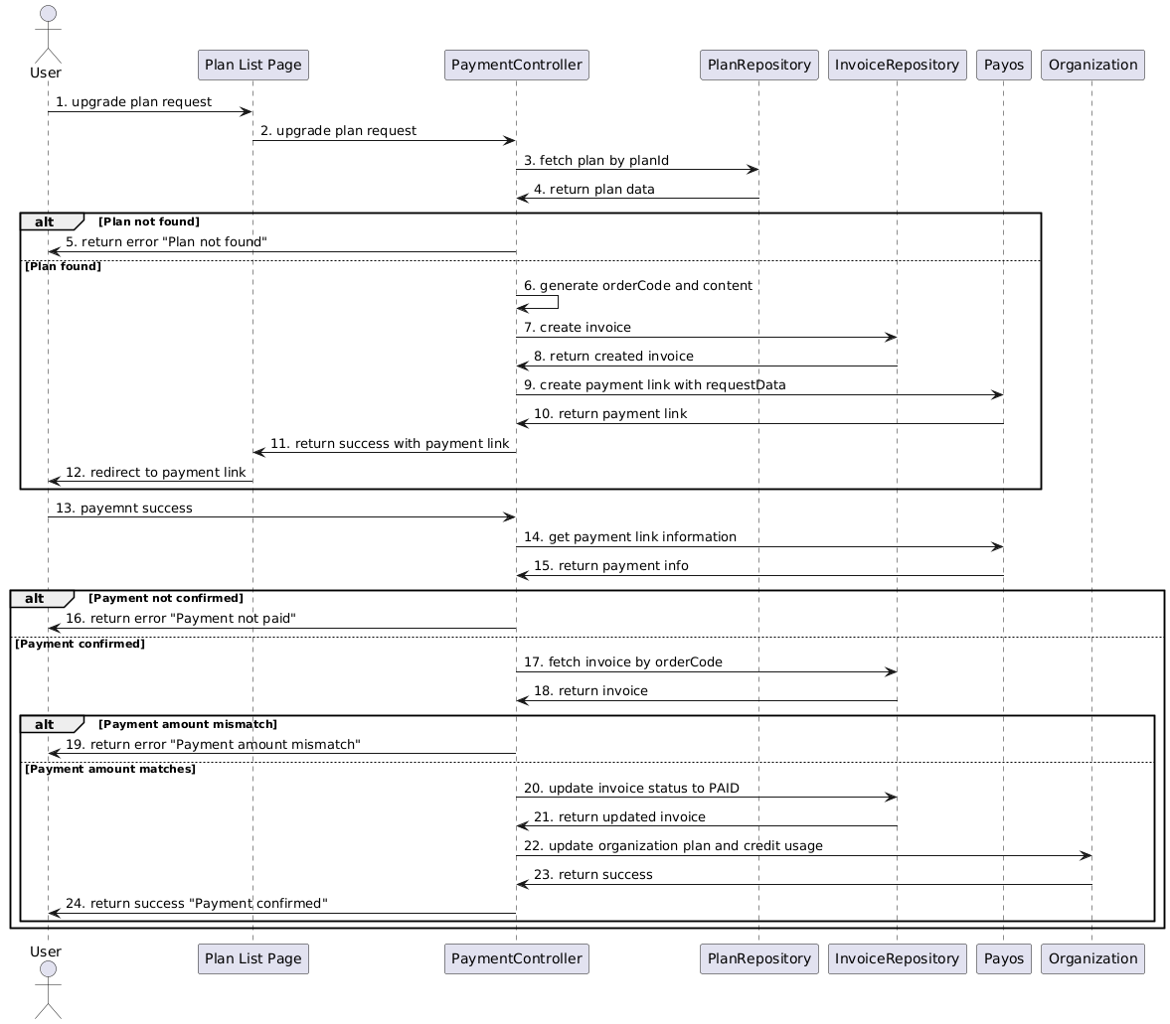

#### 3.4.11 Setup Credit Alerts

##### **a, Class Diagram**

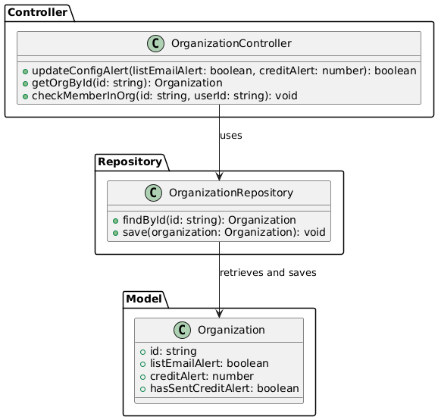

##### **b, Sequence Diagram**

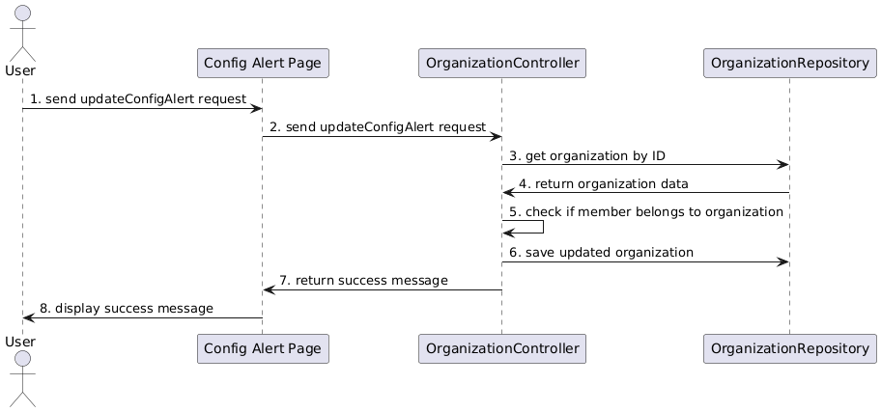

### 3.5 Admin Staff Feature

#### 3.5.1 View Model List

##### **a, Class Diagram**

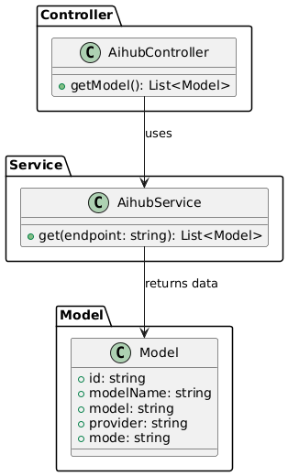

##### **b, Sequence Diagram**

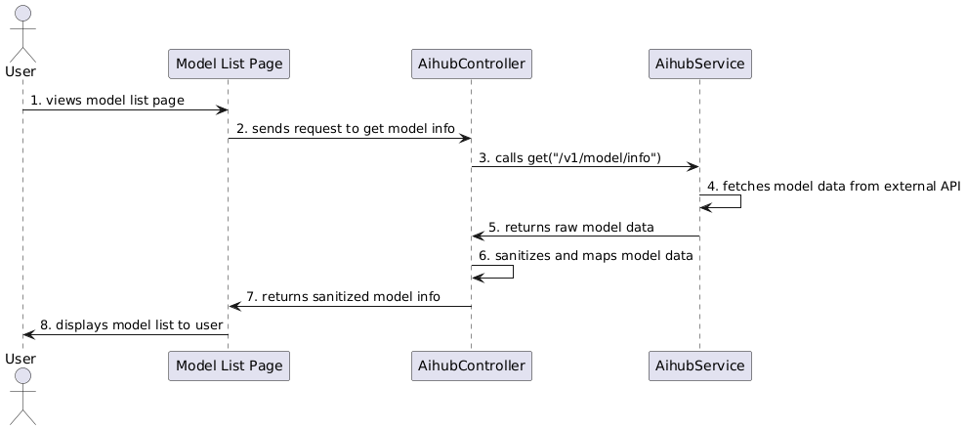

#### 3.5.2 View Invoice List

##### **a, Class Diagram**

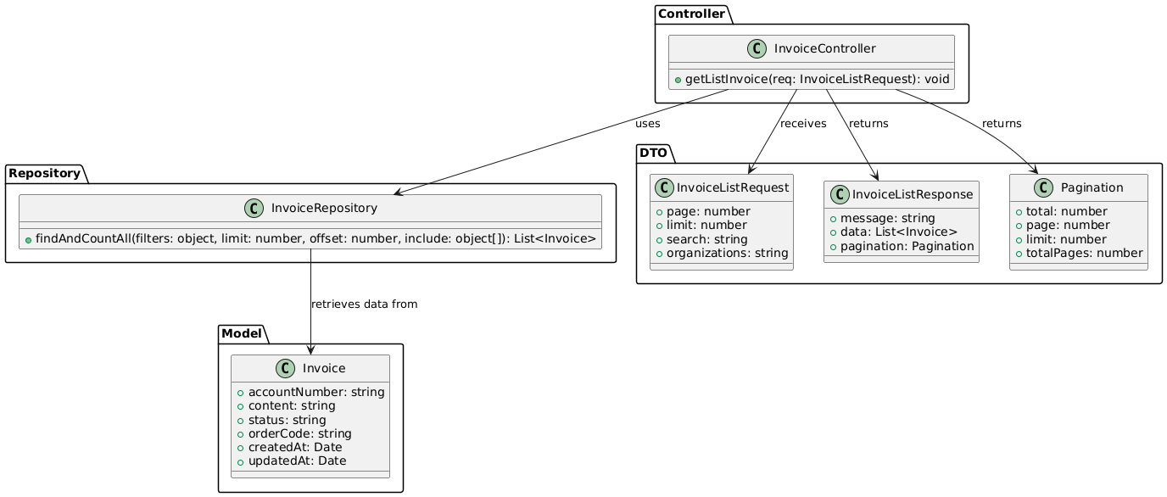

##### **b, Sequence Diagram**

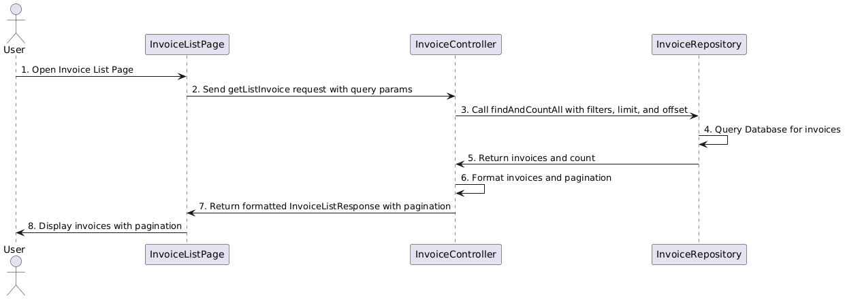

#### 3.5.3 Add New Invoice

##### **a, Class Diagram**

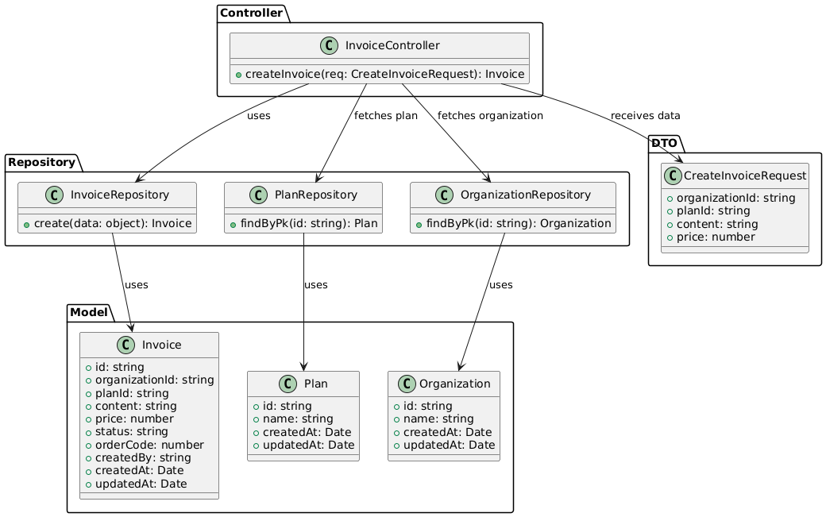

##### **b, Sequence Diagram**

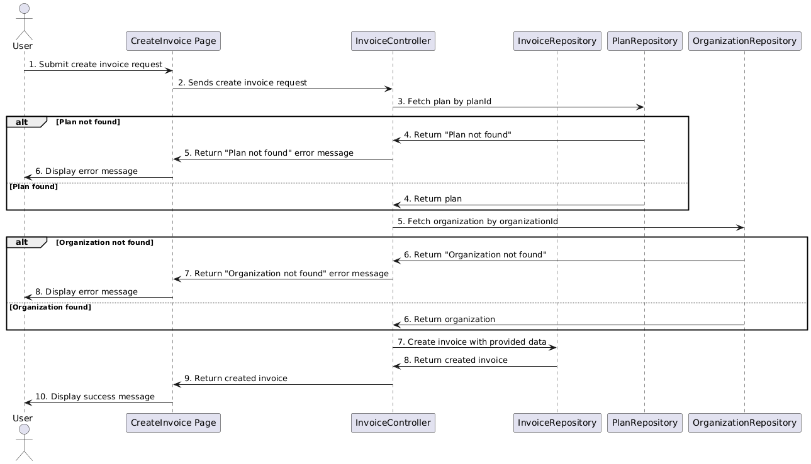

#### 3.5.4 Update Invoice Details

##### **a, Class Diagram**

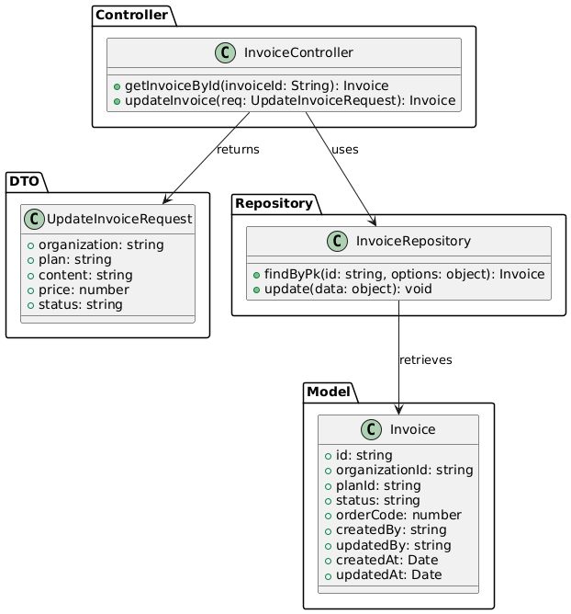

##### **b, Sequence Diagram**

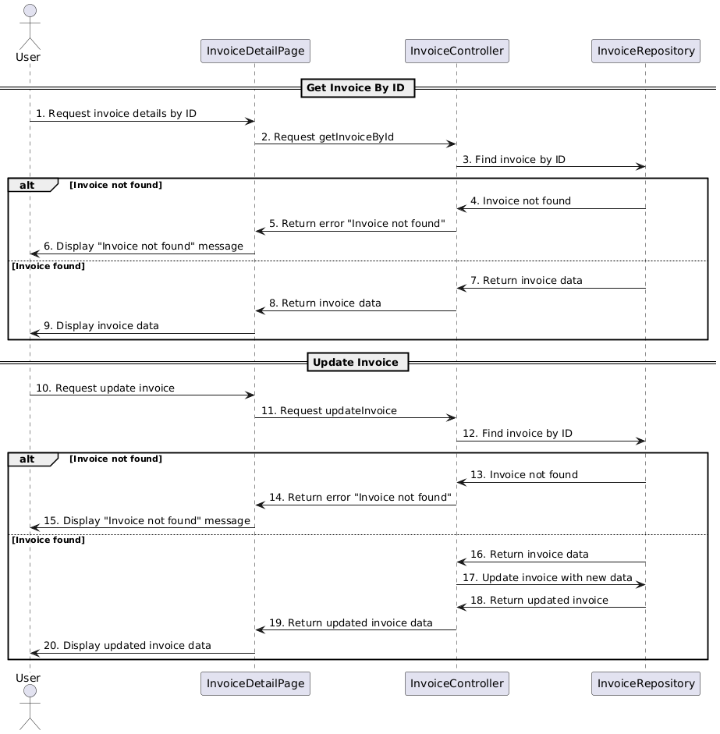

### 3.6 Admin Feature

#### 3.6.1 View User List

##### **a, Class Diagram**

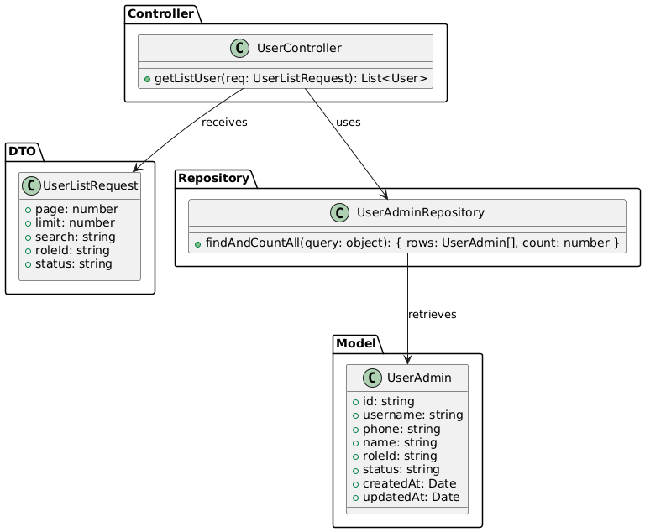

##### **b, Sequence Diagram**

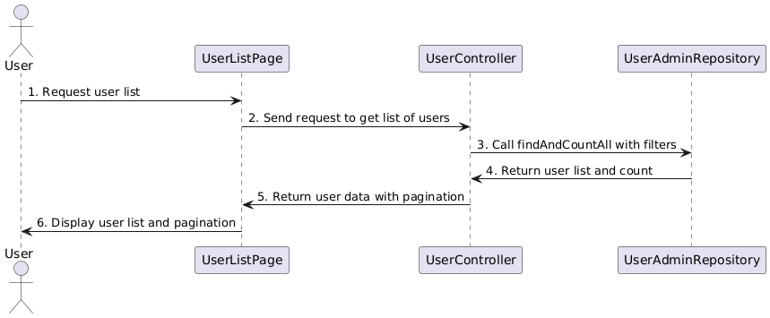

#### 3.6.2 Add New User

##### **a, Class Diagram**

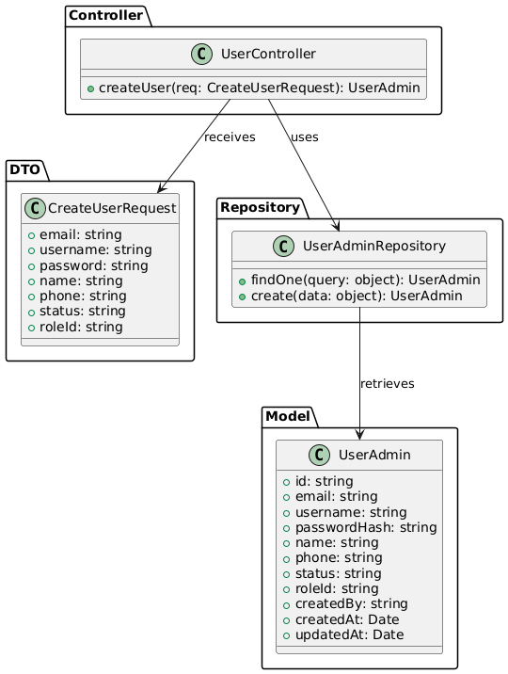

##### **b, Sequence Diagram**

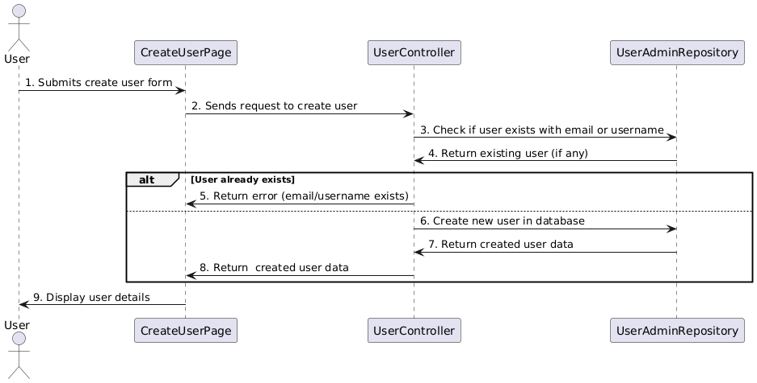

#### 3.6.3 Update User Details

##### **a, Class Diagram**

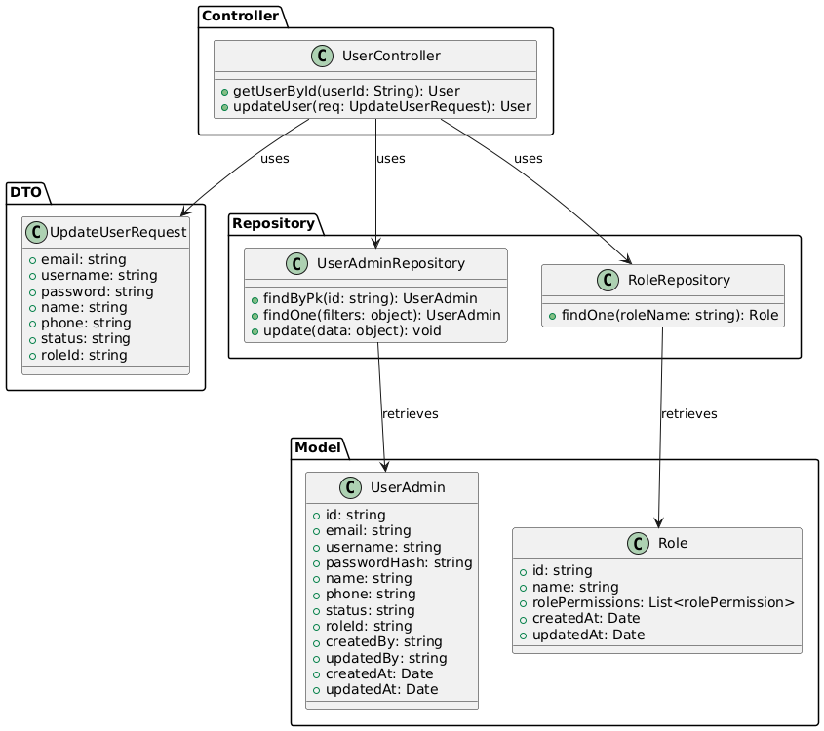

##### **b, Sequence Diagram**

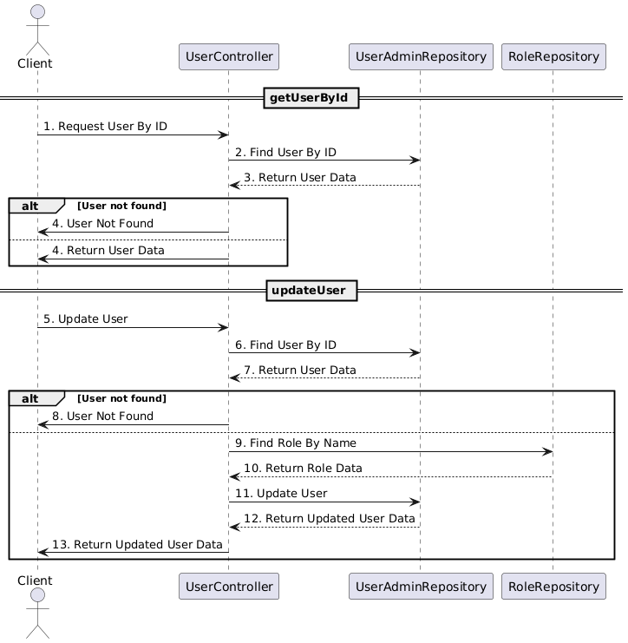

#### 3.6.4 View Plan List

##### **a, Class Diagram**

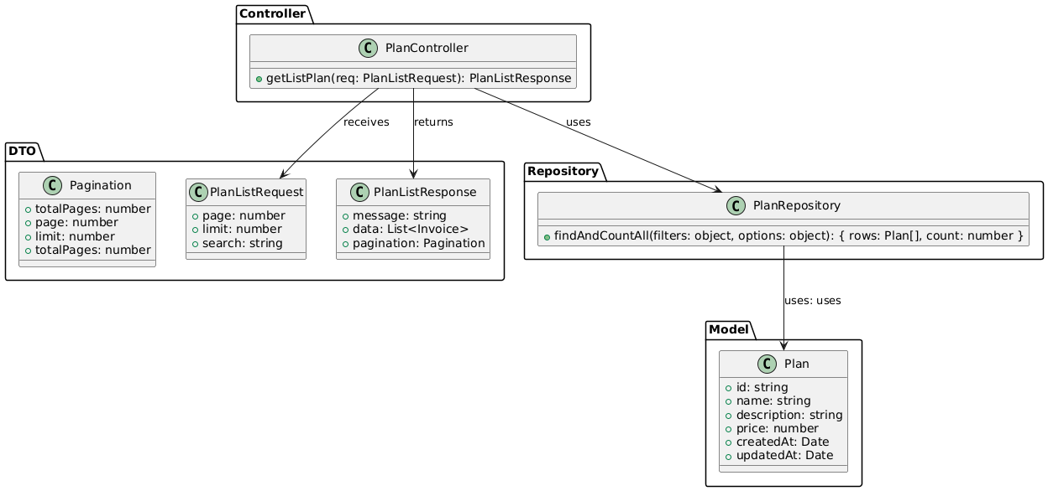

##### **b, Sequence Diagram**

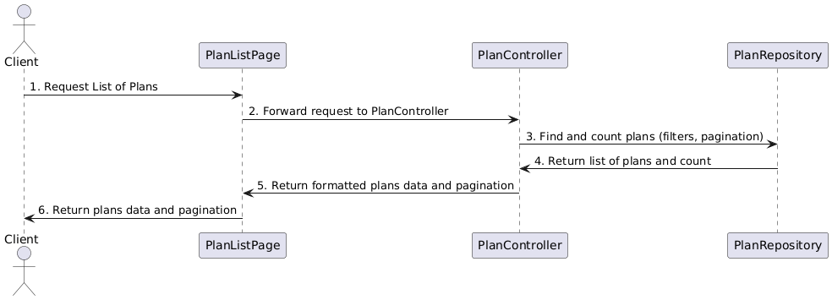

#### 3.6.5 Add New Plan

##### **a, Class Diagram**

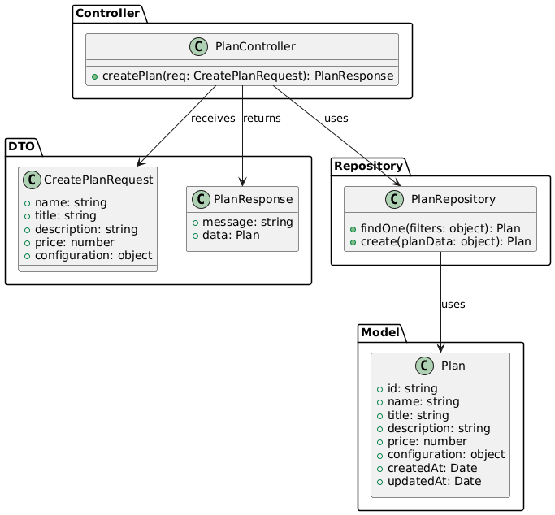

##### **b, Sequence Diagram**

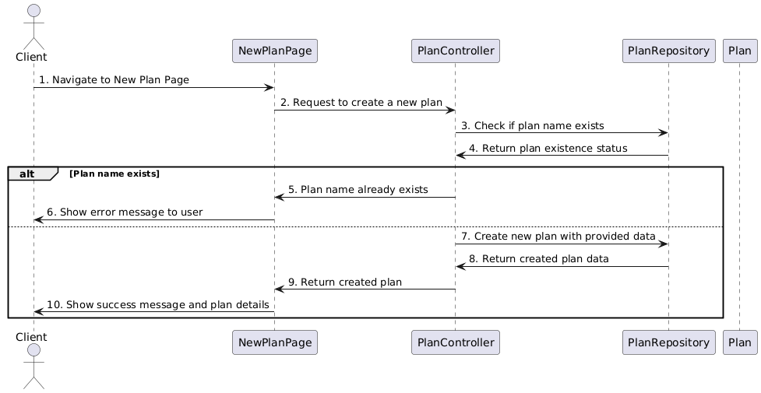

#### 3.6.6 Update Plan Details

##### **a, Class Diagram**

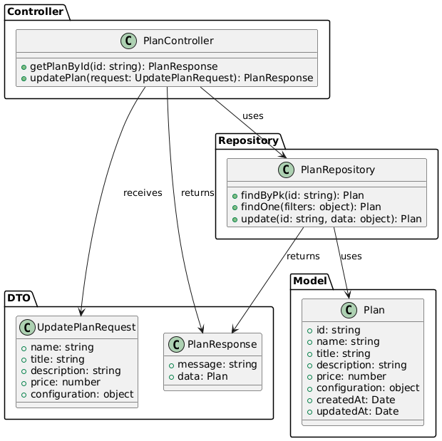

##### **b, Sequence Diagram**

##### 

#### 

# V. Software Testing Documentation

## 1. Scope of Testing

### 1.1. Testing Targets

#### 1.1.1 Functional requirement

* The test scope includes all the features and functions defined in [SEP490_G47_Report3_SRS]
* Develop test cases to verify each functional requirement.
* Ensure that the software behaves as expected and meets the functional specifications.

#### 1.1.2 Test coverage

* Enumerate major features and functions to be tested.
* Verify that the test coverage aligns with the requirements specified in [SEP490_G47_Report3_SRS].

#### 1.1.3 Non - functional

[*Refer [SEP490_G47_Report3_SRS] - IV. Non-functional requirements*](https://docs.google.com/document/d/1-4yakaZLn13jfdYWs4fVUbMTg9bTuWtj/edit?tab=t.0)

[*Refer [SEP490_G47_Report3_SRS] - V. Other Requirements*](https://docs.google.com/document/d/1-4yakaZLn13jfdYWs4fVUbMTg9bTuWtj/edit?tab=t.0)

### 1.2. Testing Levels

We have 3 levels of testing: Unit Test, Integration Test, System Test

## 2. Test Strategy

### 2.1 Testing Types

The test team has to test the following types on Postman, Google Chrome browser, and Edge browser:

* Unit Testing
* GUI Testing
* API Testing
* Functional Testing
* Non-Functional Testing
* Regression Testing

### 2.2 Test Levels

| **Type of Tests** | **Test Level** | | |
| --- | --- | --- | --- |
| **Unit** | **Integration** | **System** |
| Unit Test | X |  |  |
| GUI Test |  | X | X |
| API Test |  | X |  |
| Functional Testing | X | X | X |
| Non-functional Testing |  |  | X |
| Usability Testing |  |  | X |
| Regression Testing | X | X | X |

*Table 2.2.1. Test Environment*

### 2.3 Supporting Tools

| **Purpose** | **Tool** | **Vendor/In-house** | **Version** |
| --- | --- | --- | --- |
| Test Report | Microsoft Word | Microsoft | Office 16 |
| Manage test case and data index | Google Sheet | Google | Latest |
| Manage bugs and the status of bugs | Jira Software | Atlassian | Latest |
| Unit Test | Jest | Openjsf Foundation | Latest |
| Testing API | Postman | Postman | 2016 |

*Table 2.3.1. Supporting Tools*

## 3. Test Plan

### 3.1 Human Resources

| **Worker/Doer** | **Role** | **Specific Responsibilities/Comments** |
| --- | --- | --- |
| DucNM | PM | * Responsible for project schedule and overall success of the project. * Review test cases and reports. |
| DungHM | Tester | * Performing the actual system testing. * Manage test resources and assign test tasks. * Create a test plan. * Create test cases. * Create a test report. * Execute test. * Test log report. |
| DucNM  LongPV  DucTA  AnhNMT | Team member | * Create unit tests. * Fix bugs |

*Table 3.1.1. Human Resources*

### 3.2 Test Environment

| **Purpose** | **Tool** | **Provider** |
| --- | --- | --- |
| Write unit test documents | Excel | Microsoft |
| Write test report documents | Excel | Microsoft |
| Run UT | Postman |  |
| Run IT | Chrome, Edge, Postman |  |
| Run ST | Chrome, Edge |  |
| Tracking defects, issues, and Q&A | Jira, Gitlab, Excel |  |

*Table 3.2.1. Test Environment*

### 3.3 Test Milestones

| **Milestone Task** | **Start Date** | **End Date** |
| --- | --- | --- |
| Create test plan | 05/02/2025 | 09/02/2025 |
| Create Test Report | 05/02/2025 | 18/04/2025 |
| Create, update, and execute UT test cases | 19/02/2025 | 03/03/2025 |
| Create, update, and execute IT test cases | 22/03/2025 | 03/03/2025 |
| Create, update, and execute UT test cases | 04/03/2025 | 17/03/2025 |
| Create, update, and execute IT test cases | 08/03/2025 | 17/03/2025 |
| Create, update, and execute UT test cases | 18/03/2025 | 31/03/2025 |
| Create, update, and execute IT test cases | 22/03/2025 | 31/03/2025 |
| Create, update, and execute ST test cases | 01/04/2025 | 05/04/2025 |
| Full system testing | 01/04/2025 | 22/04/2025 |

## 

*Table 3.3.1. Test milestones plan*

## 4. Test Cases

### 4.1 Unit Test

Functional testing will be done on the server development side by the backend developer:

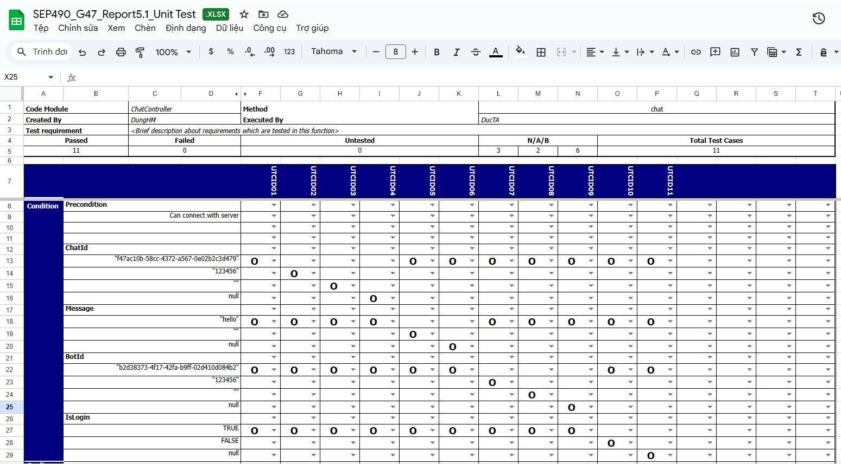

*Figure 4.1.1. Test cases for Unit Test*

Detail test cases for Unit Test will be described in: [SEP490-G47_Report5.1_UnitTest.xlxs](https://docs.google.com/spreadsheets/d/1B-vDkOS9gOKFfI1wu9sNyE0geB-FOUum/edit?gid=981070352#gid=981070352)

### 4.2 Integration Test

Integration testing will involve incorporating the API into the app's interface to assess the data

representation for user The tester will select test cases from the Test Report wherein actions

are performed between functions or data is exchanged between modules.

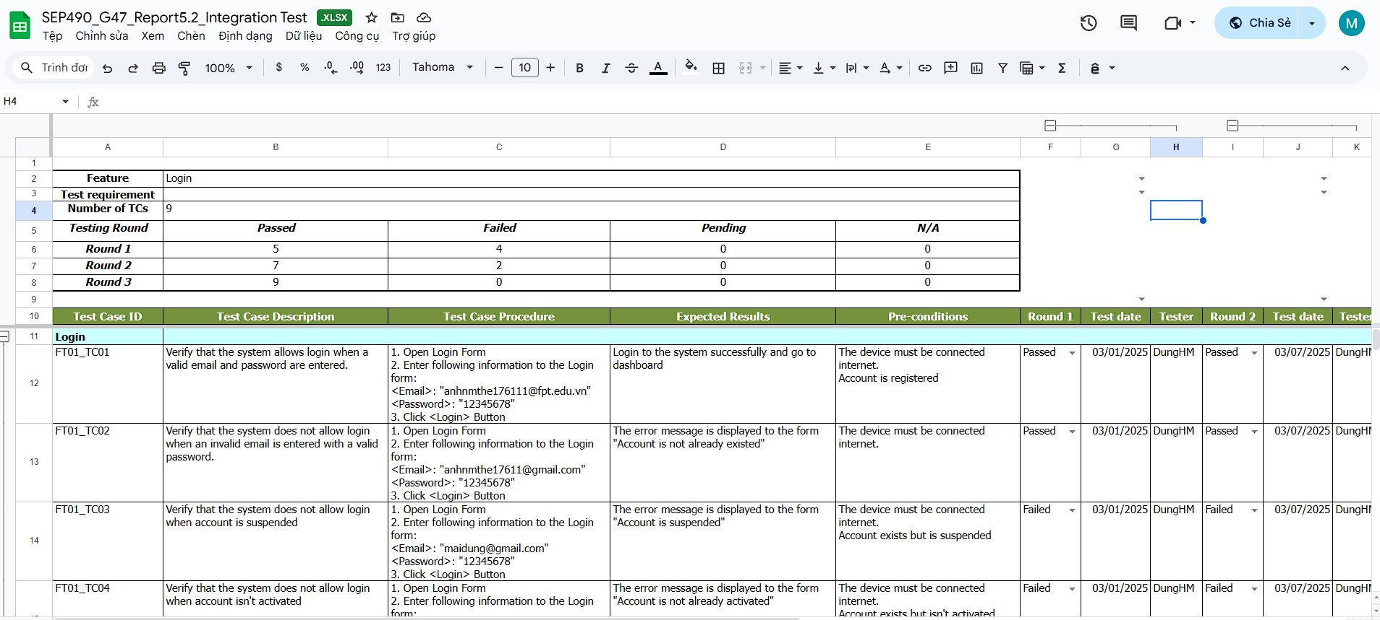

*Figure 4.2.1. Test cases for Integration Test*

Detail test cases for Integration Test will be described in: [SEP490-G47_Report5.2_IntegrationTest.xlxs](https://docs.google.com/spreadsheets/d/1-RNGrmeijL9W1TNaY986CiE-NwRku0qh/edit?gid=107846304#gid=107846304)

### 4.3 System Test

This testing stage occurs after the functions outlined in the requirements have been completely

implemented. At this stage, the entire system is tested as a whole to ensure that all components work correctly and that the overall workflow behaves as designed

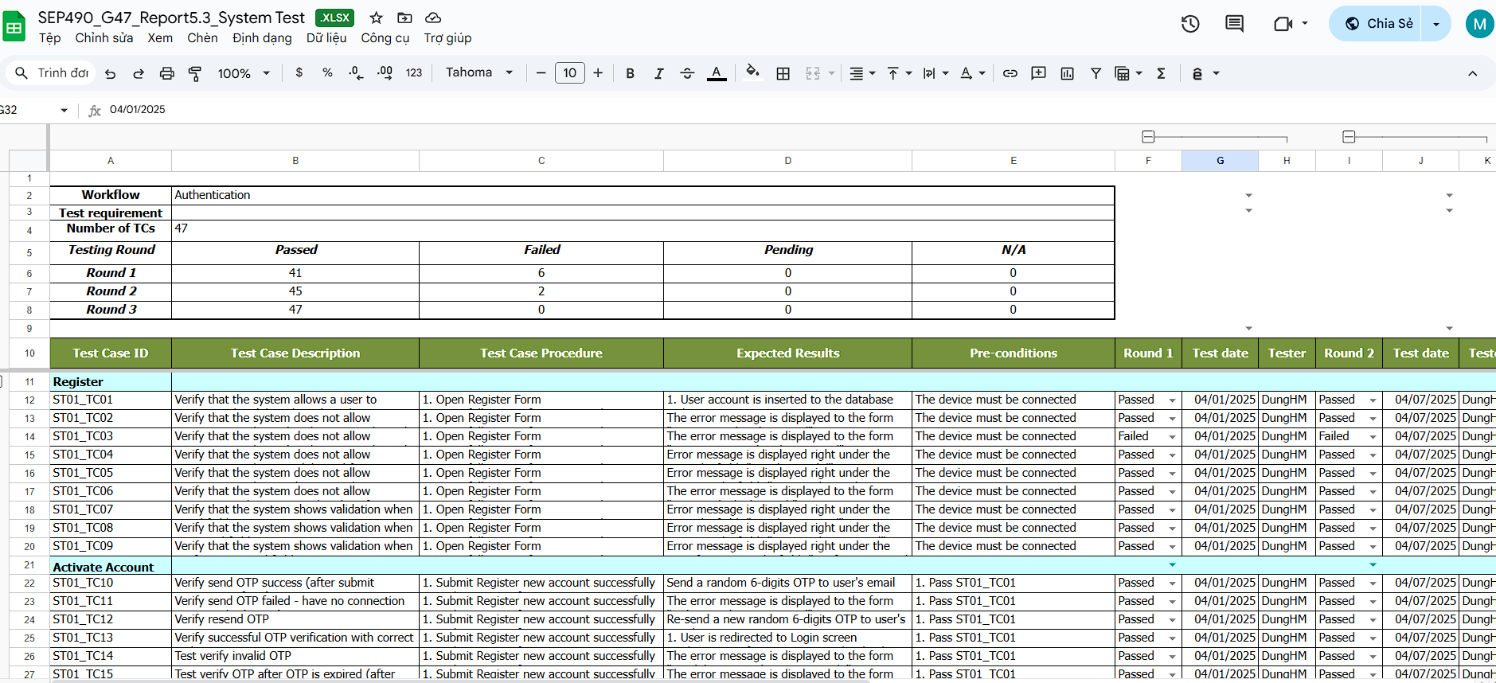

*Figure 4.3.1. Test cases for System Test*

Detail test cases for System Test will be described in: [SEP490-G47_Report5.3_SystemTest.xlxs](https://docs.google.com/spreadsheets/d/1ffGbDgMZFxEgufKREIiyfD2vdOtenOyg/edit?gid=1381083078#gid=1381083078)

## 5. Test Reports

### 5.1 Unit Test

| **No** | **Function code** | **Passed** | **Failed** | **Untested** | **N** | **A** | **B** | **Total Test Cases** |
| --- | --- | --- | --- | --- | --- | --- | --- | --- |
| 1 | chat | 11 | 0 | 0 | 3 | 2 | 6 | 11 |
| 2 | getLiveChatList | 20 | 0 | 0 | 1 | 2 | 17 | 20 |
| 3 | getMessagesByLiveChatId | 12 | 0 | 0 | 3 | 1 | 8 | 12 |
| 4 | getListChat | 12 | 0 | 0 | 1 | 1 | 10 | 12 |
| 5 | getChatMessage | 12 | 0 | 0 | 3 | 1 | 8 | 12 |
| 6 | chat | 9 | 0 | 0 | 3 | 2 | 6 | 11 |
| 7 | getPromptDocument | 11 | 0 | 0 | 1 | 2 | 8 | 11 |
| 8 | getHistoryMessages | 8 | 0 | 0 | 2 | 1 | 5 | 8 |
| 9 | getListBot | 11 | 0 | 0 | 4 | 0 | 7 | 11 |
| 10 | getBotById | 4 | 0 | 0 | 1 | 0 | 3 | 4 |
| 11 | getBotConfigurationById | 4 | 0 | 0 | 1 | 0 | 3 | 4 |
| 12 | createBot | 8 | 0 | 0 | 1 | 1 | 6 | 8 |
| 13 | updateBot | 8 | 0 | 0 | 1 | 1 | 6 | 8S |
| 14 | getPaginateDataContent | 17 | 0 | 0 | 1 | 2 | 14 | 17 |
| 15 | getDetailDataContent | 4 | 0 | 0 | 1 | 0 | 3 | 4 |
| 16 | createDataContent | 6 | 0 | 0 | 1 | 1 | 4 | 6 |
| 17 | createDataContentURL | 9 | 0 | 0 | 1 | 2 | 6 | 9 |
| 18 | createDataContentText | 8 | 0 | 0 | 1 | 1 | 6 | 8 |
| 19 | updateDataContent | 13 | 0 | 0 | 1 | 2 | 10 | 13 |
| 20 | updateStatusDataContent | 8 | 0 | 0 | 1 | 1 | 6 | 8 |
| 21 | createPaymentLink | 4 | 0 | 0 | 1 | 1 | 2 | 4 |
| 22 | confirmPayment | 4 | 0 | 0 | 1 | 1 | 2 | 4 |
| 23 | insert_data | 10 | 0 | 0 | 1 | 2 | 7 | 10 |
| 24 | insert_data_url | 12 | 0 | 0 | 1 | 3 | 8 | 12 |
| 25 | insert_data_text | 11 | 0 | 0 | 1 | 2 | 8 | 11 |
| 26 | query_data | 9 | 0 | 0 | 1 | 2 | 6 | 9 |
| 27 | HandleUserMessage | 17 | 0 | 0 | 2 | 4 | 11 | 17 |
|  | **Sub total** | 270 | 0 | 0 | 40 | 40 | 190 | 270 |
|  |  |  |  |  |  |  |  |  |
|  | **Test coverage** |  | **100.00** | % |  |  |  |  |
|  | **Test successful coverage** |  | **100.00** | % |  |  |  |  |
|  | **Normal case** |  | **14.55** | % |  |  |  |  |
|  | **Abnormal case** |  | **10.91** | % |  |  |  |  |
|  | **Boundary case** |  | **74.55** | % |  |  |  |  |

*Table 5.1.1. Unit Test Report*

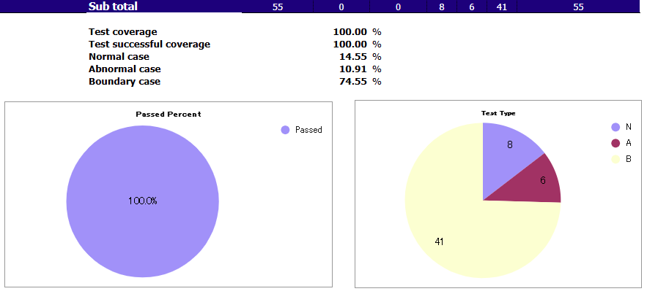

*Figure 5.1.1. Unit Test Statistics*

### 5.2 Integration Test

| **No** | **Module code** | **Passed** | **Failed** | **Pending** | **N/A** | **Number of test cases** |
| --- | --- | --- | --- | --- | --- | --- |
| 1 | Login | 9 | 0 | 0 | 0 | 9 |
| 2 | Register | 17 | 0 | 0 | 0 | 17 |
| 3 | Password Reset | 11 | 0 | 0 | 0 | 11 |
| 4 | Profile | 10 | 0 | 0 | 0 | 10 |
| 5 | User List | 33 | 0 | 0 | 0 | 33 |
| 6 | Chat | 6 | 0 | 0 | 0 | 6 |
| 7 | Live chat | 4 | 0 | 0 | 0 | 4 |
| 8 | Bot | 16 | 0 | 0 | 0 | 16 |
| 9 | Bot Details | 40 | 0 | 0 | 0 | 40 |
| 10 | Model | 12 | 0 | 0 | 0 | 12 |
| 11 | Organization | 14 | 0 | 0 | 0 | 14 |
| 12 | Organization Details | 24 | 0 | 0 | 0 | 24 |
| 13 | Role | 18 | 0 | 0 | 0 | 18 |
| 14 | Plan | 24 | 0 | 0 | 0 | 24 |
| 15 | Invoice | 23 | 0 | 0 | 0 | 23 |
|  | **Sub total** | 261 | 0 | 0 | 0 | 261 |
|  |  |  |  |  |  |  |
|  | **Test coverage** |  | **100.00** | % |  |  |
|  | **Test successful coverage** |  | **100.00** | % |  |  |

*Table 5.2.1. Integration Test Report*

### 5.3 System Test

| **No** | **Module code** | **Passed** | **Failed** | **Pending** | **N/A** | **Number of test cases** |
| --- | --- | --- | --- | --- | --- | --- |
| 1 | Authentication | 47 | 0 | 0 | 0 | 47 |
| 2 | User Management | 51 | 0 | 0 | 0 | 51 |
| 3 | Plan Process & Payment | 47 | 0 | 0 | 0 | 47 |
| 4 | Bot Config | 47 | 0 | 0 | 0 | 47 |
| 5 | Chat | 19 | 0 | 0 | 0 | 19 |
| 6 | Business Management | 24 | 0 | 0 | 0 | 24 |
|  | **Sub total** | 235 | 0 | 0 | 0 | 235 |
|  |  |  |  |  |  |  |
|  | **Test coverage** |  | **100.00** | % |  |  |
|  | **Test successful coverage** |  | **100.00** | % |  |  |

*Figure 5.3.1. System Test Report*

# VI. Release Package & User Guides

## 1. Deliverable Package

| **No.** | **Deliverable Item** | **Description** |
| --- | --- | --- |
| 1 | Project Schedule/Tracking | SEP490_G47_Report2_Project_Tracking.xlxs |
| 2 | Source Codes | SEP490_G47_CMS_BE.zip |
| SEP490_G47_CMS_FE.zip |
| SEP490_G47_Job_Server.zip |
| SEP490_G47_Socket_Server.zip |
| SEP490_G47_Data_Hub.zip |
| SEP490_G47_AI_Hub.zip |
| SEP490_G47_Report.zip |
| 3 | Database Script(s) | SEP490_G47_Database_script.sql |
| 4 | Final Report Document | SEP490_G47_Report7_Final_Project_Report.pdf |
| 5 | Unit Test | SEP490_G47_Report5.1_Unit_Test.xlxs |
| 5 | Integration Test | SEP490_G47_Report5.2_Integration_Test.xlxs |
| 6 | System Test | SEP490_G47_Report5.3_System_Test.xlxs |
| 7 | Defects List | SEP490_G47_Report2_Project_Tracking.xlxs |
| 8 | Slide | SEP490_G47_Slide_Final_Presentation.pdf |

*Table 1.1. Deliverable Packages*

## 2. Installation Guides

### 2.1 System Requirements

* For Develop CAIP CMS-FE application, the system requirements
  + **Hardware:** Intel® CoreTM i5 or higher, RAM at least 4.00GB
  + **Operating System:** Windows 10/11 or Ubuntu 22.04 LTS 64-bit
  + **Software:** Visual Studio Code
  + **Technologies:** Node.js v22, Git
* For Develop CAIP CMS-BE application, the system requirements
  + **Hardware:** Intel® CoreTM i5 or higher, RAM at least 4.00GB
  + **Operating System:** Windows 10/11 or Ubuntu 22.04 LTS 64-bit
  + **Software:** Visual Studio Code
  + **Technologies:** Node.js v22, Git
* For Develop CAIP Job Server application, the system requirements
  + **Hardware:** Intel® CoreTM i5 or higher, RAM at least 4.00GB
  + **Operating System:** Windows 10/11 or Ubuntu 22.04 LTS 64-bit
  + **Software:** Visual Studio Code
  + **Technologies:** Node.js v22, Git
* For Develop CAIP Socket Server application, the system requirements
  + **Hardware:** Intel® CoreTM i5 or higher, RAM at least 4.00GB
  + **Operating System:** Windows 10/11 or Ubuntu 22.04 LTS 64-bit
  + **Software:** Visual Studio Code
  + **Technologies:** Node.js v22, Git
* For Develop CAIP Report application, the system requirements
  + **Hardware:** Intel® CoreTM i5 or higher, RAM at least 4.00GB
  + **Operating System:** Windows 10/11 or Ubuntu 22.04 LTS 64-bit
  + **Software:** Visual Studio Code
  + **Technologies:** Node.js v22, Git
* For Develop CAIP Data Hub application, the system requirements
  + **Hardware:** Intel® CoreTM i5 or higher, RAM at least 4.00GB
  + **Operating System:** Windows 10/11 or Ubuntu 22.04 LTS 64-bit
  + **Software:** Visual Studio Code
  + **Technologies:** Python 3.9, Git
* For Develop CAIP AI Hub application, the system requirements
  + **Hardware:** Intel® CoreTM i5 or higher, RAM at least 4.00GB
  + **Operating System:** Windows 10/11 or Ubuntu 22.04 LTS 64-bit
  + **Software:** Visual Studio Code
  + **Technologies:** Python 3.9, Git
* For Production Environment, the system requirements
  + **Hardware:** CPU at least 8 cores, RAM at least 16.00GB
  + **Storage:** 256GB SSD
  + **Operating System:** Ubuntu 22.04 LTS 64-bit
  + **Technologies:** Docker, Git

### 2.2 Installation Instruction

### 2.2.1 Install Docker

1. Setup Docker's apt repository

| # Add Docker’s official GPG key  sudo apt update  sudo apt install -y apt-transport-https ca-certificates curl software-properties-common  curl -fsSL https://download.docker.com/linux/ubuntu/gpg | sudo gpg --dearmor -o /usr/share/keyrings/docker-archive-keyring.gpg  # Add Docker repository  echo "deb [arch=$(dpkg --print-architecture) signed-by=/usr/share/keyrings/docker-archive-keyring.gpg] https://download.docker.com/linux/ubuntu $(lsb_release -cs) stable" | sudo tee /etc/apt/sources.list.d/docker.list > /dev/null |
| --- |

1. Install the Docker packages

| sudo apt update  sudo apt install -y docker-ce docker-ce-cli containerd.io  # Add user to Docker group  sudo usermod -aG docker $USER |
| --- |

1. Verify Docker installation

| docker --version |
| --- |

1. **Log out** and **Log back** in to apply group changes

### 2.2.2 Install Docker Compose and Infrastructure Services

1. Install the Docker Compose

| sudo curl -L "https://github.com/docker/compose/releases/download/v2.29.2/docker-compose-$(uname -s)-$(uname -m)" -o /usr/local/bin/docker-compose  sudo chmod +x /usr/local/bin/docker-compose |
| --- |

1. Verify installation

| docker-compose --version |
| --- |

1. Create .env file modify environment variables if needed
2. Create file docker-compose.yml

| version: '3.8'  services:  rabbitmq:  image: rabbitmq:3-management-alpine  container_name: rabbitmq  ports:  - 5672:5672  - 15672:15672  env_file:  - .env  environment:  RABBITMQ_DEFAULT_USER: ${RABBITMQ_DEFAULT_USER}  RABBITMQ_DEFAULT_PASS: ${RABBITMQ_DEFAULT_PASS}  volumes:  - rabbitmq_data:/var/lib/rabbitmq  restart: always  networks:  - caip-network  mongodb:  image: mongo:6.0  container_name: mongodb  ports:  - 27017:27017  env_file:  - .env  environment:  MONGO_INITDB_ROOT_USERNAME: ${MONGO_INITDB_ROOT_USERNAME}  MONGO_INITDB_ROOT_PASSWORD: ${MONGO_INITDB_ROOT_PASSWORD}  volumes:  - mongodb_data:/data/db  restart: always  networks:  - caip-network  postgresql:  image: postgres:15  container_name: postgresql  ports:  - 5432:5432  env_file:  - .env  environment:  POSTGRES_USER: ${POSTGRES_USER}  POSTGRES_PASSWORD: ${POSTGRES_PASSWORD}  POSTGRES_DB: ${POSTGRES_DB}  volumes:  - postgresql_data:/var/lib/postgresql/data  - ./SEP490_G47_Database_script.sql:/docker-entrypoint-initdb.d/SEP490_G47_Database_script.sql  restart: always  networks:  - caip-network  volumes:  rabbitmq_data:  mongodb_data:  postgresql_data:  networks:  caip-network:  driver: bridge |
| --- |

1. Start the services

| docker-compose up -d  # view services  docker ps |
| --- |

### 2.2.3 Install CAIP CMS-FE

1. Create .env file by copy .env.example file content and modify environment variables if needed
2. Start the services

| docker build -t cms-fe:latest .  docker run -d --name cms-fe -p 5173:5173 cms-fe:latest |
| --- |

### 2.2.4 Install CAIP CMS-BE

1. Create .env file by copy .env.example file content and modify environment variables if needed
2. Start the services

| docker build -t cms-be:latest .  docker run -d --name cms-be -p 8000:8000 cms-be:latest |
| --- |

### 2.2.5 Install CAIP Job Server

1. Create .env file by copy .env.example file content and modify environment variables if needed
2. Start the services

| docker build -t job-server:latest .  docker run -d --name job-server -p 8100:8100 cms-be:latest |
| --- |

### 2.2.6 Install CAIP Socket Server

1. Create .env file by copy .env.example file content and modify environment variables if needed
2. Start the services

| docker build -t socket-server:latest .  docker run -d --name socket-server -p 5001:5001 socket-server:latest |
| --- |

### 2.2.7 Install CAIP Report

1. Create .env file by copy .env.example file content and modify environment variables if needed
2. Start the services

| docker build -t report:latest .  docker run -d --name report -p 8300:8300 report:latest |
| --- |

### 2.2.8 Install CAIP Data Hub

1. Create .env file by copy .env.example file content and modify environment variables if needed
2. Start the services

| docker build -t datahub:latest .  docker run -d --name datahub -p 8200:8200 datahub:latest |
| --- |

### 2.2.9 Install CAIP AI Hub

1. Create litellm_config.yaml file by copy litellm_config.yaml.example file content and modify environment variables if needed
2. Create start.sh file by copy start.sh.example file content and modify environment variables if needed
3. Start the services

| chmod +x start.sh  ./start.sh |
| --- |

## 3. User Guides

### 3.1 Overview

This document aims to describe and provide detailed instructions for operations on the screens of the Chatbees system.

### 3.2. Authentication

#### 3.2.1 Login

##### 3.2.1.1 Login with System Account

Description: User want to log in to use the system

* User fill in their login information, including their registered "Email" and "Password".
* Click “Login”

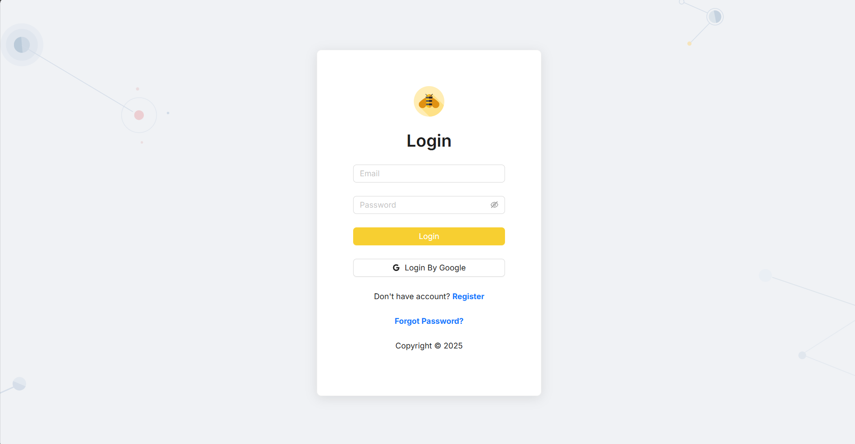

##### 3.2.1.2 Login with Google

Description: User wants to log in using their Google account.

* User clicks the “Login ByGoogle” button.
* The system will redirect to Google’s authentication page.
* After successful authentication, the user will be logged into the system.

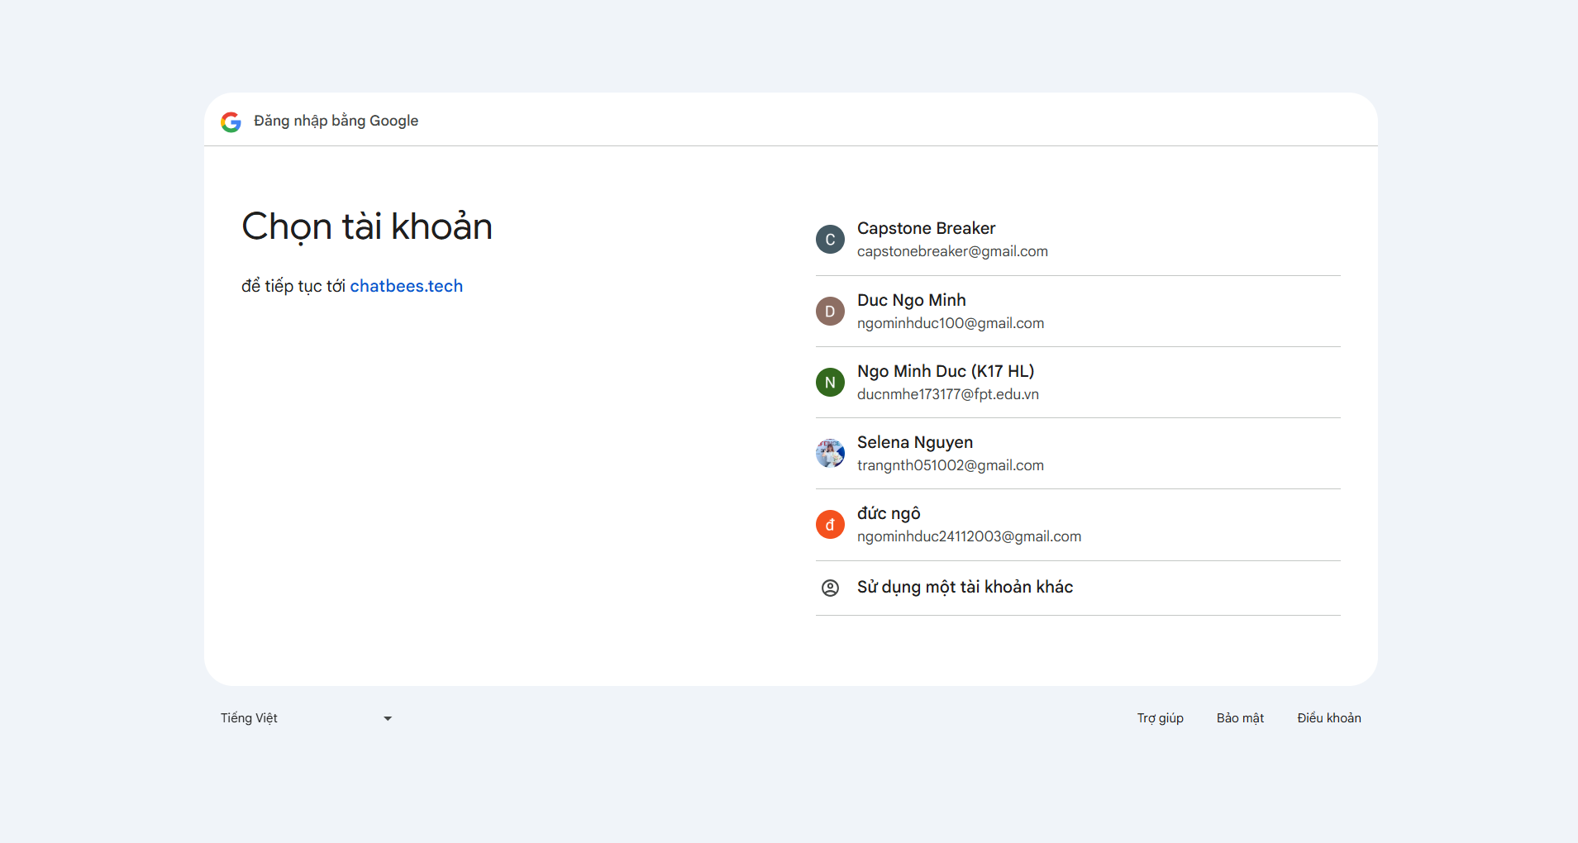

#### 3.2.2 Register

##### 3.2.2.1 Signup with System Account

Description: User wants to use the system to register a new account in the user role.

* User fill in their login information, including their registered "Email", "Password" and "Confirm Password".
* Click the button “Register” on the Login page
* The system sends an OTP code to the user's registered email address.
* User enters the received OTP into the input field and clicks the **Submit** button to verify the account.
* When user is verified, they can login to use Chatbees

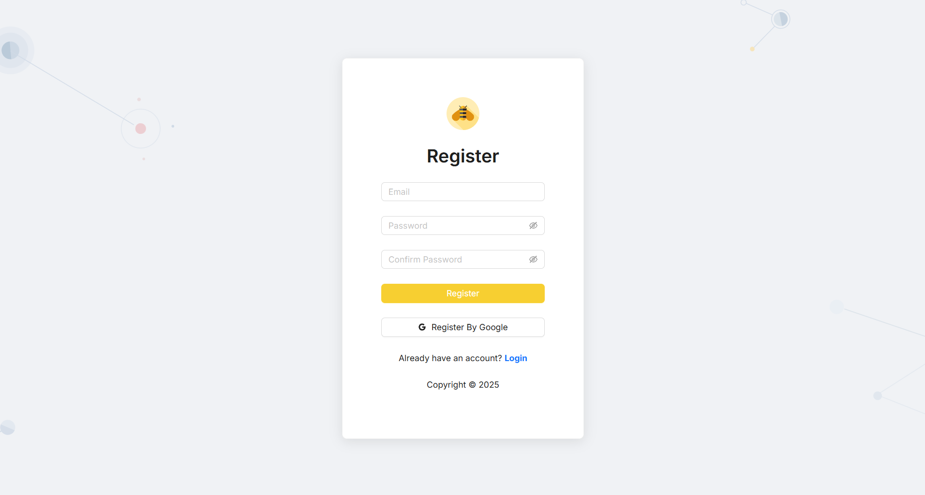

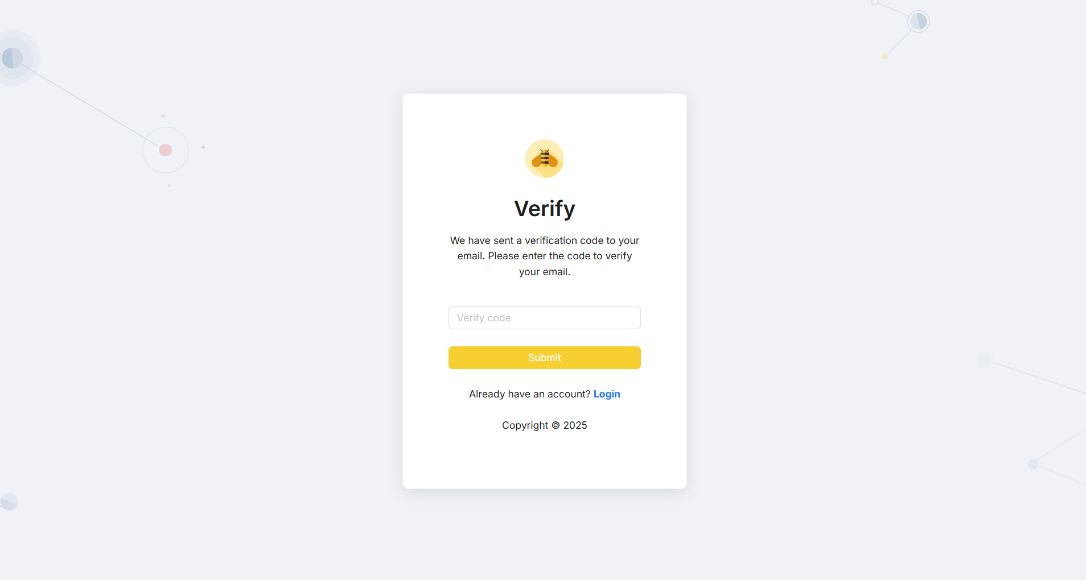

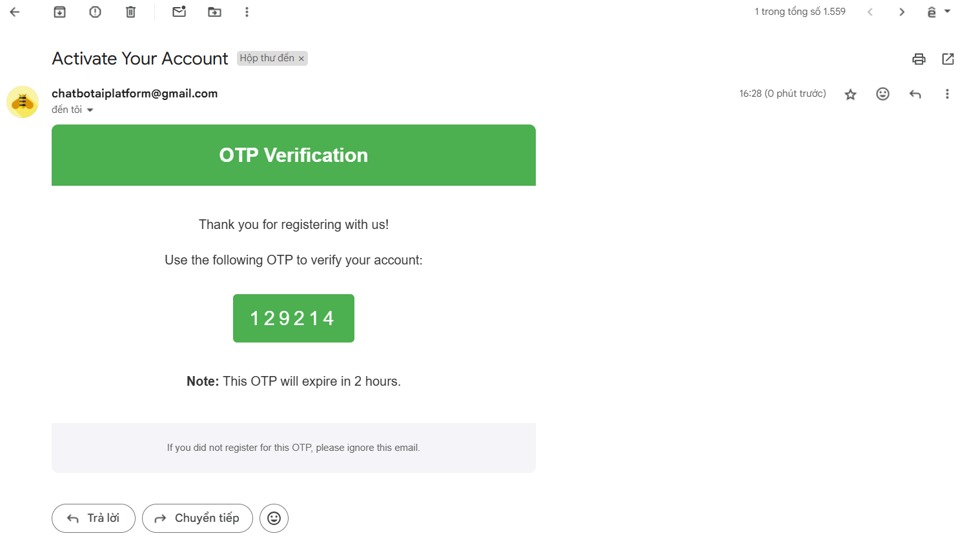

##### 3.2.2.2 Signup with Google

Description: User wants to use google to register a new account in the user role.

* Click the button “Register By Google” on the Login page
* The system will redirect to Google’s authentication page.
* After successful authentication, the user will be logged into the system.

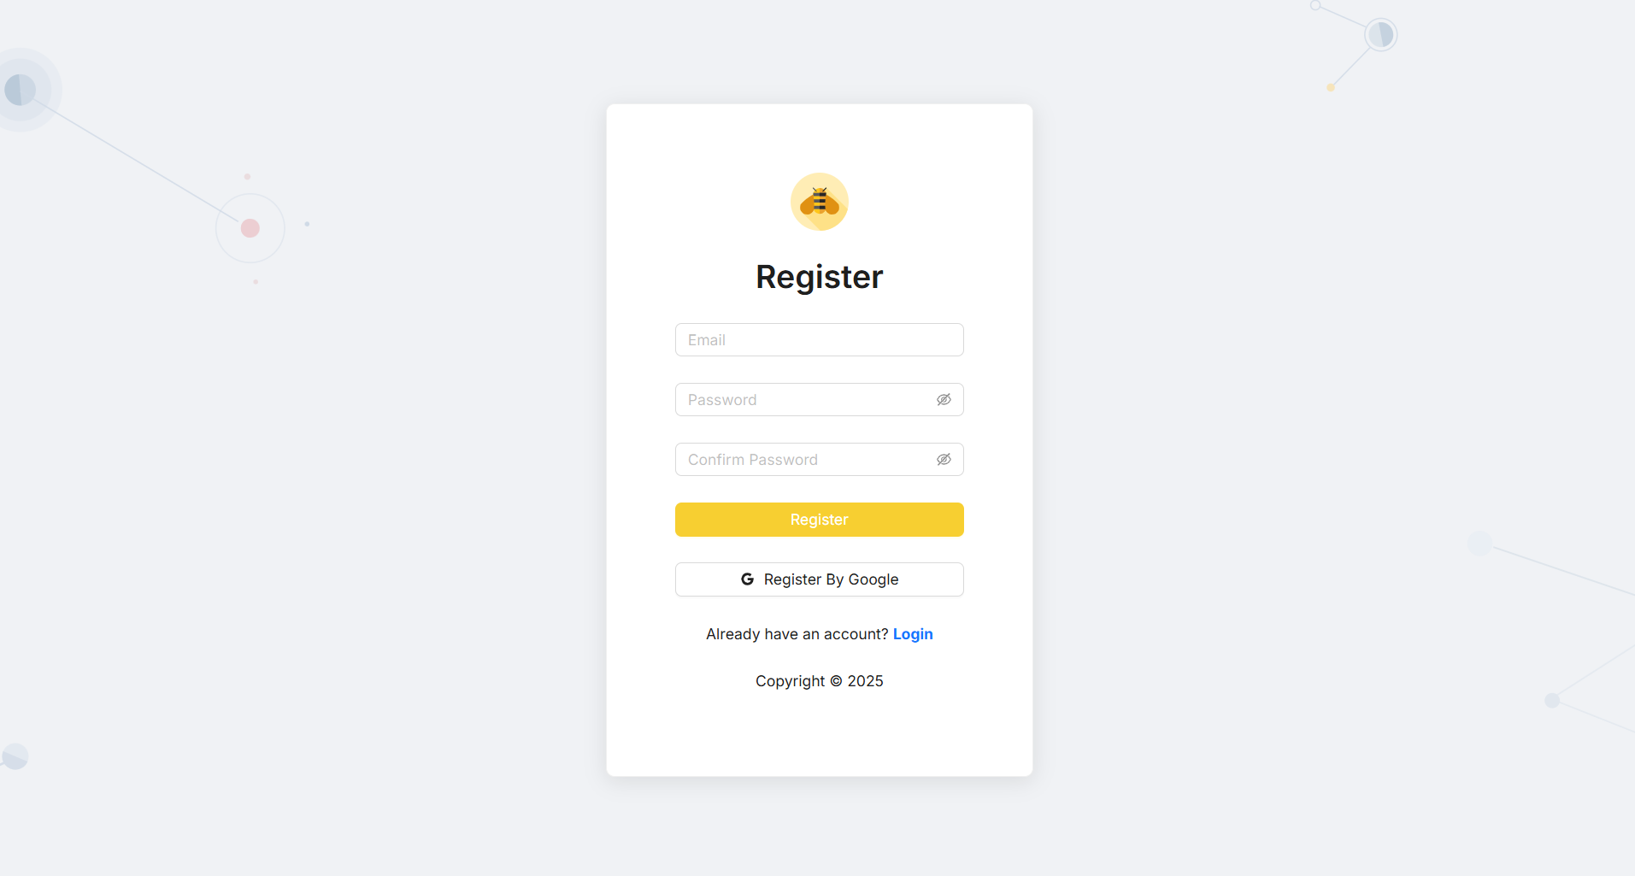

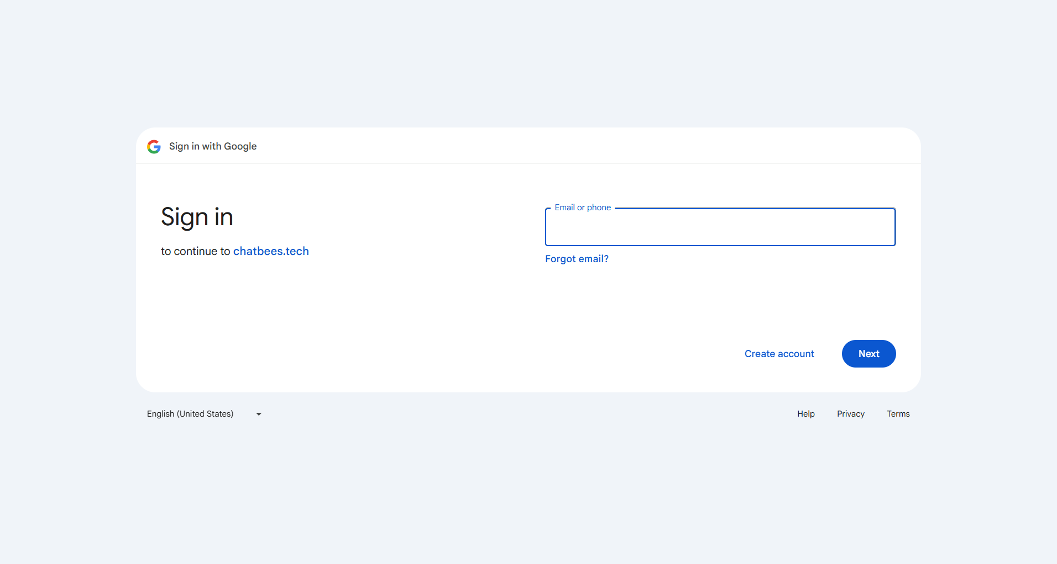

#### 3.2.3 Forgot password

Description: User wants to reset their password because they forgot it.

* From the Login page, the user clicks the "Forgot Password" link.

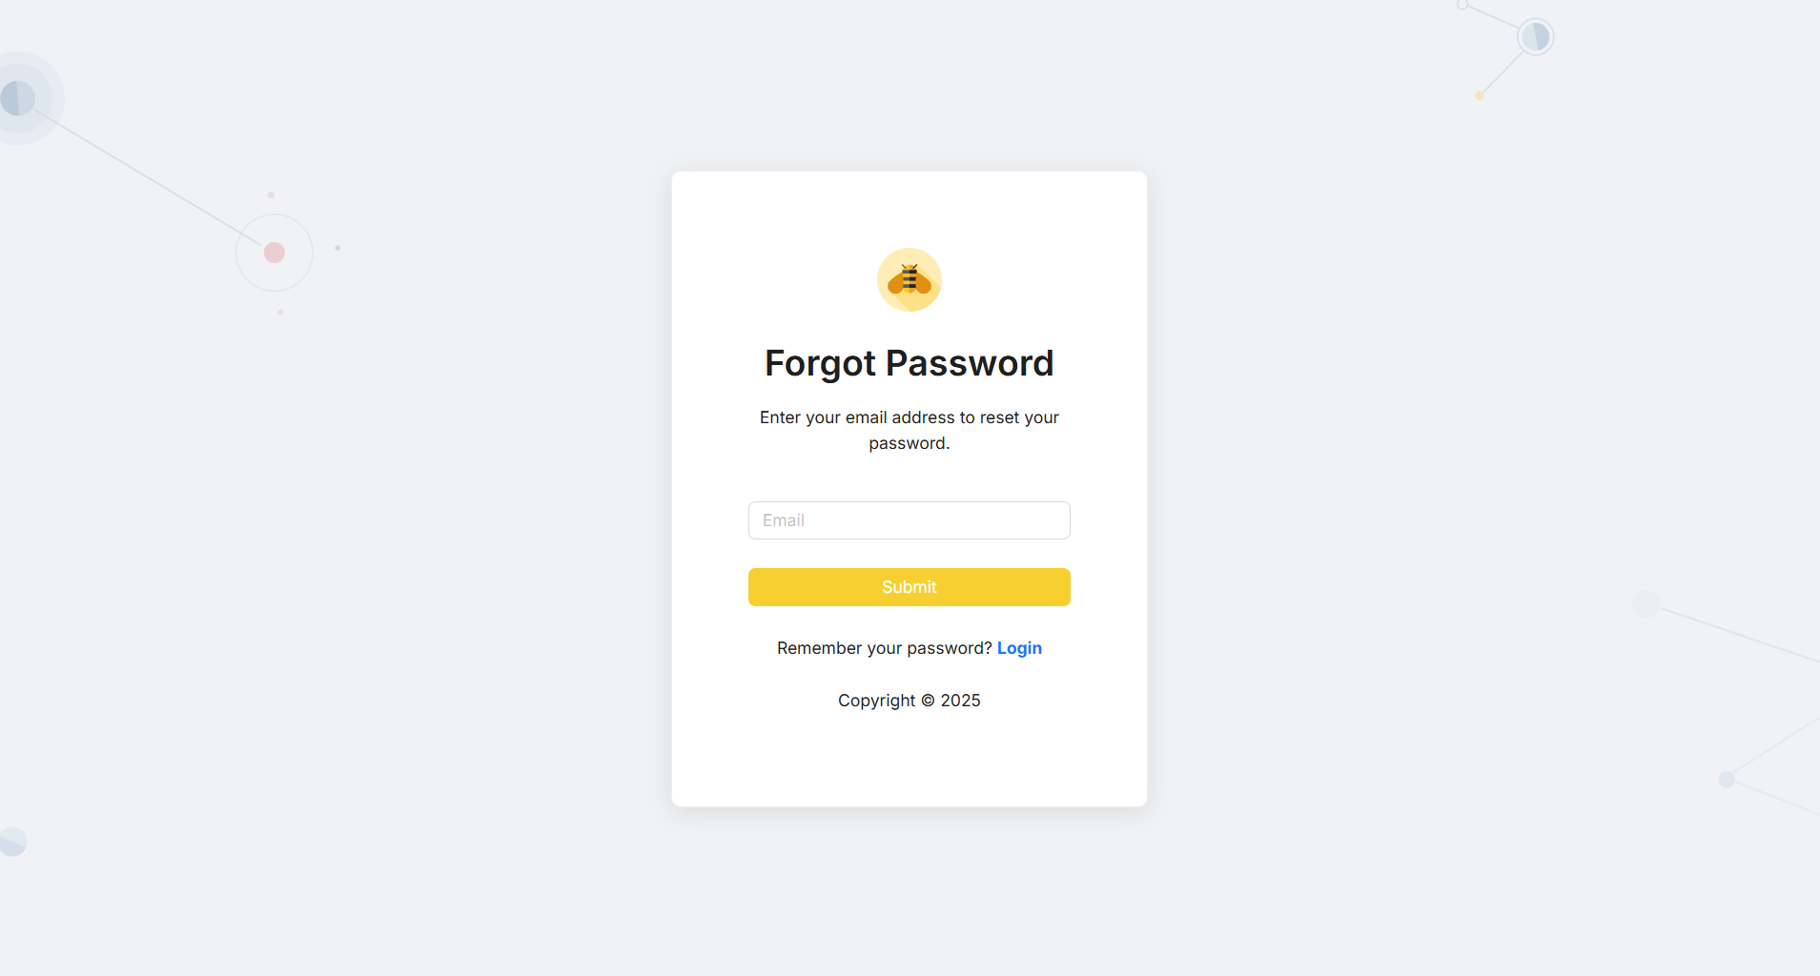

#### 3.2.4 Change password

Description: User wants to reset their password because they forgot it.

* After logging into the system, the user is on the Home Page.
* User click on their Profile icon in the header bar.
* On the Profile page, the user clicks the "Edit Profile" button.

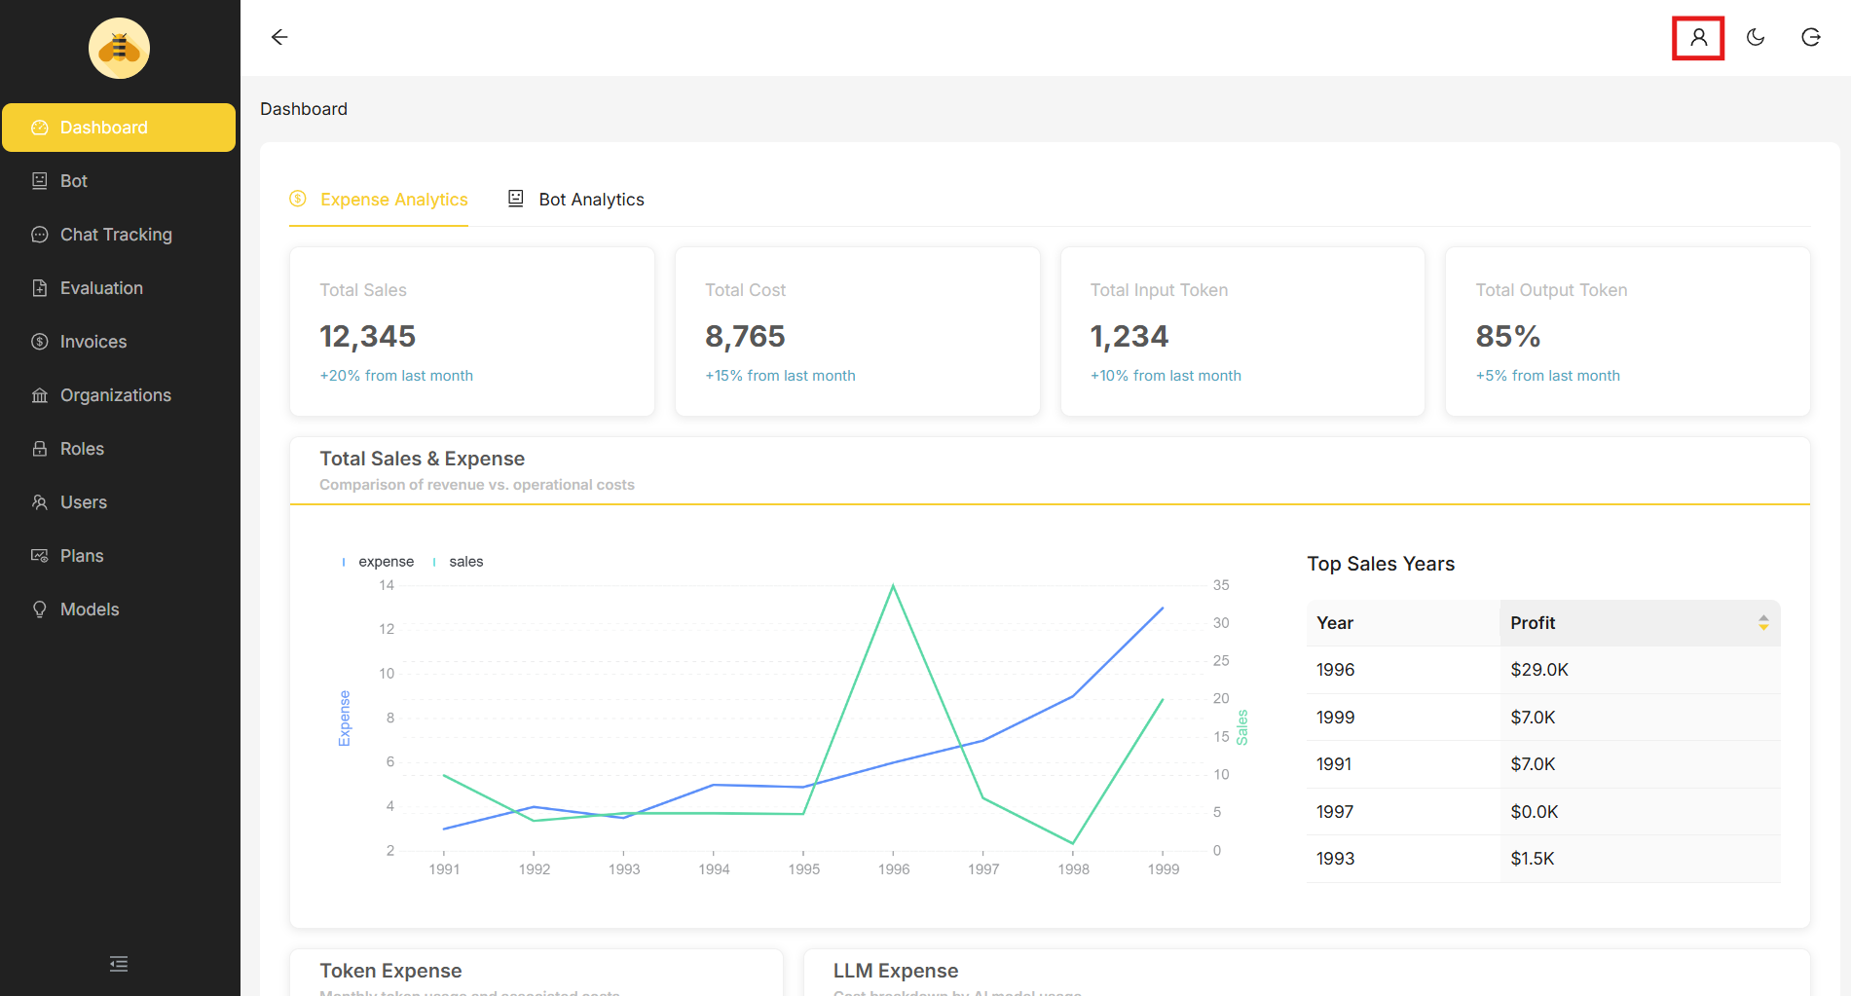

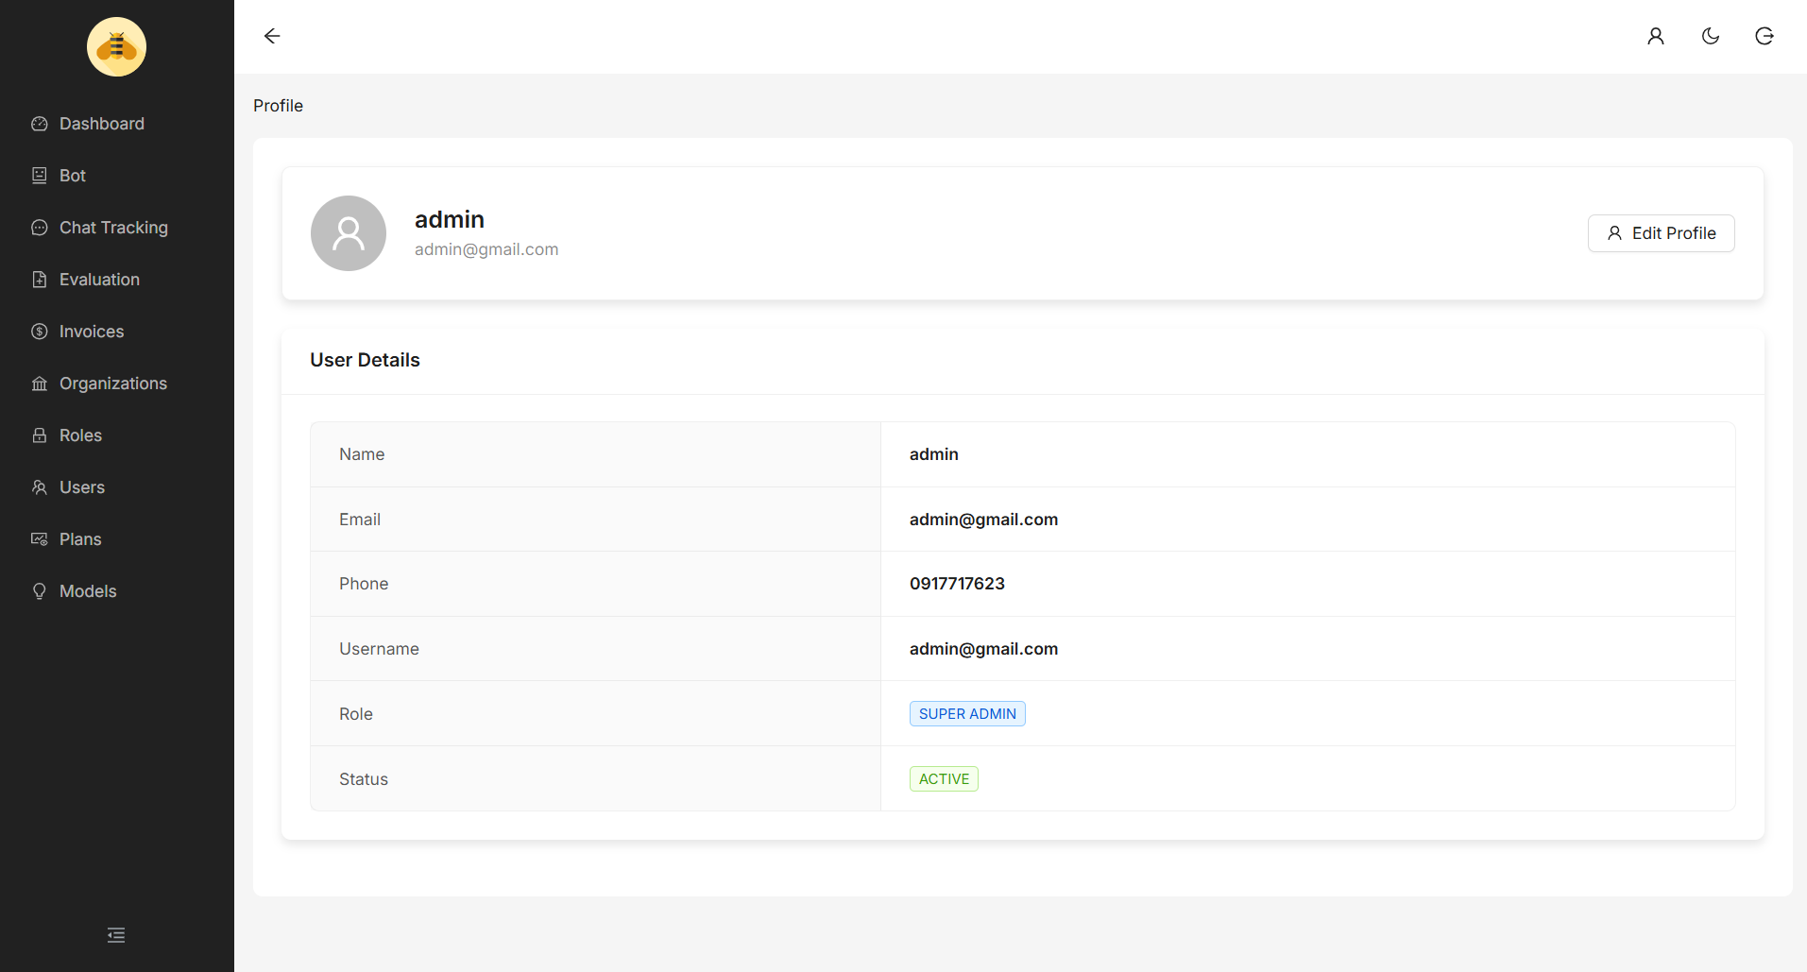

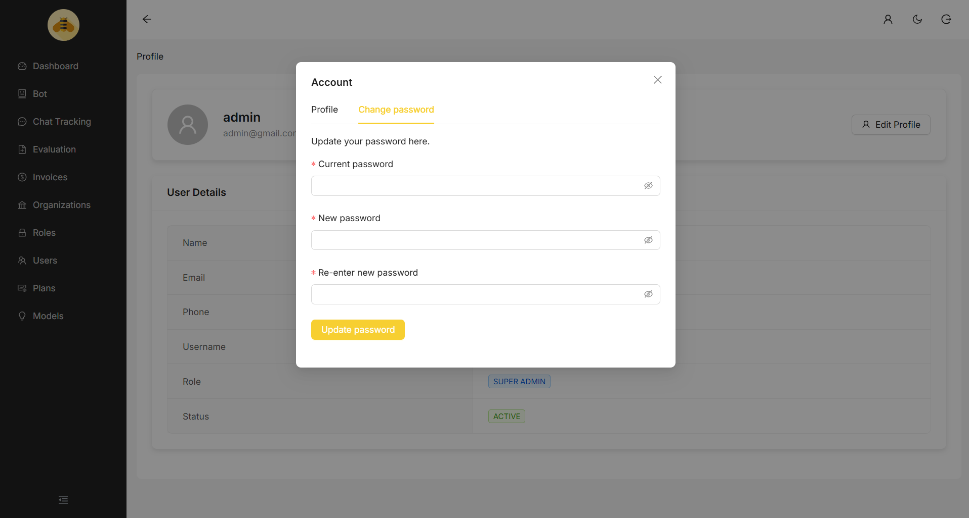

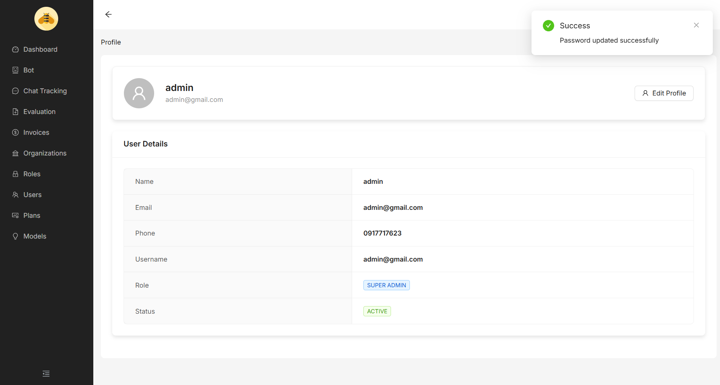

#### 3.2.5 Change profile

Description: User wants to change their profile.

* After logging into the system, the user is on the Home Page.
* User clicks on their Profile icon in the header bar.
* On the Profile page, the user clicks the "Edit Profile" button.
* A popup menu appears, the user selects tab "Profile" from the popup menu.
* User updates information such as Full Name and/or Phone Number.
* Click the “Update profile” button to submit changes.
* The system updates the user's profile and shows a success message.



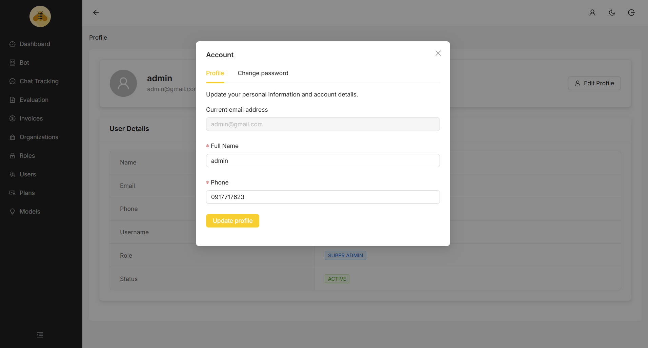

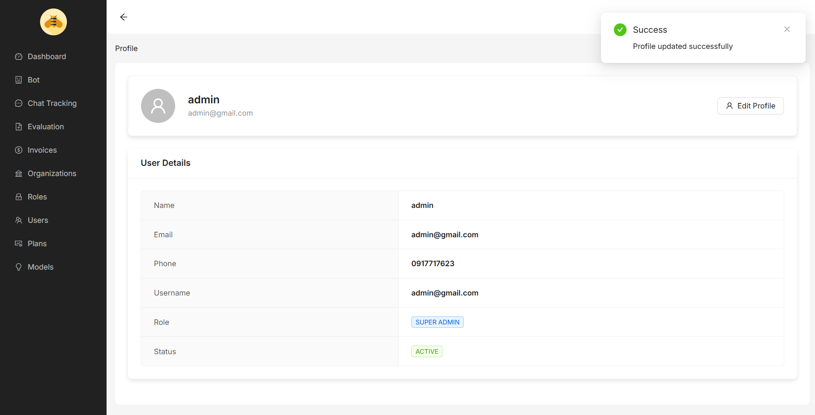

### 3.3. Setup Organization

### 3.3.1 Update plan for organization

##### 3.3.1.1 View Plan

Description: User wants to view all plans with a selected organization.

* After logging into the system, user is on the Home Page.
* User selects an Organization they want to upgrade the plan for from the organization list in the header.
* User selects an tab “Organization” form the sidebar.

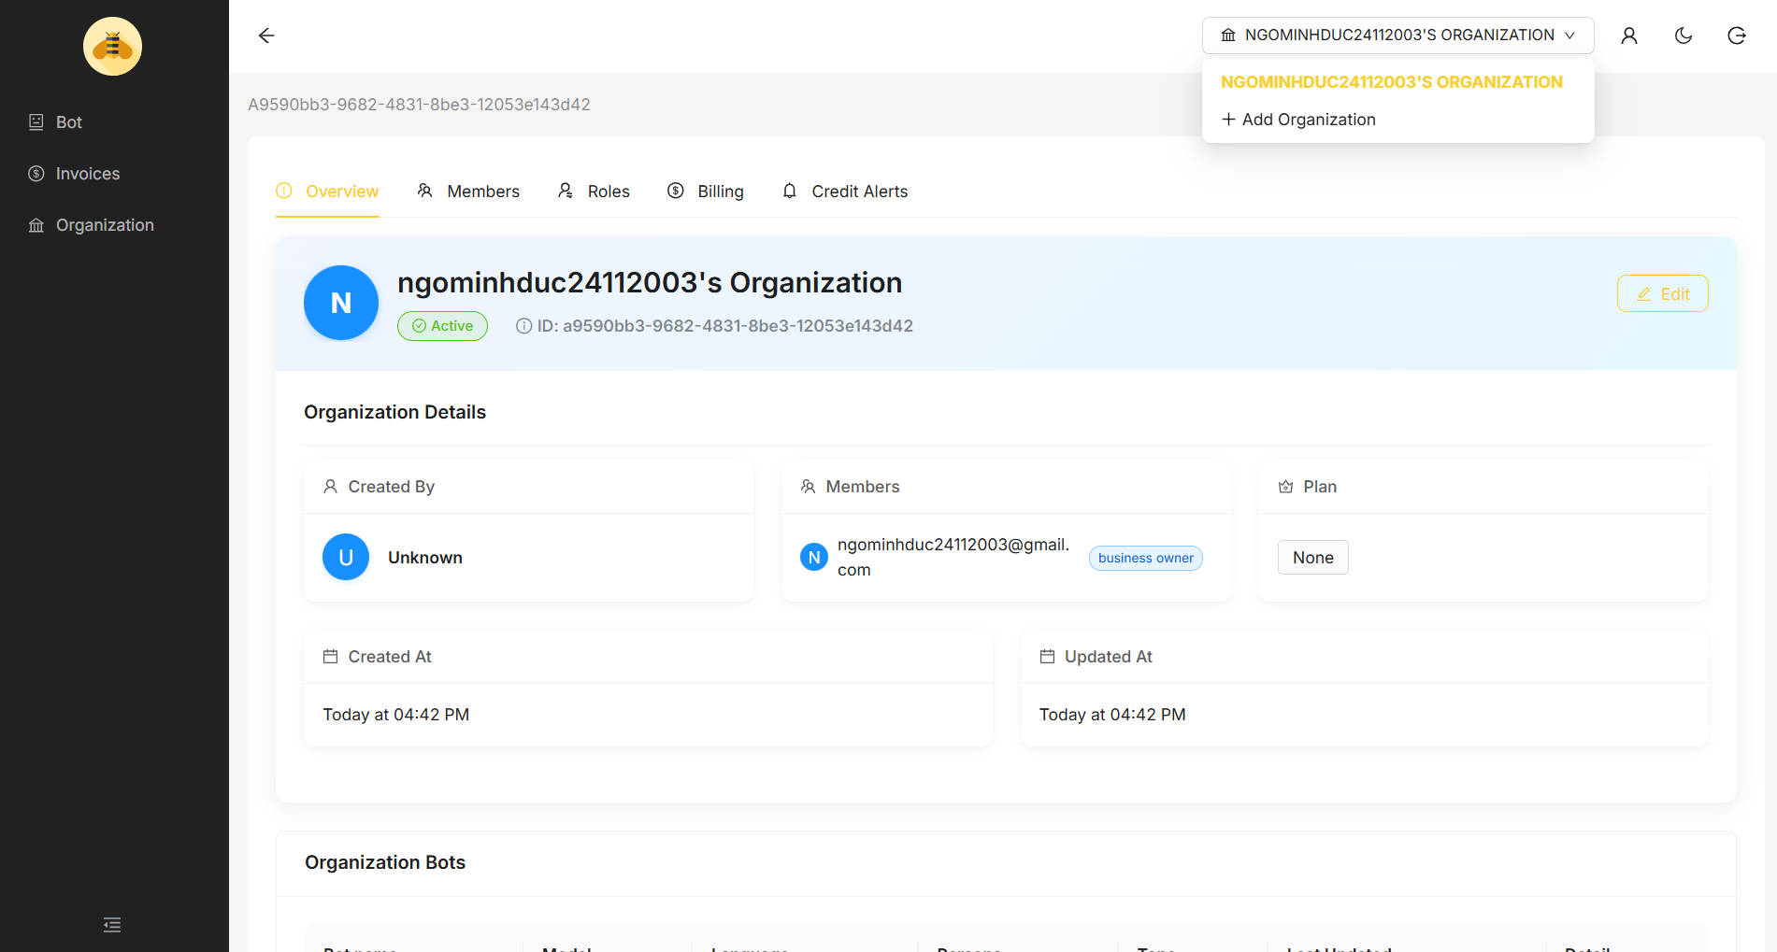

* After entering the selected Organization, user navigates to the “Billing” section.
* In the Billing section, user can view the current plan and available upgrade options.

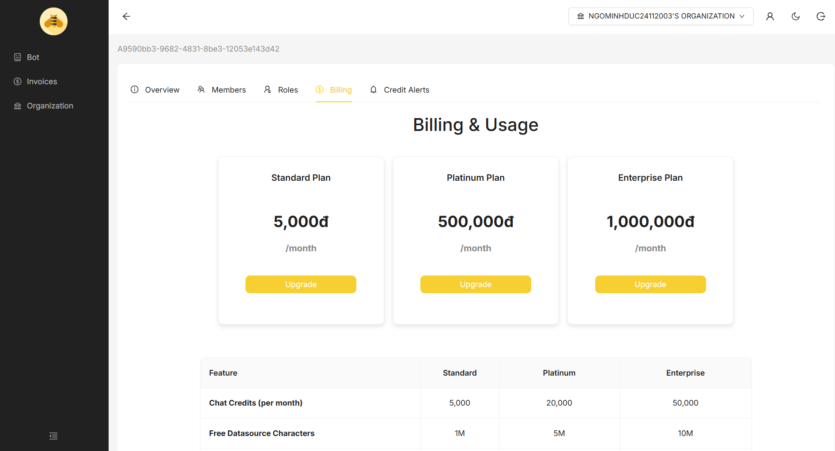

##### 3.3.1.2 Upgrade plan

Description: User wants to upgrade their organization's plan.

* In the Billing section, user views available plans.
* User clicks the “Upgrade” button on the desired plan.
* The system redirects the user to the VietQR payment page.
* User scans the displayed QR code using their banking app to complete the payment.
* After successful payment, the system payment displays a "Payment Successful" confirmation page.
* Back to the Billing page, the new plan is now shown as the active plan for the organization.



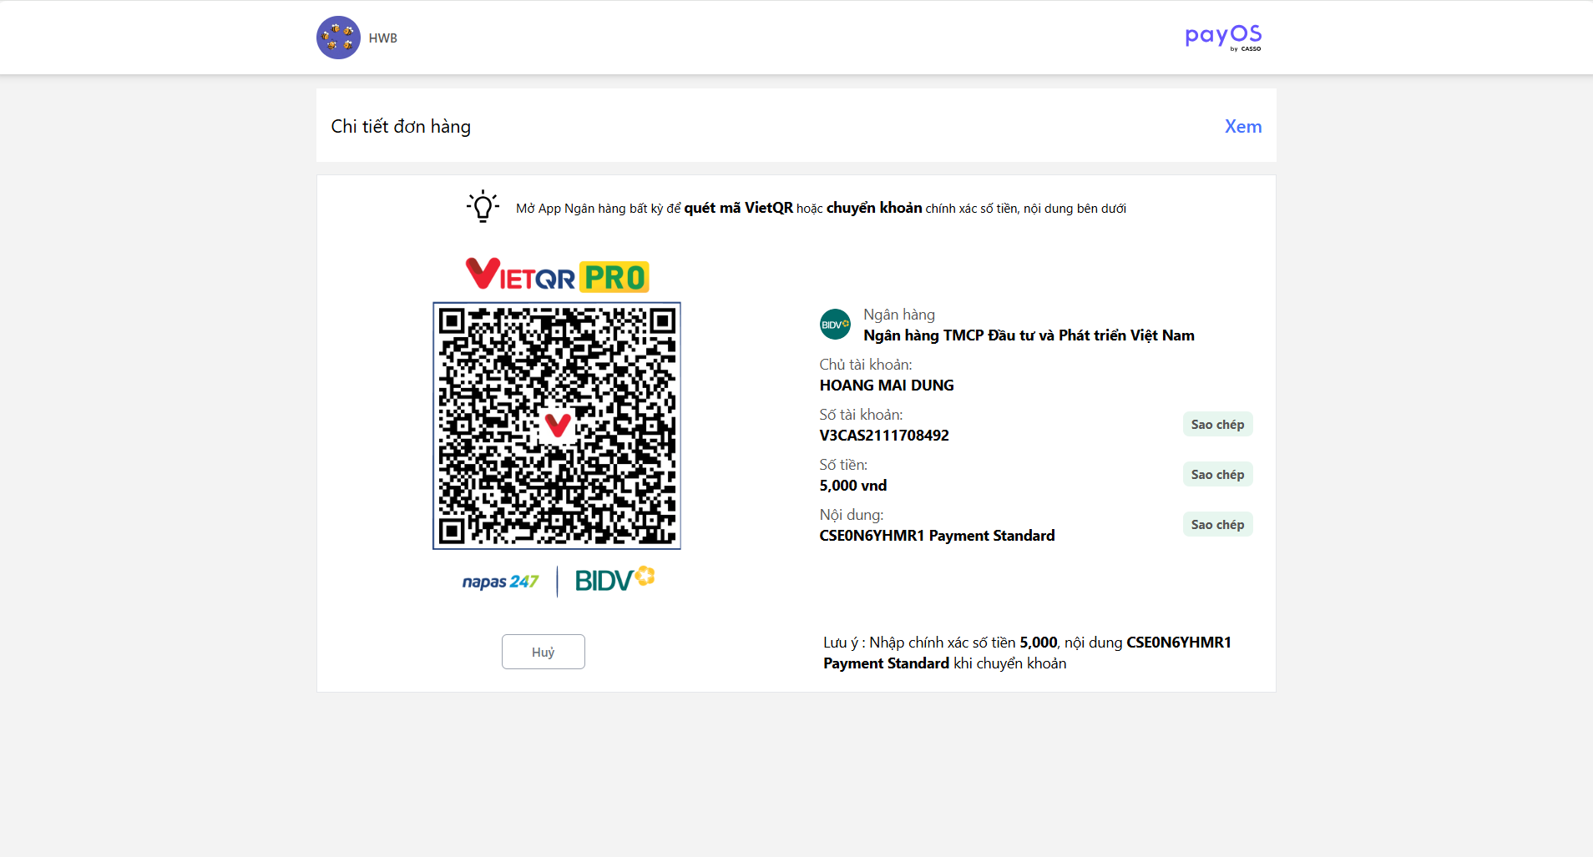

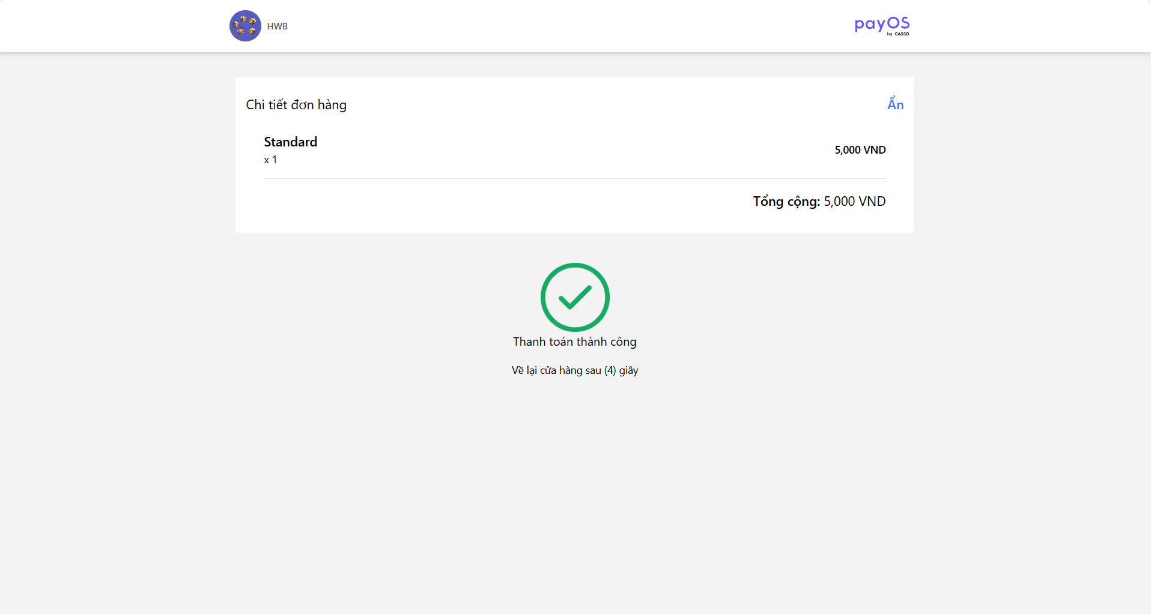

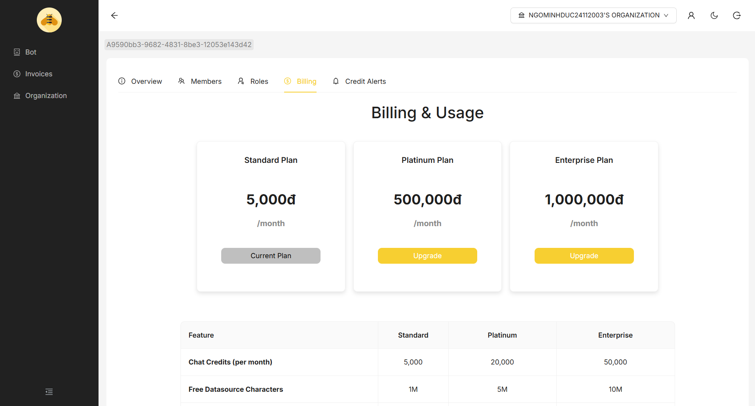

### 3.3.2 Add member for organization

##### 3.3.2.1 Create Role and Assign Permissions

Description: User wants to create a new role and assign permissions to that role.

* After logging into the system and selecting an Organization, user navigates to the Roles section.

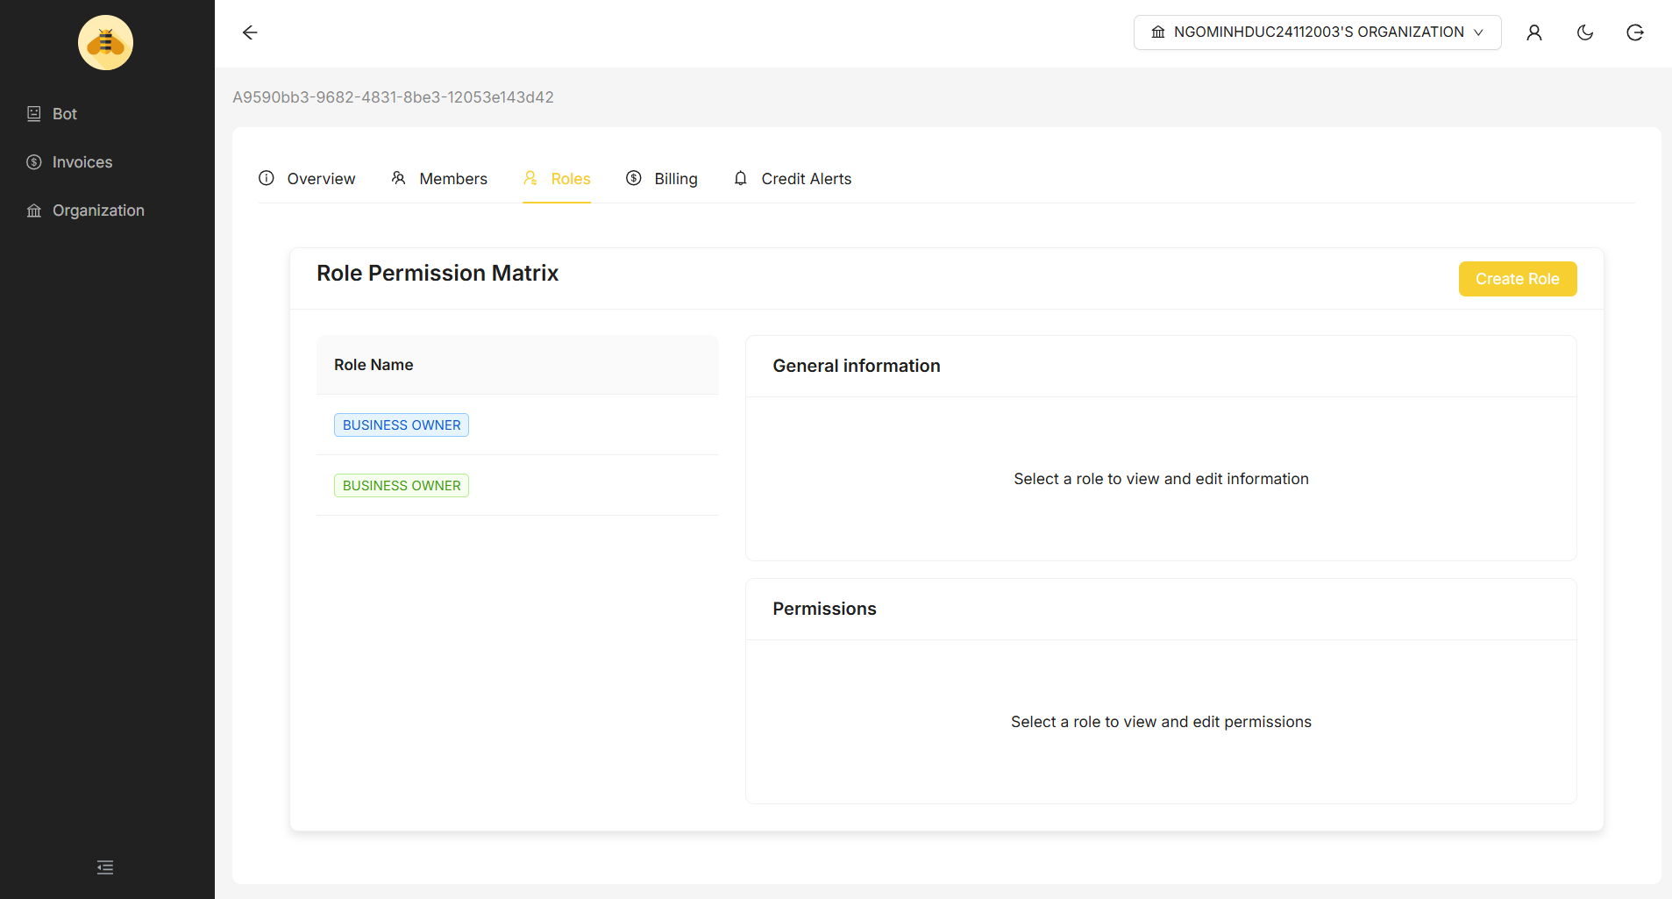

* User clicks “Create Role”.
* User fills in the Role Name and optional Role Description.
* User clicks “Save” to create the new role.

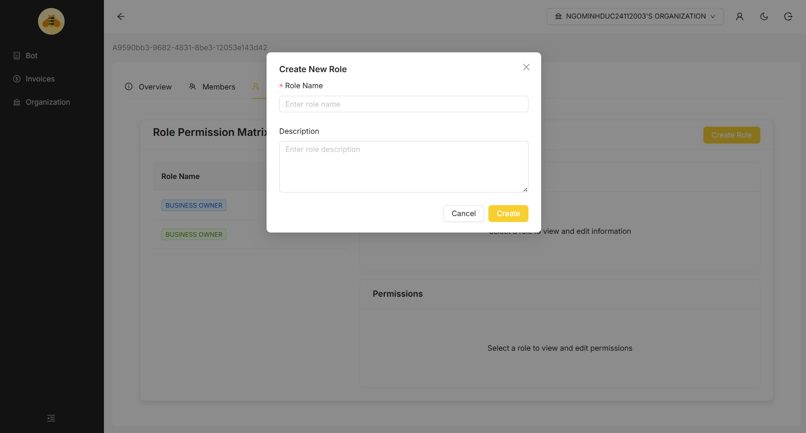

* After successful creation, the system redirects back to the List Roles page.
* User finds and clicks on the newly created Role from the list.
* On the Role Details page, user selects or configures the Permissions associated with this Role.
* User clicks “Save” to confirm the assigned permissions.

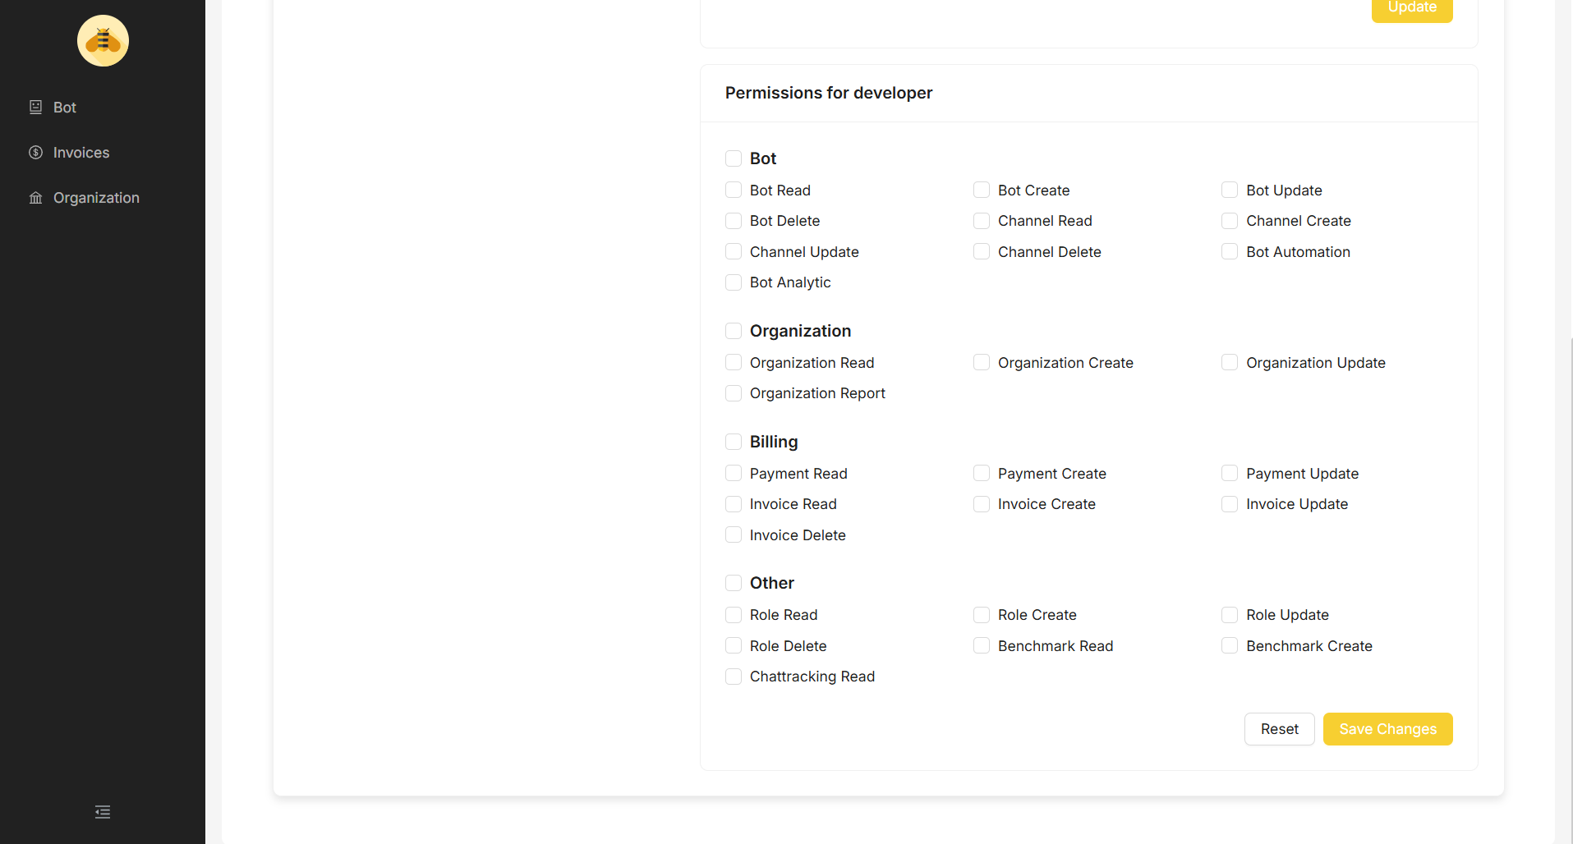

##### 3.3.2.2 Invite Member to Organization

Description: User wants to invite new members into the organization and assign roles to them.

* After logging into the system and selecting an Organization, user navigates to the Members section.
* User clicks “Invite Member”.
* User enters the email address of the member they want to invite and selects the Role for this member
* User clicks the “Invite” button.
* The system sends an invitation email to the provided email address with a link to join the organization.

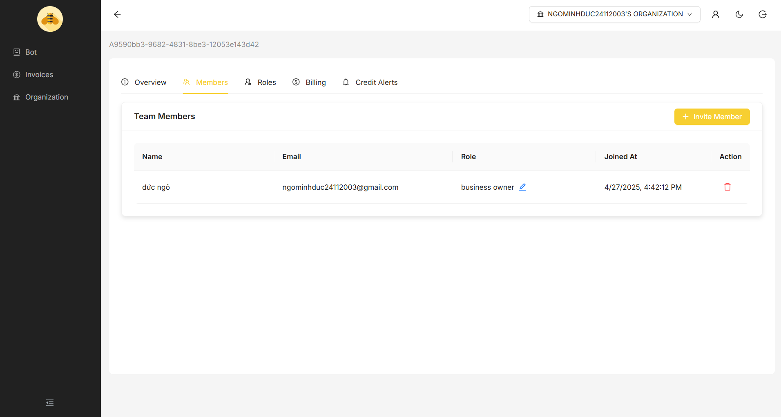

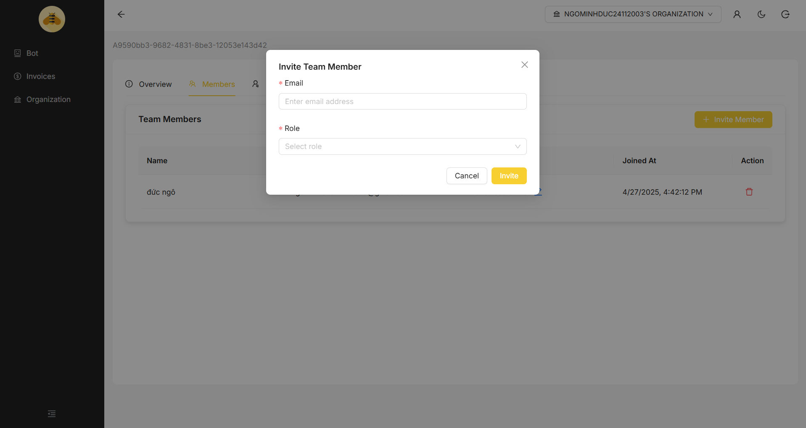

* Once the member click “accept invitation”, their status is updated, and they are added to the list of members in the organization.
* The system navigates users to the new organization.

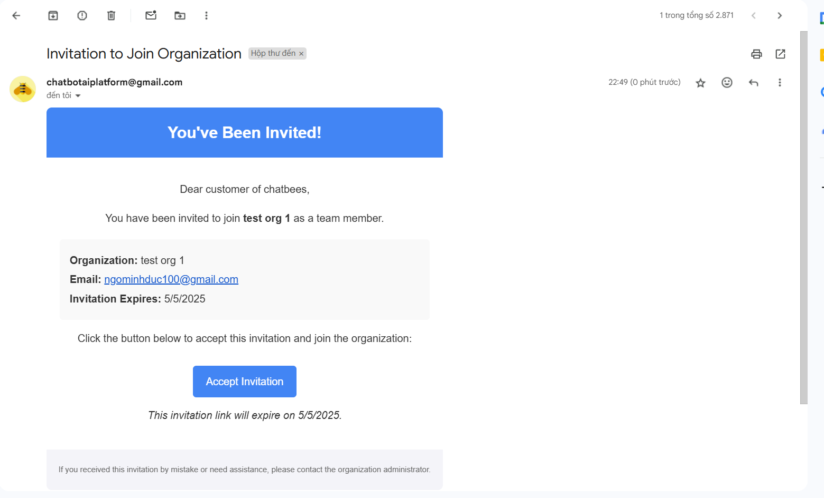

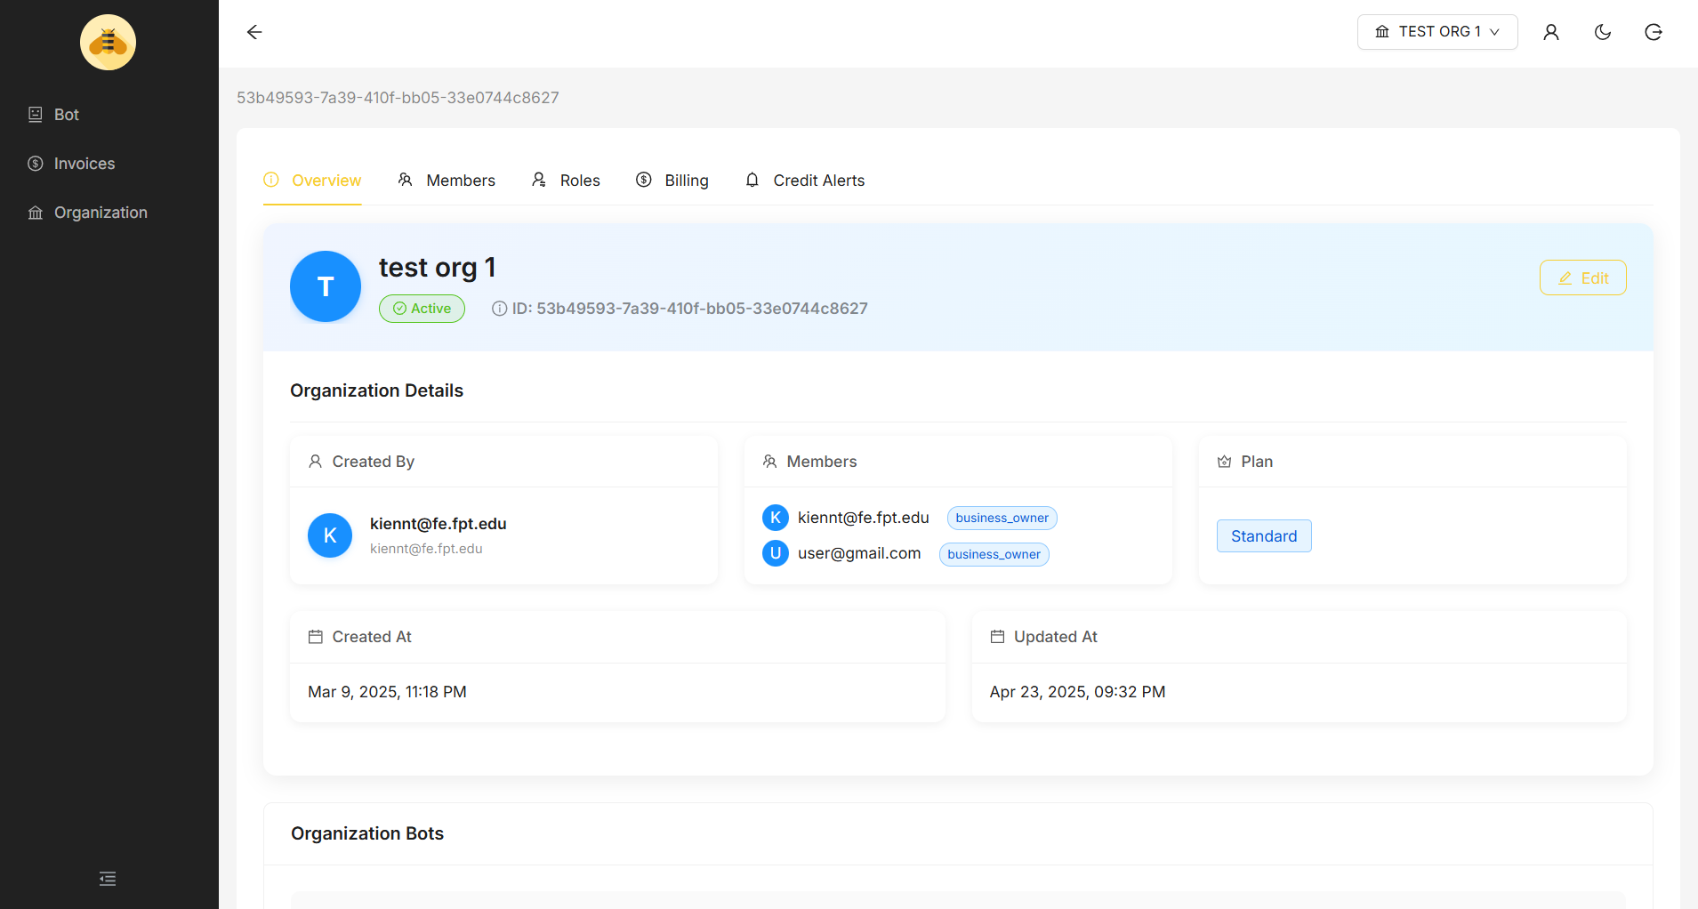

## 3.4. Config Bot

### 3.4.1 Create a new bot

Description: Create a new bot

* Navigate to the Bot Management dashboard to view all your bots. Click the "Add Bot" yellow button in the top-right corner

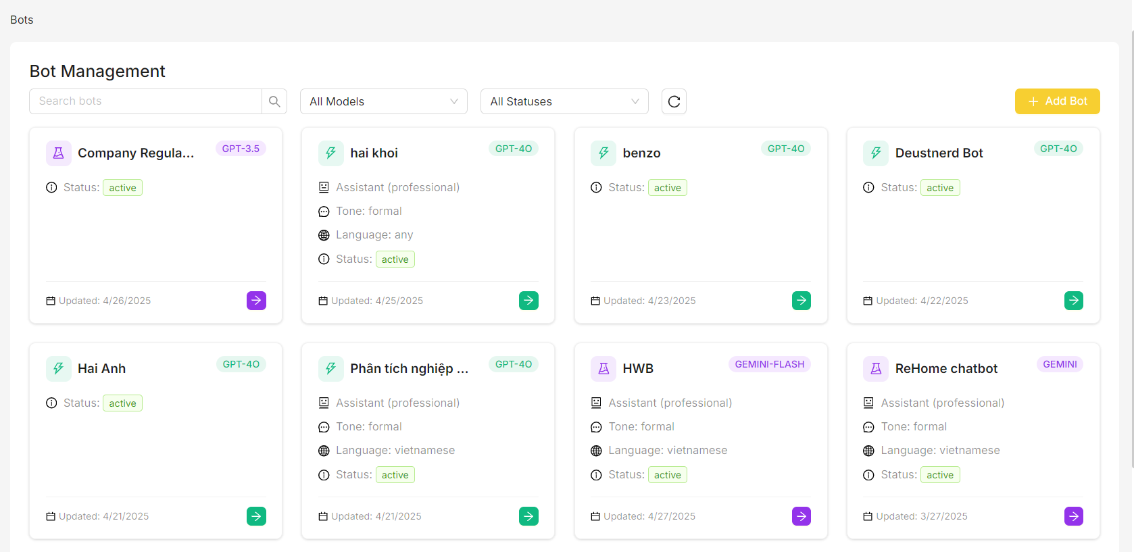

* **Enter Bot Name**: Type your desired bot name in the required field
* **Set Status**: Choose "Active" from the dropdown to make your bot available immediately
* **Select Model**: Choose AI model (GPT-3.5, GPT-4.0, GEMINI, etc.) based on your needs

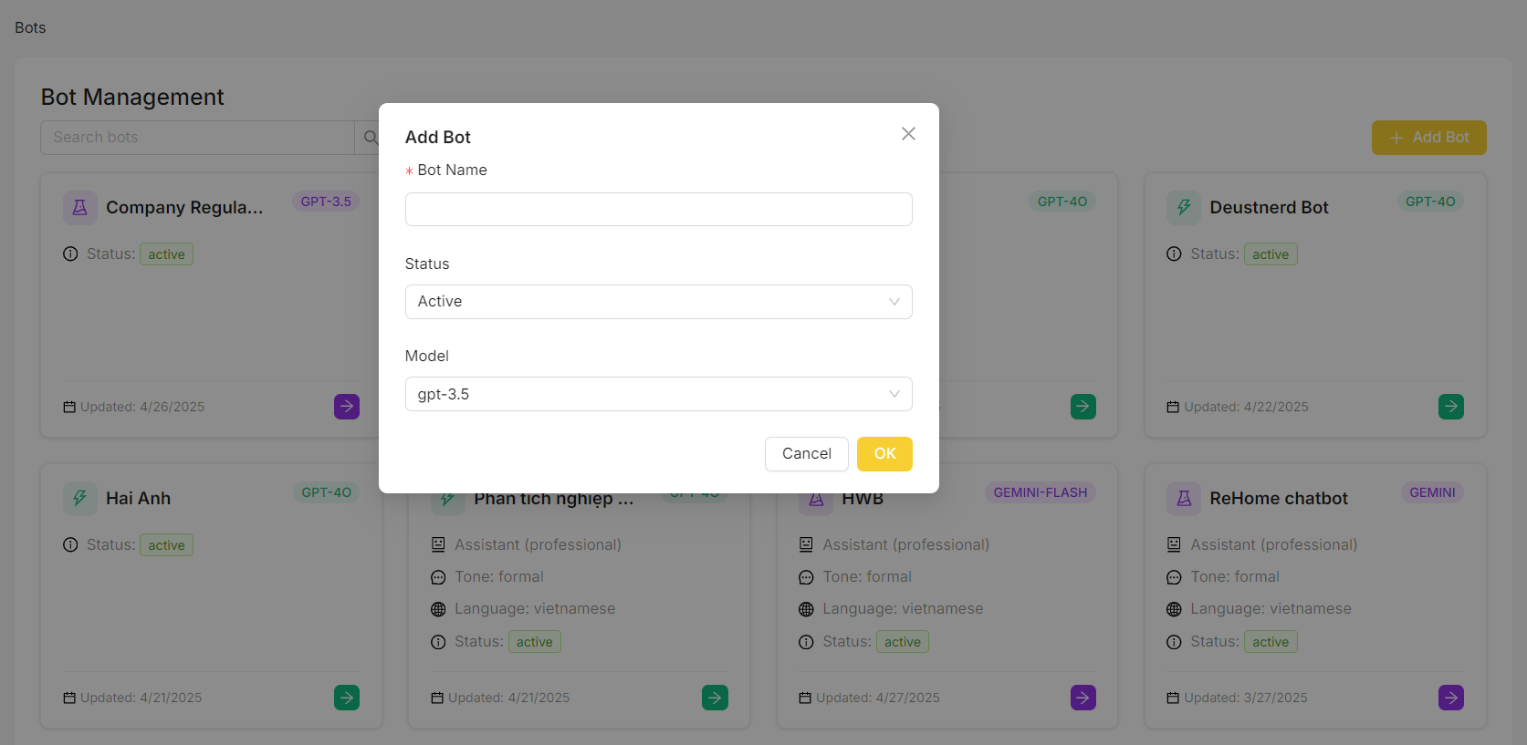

* After creation, the system take you to your bot overview page

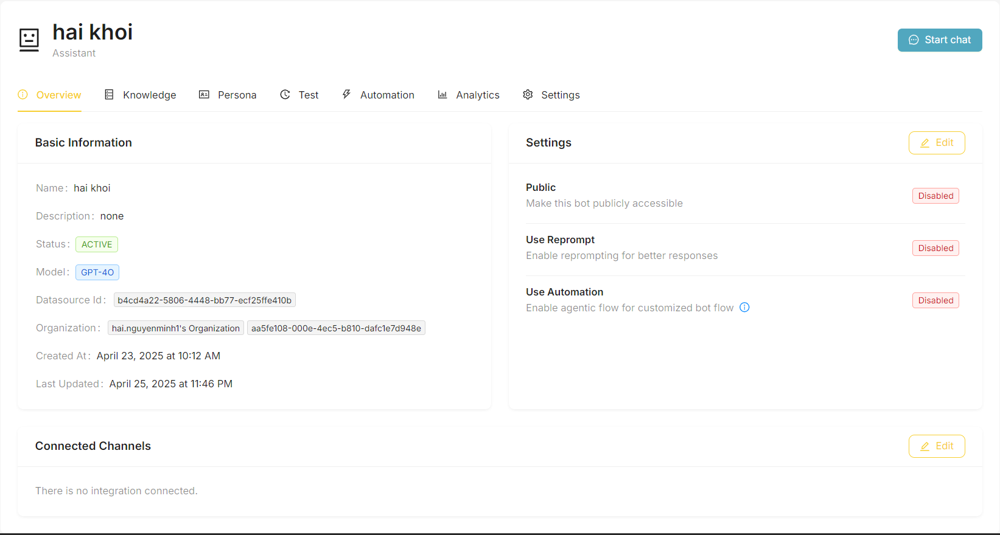

### 3.4.2 Config bot settings

### 3.4.3 Config prompt

### 3.4.4 Config bot knowledge

Description: Adding and managing knowledge sources for your bot. Properly configured knowledge lets your bot provide accurate information based on your specific content.

* Navigate to the Knowledge tab to view list knowledge page

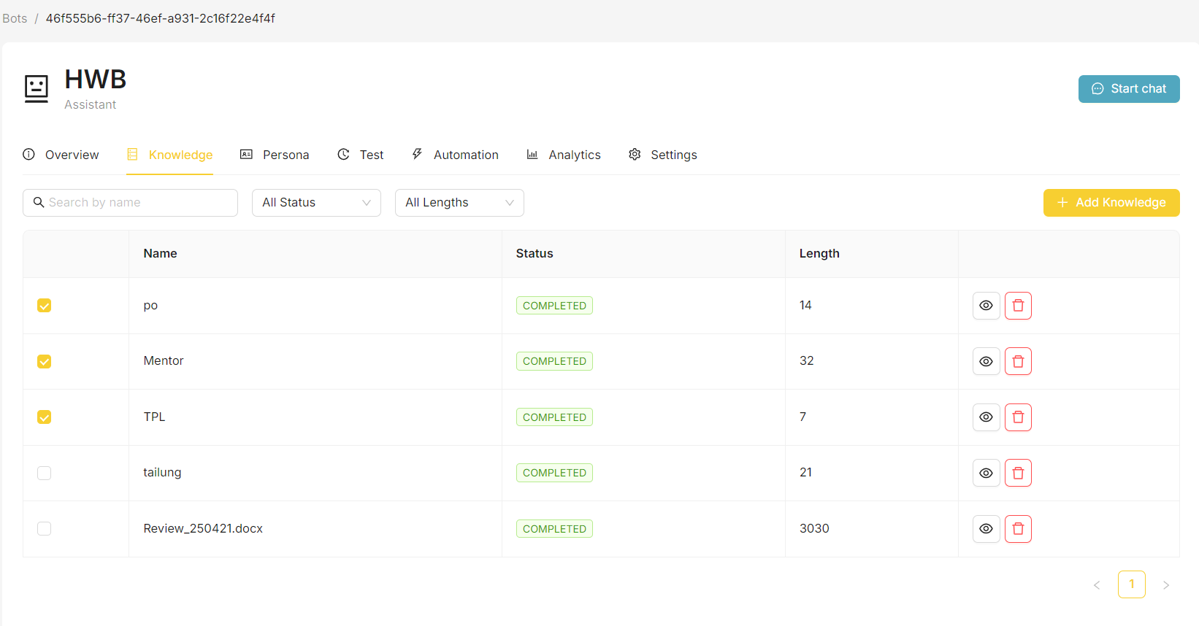

* The user can add new knowledge to the bot by clicking the "Add Knowledge" button in the top-right corner
* Choose your knowledge source type:
  + File: Upload documents (.txt, .pdf, .doc, .docx, .csv, .xls, .xlsx)
  + URL: Add website content
  + Text: Enter text directly

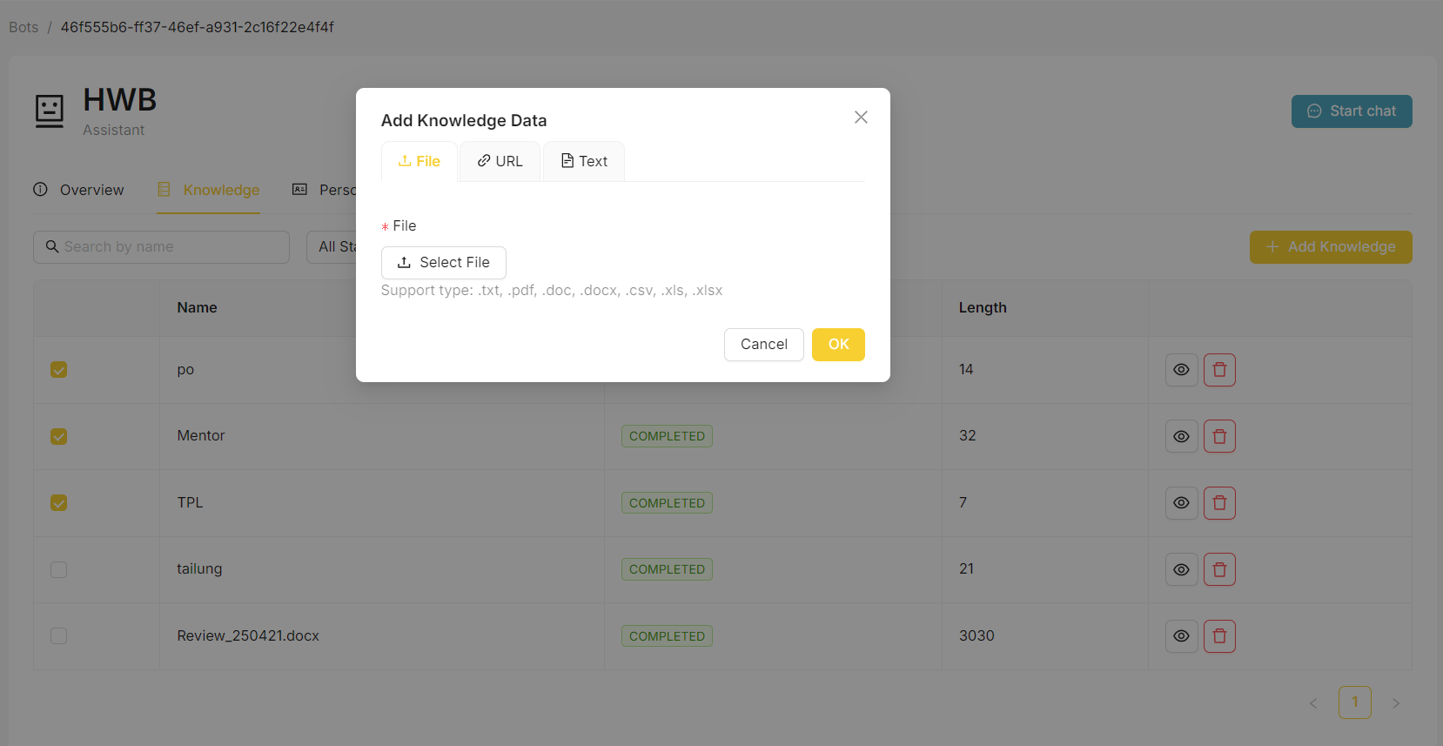

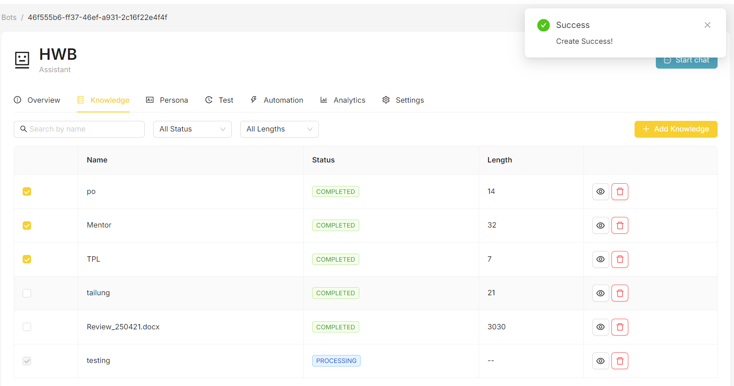

* Click the checkbox in the leftmost column next to any knowledge source you want to activate

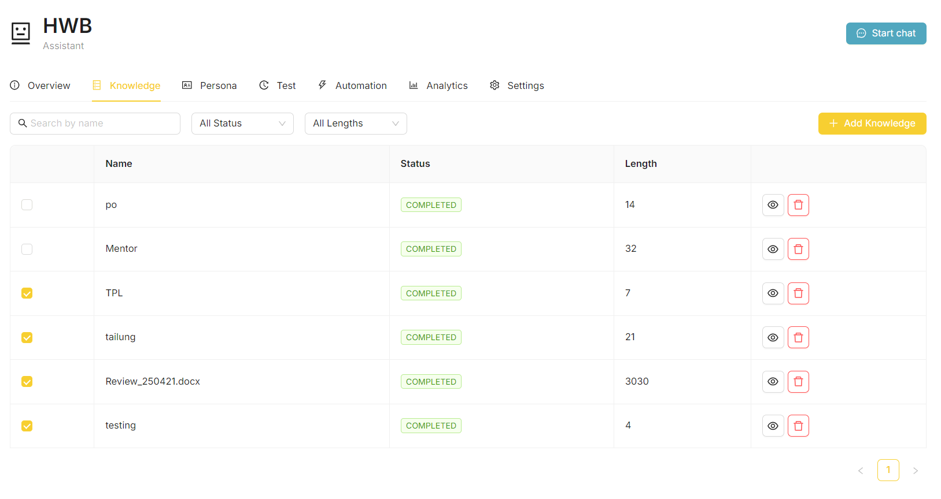

### 3.4.5 Config automation

### 3.4.6 Config analytic

Description: The User wants to view previous bot testing conversations

* In the bot detail page, click on the test tab.
* The user will then have a list of previous bot testing conversations

Description: The user wants to define insights that the bot should recognize and analyze. These insights help the agent detect valuable patterns or important events in conversations.

In the bot detail page, under the "Insight" section, click on the "+ New Insight" button.

The user can then define a new insight by entering its name and relevant keywords.

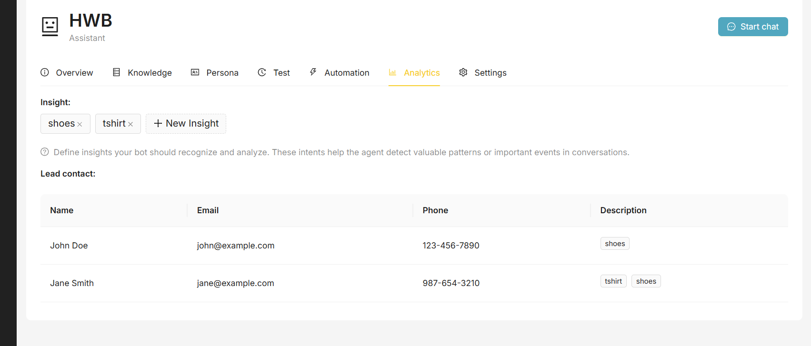

### 3.4.7 View test bot history

Description: The User wants to view previous bot testing conversations

* In the bot detail page, click on the test tab.
* The user will then have a list of previous bot testing conversations

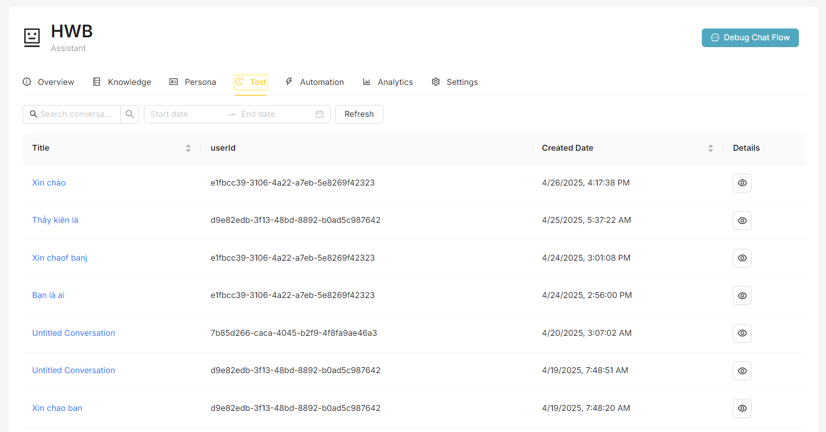

* Click on one of the conversations to preview its message content

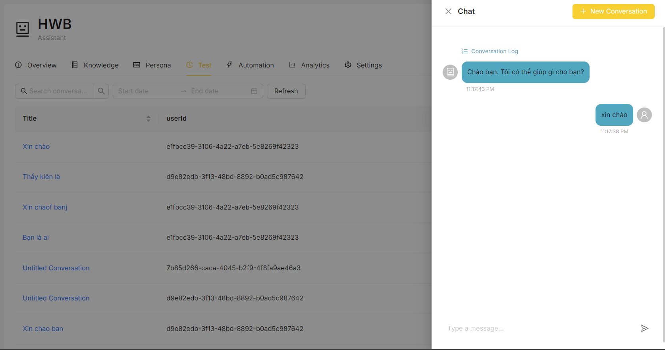

* To view insight on how the response was made, click on the “conversation log” button, and it will display information such as response time, token usages, and in in-depth workflow of the bot

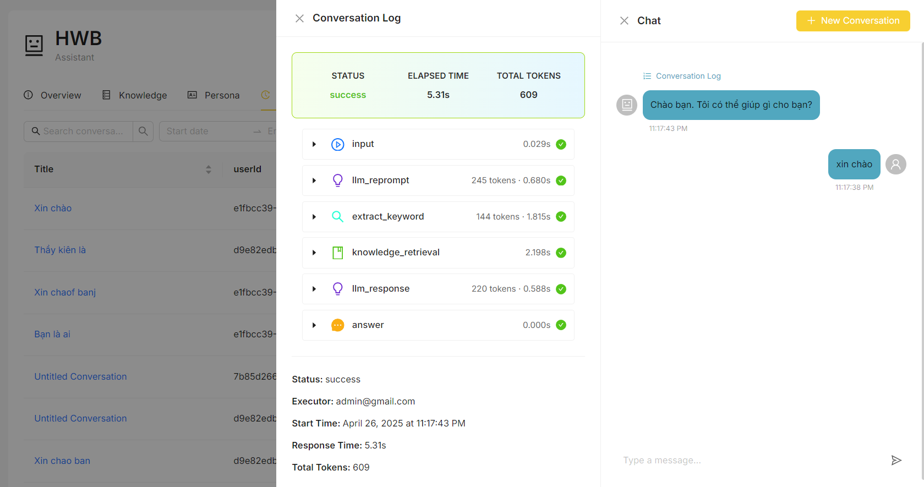

* From here, you can see the input and output of each step, you can check your prompt to see how the bot responds to the prompt, how the bot extracts keywords from previous messages, or which document the bot retrieves to answer the question.

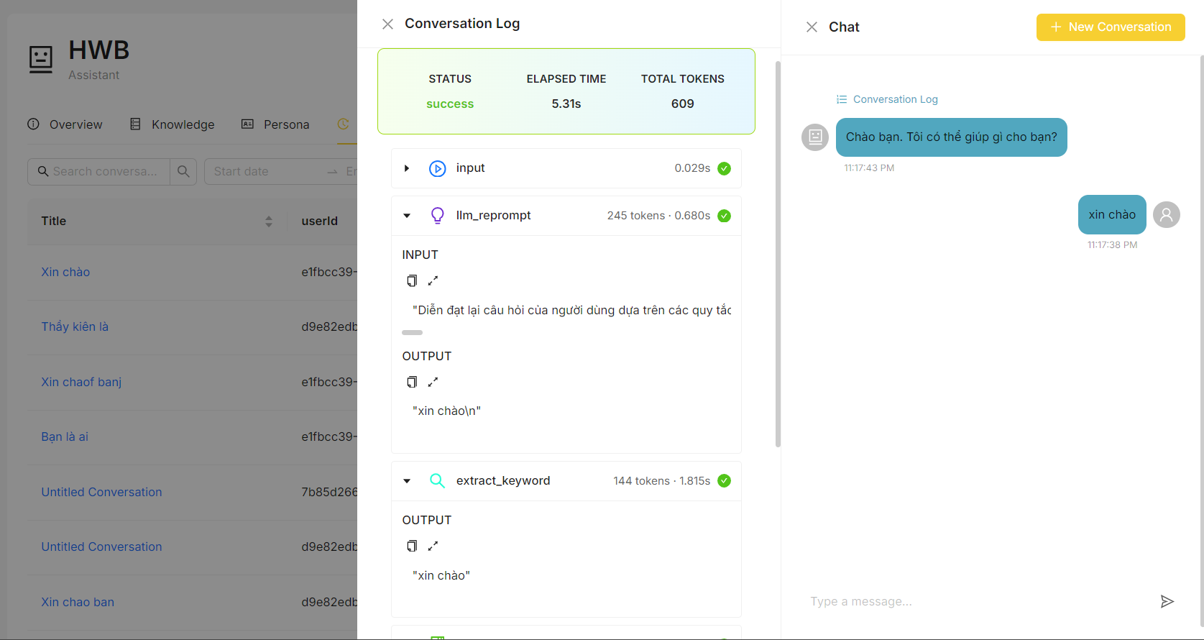

### 3.4.8 Create a test for bot conversation

Description: The User wants to create a new testing conversation

* In the bot detail page, click on the test tab.
* Click on Debug chat flow.

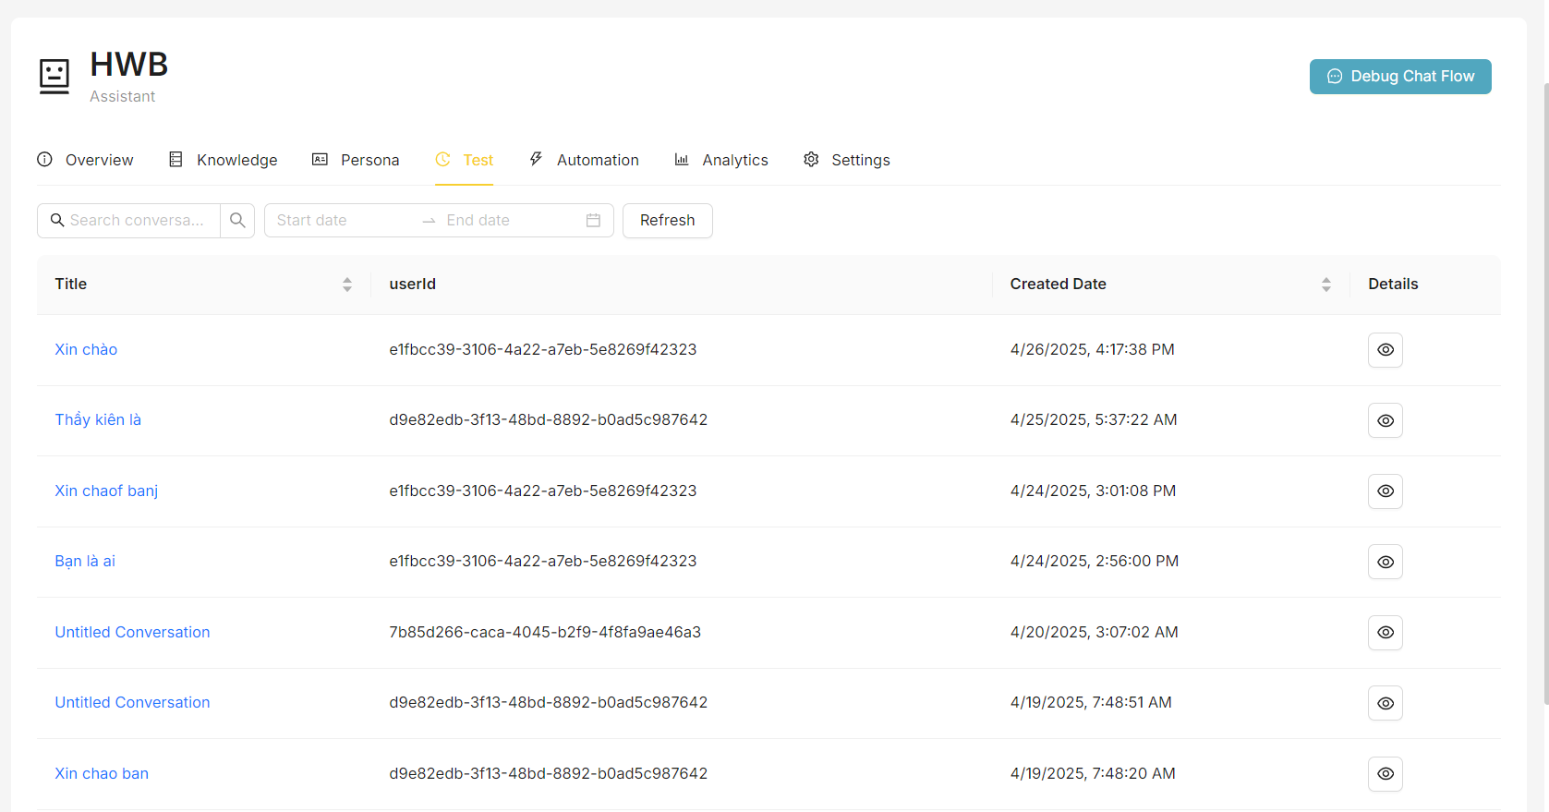

* If you have previously opened a conversation, then click on the “New Conversation” button. Otherwise, a new conversation will be automatically opened.

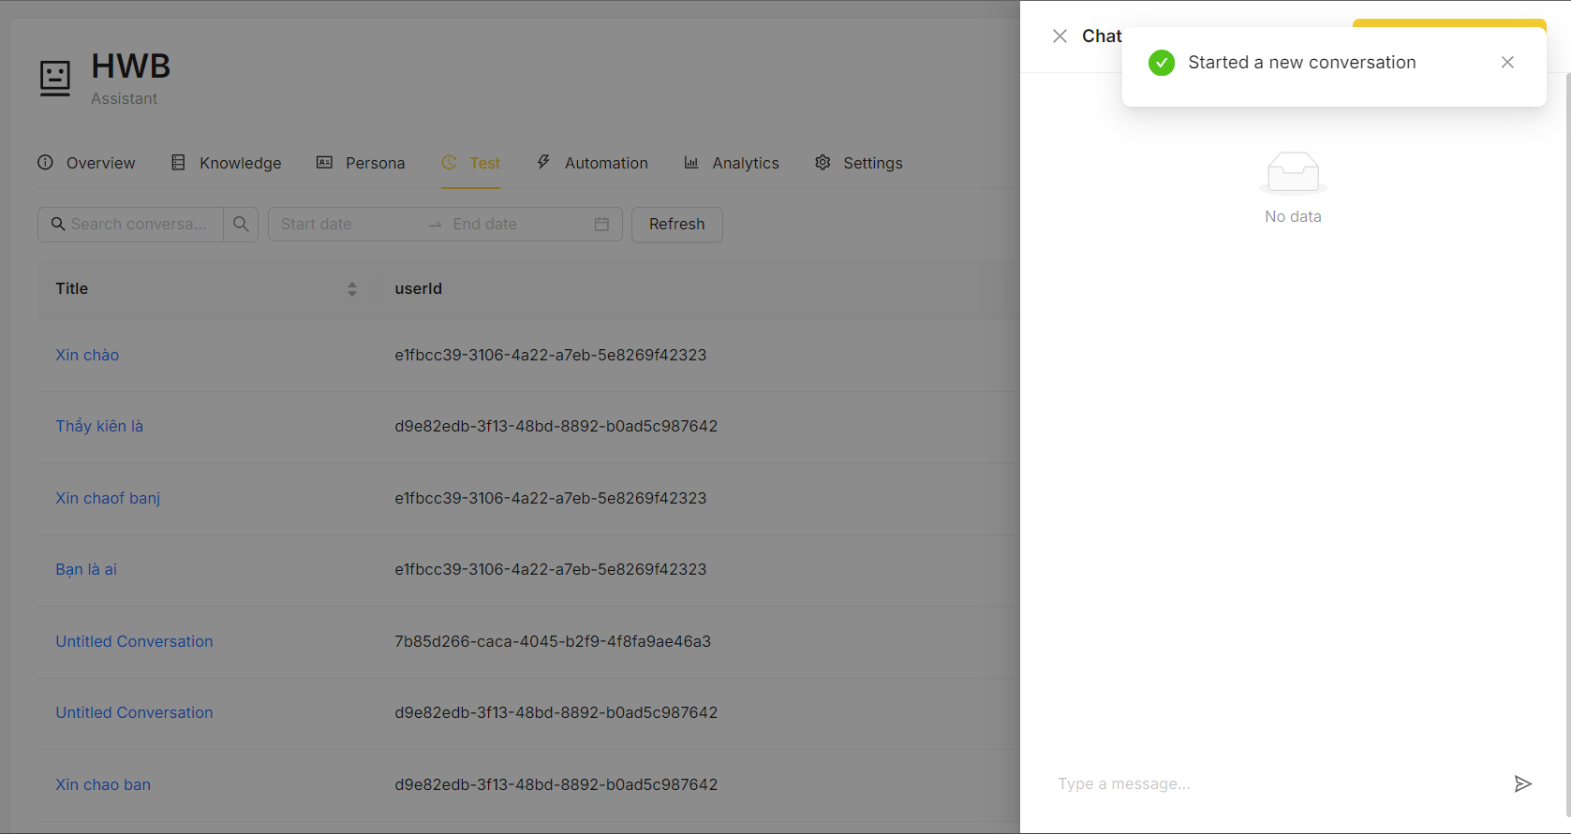

* From here, chat normally to view conversation logs.



### 3.4.9 Create a test for bot evaluation

Description: The User wants to create a new bot evaluation test

* Open the evaluation page, the user will see a list of previous evaluation tests. Click on the “new evaluation” button to start testing

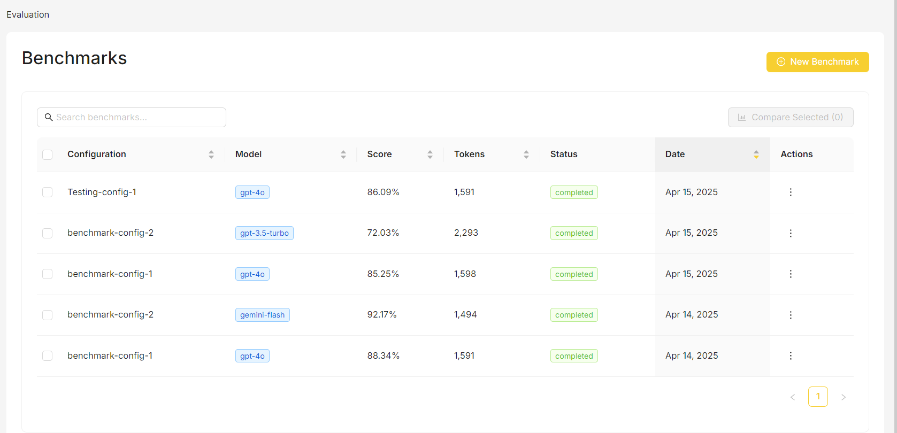

* Inside the new evaluation page, the user will input a title for the evaluation test.
* Then the user will select which bot they want to test. The bot list will include all the bots of the organization the user is in.

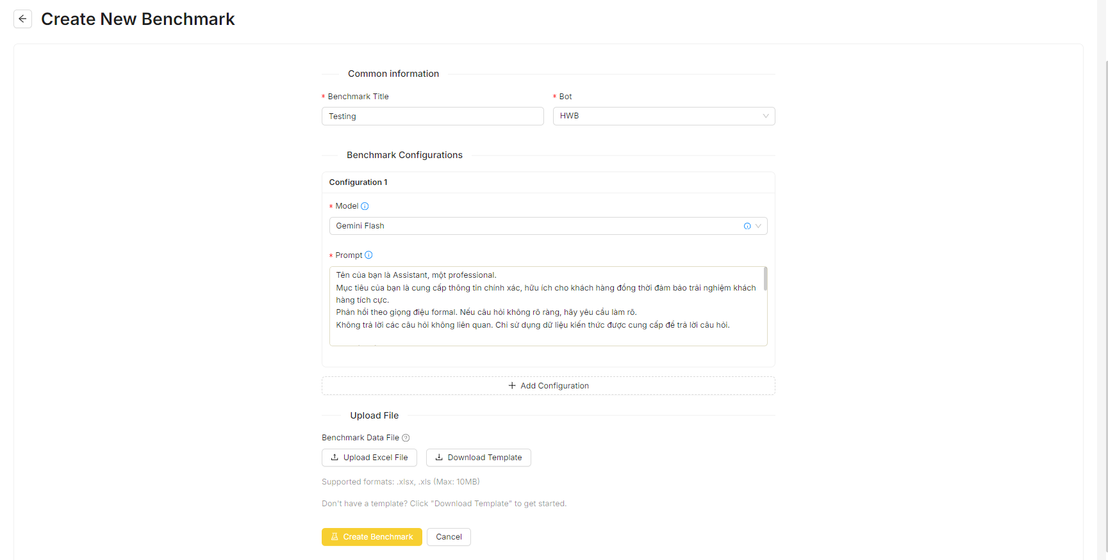

* To properly test bot evaluation, users need to input a question file. The user can download the template file and update it with their own questions and expect answers

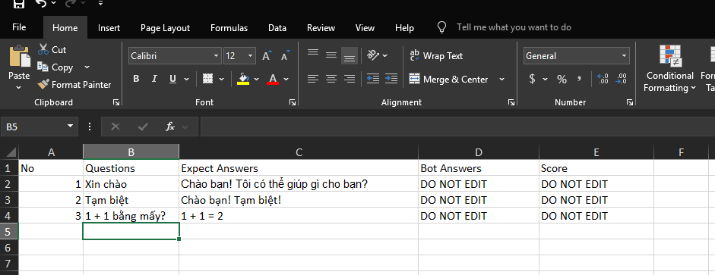

* The user then chooses to configure the evaluation to evaluate their bot, including choosing models and choosing their prompt.
* If they want to do more than one config, they can click on “new configuration” button and a new config form will display. Input this and the system will run more than one configuration.

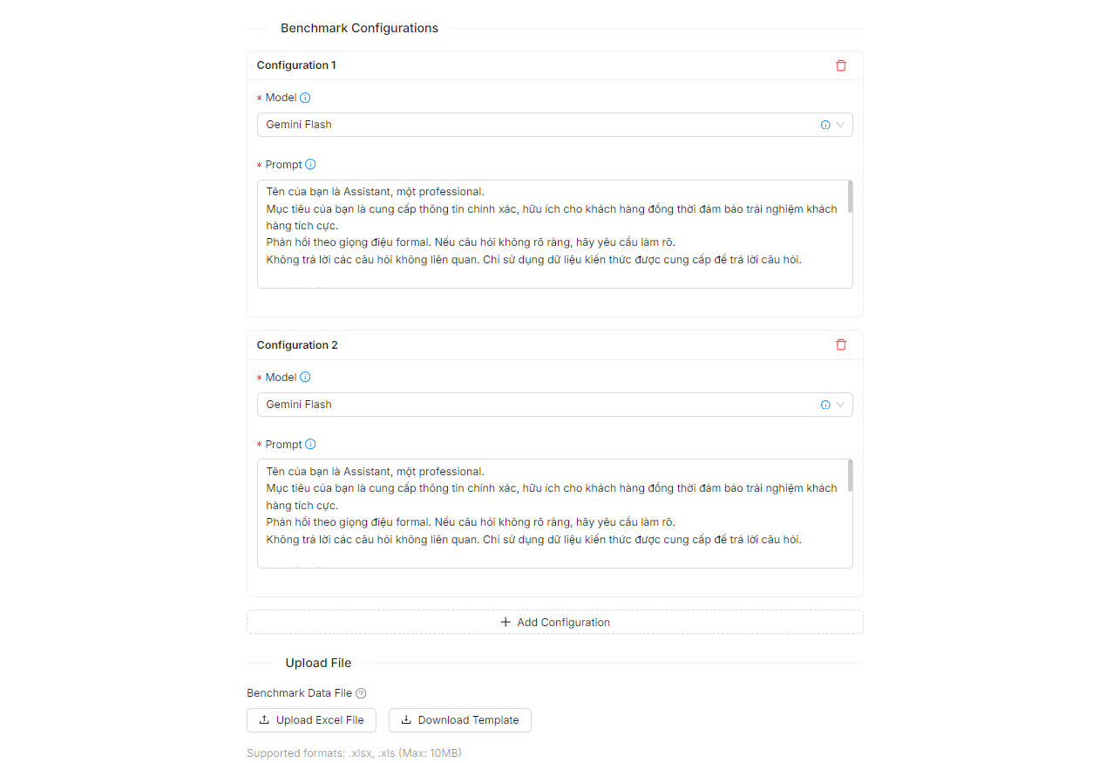

* Once ready, click the “create evaluation” button and let the system run the configs.

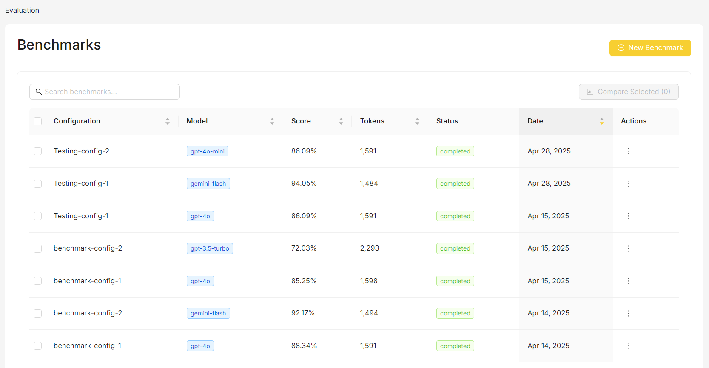

### 3.4.10 View bot evaluation test detail

Description: The User wants to view details of the bot evaluation test

* In the list, click on View Detail in the action column

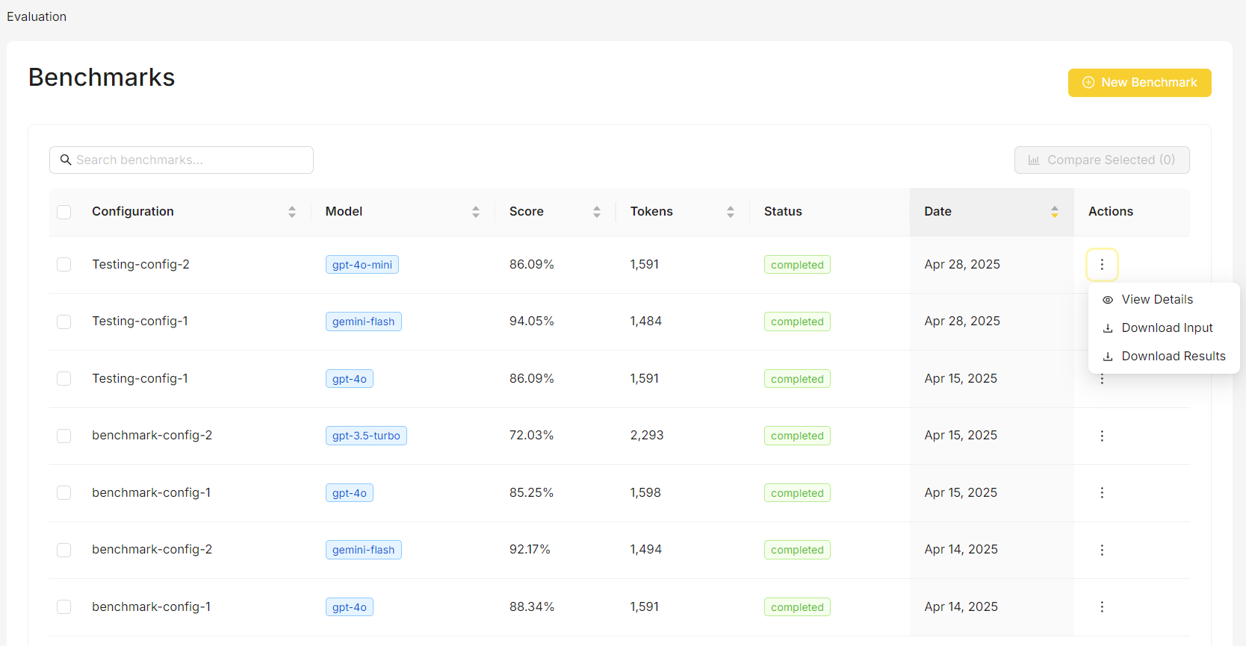

* In the detail page, the user can view details of the evaluation run, including response time, token usage, chosen bot configurations, and scores of the similarity to expected answers.
* Shows a side-by-side performance comparison of your selected AI models, displaying key metrics like scores, token usage, and efficiency in an easy-to-read table format. This gives you a quick overview of how different configurations perform against each other.

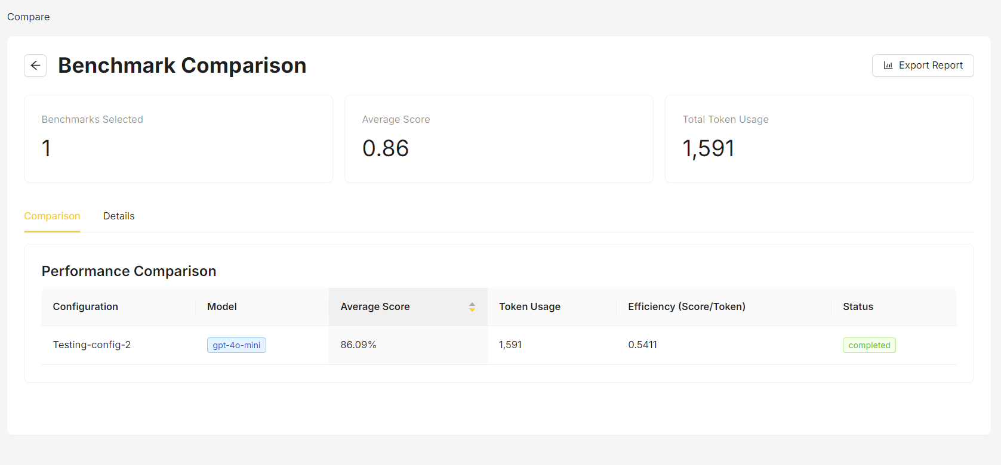

* Provides in-depth information about each individual evaluation run, including the specific prompts used, timing information, processing speeds, and completion rates. Here you can examine the full context of each test and download the associated data files for further analysis.

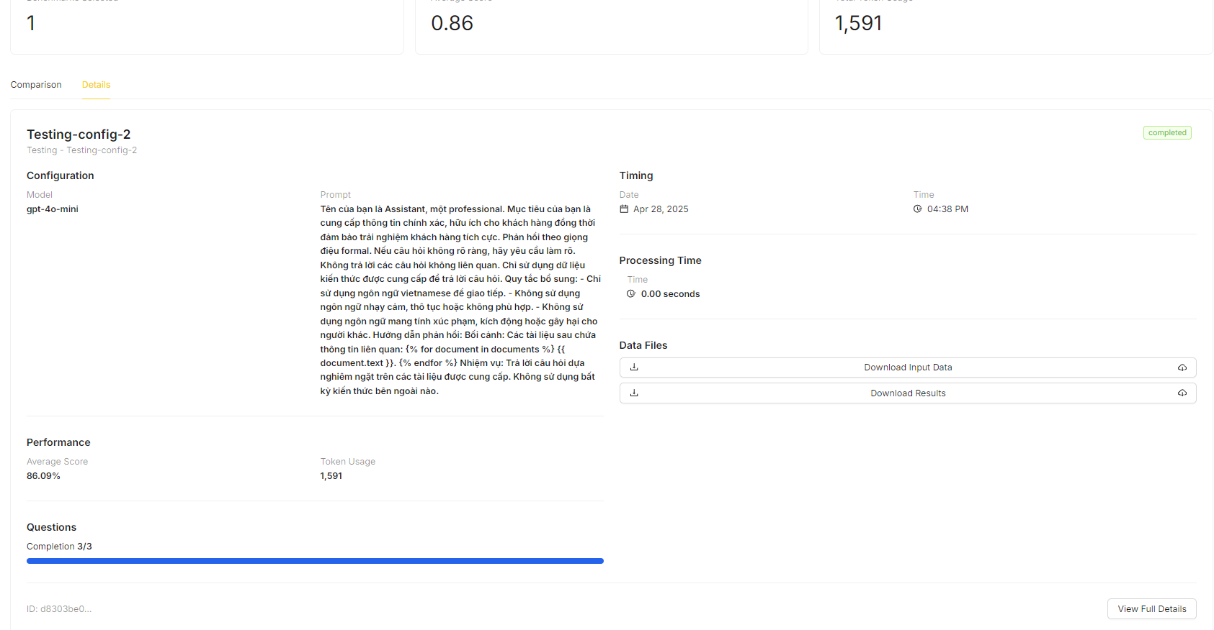

* Users can also download input data files, output data files for further inspection.

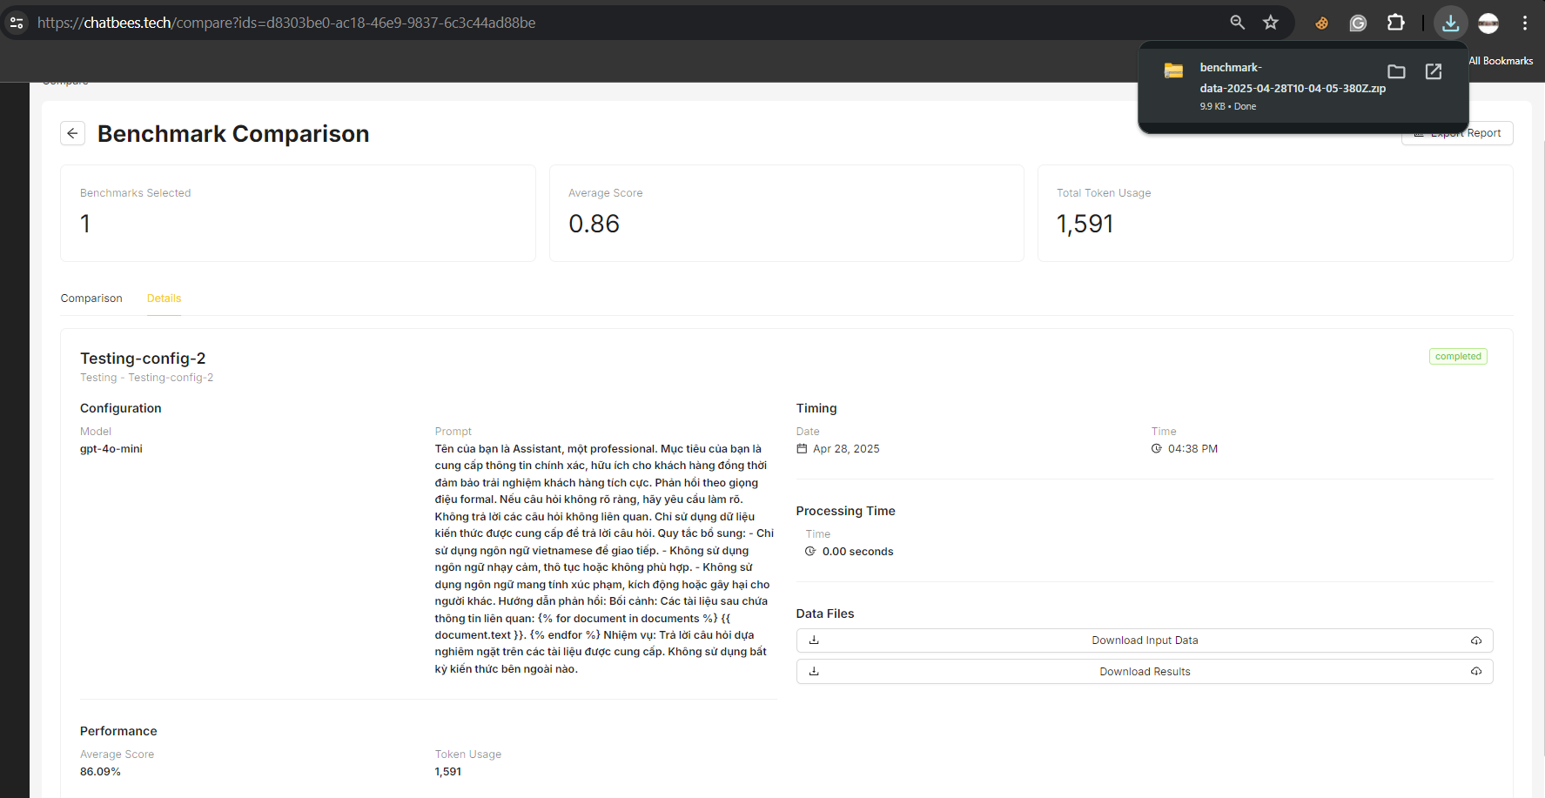

### 

### 3.4.11 Compare different bot evaluation tests

Description: The User wants to view and compare bot evaluation tests

* In the list, click on the check box in the first column to select multiple evaluation tests. Click the “compare selected” button to be directed to the detail page.

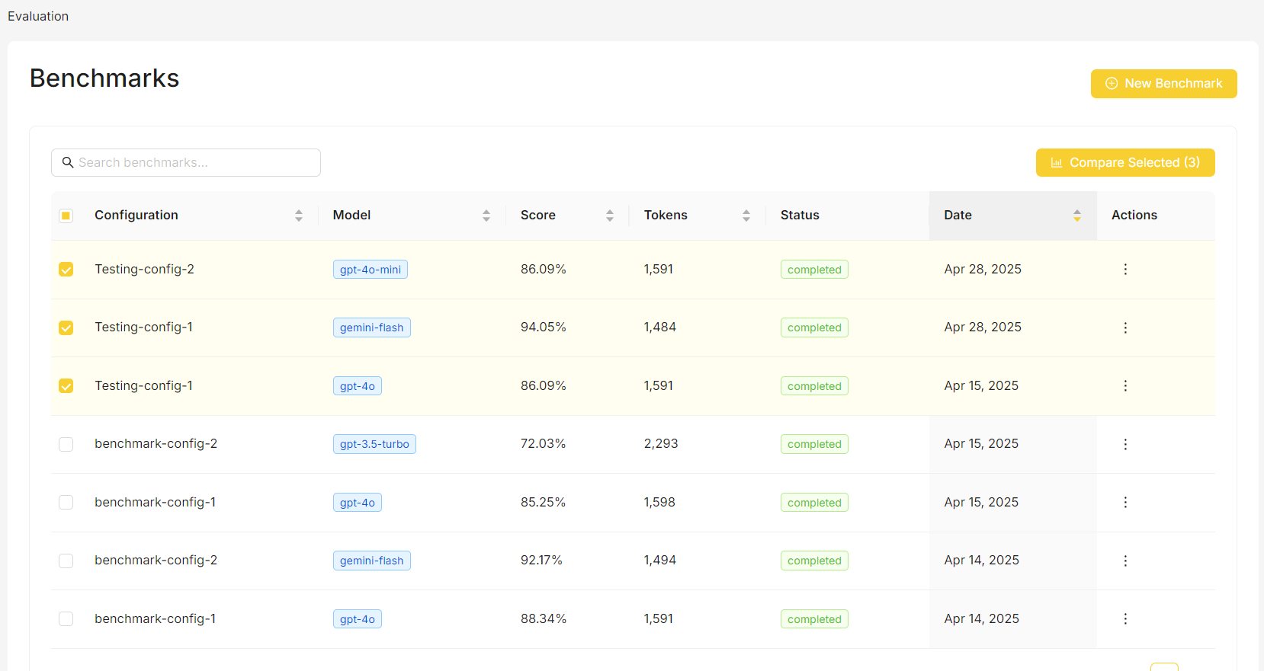

* Shows a side-by-side performance comparison of your selected AI models, displaying key metrics like scores, token usage, and efficiency in an easy-to-read table format. This gives you a quick overview of how different configurations perform against each other.

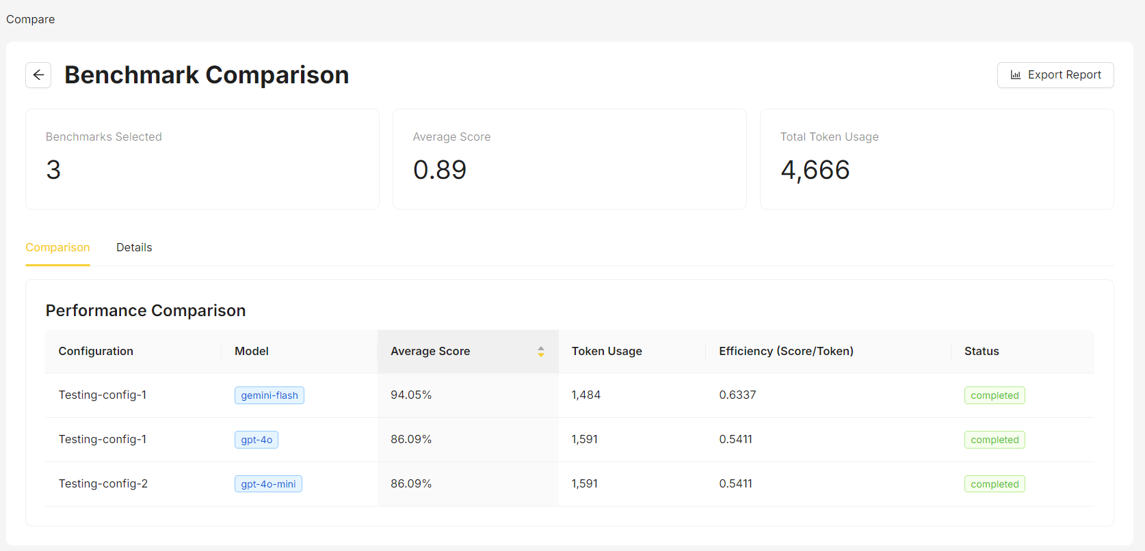

* Provides in-depth information about each individual evaluation run, including the specific prompts used, timing information, processing speeds, and completion rates. Here you can examine the full context of each test and download the associated data files for further analysis.

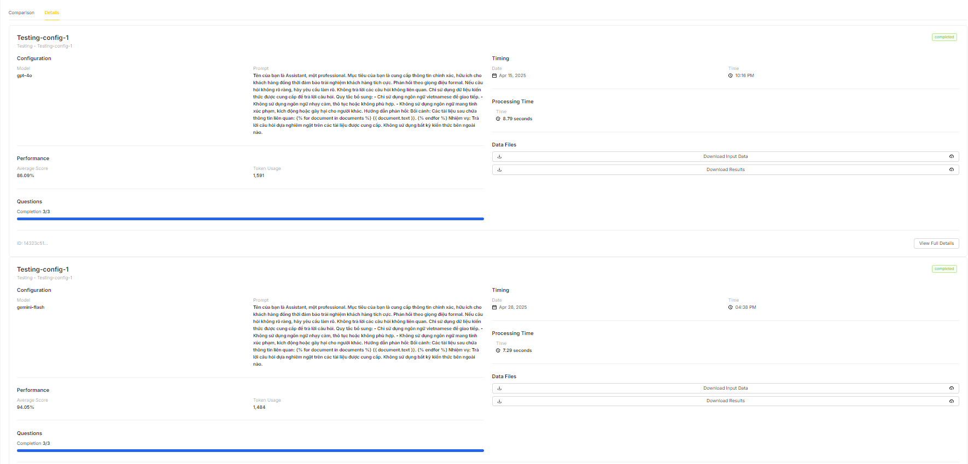

* Users can also download input data files, output data files for further inspection.

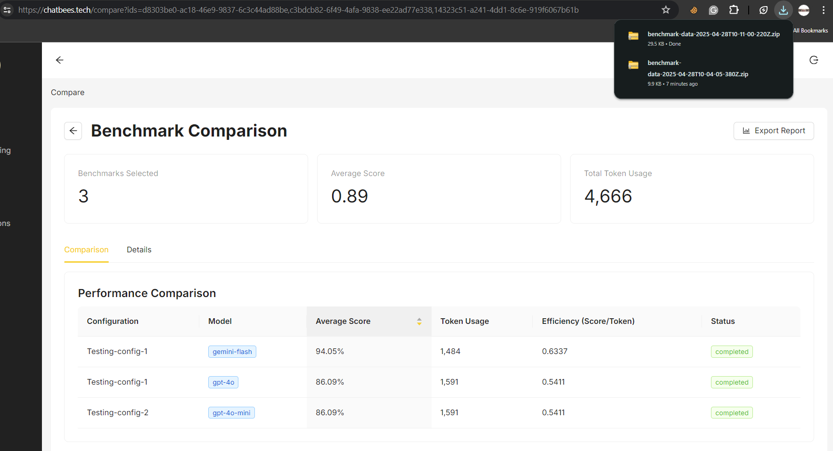

### 3.4.12 View live chat

Description: The User wants to view customer conversation

* Click on tab “Chat tracking” on the sidebar, the system will take the user to a live chat page where user can monitor user conversations.

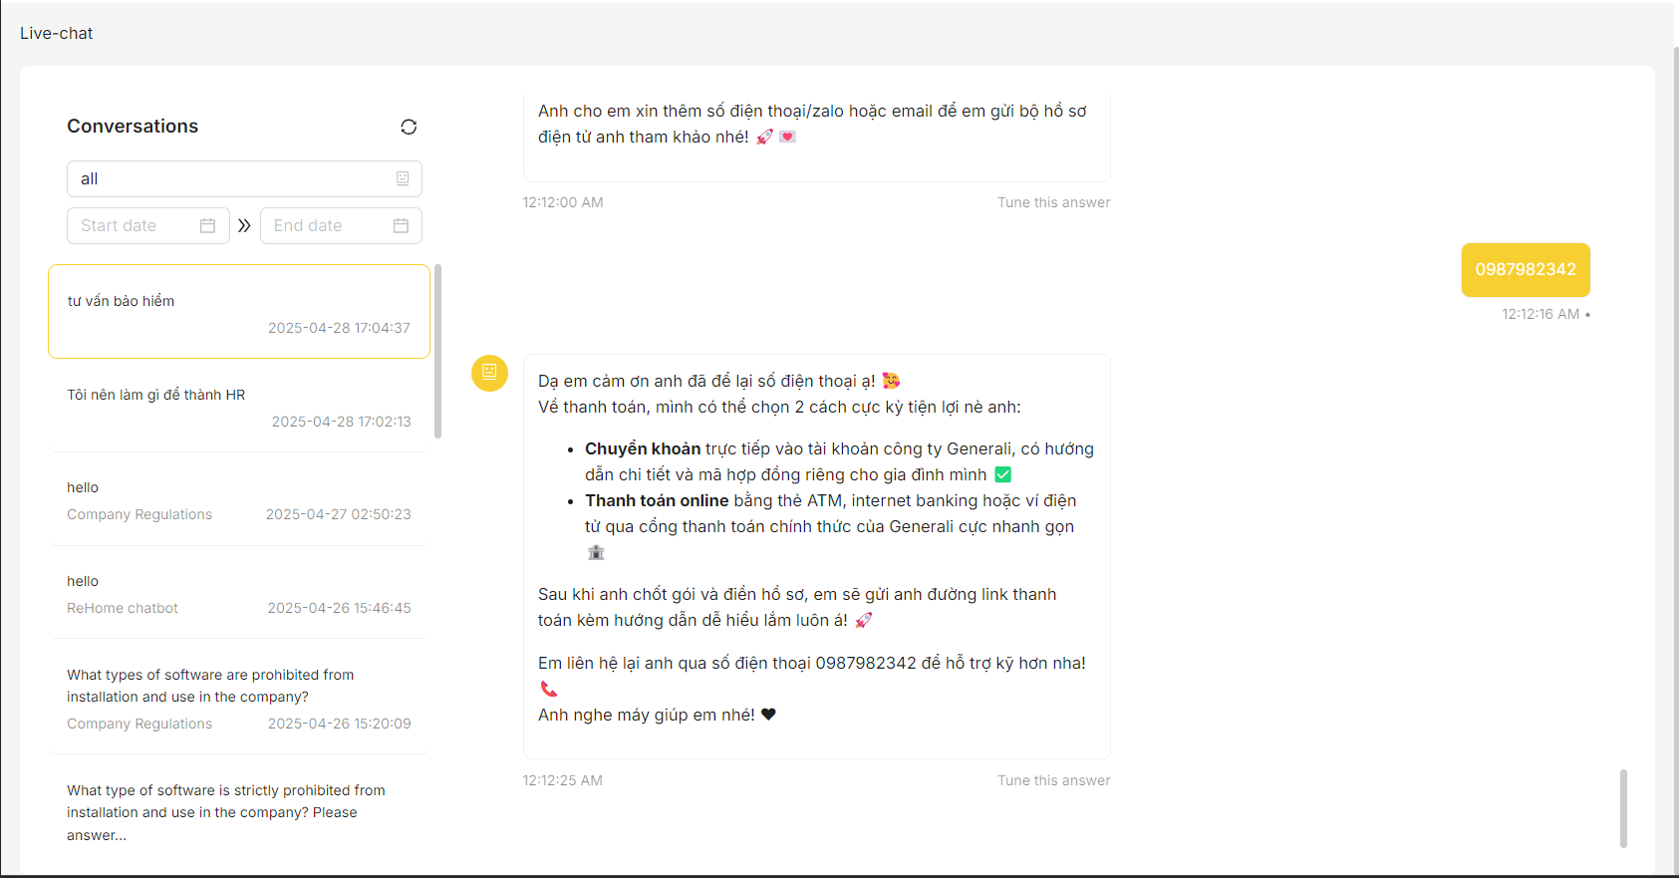

* The user can select which bot they want to specifically monitor, or the date range from which the conversation happens.

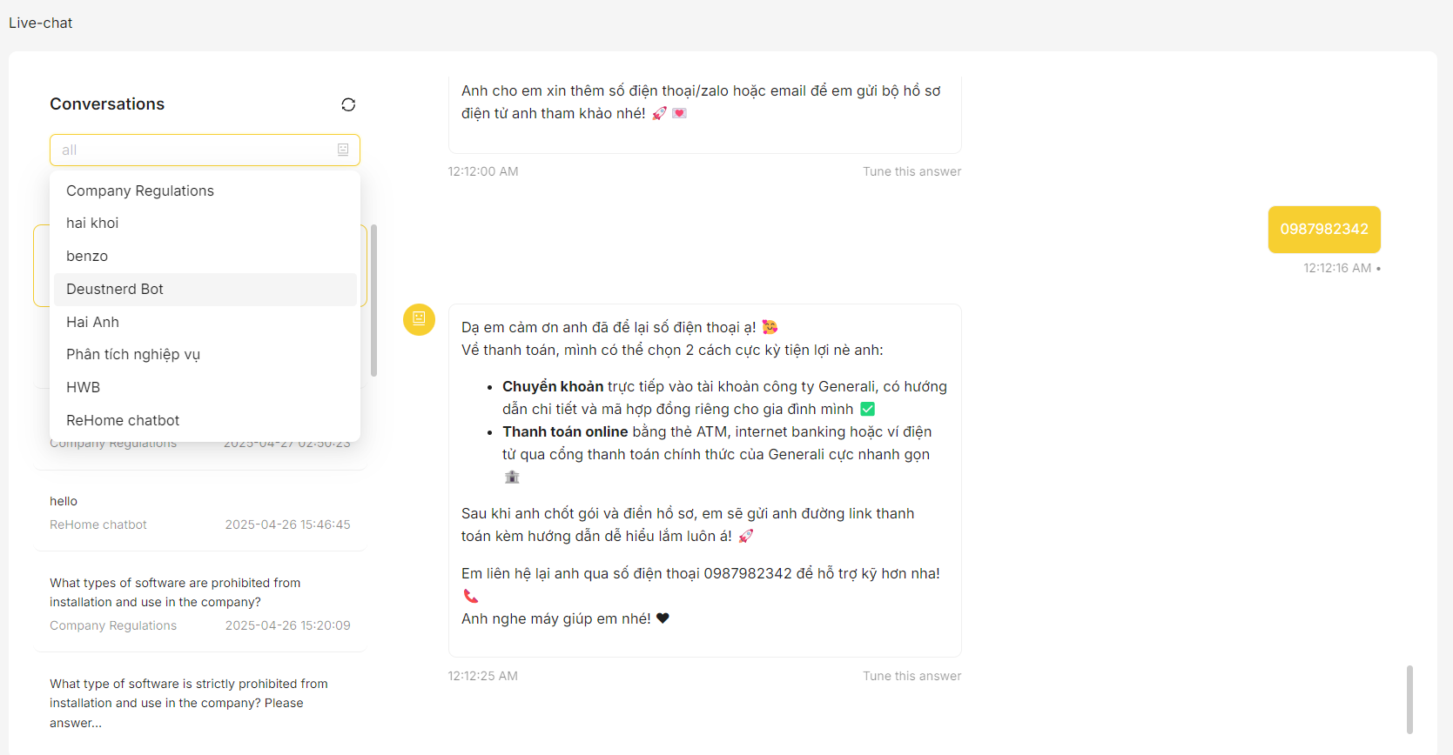

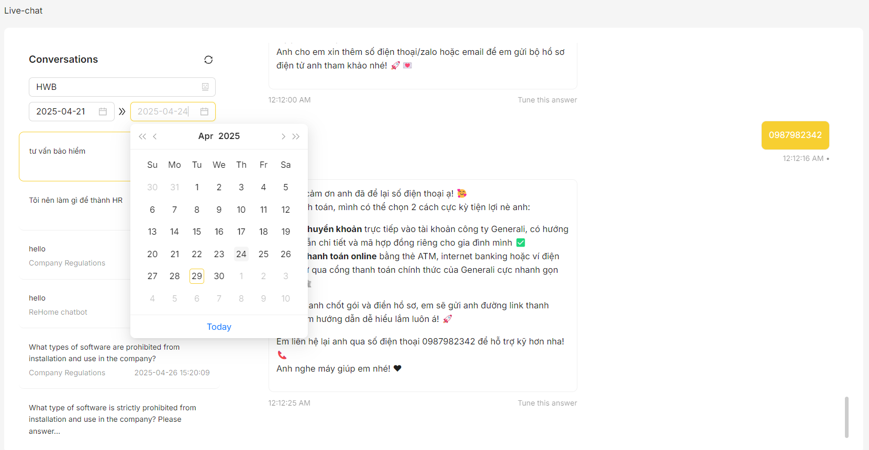

## 3.5. Bot Integration

### 3.5.1 Embed Web

Description: Embed the bot on a website using a script tag to respond based on parsed data

* Copy “Embed script” from the "Embed Web" section in the Settings tab.

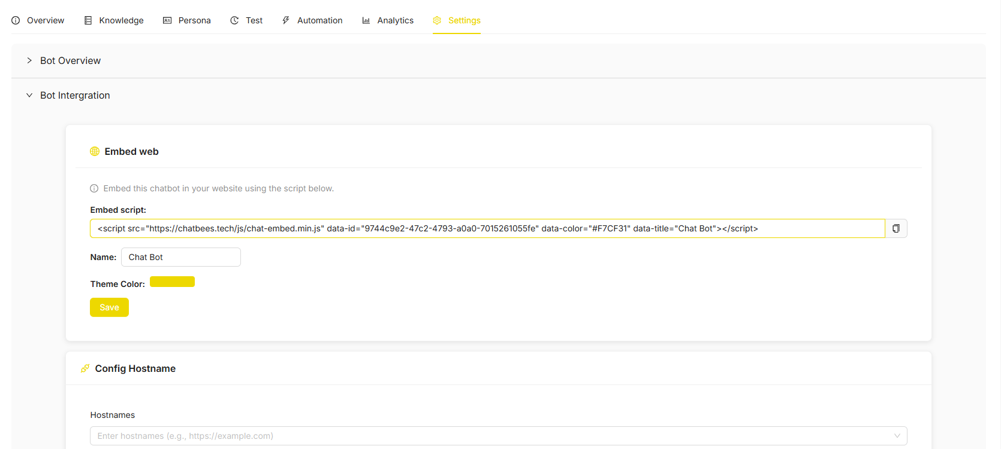

* Paste it into your website's source code to enable chat functionality.

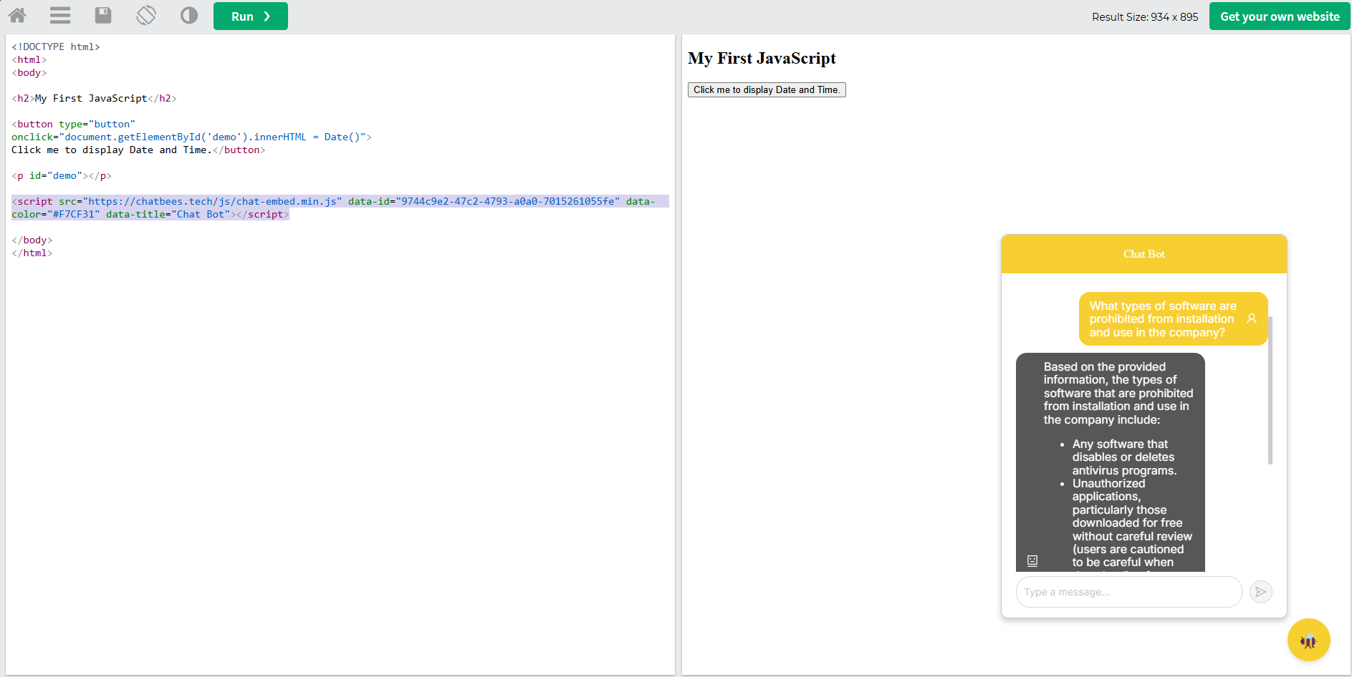

### 3,5.2 Telegram Integration

Description: Integrate the bot with Telegram for automated responses using parsed data.

* Open Telegram and search for @BotFather.

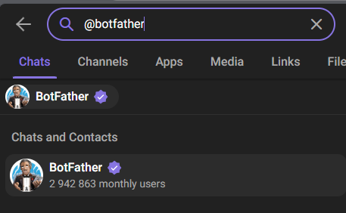

* Start a chat with BotFather and send the command /start.
* Send the command /newbot to create a new bot.
* Follow the instructions to set a name and username for your bot.
* Once created, BotFather will provide you with an API token.

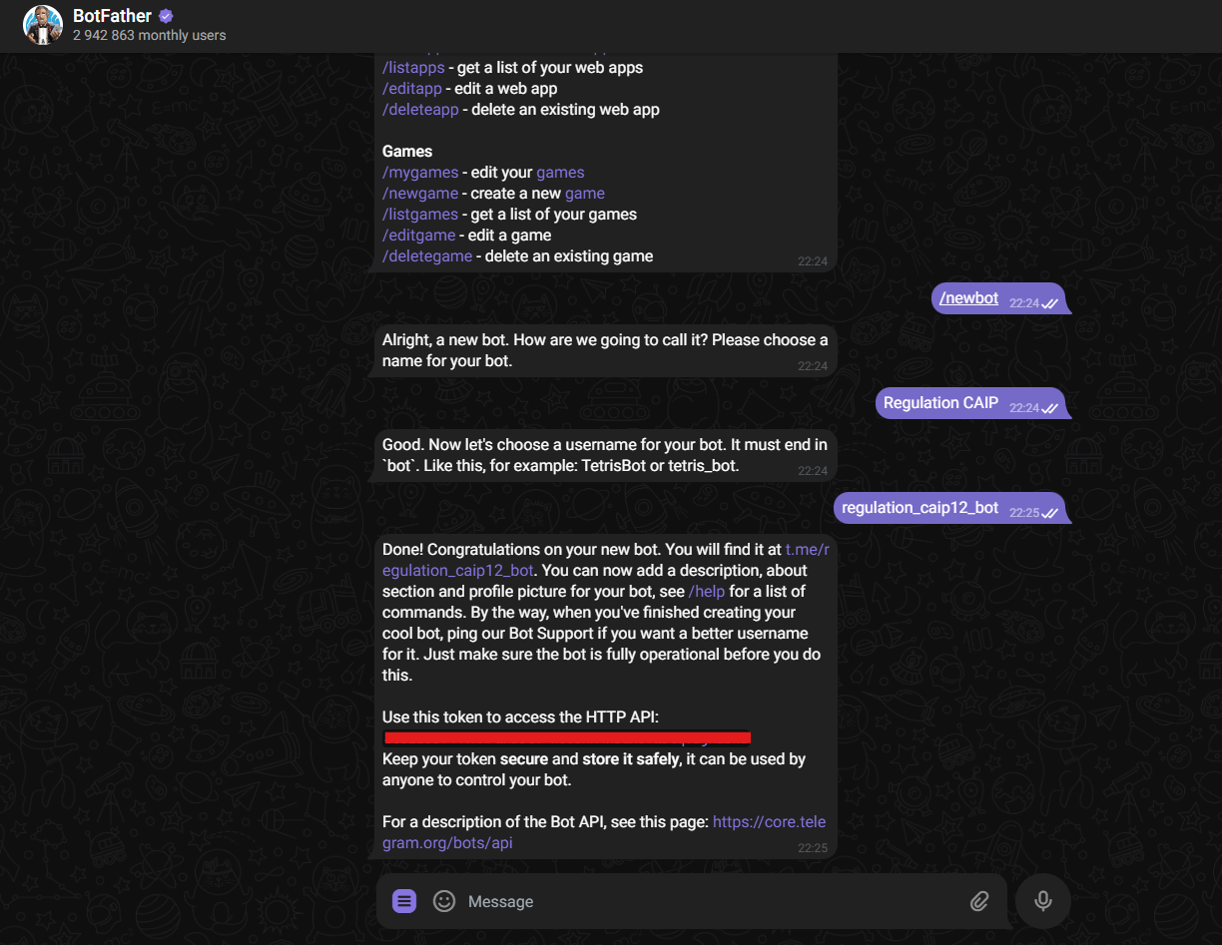

* Copy API token and paste it into the field “Telegram API Token”.

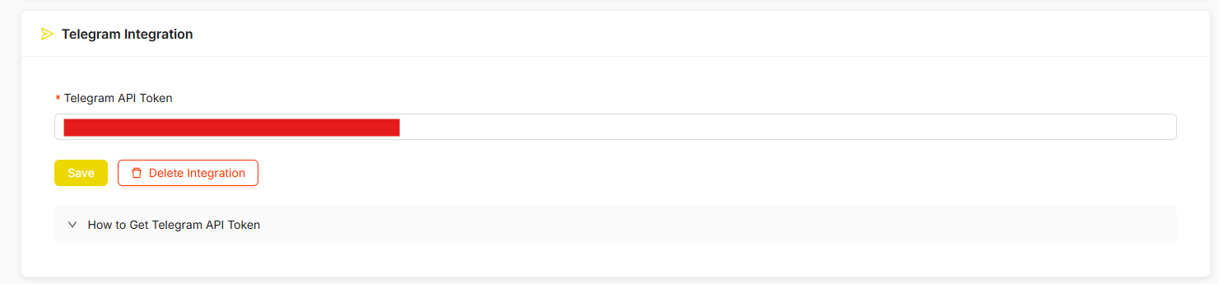

* Start chatting with bot.

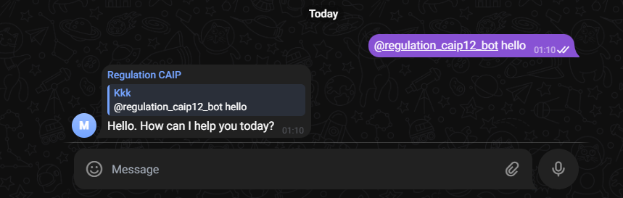

### 3.5.3 Slack Integration

Description: Integrate the bot with Slack for automated responses in channels using parsed data.

* Go to <https://api.slack.com> and sign in with your Slack account.
* Click "Create New App" → Select "From scratch".
* Name your app (e.g., MySlackBot) and choose a workspace.

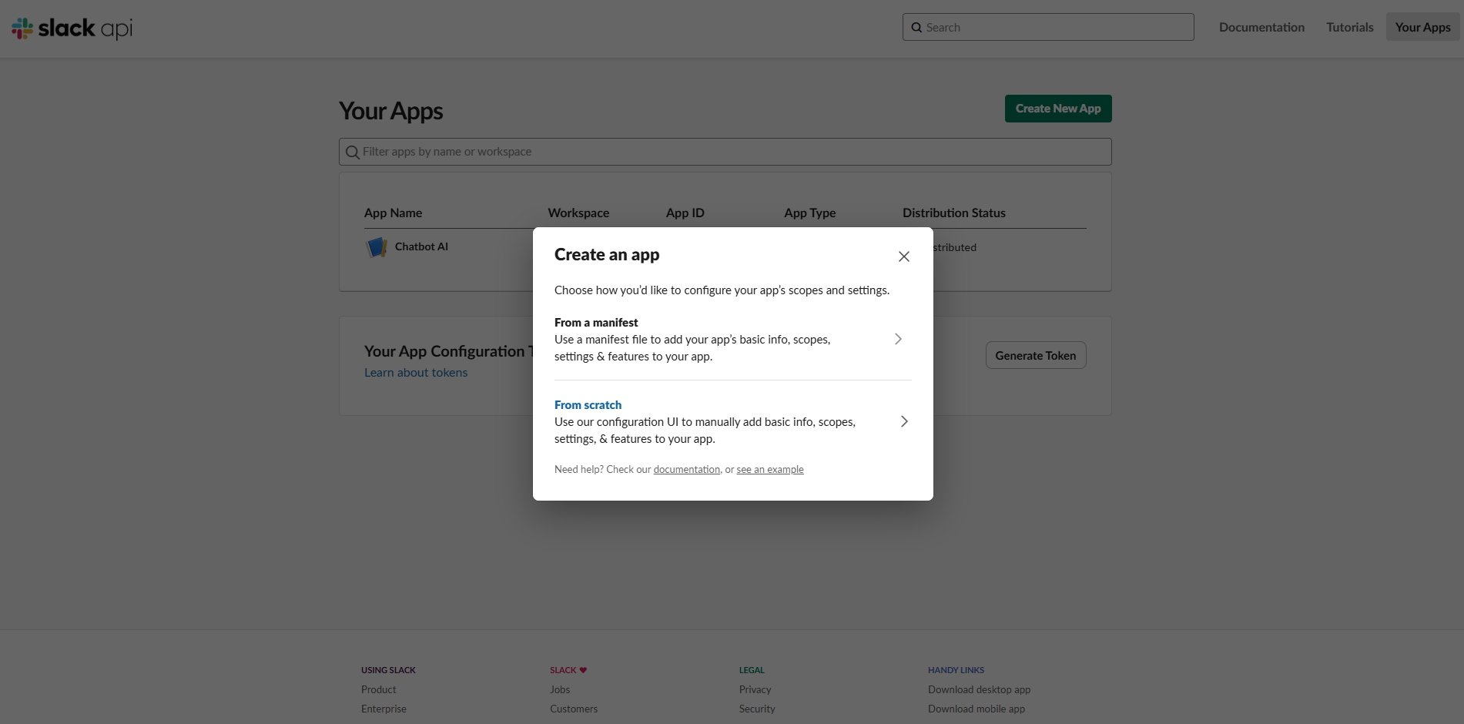

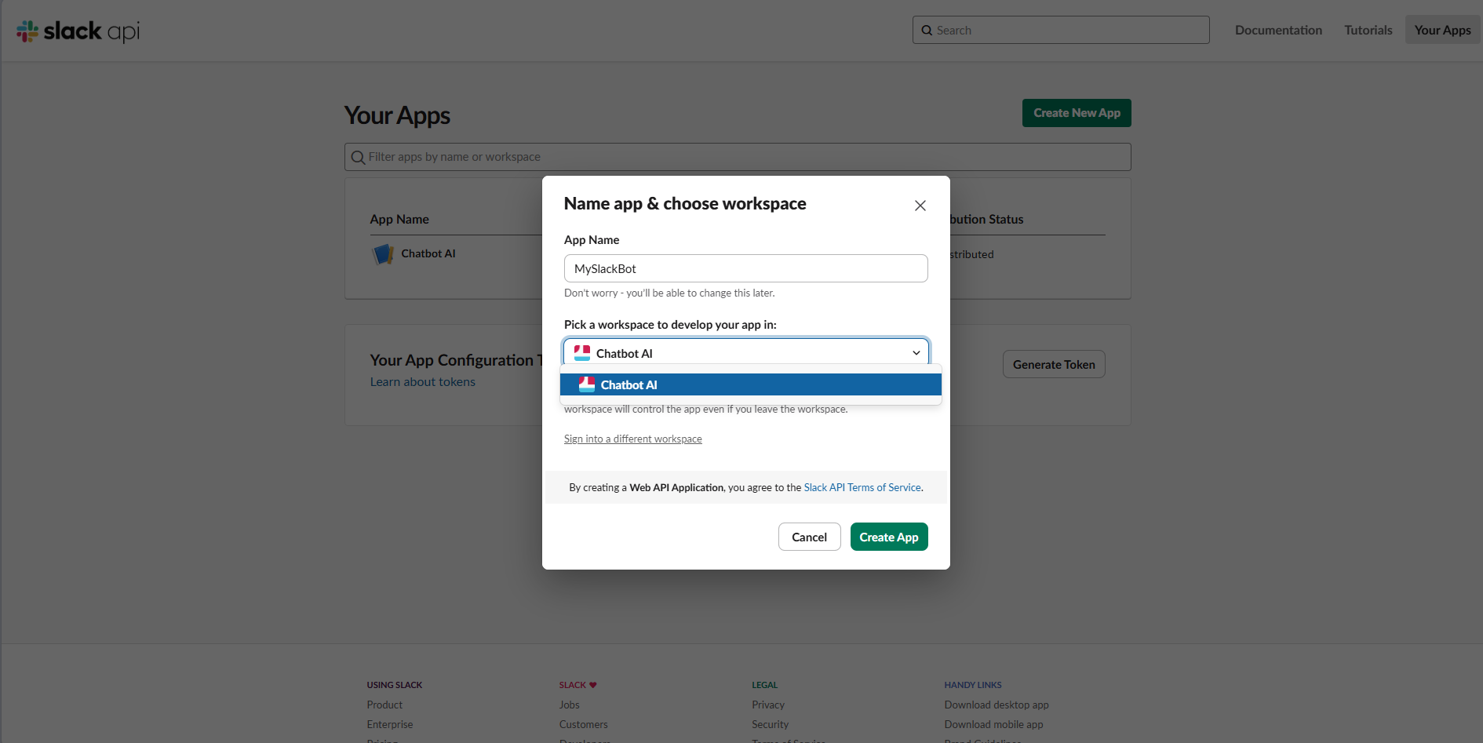

* Navigate to the "OAuth & Permissions" section in the sidebar.

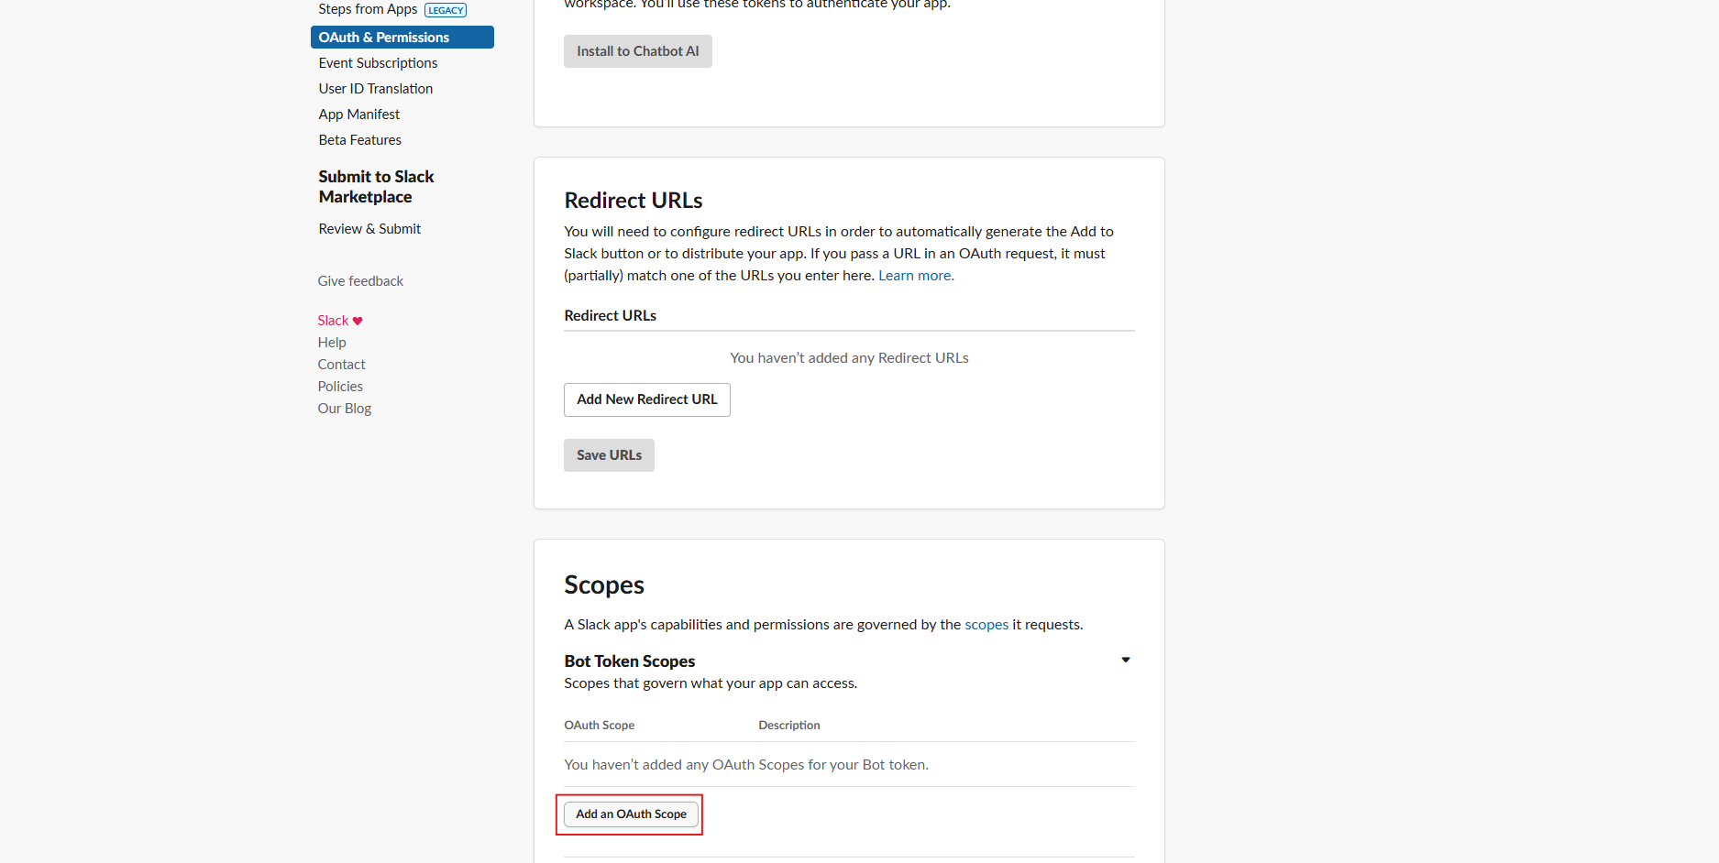

* Add the following Bot Token Scopes: channels:read, channels:history, chat:write, incoming-webhook, groups:history, im:history.

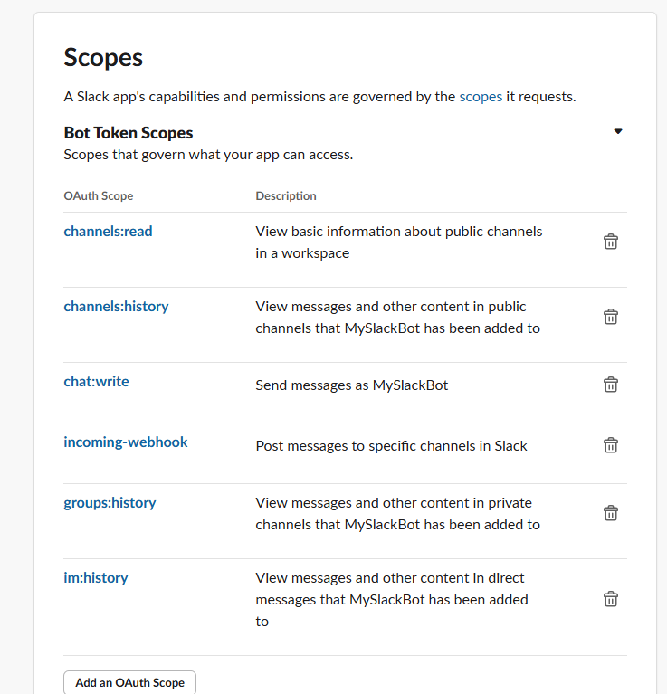

* Click "Install to Workspace" to install the app to your workspace, then authorize it.

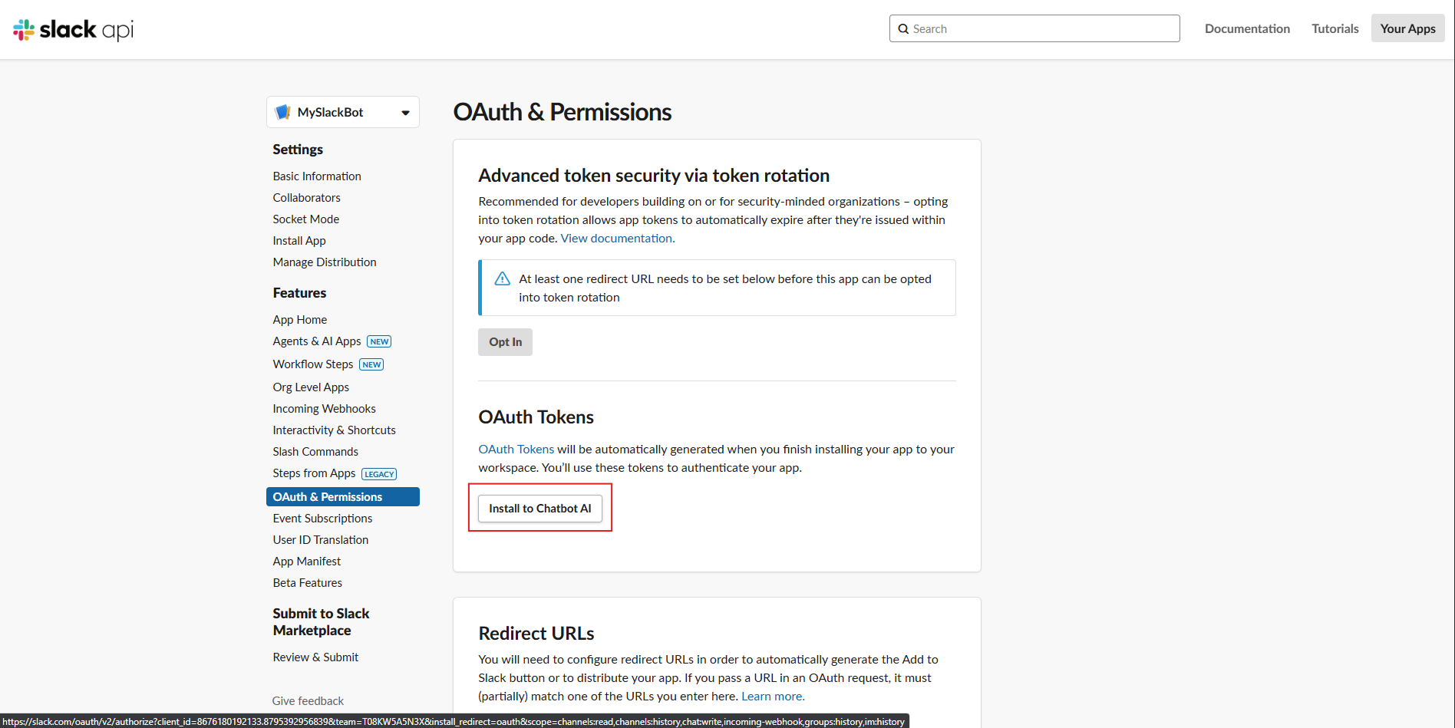

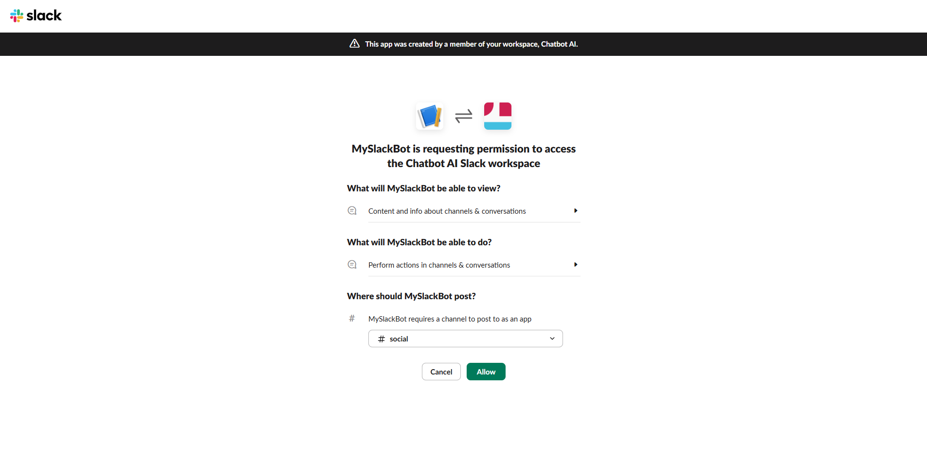

* Copy the Bot User OAuth Token (it starts with xoxb-) and paste it into the "Slack Bot Token" field.

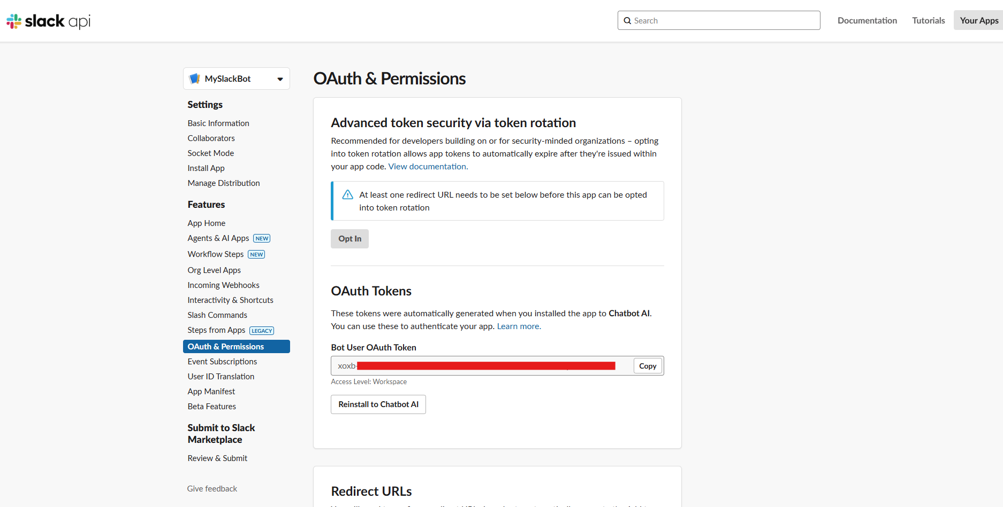

* In the "Basic Information" section, find the App ID.
* Copy the App ID and paste it into the "Slack App ID" field

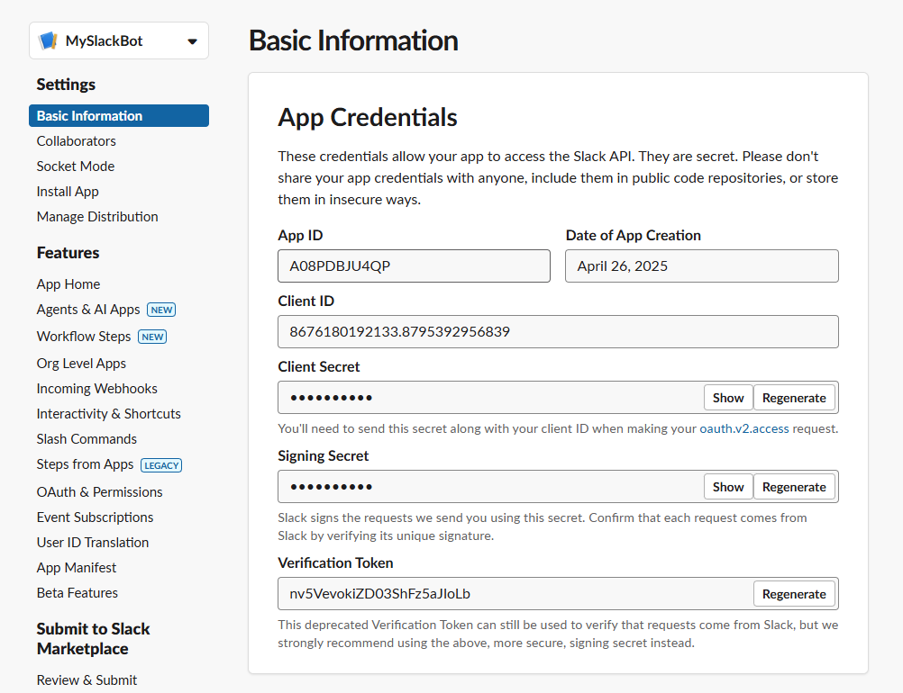

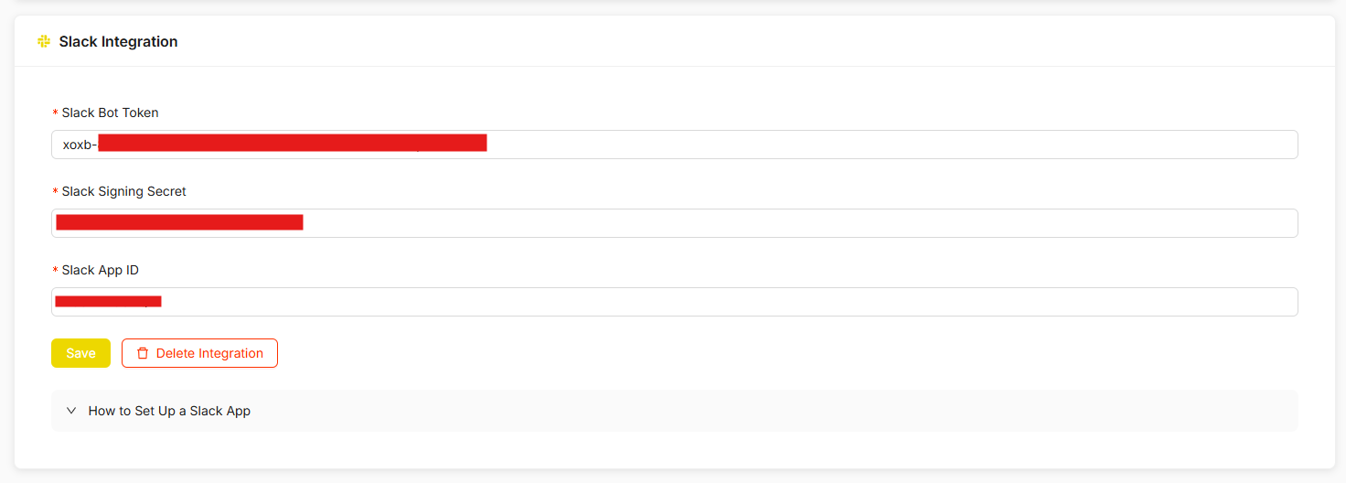

* Navigate to the "Event Subscriptions" section in the sidebar.
* Enable Events by toggling the switch to "On".
* Add a Request URL: https://api.chatbees.tech/api/slack/events
* Subscribe to the following bot events: message.channels, message.groups, message.im.
* Click "Save Changes" to apply the settings.

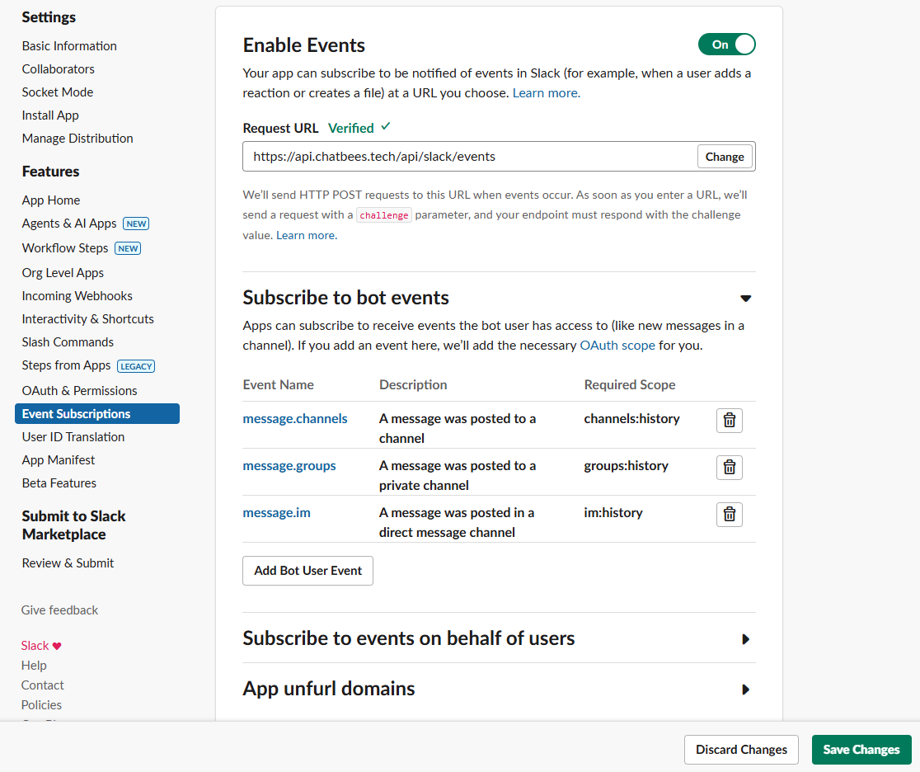

* Start chatting with bot in Channel.

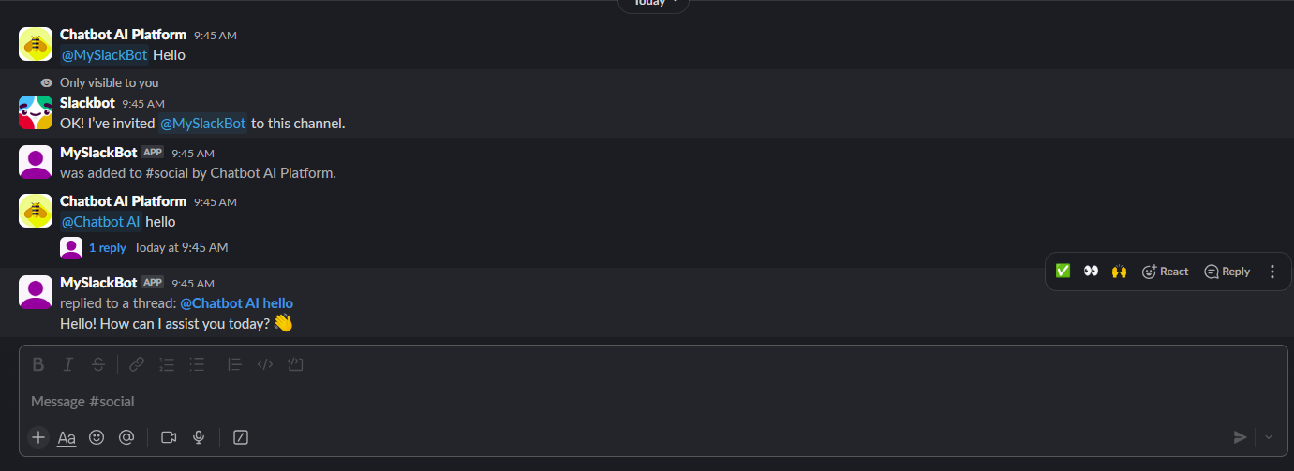

## 3.6. Admin Management

### 3.6.1 Plan Management

##### 3.6.1.1 Create Plan

Description: Admin wants to create new plan for system

* After logging into the system, Admin navigates to the Plans section.
* Admin clicks “Create New Plan”.
* Admin fills in Name, Title, Description and Price for new plan.
* User clicks the “Create Plab” button.

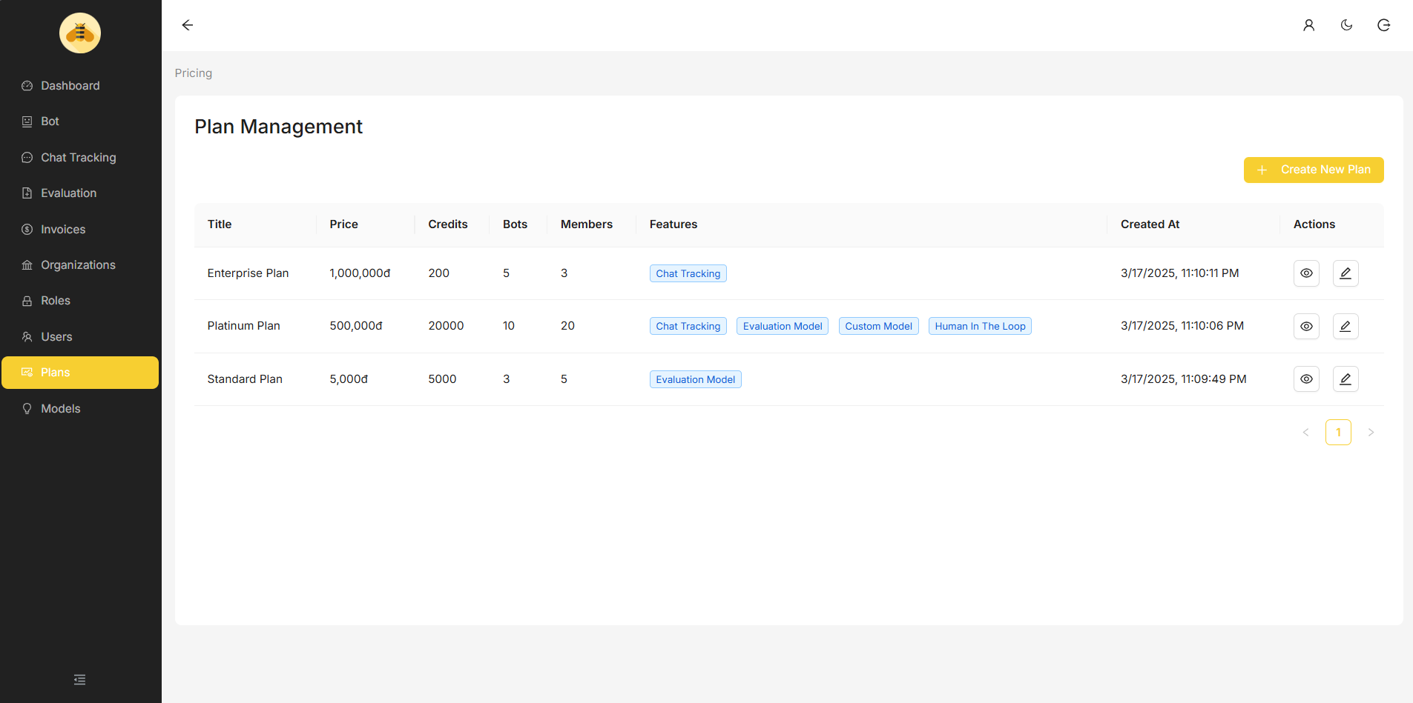

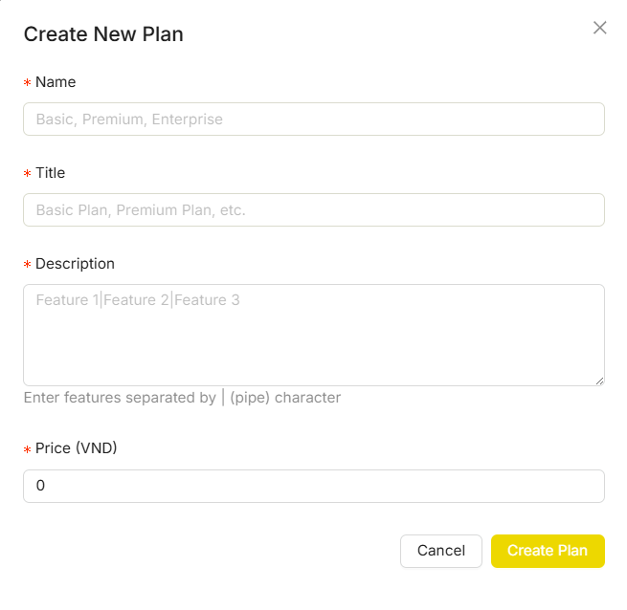

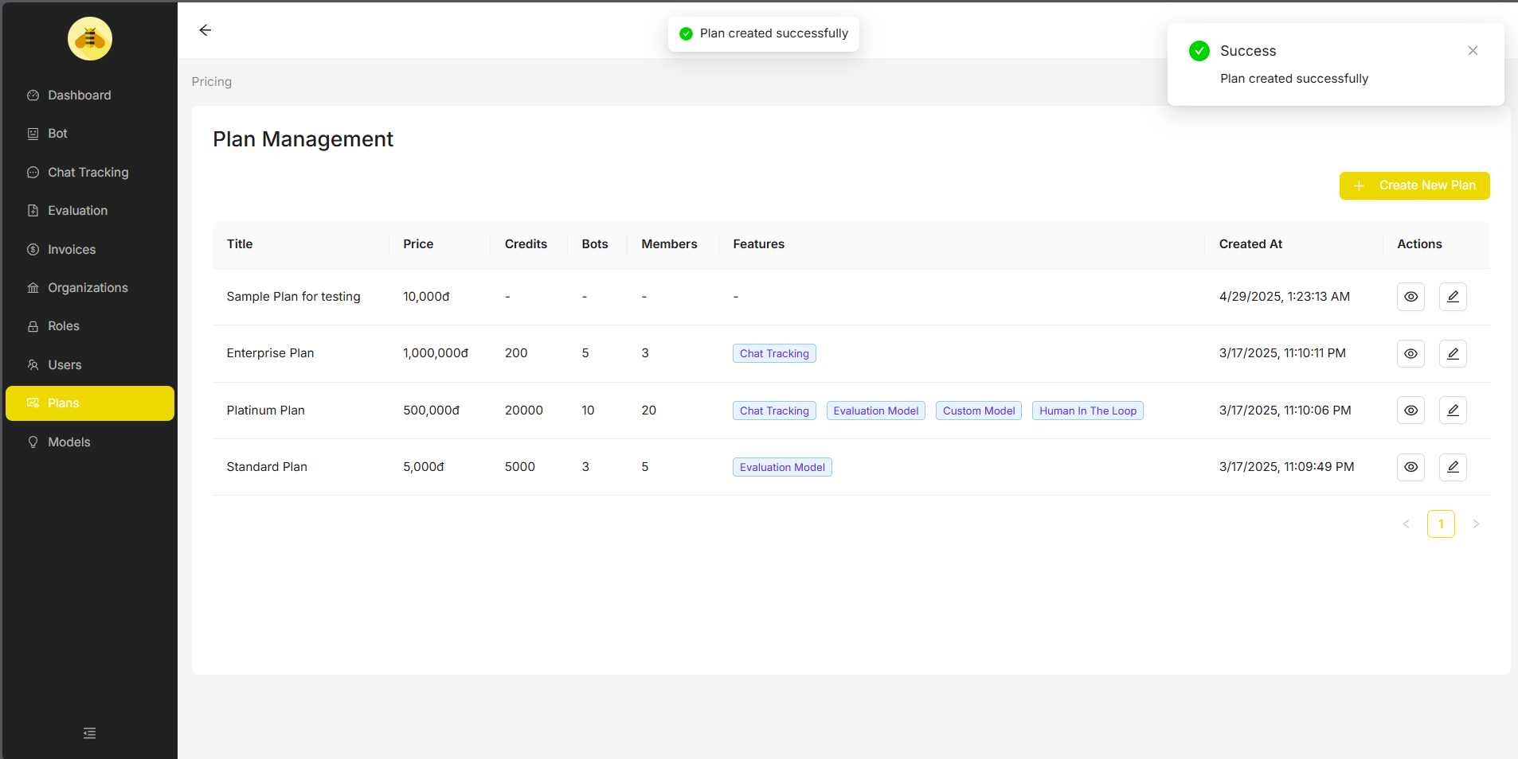

##### 3.6.1.2 Update Plan

Description: Admin wants to update plan

* Admin clicks icon edit in Column Actions of the plan Admin wants to change.
* Admin enters the fields that need to be changed to suit the plan.

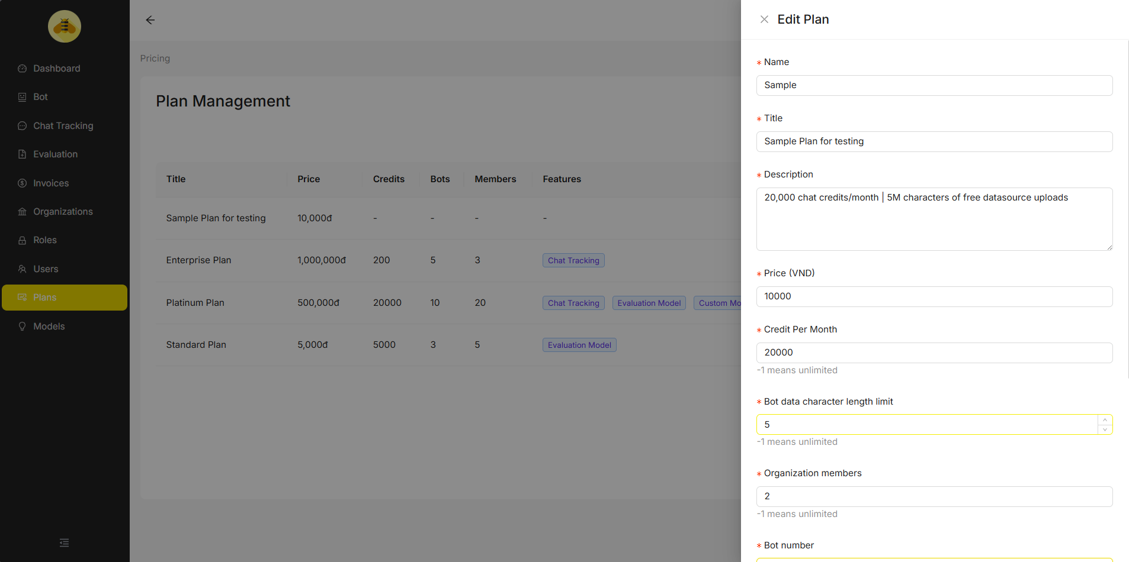

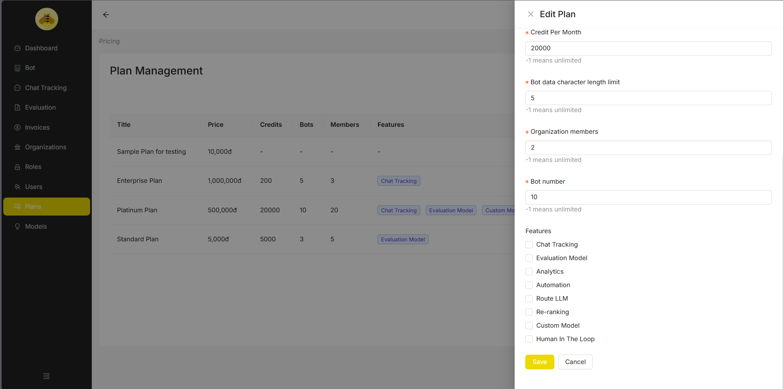

* User clicks the “Save” button.

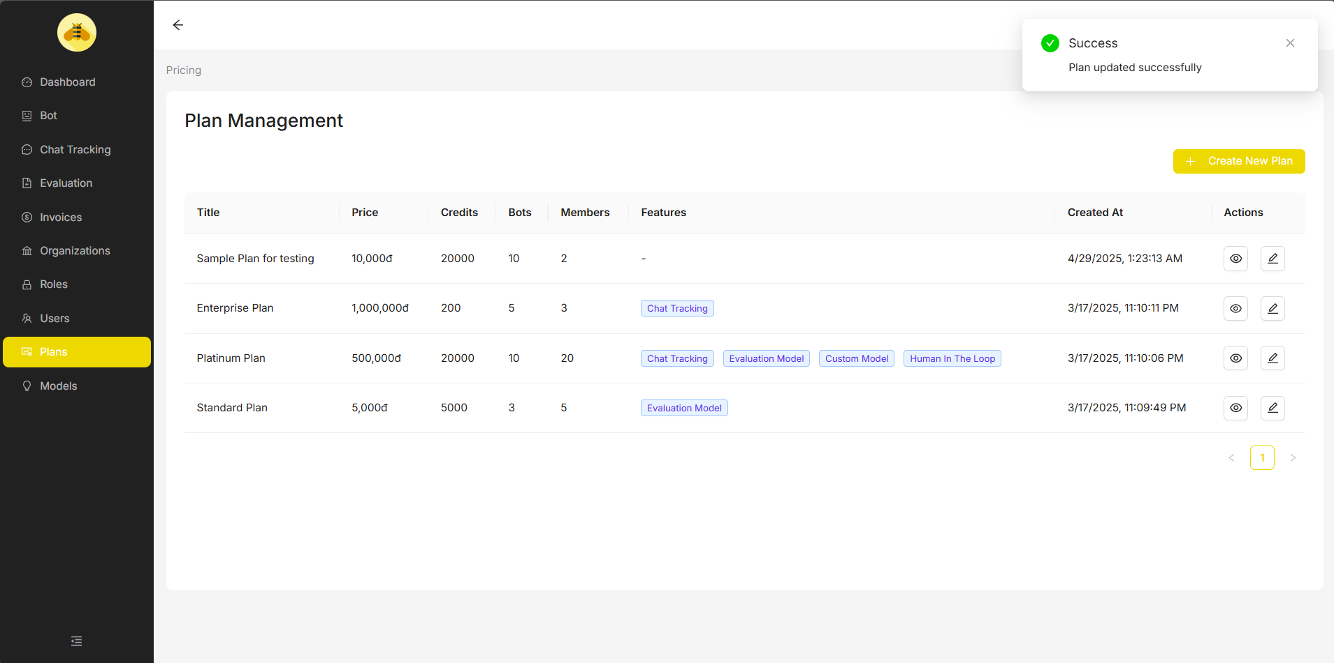

### 3.6.2 Invoice Management

##### 3.6.2.1 Create Invoice

Description: Admin wants to create a new invoice for Organization.

* After logging into the system, Admin navigates to the Invoices section.
* Admin click “Create Invoice” button on Table
* Admin choose Organization, Plan, and fill in Description, Price.

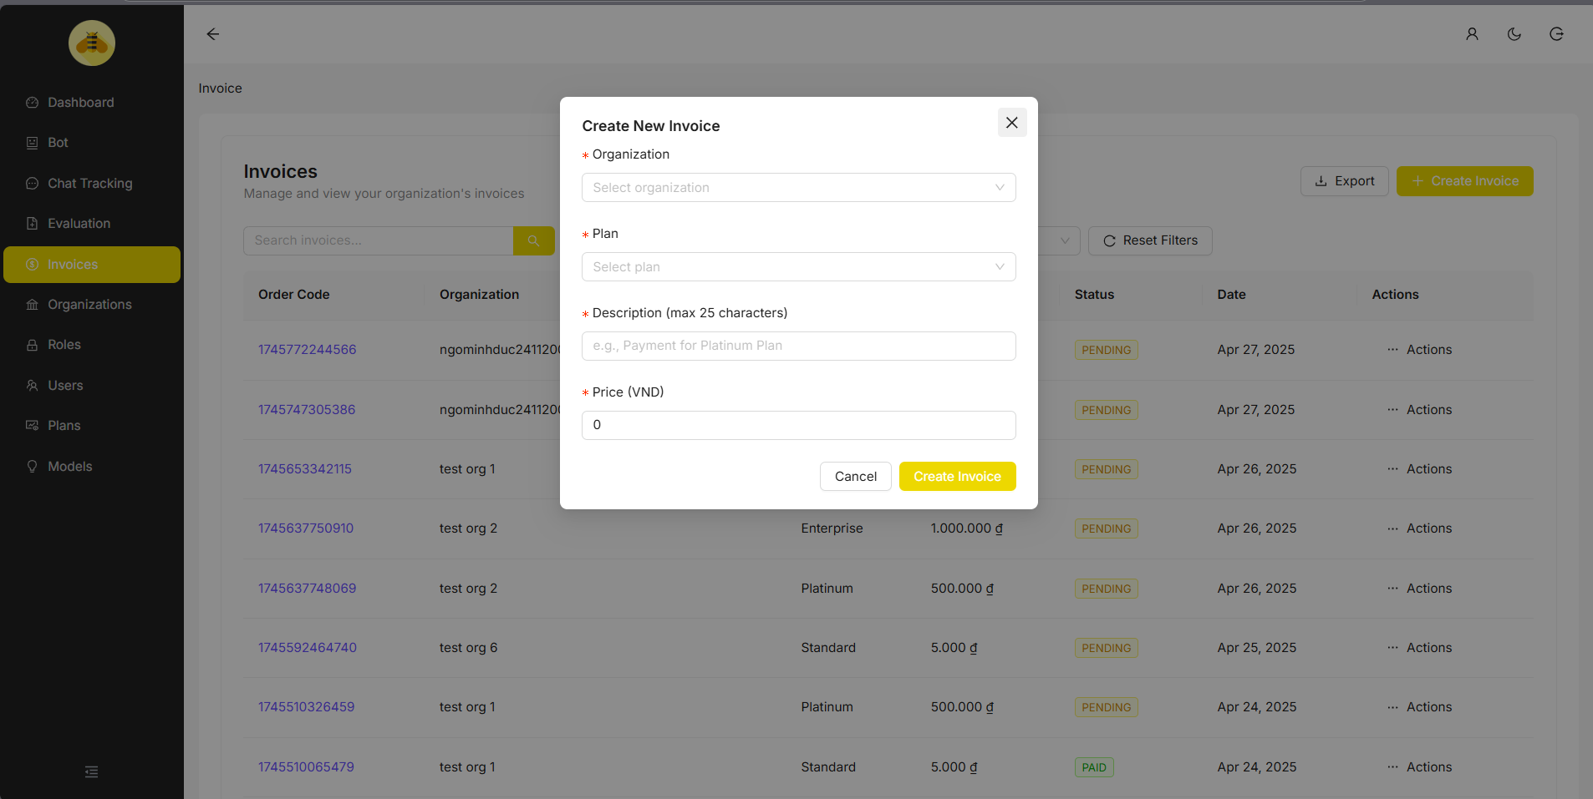

* Admin click “Create Invoice” button on “Create New Invoice” Dialog

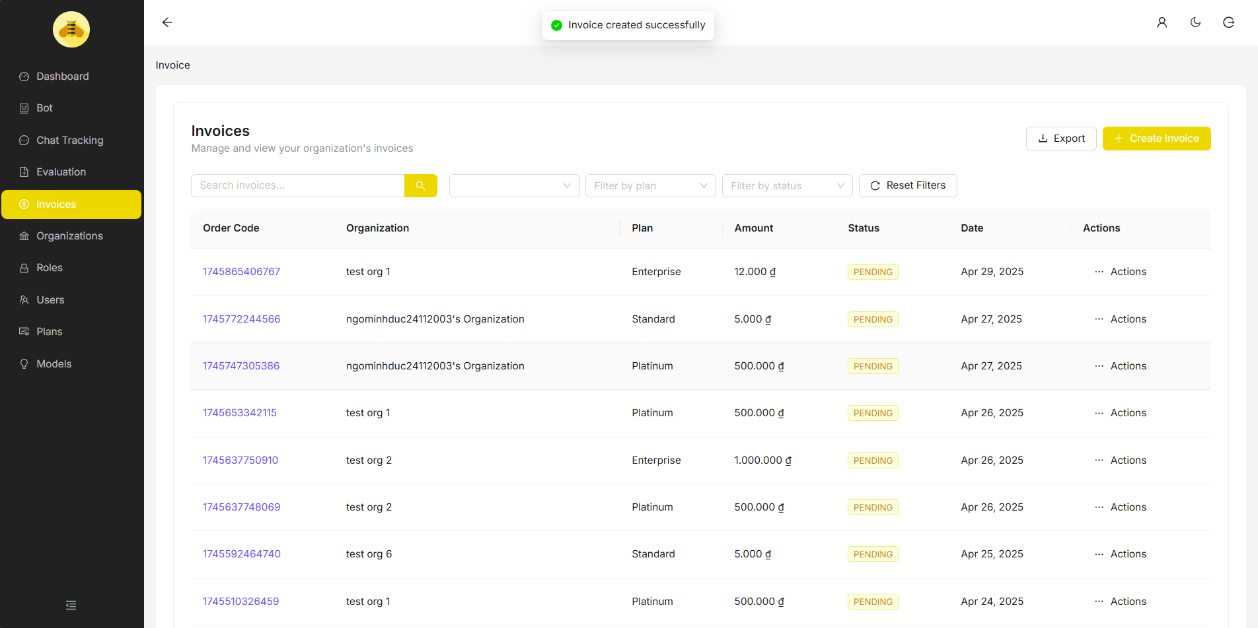

##### 3.6.2.2 Update Invoice

Description: Admin wants to change Status “PENDING” to “PAID” of an Invoice.

* Admin hover to field Actions of an pending-status Invoice that need to be updated.

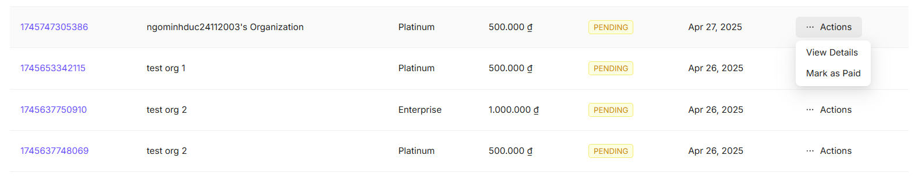

* Admin click “Mark as Paid”

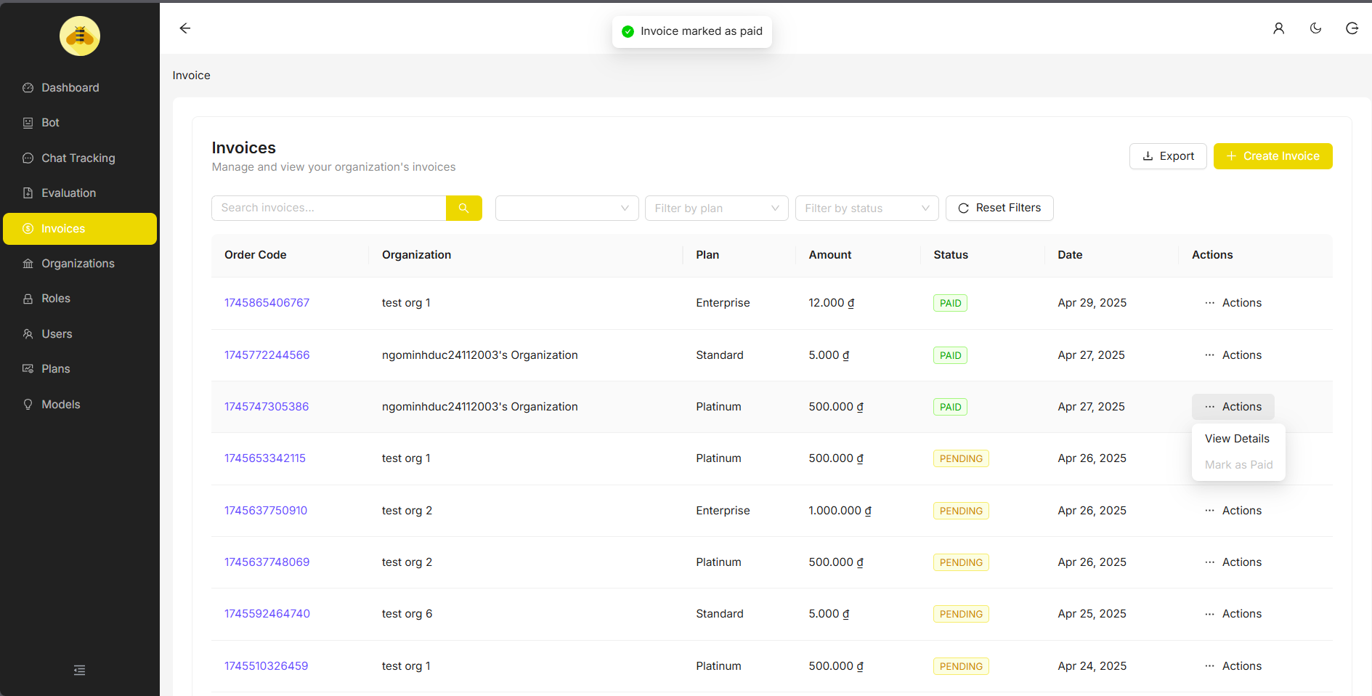

### 3.6.3 User Management

##### 3.6.3.1 Create User

Description: Admin wants to create new account

* After logging into the system, Admin navigates to the Users section.
* Admin click “Create Invoice” button on Table
* Admin fill in new Account information.

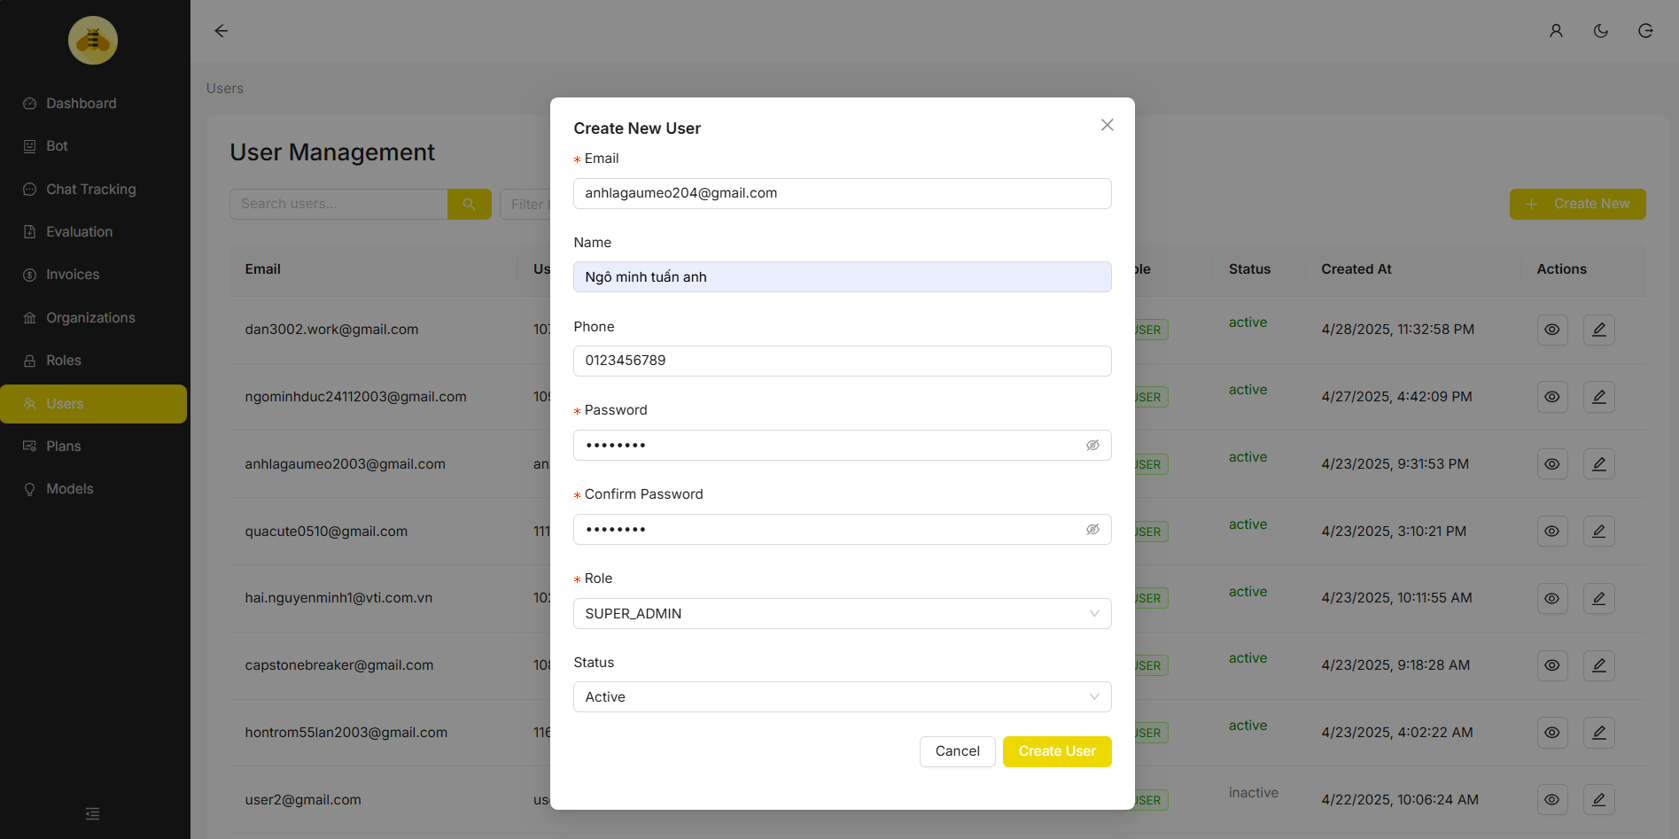

* Admin click “Create User” on “Create New User” Dialog

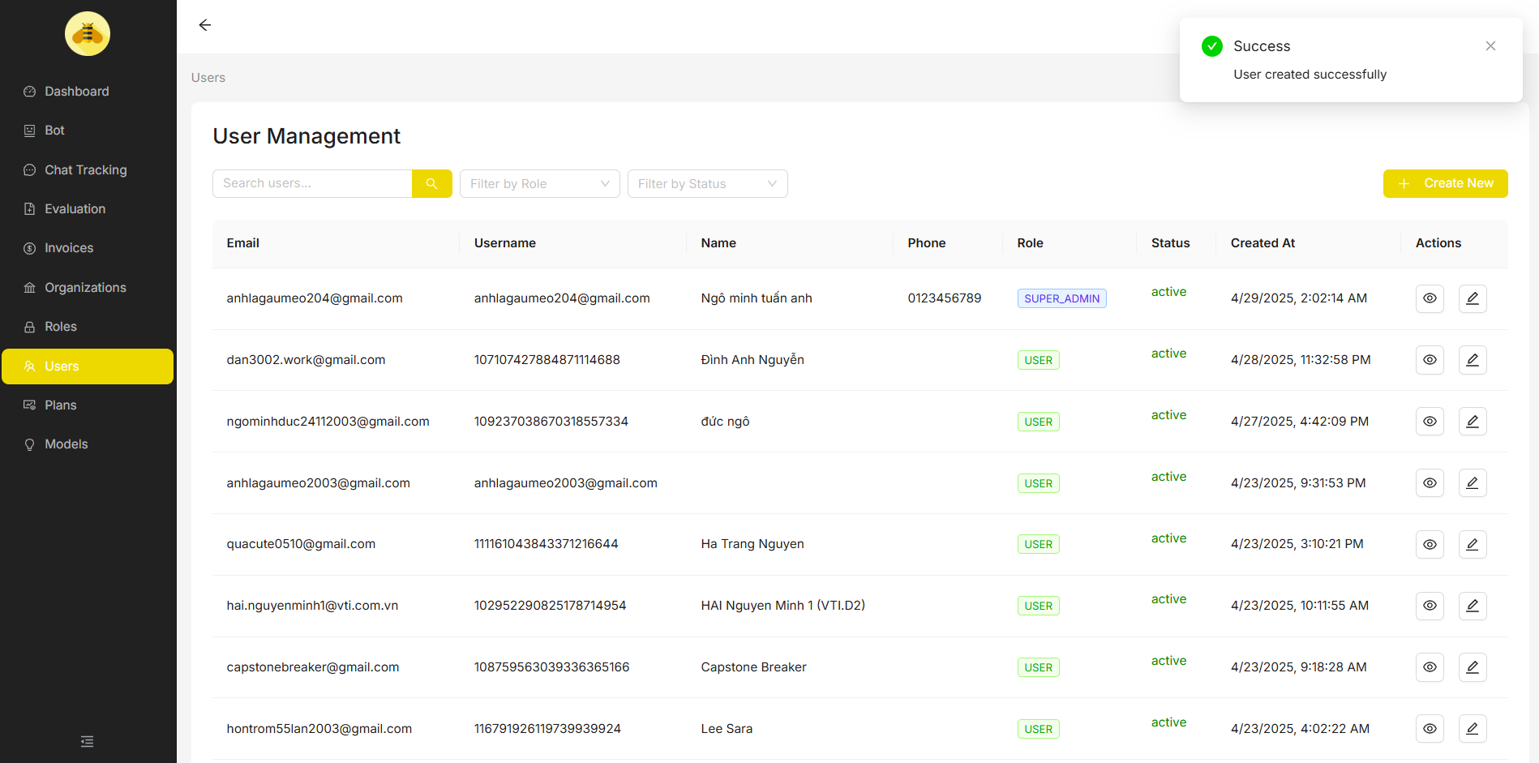

##### 3.6.3.2 Update User

Description: Admin wants to update user

* Admin clicks the editing icon on the user that admin wants to update.
* Admin update user information.

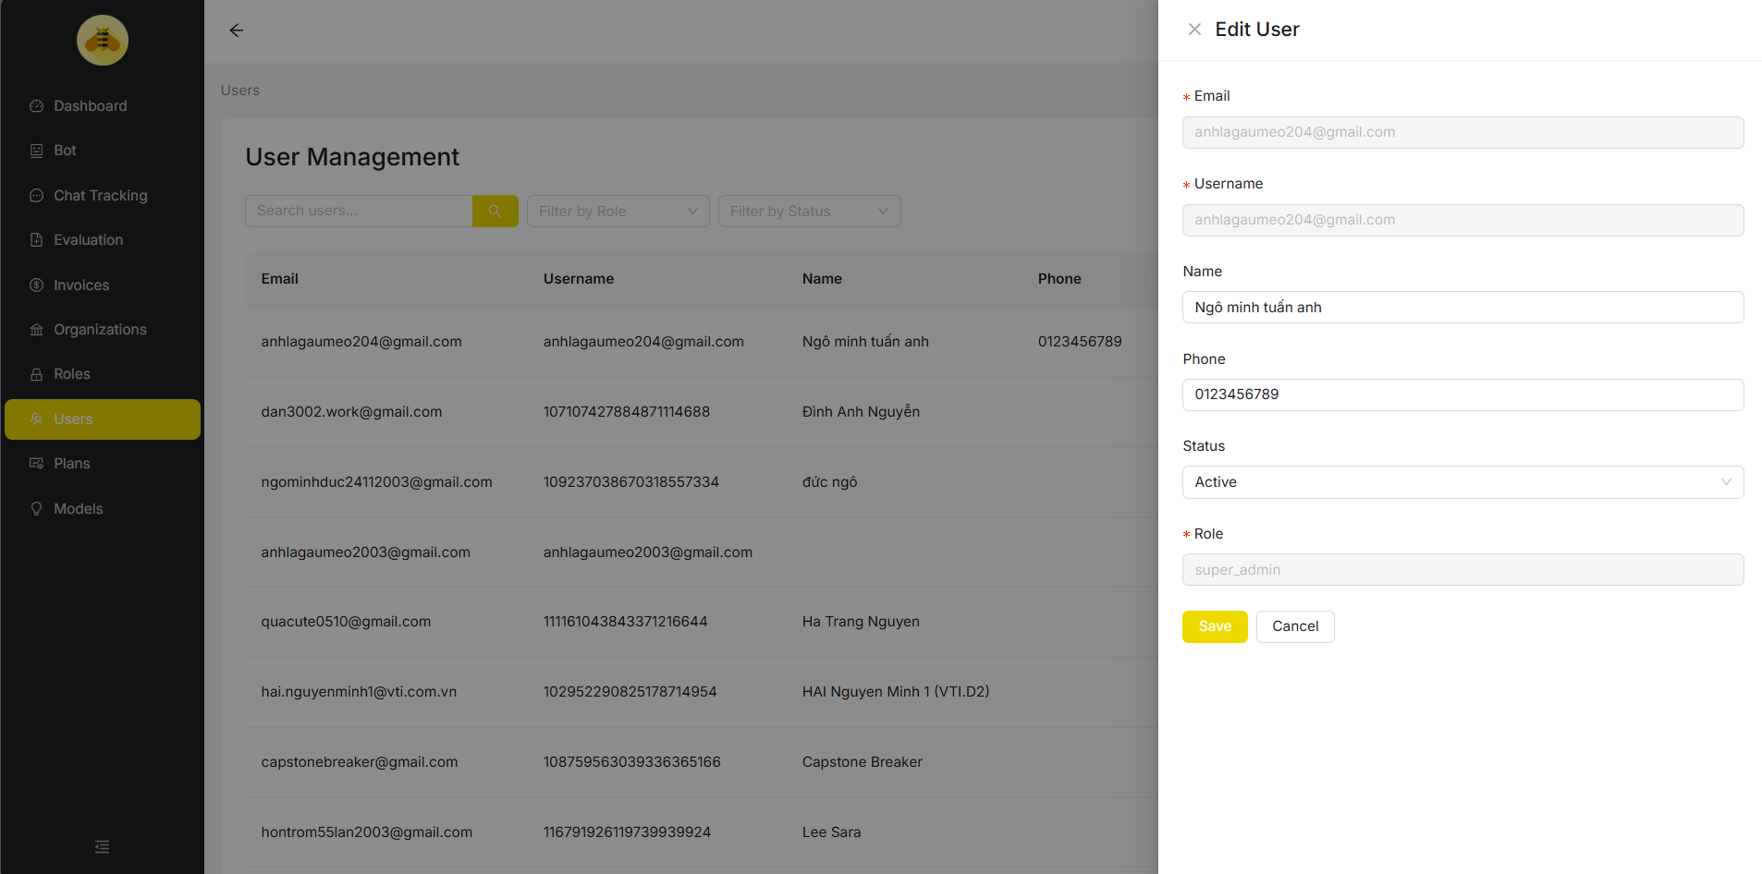

* Admin click “Save” button to update user information

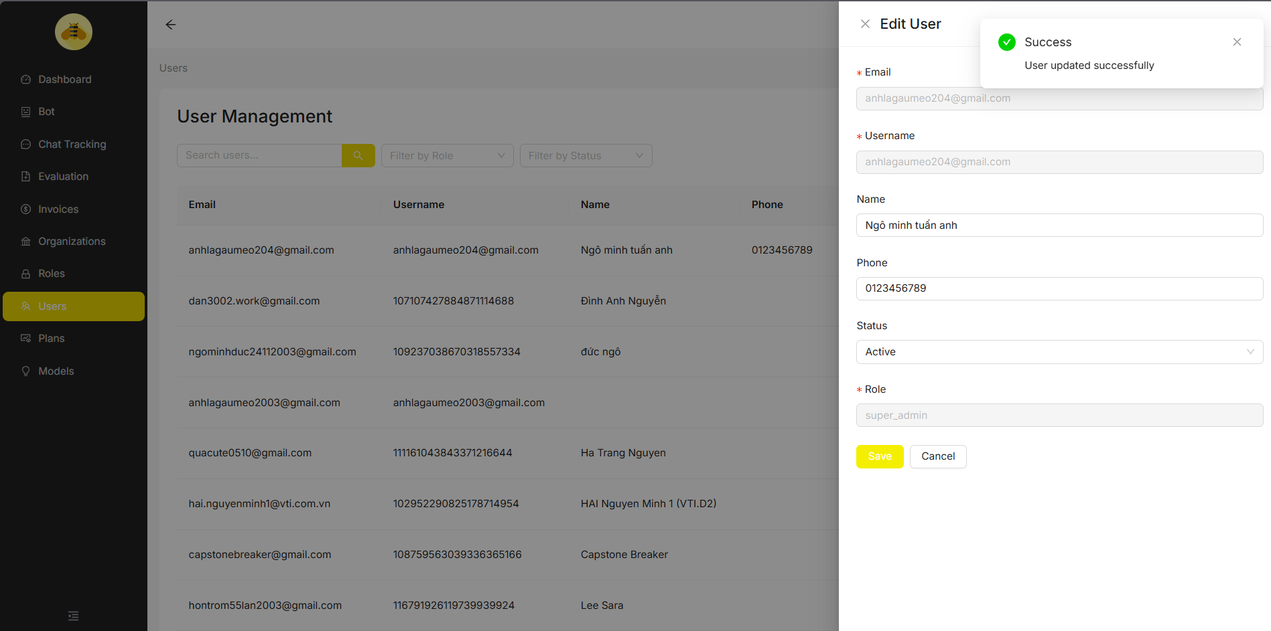

### 3.6.4 Organization Management

Description: Admin can view and update organization information

* After logging into the system, Admin navigates to the Organization section.
* Admin clicks the editing icon on the Organization that admin wants to update
* Admin change Organization information.

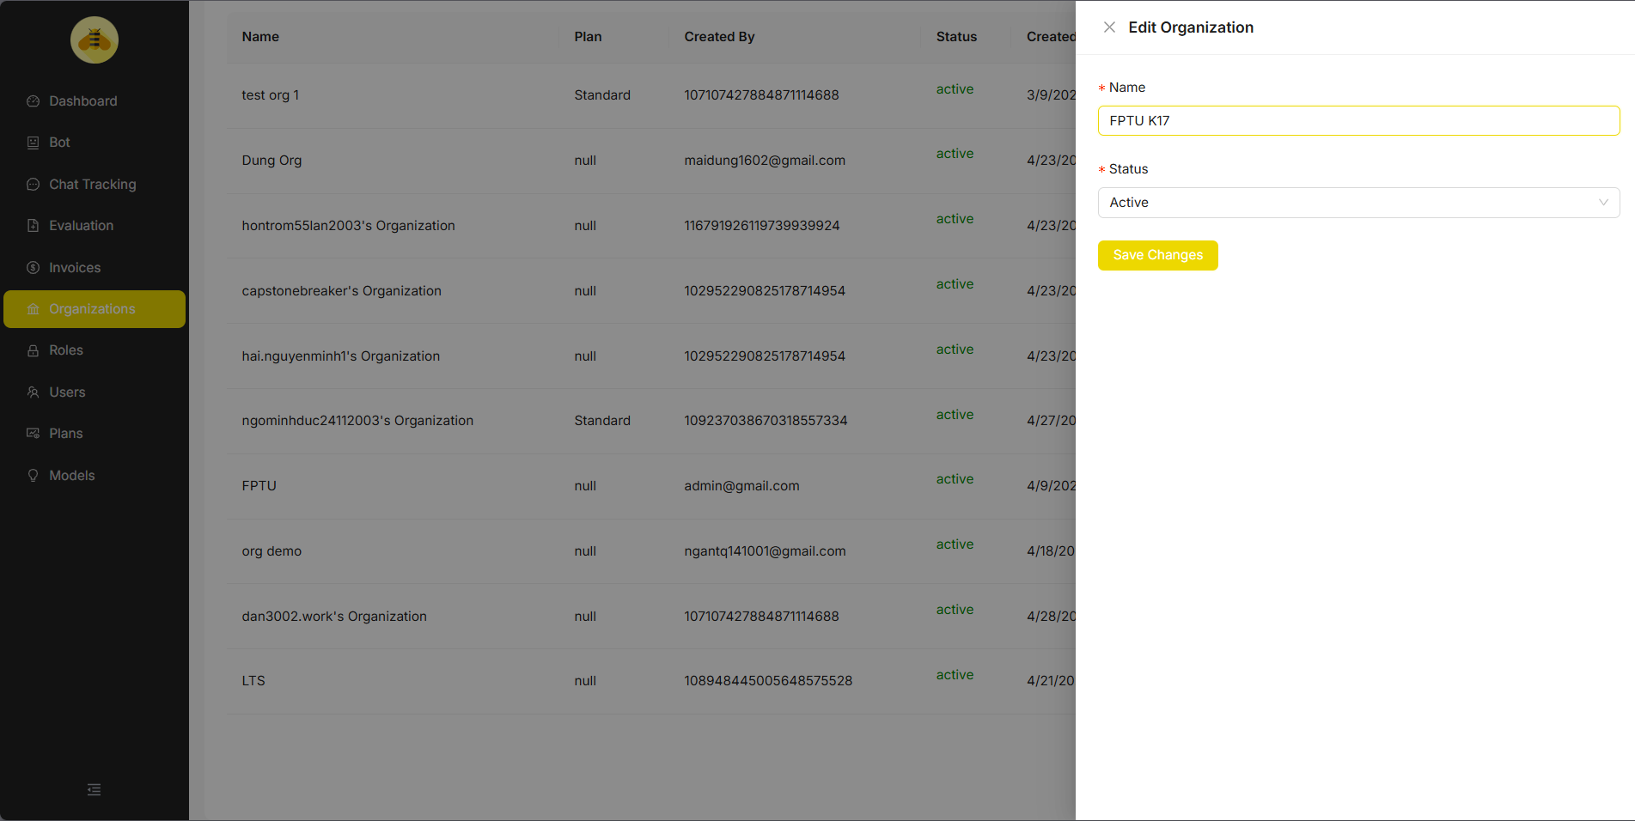

* Admin click “Save Changes” to update Organization.

